

**Batch: A1 Roll No.: 16010121045**

**Experiment / Assignment / Tutorial No:**

|  |
| --- |
| **TITLE:** To understand the importance of card sorting technique for information architecture in UX design process. |

**Objective:** To study and understand the role of card sorting process in UI/UX design. ______________________________________________________________________

**Expected OUTCOME of Experiment:**

**CO 3:** To understand the importance of card sorting technique for information architecture in UX design process.

**______________________________________________________________________**

**Books/ Journals/ Websites referred:**

* <https://careerfoundry.com/en/blog/ux-design/a-beginners-guide-to-information-architecture/>
* https://medium.theuxblog.com/information-architecture-what-is-it-and-where-did-it-come-from-5ba3105fe6b4
* https://www.interaction-design.org/literature/topics/information-architecture

**______________________________________________________________________**

**New Concepts to be learned:**

1. Information Architecture.

**Introduction to card sorting:**

Card sorting is a user research technique used in information architecture to help design or evaluate the structure of a website or application. It involves asking users to organize content topics into categories that make sense to them. This method helps designers understand users' mental models and create intuitive navigation systems.

There are two main types of card sorting:

1. Open card sorting: Users create their own category names
2. Closed card sorting: Users sort items into predefined categories

**Role of Information Architecture in UX design process.**

Information Architecture (IA) plays a crucial role in the UX design process by:

1. Organizing and structuring content
2. Improving navigation and findability
3. Enhancing user understanding and engagement
4. Supporting scalability and future growth
5. Facilitating effective communication between design teams and stakeholders

IA typically comes early in the UX design process, after user research but before visual design and prototyping.

**Components in Information Architecture:**

The main components of Information Architecture include:

1. Organization systems: How information is categorized (e.g., hierarchical, sequential, matrix)
2. Labeling systems: How information is represented (e.g., terminology used in navigation)
3. Navigation systems: How users move through information (e.g., global navigation, local navigation, contextual navigation)
4. Search systems: How users look for information
5. Metadata: Information about the content that aids in organization and retrieval

**Principles of Information Architecture:**

Some key principles of Information Architecture include:

1. Principle of Objects: Treat content as a living, breathing thing with lifecycles, behaviors, and attributes
2. Principle of Choices: Create pages that offer meaningful choices to users while minimizing cognitive load
3. Principle of Disclosure: Show only enough information to help people understand what kinds of information they'll find as they dig deeper
4. Principle of Exemplars: Describe the contents of categories by showing examples of the contents
5. Principle of Front Doors: Assume at least half of the website's visitors will come through some page other than the home page
6. Principle of Multiple Classification: Offer users several different classification schemes to browse the site's content
7. Principle of Focused Navigation: Don't mix apples and oranges in your navigation schemes

**Results:**

Open Card Sorting

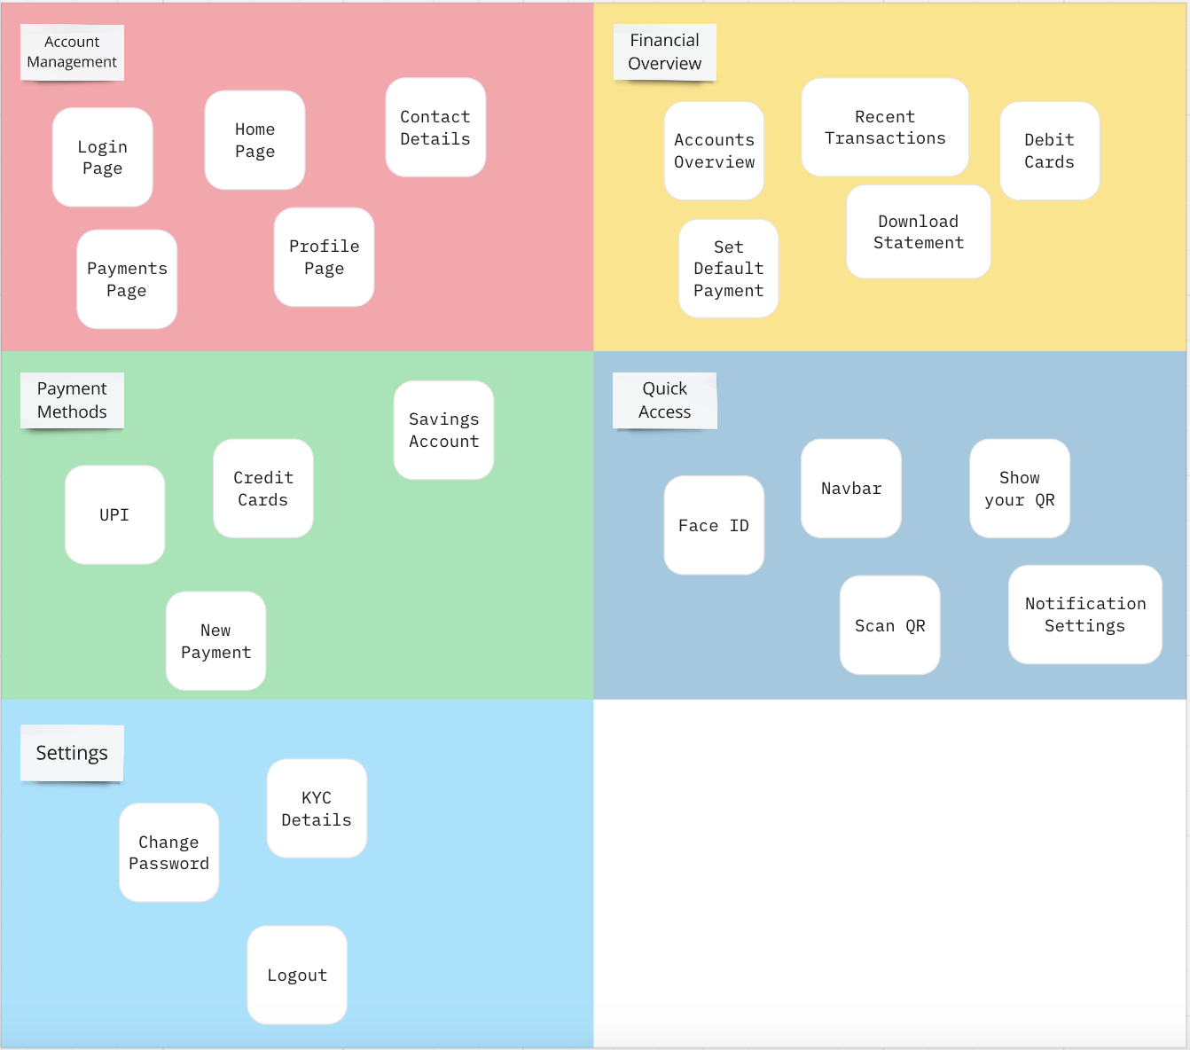

Closed Card Sorting

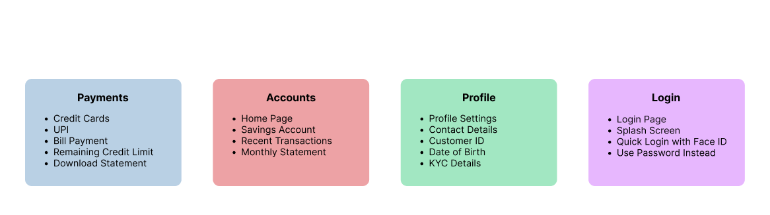

**Conclusion:**

Information Architecture is crucial for creating intuitive, user-friendly digital experiences. By organizing content effectively, IA improves navigation, enhances user understanding, and forms the foundation of successful UX design. As digital products grow more complex, sound IA principles become increasingly important in crafting coherent, accessible, and user-centered designs.