

**Batch: A1 Roll No.: 16010121045**

**Experiment / Assignment / Tutorial No:**

|  |
| --- |
| **TITLE:** To design the prototype of the application under consideration. |

**Objective:** To incorporate the UI-UX design principles for the prototype design. ______________________________________________________________________

**Expected OUTCOME of Experiment:**

**CO 4: Analyze tools and techniques for prototyping and designing applications.**

**______________________________________________________________________**

**Books/ Journals/ Websites referred:**

[**https://digitalpromise.org/initiative/360-story-lab/360-production-guide/investigate/augmented-reality/pre-production/what-is-prototyping/#:~:text=Prototyping%20is%20the%20process%20of,without%20using%20too%20many%20resources**](https://digitalpromise.org/initiative/360-story-lab/360-production-guide/investigate/augmented-reality/pre-production/what-is-prototyping/#:~:text=Prototyping%20is%20the%20process%20of,without%20using%20too%20many%20resources)**.**

**______________________________________________________________________**

**New Concepts to be learned:**

Prototyping

**Vlab: Prototyping of TV Remote Control Panel**

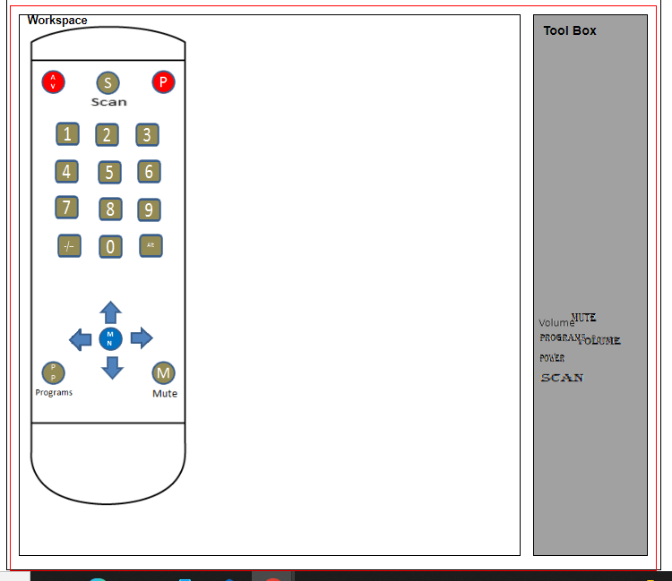

**Vlab: Prototyping of Control Panel of Domestic Appliances**

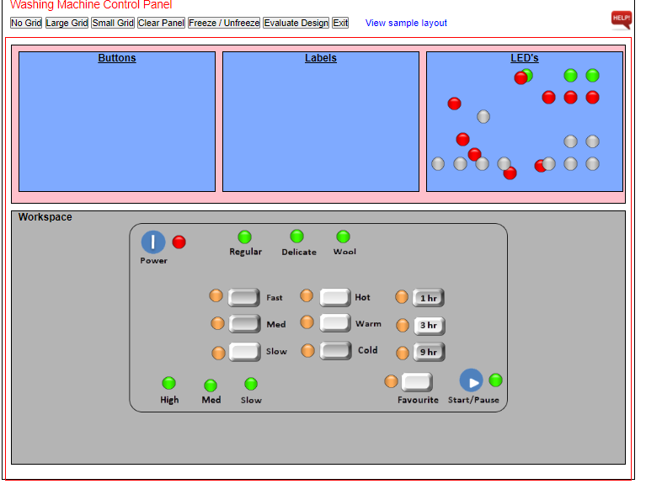

**Title:** HDFC Bank Mobile Application Prototype

**Problem Definition:**

The need for a mobile banking application that provides users with easy, secure access to their banking services, including payments, account overviews, and personal profile management.

**Features of the application/product:**

The application provides the following features:

1. Login and Authentication:

* 4-digit PIN login and biometric login options (Face ID).
* Option to add multiple users for quick account access.

1. Home Page (Dashboard):

* Display of account balance and quick links to payments, money transfers, and recent transactions.
* Quick actions (Pay, Transfer, Recharge, etc.) for fast access to banking services.

1. Payments Section:

* Credit and Debit card management, including outstanding amounts, total credit limits, rewards, and transaction history.
* Quick bill payment feature for credit card bills.

1. Payments Page:

* Overview of savings accounts and monthly statements.
* Downloadable statement option and transaction history listing.

1. UPI (Unified Payments Interface):

* Scan and pay feature with QR code (Paytm) integration.
* User information is displayed for easy sharing.

1. Profile Management:

* User profile with contact details, KYC details, and customer ID for easy identification.

1. Contact Details:

* Allows the user to update their personal information, such as email, phone number, and address.

**Functionalities covered using each of the UI designed with appropriate description:**

1. Splash Screen:

* A simple introduction to the bank, helping users familiarize themselves with the branding.

1. Login:

* Secure access via PIN or Face ID. Easy account management with the option to switch users or log in via other methods.

1. Home Page:

* Provides a consolidated view of the user’s account balance and recent transactions. Quick access to essential banking services is available via icons.

1. Payments Section:

* Detailed breakdown of credit and debit card statuses, outstanding balances, and billing information. Bill payment is easily accessible for faster settlements.

1. UPI:

* Allows for contactless payments via QR code scanning.

1. Profile and Contact Details:

* Personal information can be managed and updated seamlessly within the app for security and accuracy.

**Different design principles adhered to in the prototype design with supporting screengrab and justification:**

1. Consistency:

* The design follows a consistent visual pattern with uniform navigation bars and card styles. This allows users to feel comfortable and easily understand the interface.

1. Minimalist Design:

* The interface is clean and clutter-free, ensuring the user can focus on important tasks such as payments and transactions without distractions.

1. Visibility of System Status:

* Users are provided real-time updates on account balances, recent transactions, and pending bills. This transparency ensures a smooth banking experience.

1. Feedback:

* Buttons like “Pay Statement” and icons for scanning QR codes provide immediate responses to user actions, making interactions intuitive.

1. User Control:

* The app allows users to manage their profiles, view transaction history, and set up payments according to their needs, providing a high level of control.

**Reference link to the working prototype:**

[**https://www.figma.com/proto/IRgLm9UDEQDQQf94h0sO49/HDFC-Bank?page-id=0%3A1&node-id=31-673&node-type=canvas&viewport=592%2C327%2C0.28&t=62VK6yf5pkjjbl5I-1&scaling=scale-down&content-scaling=fixed&starting-point-node-id=41%3A570**](https://www.figma.com/proto/IRgLm9UDEQDQQf94h0sO49/HDFC-Bank?page-id=0%3A1&node-id=31-673&node-type=canvas&viewport=592%2C327%2C0.28&t=62VK6yf5pkjjbl5I-1&scaling=scale-down&content-scaling=fixed&starting-point-node-id=41%3A570)

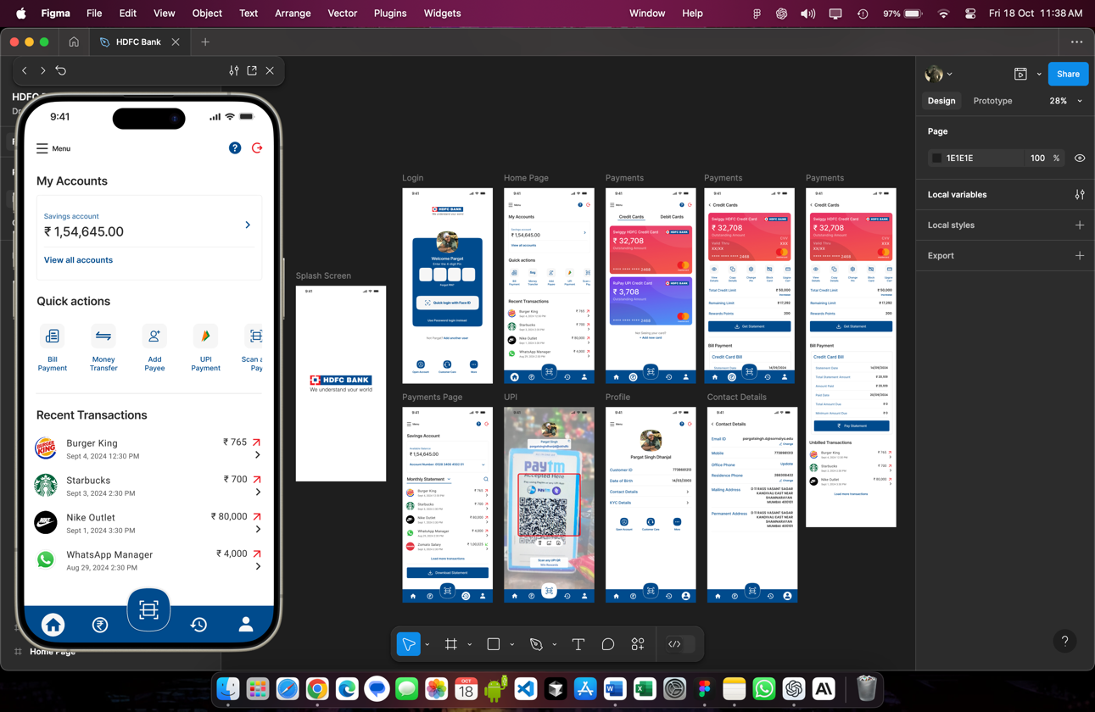

**Results:**

The mobile banking application addresses common banking needs such as account overview, payments, and UPI integration. The focus on simplicity and user experience ensures that users can efficiently manage their banking activities through an intuitive interface.

**Conclusion:**

This prototype demonstrates a functional and visually appealing mobile banking app, providing essential services in a user-friendly format. By adhering to modern design principles and offering a range of functionalities, the application improves the overall banking experience for HDFC customers.