**Batch: A3 Roll No.: 16010121045**

**Experiment No. 01**

|  |
| --- |
| **TITLE:** **Design the static web pages with the help of HTML5** |

**AIM:** To create static Web Pages using HTML5.

**______________________________________________________________________**

**Expected Outcome of Experiment:** Design static web pages using various HTML tags.

**_______________________________________________________________**

**Books/ Journals/ Websites referred:**

1. .

**_____________________________________________________________________**

The students are required to design Web Application using various technologies. A group of 2-3 students will select a topic and will design a web application. Various concepts such as static page, dynamic page, connection with a backend database are essential part of the application.

Students will be required to mention overall description of the problem (website facilities) to be provided by their application.

**Problem Statement:**

To design and implement a blog site that allows multiple users to create and manage their own blogs, while also providing functionality for users to view, search, and comment on other blogs. The site will support CRUD operations for each entity, along with the support for querying of blogs by title or content, and all blogs and comments associated with a specific user and all comments associated with a specific blog.

**Description of the application implemented with output**:

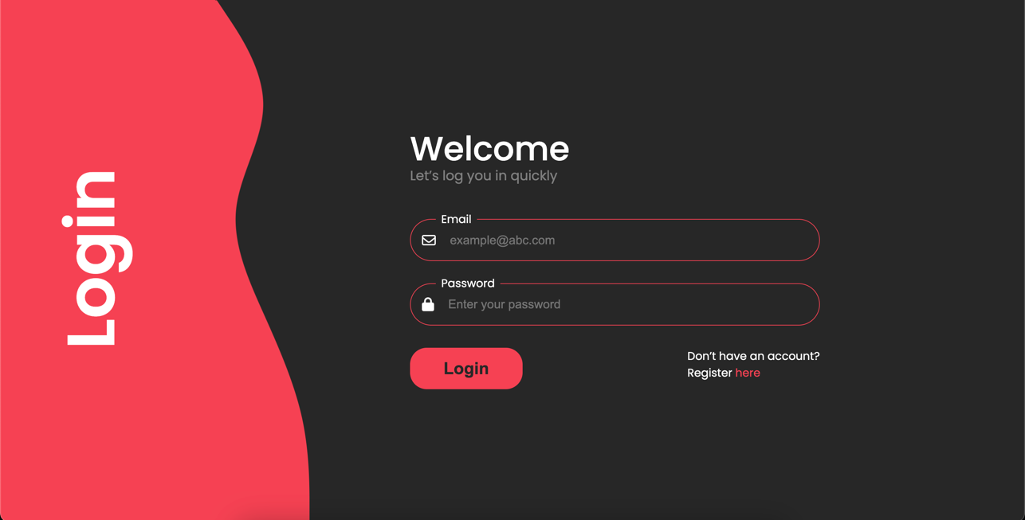

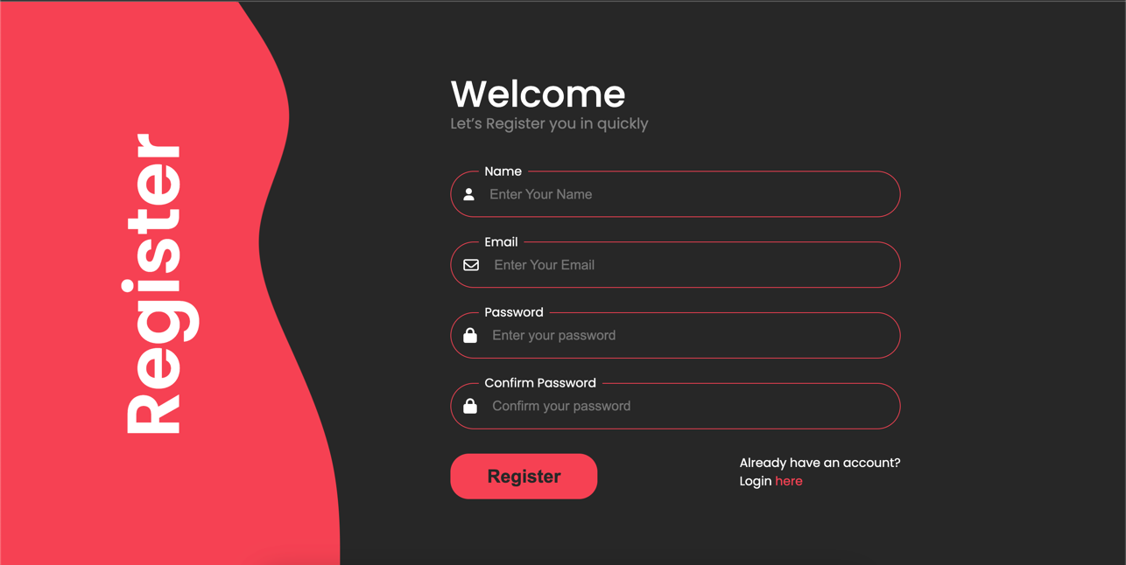

**Post Lab Objective with Ans (Min 5):**

**HTML tags Used :**

**<div>:** This tag is used to create a container element that can be styled with CSS to control the layout and presentation of the content inside. Used to group related elements together and create sections of a webpage.

**<link>:** This tag is used to link to an external resource such as a stylesheet, icon, or web font. It is placed in the <head> section of an HTML document.

**<form>:** This tag is used to create a form that allows users to submit data to a server. It can contain various types of input fields, such as text boxes, checkboxes, radio buttons, and drop-down menus.

**<label>:** This tag is used to associate a label with an input field in a form. It provides a text description of the input field, making it more accessible and user-friendly.

**<input>:** This tag is used to create various types of input fields, such as text boxes, checkboxes, radio buttons, and drop-down menus. It's typically used within a <form> element to allow users to submit data.

**<img>:** This tag is used to embed an image into an HTML document. It requires a src attribute that specifies the URL of the image file. Other attributes, such as alt and width, can also be used to provide additional information about the image.