**Batch: A2 Roll No.: 16010121045**

**Experiment No. 1**

|  |
| --- |
| **Title:**  Exploring Blockchain |

**Objective:**

* Learn about blockchain and how it works

**Expected Outcome of Experiment:**

|  |  |
| --- | --- |
| **CO** | **Outcome** |
| CO1 | Build your own Blockchain businesses with acquired knowledge. |

**Implementation Details:**

**1. Enlist all the Steps followed and various options explored**

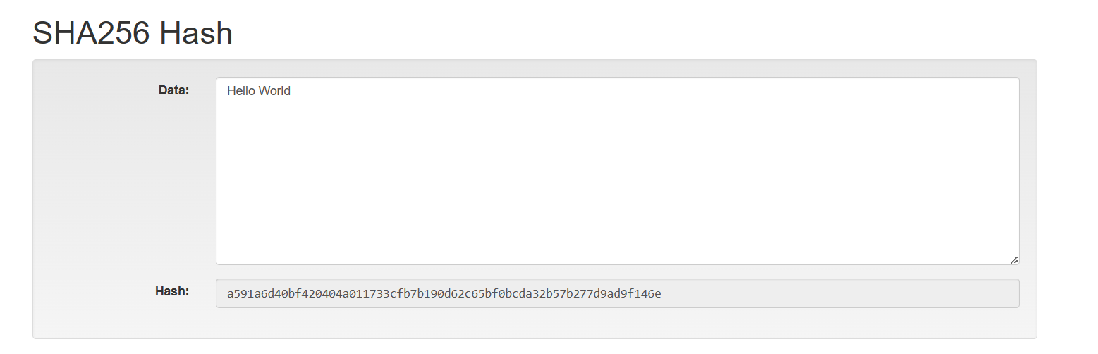

Hash changes when data is changed, the hash function is a mathematical function that is one-way in nature so impractical to reverse the function (i.e. get input from output)

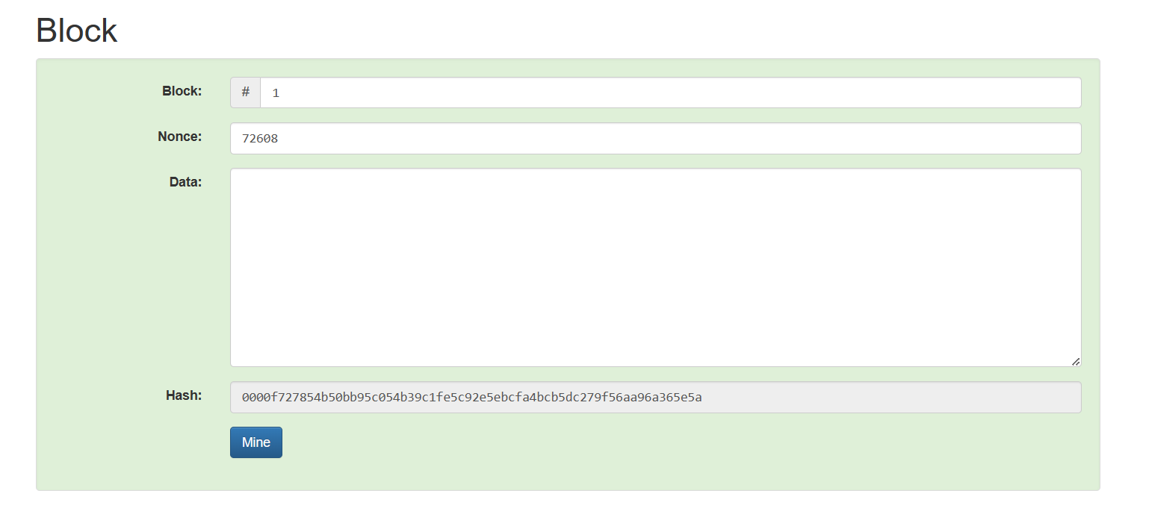

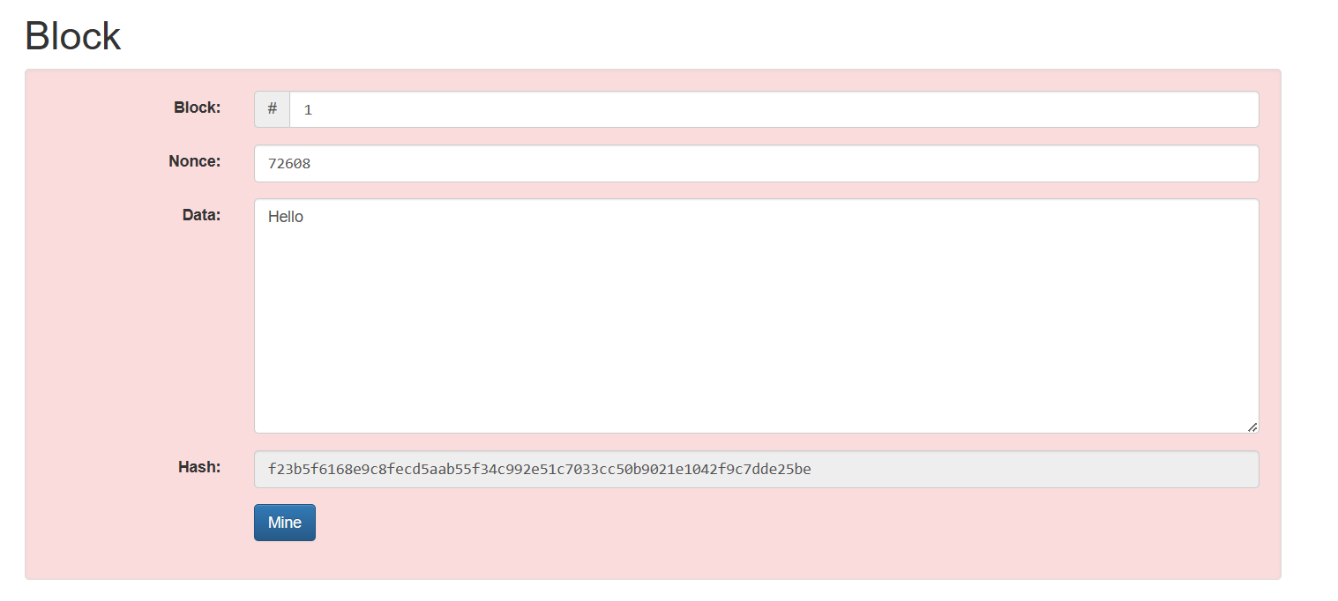

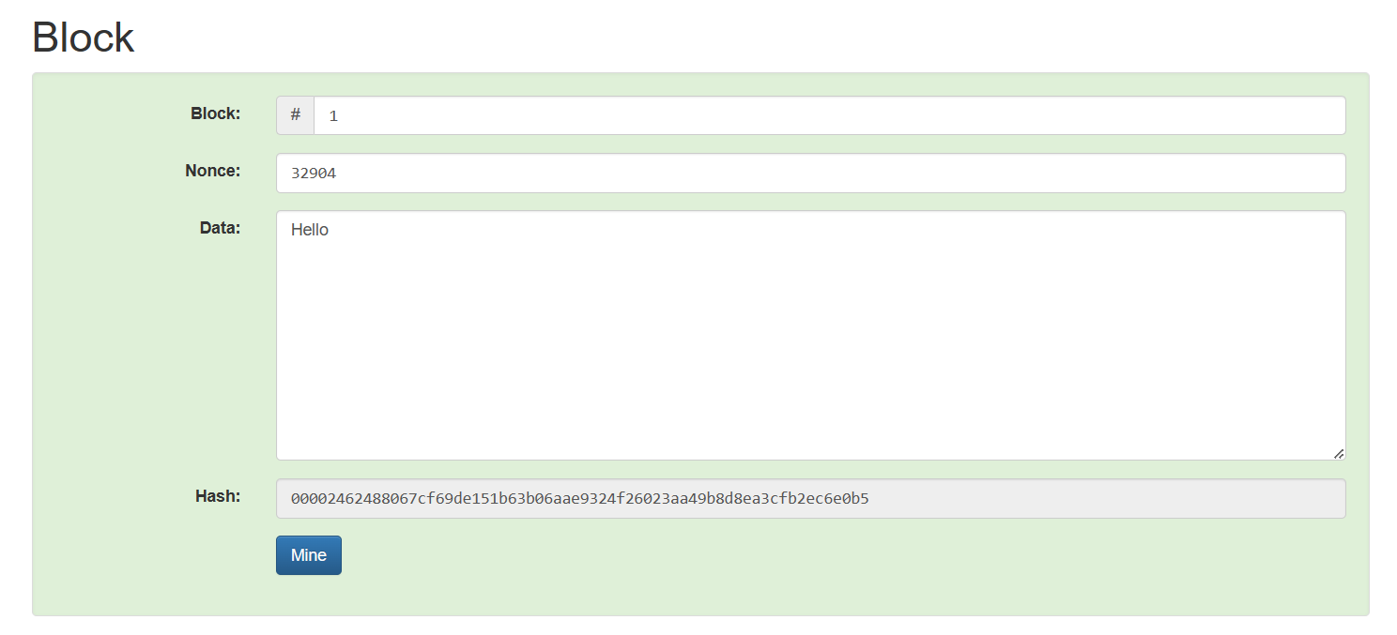

We can see that, when data is changed the hash changes and so block is invalid. We can then use the ‘Mine’ button to mine for a new nonce value that would give us a hash value that lies below the target value (i.e. three zeroes start in this case)

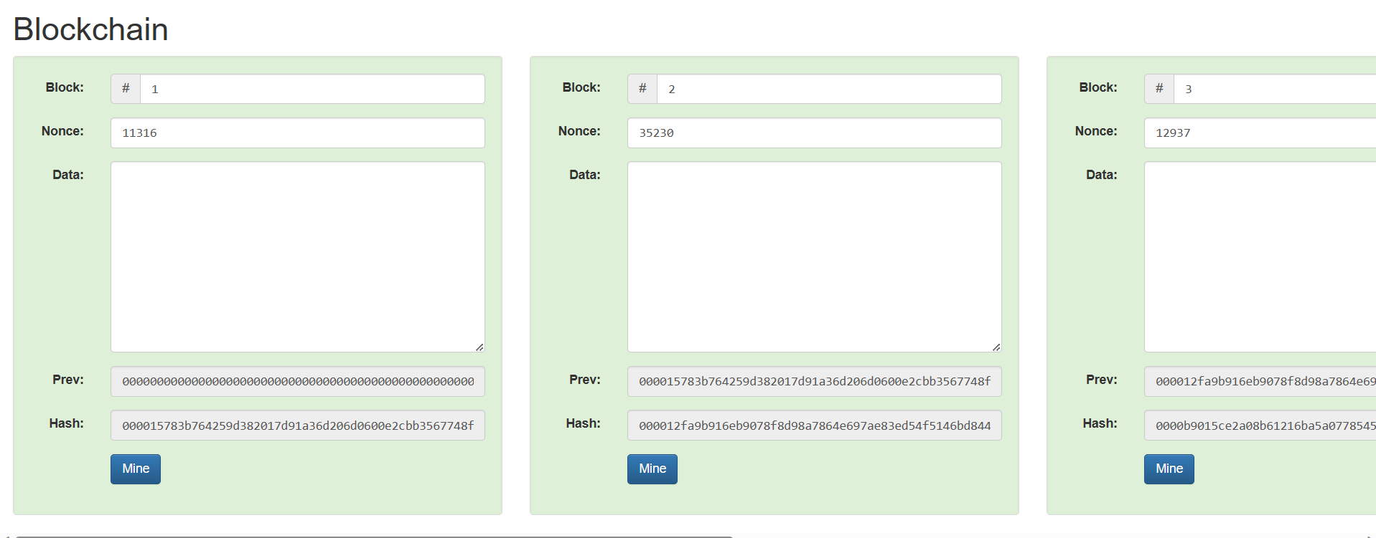

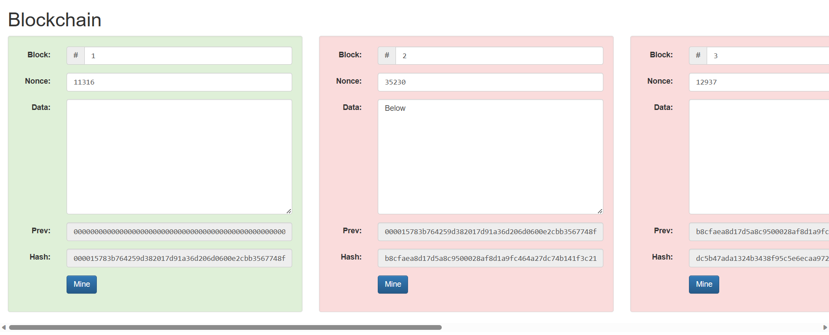

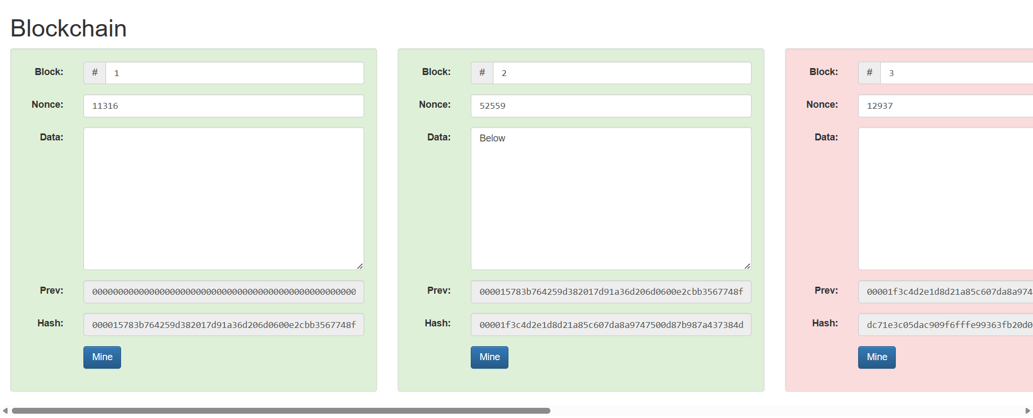

Here, we can see a blockchain, and see how changing the data value of one block makes all the following blocks in the chain invalid (which is the reason blockchains are immutable). We can see that, even after mining that particular block where data was changed, the further blocks are still invalid and will all need to be mined to reach target value and become valid.

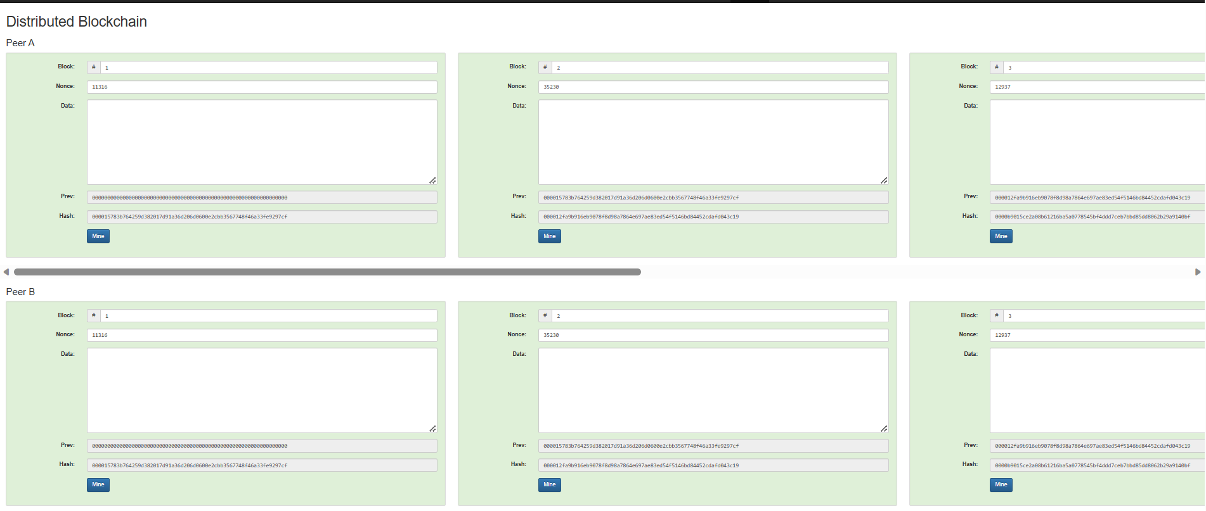

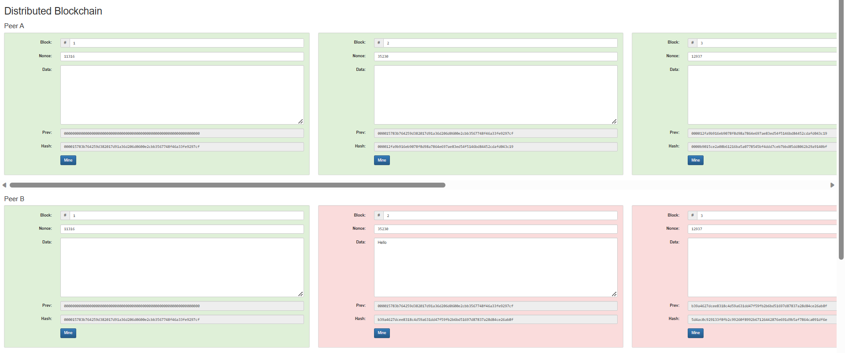

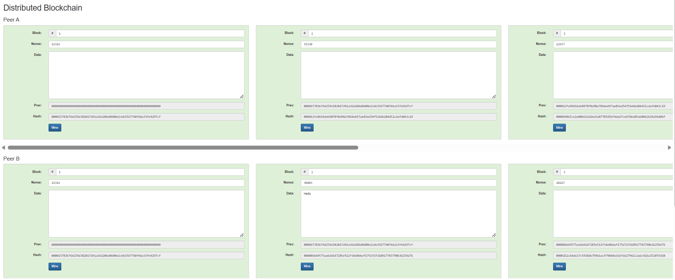

Here, we can see the example of a distributed blockchain where the same case as before happens. After mining (when changes are done), everything seems to be valid however we can see that nonce and hash values for block 2 onwards are different for Peer A and B, and so this means errors can be caught once the blockchain is decentralised (since it is public and peers can vote which chain they believe is the correct one).

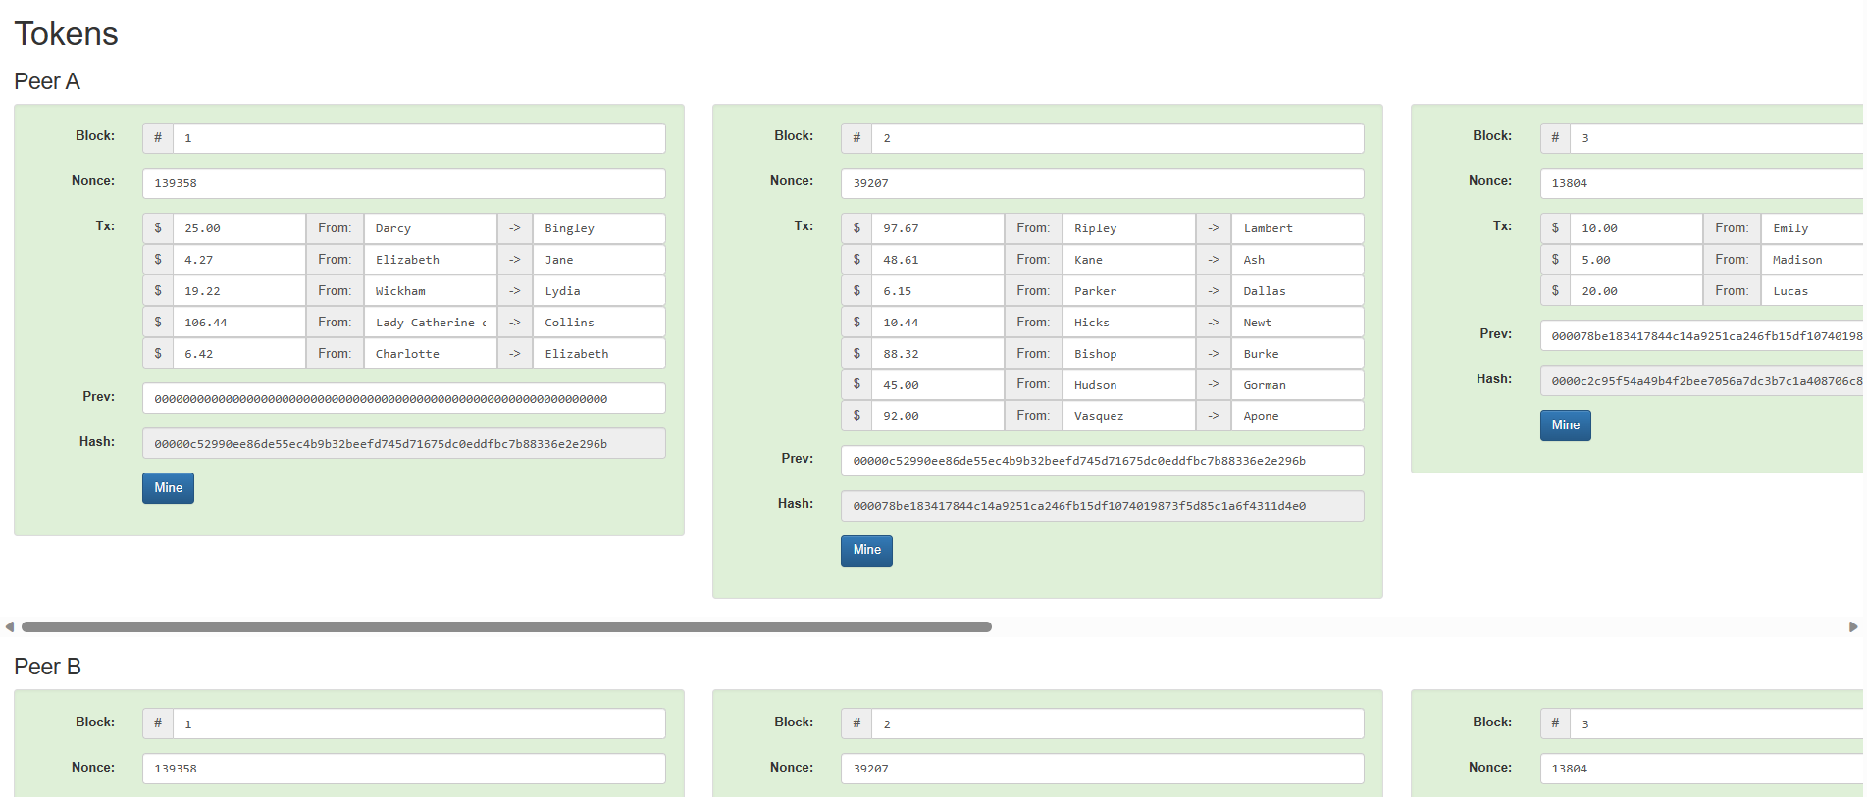

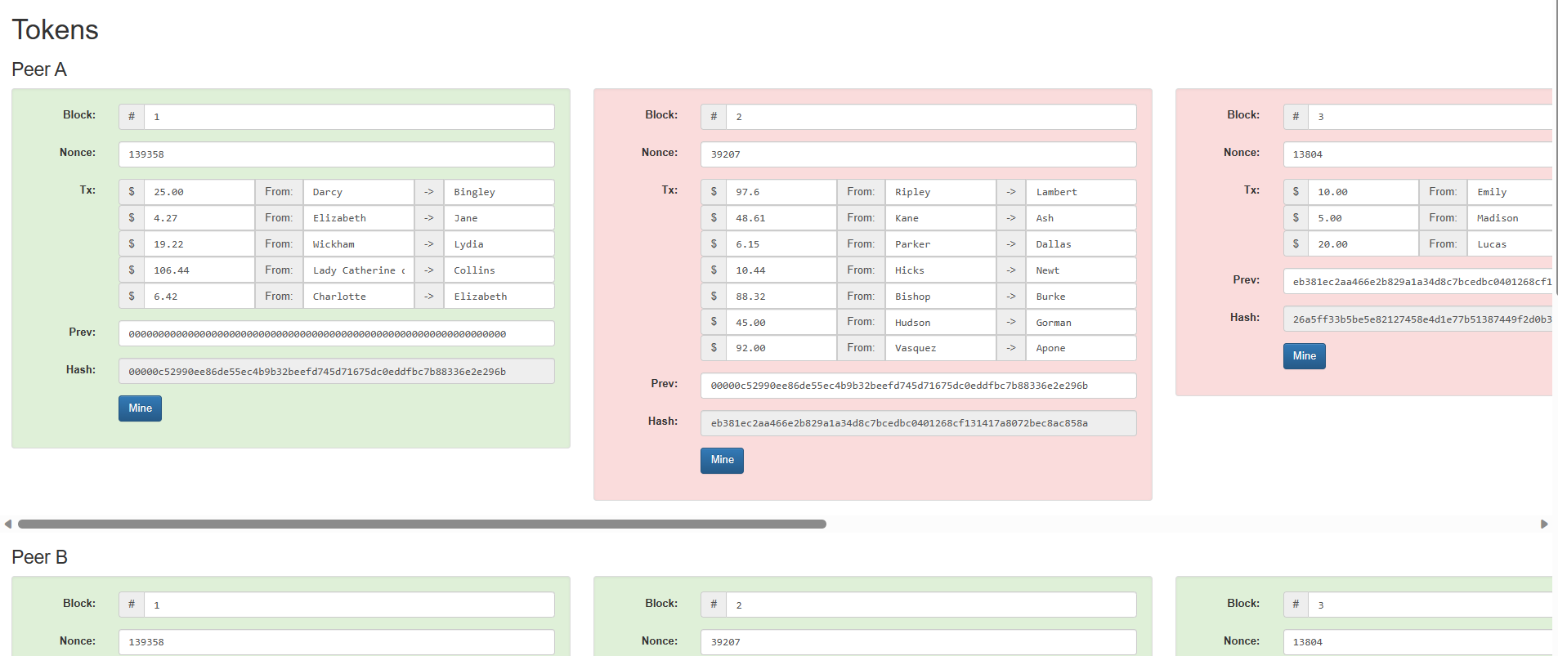

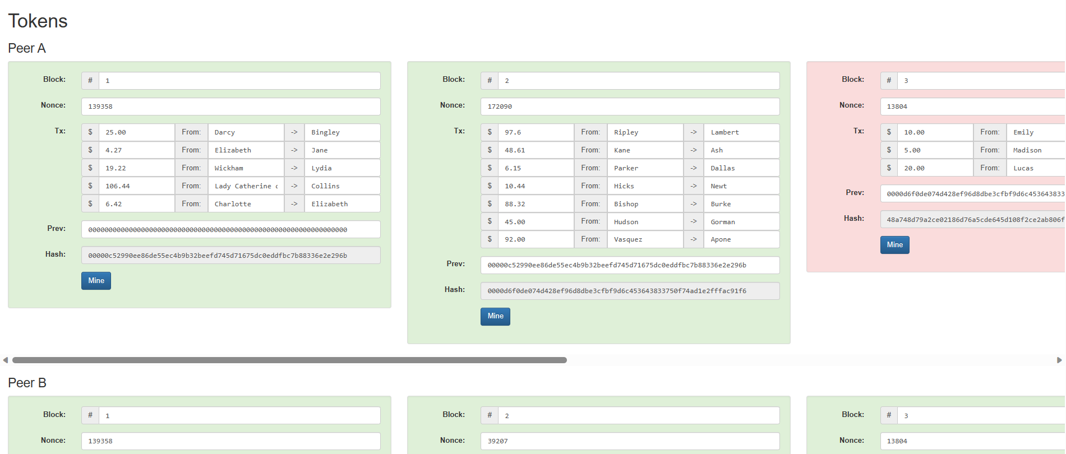

This example is of a distributed blockchain as well, just that this one involves transactions (of tokens) data instead of normal textual data in the previous examples. The conditions and immutability features remain the same.

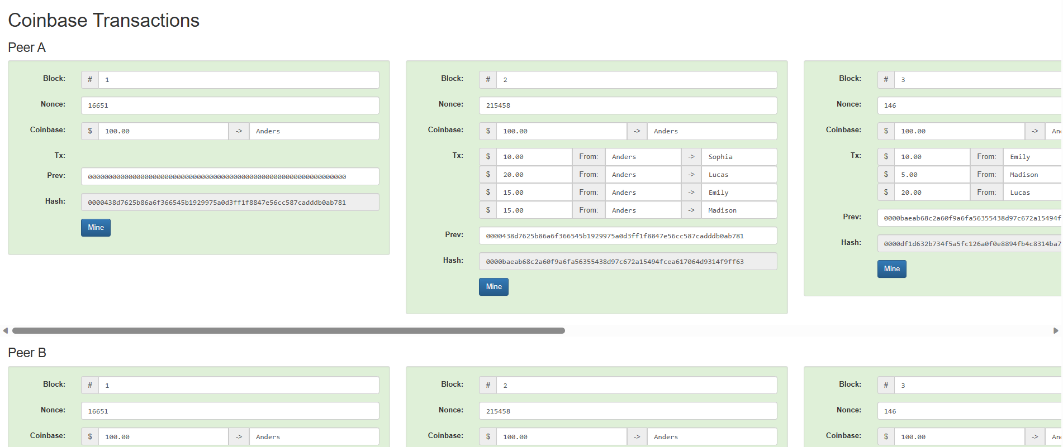

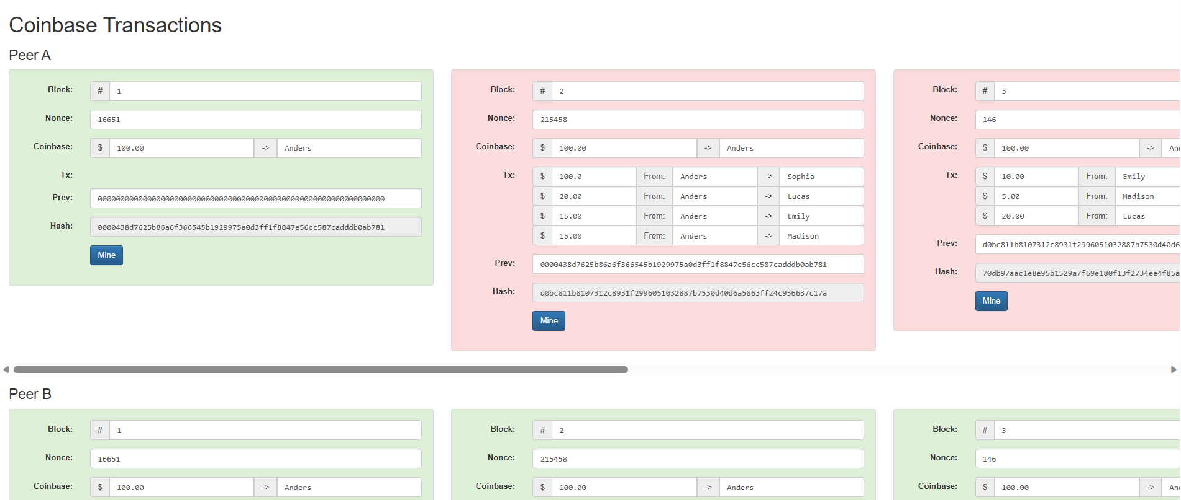

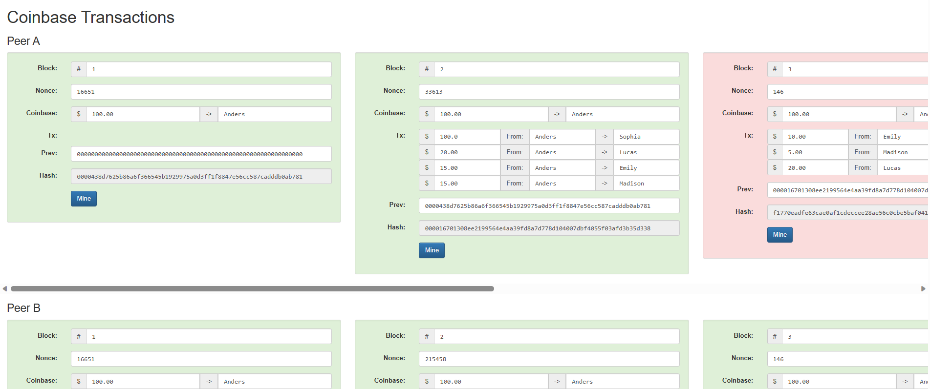

This is the same token transactions example, just one that Coinbase uses for example.

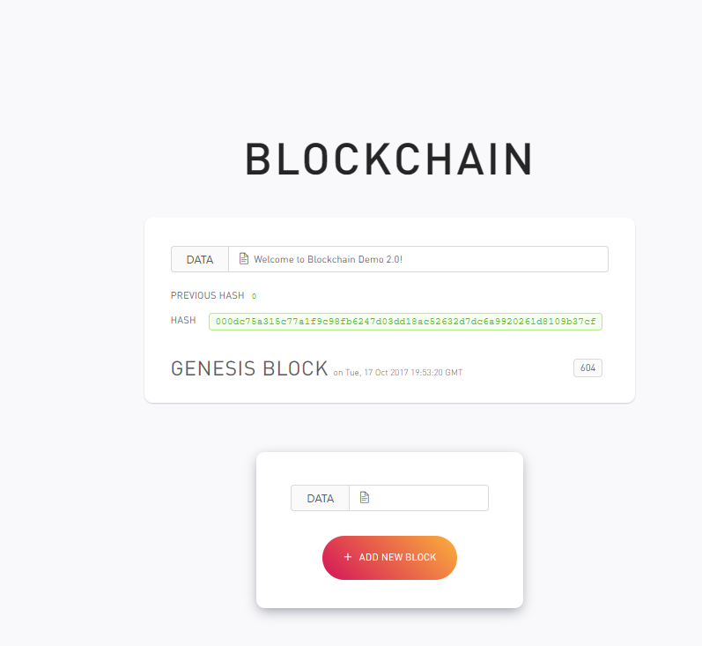

This is the next blockchain example link.

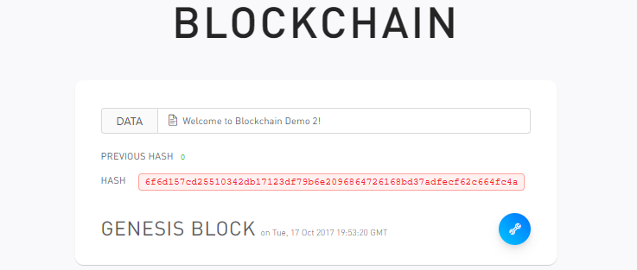

Hash value becomes invalid once the data is changed.

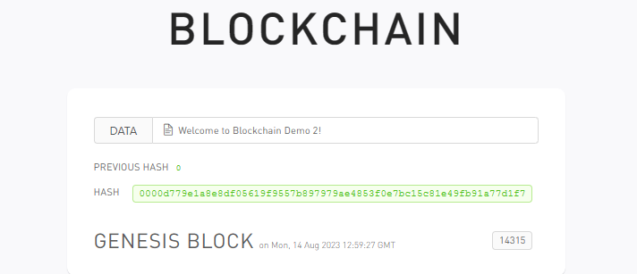

Hash can be made valid by ‘mining’ a new nonce value for the block.



New blocks can be added, and the blockchain can be continued on.

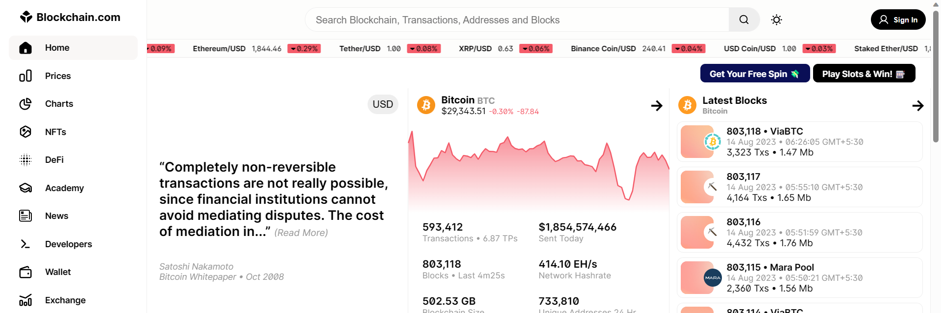

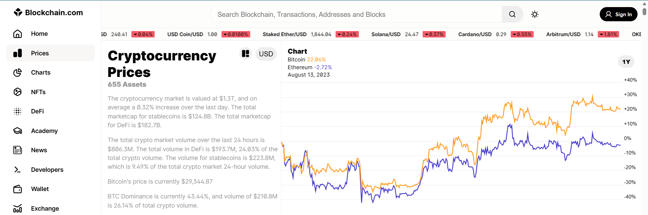

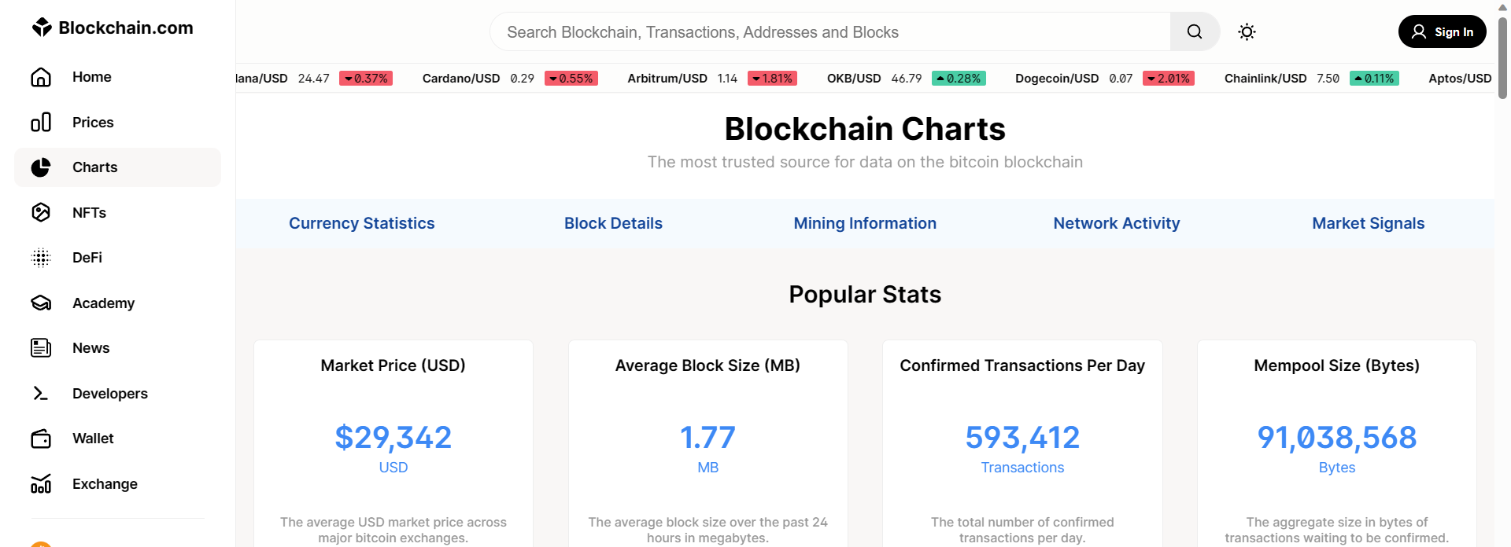

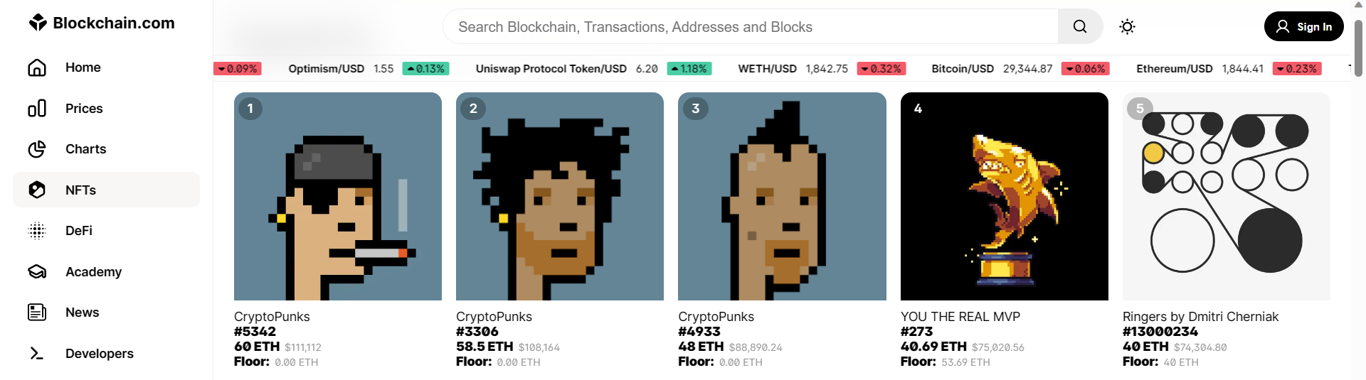

These are some screenshots from blockchain.com/explorer/

The website displays cryptocurrency prices, popular NFTs, and other important statistics related to the known blockchain systems.

**Conclusion:-**

In this experiment, we learnt about blockchains, cryptocurrencies, how blockchains work, their features and their use-cases.