**Batch: A2 Roll No.: 16010121045**

**Experiment No. 01**

**Grade: AA / AB / BB / BC / CC / CD /DD**

**Signature of the Staff In-charge with date**

|  |
| --- |
| **Title: A**ctivation functions. |

**___________________________________________________________________________________**

**Objective:** To implement activation functions of Neural Network.

**___________________________________________________________________________________**

**Expected Outcome of Experiment:**

CO1 : Identify and describe soft computing techniques and their roles **____________________________________________________________________________________**

**Books/ Journals/ Websites referred:**

* J.S.R.Jang, C.T.Sun and E.Mizutani, “Neuro-Fuzzy and Soft Computing”, PHI, 2004, Pearson Education 2004.
* Davis E.Goldberg, “Genetic Algorithms: Search, Optimization and Machine Learning”, Addison Wesley, N.Y., 1989.

____________________________________________________________________________________  
**Pre Lab/ Prior Concepts:**

Neural networks, sometimes referred to as connectionist models, are parallel-distributed models that have several distinguishing features-

1)      A set of processing units;

2)      An activation state for each unit, which is equivalent to the output of the unit;

3)      Connections between the units. Generally each connection is defined by a weight *wjk* that

determines the effect that the signal of unit *j* has on unit *k;*

4)      A propagation rule, which determines the effective input of the unit from its external inputs;

5)      An activation function, which determines the new level of activation based on the effective

input and the current activation;

6)      An external input (bias, offset) for each unit;

7)      A method for information gathering (learning rule);

8)    An environment within which the system can operate, provide input signals and, if necessary, error signals.

____________________________________________________________________________________

**Implementation Details:**

Most units in neural network transform their net inputs by using a scalar-to-scalar function called an *activation function*, yielding a value called the unit's activation. Except possibly for output units, the activation value is fed to one or more other units. Activation functions with a bounded range are often called squashing functions. Some of the most commonly used activation functions are :

**1) Identity function**

Identity or Linear activation function is the simplest activation function of all. It applies identity operation on your data and output data is proportional to the input data.

**2) Binary step function:**

Binary step function is a threshold-based activation function which means after a certain threshold neuron is activated and below the said threshold neuron is deactivated.

**3) Sigmoid function:**The sigmoid activation function is **also called the logistic function**. It is the same function used in

the logistic regression classification algorithm. The function takes any real value as input and outputs values in the range 0 to 1.

4) **Bipolar sigmoid function**:  
The Bipolar activation function **used to convert the activation level of a unit (neuron) into an output signal**. It is also known as transfer function or squashing function due to the capability to squeeze the amplitude range of output signal to some finite value.

5) **Ramp function**:  
The rectified linear activation function or ReLU is a **non-linear** function or **piecewise  
linear** function that will output the input directly if it is positive, otherwise, it will output zero.

**Code:**

*import* numpy *as* np

*import* matplotlib.pyplot *as* plt

*# Activation functions*

def identity(x):

*return* x

def binary_step(x):

*return* 0 *if* x < 0 *else* 1

def sigmoid(x):

*return* 1 / (1 + np.exp(-x))

def bipolar_sigmoid(x):

*return* (2 / (1 + np.exp(-x))) - 1

def ramp(x):

*return* np.maximum(0, x)

*# Range of x values*

n= abs(int(input("Enter the range variable: ")))

x = np.linspace(-n, n, 1000)

*# Calculate activation values for each function*

identity_values = identity(x)

binary_step_values = [binary_step(val) *for* val *in* x]

sigmoid_values = sigmoid(x)

bipolar_sigmoid_values = bipolar_sigmoid(x)

ramp_values = ramp(x)

*# Plot the activation functions*

plt.figure(figsize=(12, 8))

plt.subplot(2, 3, 1)

plt.plot(x, identity_values, label='Identity')

plt.title('Identity Function')

plt.grid()

plt.legend()

plt.subplot(2, 3, 2)

plt.plot(x, binary_step_values, label='Binary Step')

plt.title('Binary Step Function')

plt.grid()

plt.legend()

plt.subplot(2, 3, 3)

plt.plot(x, sigmoid_values, label='Sigmoid')

plt.title('Sigmoid Function')

plt.grid()

plt.legend()

plt.subplot(2, 3, 4)

plt.plot(x, bipolar_sigmoid_values, label='Bipolar Sigmoid')

plt.title('Bipolar Sigmoid Function')

plt.grid()

plt.legend()

plt.subplot(2, 3, 5)

plt.plot(x, ramp_values, label='Ramp')

plt.title('Ramp Function')

plt.grid()

plt.legend()

plt.tight_layout()

plt.show()

**Output:**



**Mathplot**

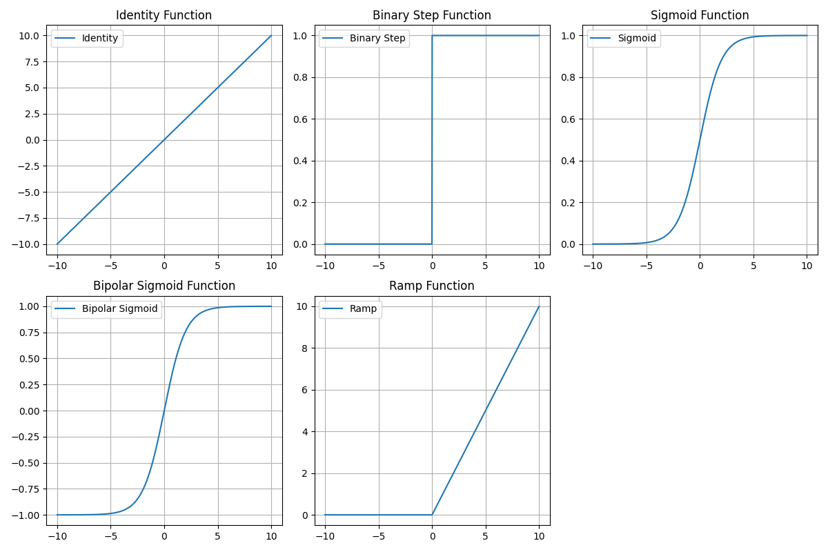

**Conclusion:** Thus, we have successfully implemented 4 Activation Functions of Neural Network.

**Post Lab Descriptive Questions :**

1. **Explain the concept behind using Activation function.**

Activation function decides, whether a neuron should be activated or not by calculating weighted sum and further adding bias with it. The purpose of the activation function is to introduce non-linearity into the output of a neuron.  
We know, neural network has neurons that work in correspondence of weight, bias and their respective activation function. In a neural network, we would update the weights and biases of the neurons on the basis of the error at the output. This process is known as back-propagation. Activation functions make the back-propagation possible since the gradients are supplied along with the error to update the weights and biases.  
A neural network without an activation function is essentially just a linear regression model. The activation function does the non-linear transformation to the input making it capable to learn and perform more complex tasks. The most important feature in an activation function is its ability to add non-linearity into a neural network.

1. **Explain the different properties of activation functions.**

Different types of ANN are:

* *Single layer feed forward network*
* *Multilayer feed-forward network*
* *Single node with its own feedback*
* *Single-layer recurrent network*
* *Multilayer recurrent network*

Single layer feed forward network

* Layer is formed by taking processing elements and combining it with other processing

elements.

* Input and output are linked with each other
* Inputs are connected to the processing nodes with various weights, resulting in series of

outputs one per node.

Multilayer feed-forward network

* Formed by the interconnection of several layers.
* Input layer receives input and buffers input signal.
* Output layer generated output.
* Layer between input and output is called *hidden layer.*
* Hidden layer is internal to the network.
* Zero to several hidden layers in a network.
* More the hidden layer, more is the complexity of network, but efficient output is

produced.

Feedback network

* If no neuron in the output layer is an input to a node in the same layer / proceeding layer –

***feed forward network.***

* If outputs are directed back as input to the processing elements in the same layer/proceeding layer –***feedback network.***
* If the output are directed back to the input of the same layer then it is ***lateral feedback.***
* ***Recurrent networks*** are networks with feedback networks with closed loop.
* 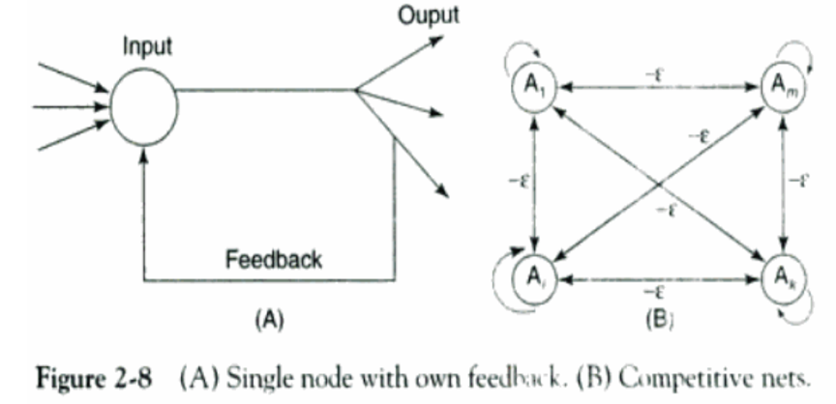Fig 2.8 (A) –simple recurrent neural network having a single neuron with feedback to itself.

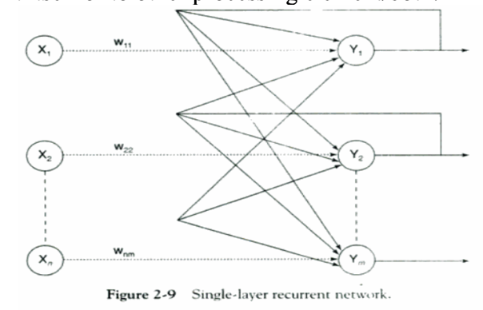

* Fig 2.9 – single layer network with feedback from output can be directed to processing element itself or to other processing element/both.
* Processing element output can be directed back to the nodes in the preceding layer, forming a ***multilayer recurrent network.***
* Processing element output can be directed to processing element itself or to other processing element in the same layer.

**Date: _____________ Signature of faculty in-charge**