**Batch: A2 Roll No.: 16010121045**

**Experiment No. 10**

**Grade: AA / AB / BB / BC / CC / CD /DD**

**Signature of the Staff In-charge with date**

|  |
| --- |
| **Title: Case study on Fuzzy Inference System** |

**____________________________________________________________________________________**

**Aim :** To apply fuzzy logic and determine the time required to run a Washing machine, given the amount of dirt and grease on clothes. **____________________________________________________________________________________**

**Expected Outcome of Experiment:**

**CO4 :** Apply basics of Fuzzy logic and neural networks

**____________________________________________________________________________________**

**Books/ Journals/ Websites referred:**

____________________________________________________________________________________  
**Pre Lab/ Prior Concepts:**

**Fuzzification:**

It is the method of transforming a crisp quantity into a fuzzy quantity. This can be achieved by identifying the various known crisp and deterministic quantities as completely nondeterministic and quite uncertain in nature. This uncertainty may have emerged because of vagueness and imprecision which then lead the variables to be represented by a membership function as they can be fuzzy in nature

Fuzzification is a module or component for transforming the system inputs, i.e., it converts the crisp number into fuzzy steps. The crisp numbers are those inputs which are measured by the sensors and then fuzzification passed them into the control systems for further processing. This component divides the input signals into following five states in any Fuzzy Logic system:

* Large Positive (LP)
* Medium Positive (MP)
* Small (S)
* Medium Negative (MN)
* Large negative (LN)

**Defuzzification:**

It is the inversion of fuzzification, there the mapping is done to convert the crisp results into fuzzy results but here the mapping is done to convert the fuzzy results into crisp results. This process is capable of generating a nonfuzzy control action which illustrates the possibility distribution of an inferred fuzzy control action. Defuzzification process can also be treated as the rounding off process, where fuzzy set having a group of membership values on the unit interval reduced to a single scalar quantity.

Defuzzification is a module or component, which takes the fuzzy set inputs generated by the Inference Engine, and then transforms them into a crisp value.  It is the last step in the process of a fuzzy logic system. The crisp value is a type of value which is acceptable by the user. Various techniques are present to do this, but the user has to select the best one for reducing the errors.

**Fuzzy rule base**

Rule Base is a component used for storing the set of rules and the If-Then conditions given by the experts are used for controlling the decision-making systems. There are so many updates that come in the Fuzzy theory recently, which offers effective methods for designing and tuning of fuzzy controllers. These updates or developments decreases the number of fuzzy set of rules.

**Membership functions**

The membership function is a function which represents the graph of fuzzy sets, and allows users to quantify the linguistic term. It is a graph which is used for mapping each element of x to the value between 0 and 1. This function is also known as indicator or characteristics function. This function of Membership was introduced in the first papers of fuzzy set by Zadeh. For the Fuzzy set B, the membership function for X is defined as: μB:X → [0,1]. In this function X, each element of set B is mapped to the value between 0 and 1. This is called a degree of membership or membership value.

**Designing of Fuzzy Controller**

The following diagram shows the architecture of Fuzzy Logic Control (FLC).

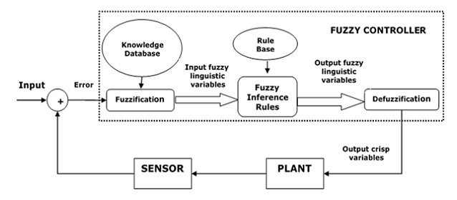

## Major Components of FLC

Followings are the major components of the FLC as shown in the above figure −

* **Fuzzifier** − the role of fuzzifier is to convert the crisp input values into fuzzy values.
* **Fuzzy Knowledge Base** − It stores the knowledge about all the input-output fuzzy relationships. It also has the membership function which defines the input variables to the fuzzy rule base and the output variables to the plant under control.
* **Fuzzy Rule Base** − It stores the knowledge about the operation of the process of domain.
* **Inference Engine** − It acts as a kernel of any FLC. Basically it simulates human decisions by performing approximate reasoning.
* **Defuzzifier** − The role of defuzzifier is to convert the fuzzy values into crisp values getting from fuzzy inference engine

## Steps in Designing FLC

Following are the steps involved in designing FLC −

* **Identification of variables** − Here, the input, output and state variables must be identified of the plant which is under consideration.
* **Fuzzy subset configuration** − the universe of information is divided into number of fuzzy subsets and each subset is assigned a linguistic label. Always make sure that these fuzzy subsets include all the elements of universe.
* **Obtaining membership function** − Now obtain the membership function for each fuzzy subset that we get in the above step.
* **Fuzzy rule base configuration** − Now formulate the fuzzy rule base by assigning relationship between fuzzy input and output.
* **Fuzzification** − the fuzzification process is initiated in this step.
* **Combining fuzzy outputs** − by applying fuzzy approximate reasoning, locate the fuzzy output and merge them.
* **Defuzzification** − finally, initiate defuzzification process to form a crisp output.

**Overall steps in designing a fuzzy logic controller:**

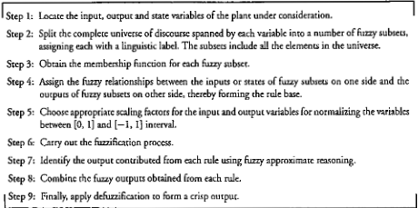

**Problem:**

*Design a controller to determine the wash time of a domestic washing machine. Assume the input is dirt and grease on cloths. Use 3 descriptors for input variables and five descriptors for output variables. Derive the set of rules for controller action and defuzzification. The design should be supported by figures wherever possible. Show that the cloths are soiled to larger degree the wash time will be more and vice-versa.*

*(Assume the the inputs dirt and grease measured in percentage and wash time in minutes).*

*Evaluate the rule for dirt=60% and grease=70% using appropriate deffuzification method*

**Solution for FLC design for washing machine :**

**(Write each of steps clearly and draw the graphs )**

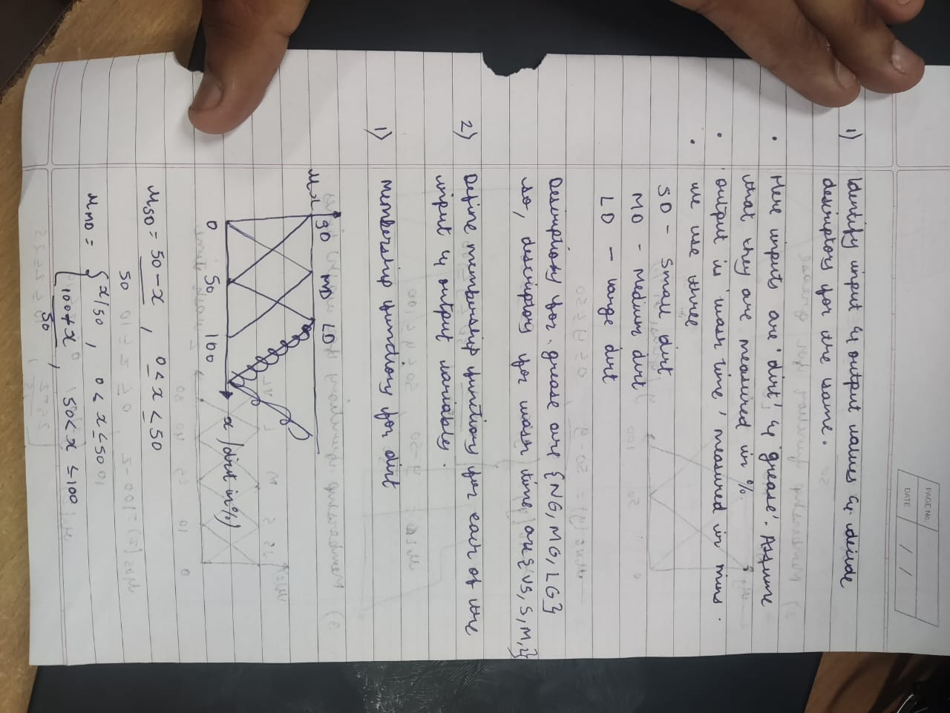

**Conclusion:** Learnt about fuzzy logic and defuzzification techniques.

**Date: _____ Signature of faculty in-charge**

Post lab question:

1. Explain application of fuzzy logic in image processing.

Fuzzy logic is a mathematical framework that extends classical binary logic, which is based on "true" and "false" values, to handle partial truth and uncertainty. Fuzzy logic is widely applied in various fields, including image processing. Here are some of the key applications of fuzzy logic in image processing:

1. **Image Enhancement:** Fuzzy logic can be used to improve image quality by enhancing the contrast and reducing noise. Fuzzy enhancement techniques consider the ambiguity and imprecision in human perception. By defining membership functions that represent the degree of belongingness of pixel values to different contrast levels, fuzzy enhancement can effectively adjust the brightness and contrast of images.
2. **Image Segmentation:** Fuzzy logic can be applied to image segmentation, which involves dividing an image into regions or objects of interest. Fuzzy clustering algorithms, such as Fuzzy C-Means (FCM), assign pixels to different clusters with degrees of membership. This allows for a more flexible and less rigid delineation of image regions.
3. **Image Thresholding:** Fuzzy thresholding methods are used to partition an image into foreground and background regions based on the grayscale intensity of pixels. Unlike traditional binary thresholding, fuzzy thresholding assigns each pixel a degree of membership in both the foreground and background classes, which is particularly useful for images with complex or uneven lighting conditions.
4. **Pattern Recognition:** Fuzzy logic can be employed in image pattern recognition tasks, such as character recognition or object detection. Fuzzy systems can handle uncertainty in feature extraction and classification by assigning degrees of membership to different classes, making them suitable for applications where patterns may not be well-defined.
5. **Image Fusion:** In multispectral or multi-modal image processing, fuzzy logic can be used for image fusion. This involves combining information from different sources to create a more informative and comprehensive image. Fuzzy fusion techniques consider the uncertainty associated with each input source and allow for the weighted combination of data.
6. **Image Denoising:** Fuzzy logic-based filters can effectively reduce noise in images. Fuzzy filters take into account the degree of uncertainty in the presence of noise, adaptively smoothing the image while preserving edges and important image features.
7. **Content-Based Image Retrieval:** Fuzzy logic can be used to improve image retrieval systems by allowing for similarity measures that consider the fuzzy semantics of image content. This enables more flexible and context-aware retrieval based on user queries.
8. **Medical Image Analysis:** Fuzzy logic is applied in medical image processing for tasks like tumor detection, organ segmentation, and disease diagnosis. Fuzzy systems can handle the inherent uncertainty in medical images and provide more accurate and clinically relevant results.

In all these applications, fuzzy logic allows for more human-like reasoning and decision-making, taking into account uncertainty, imprecision, and ambiguity in image data. It can lead to improved image processing results, making it a valuable tool in various image-related tasks.