**Batch: B1**

**Roll No.:16010121045**

**Experiment / assignment / tutorial No. 1**

**Title:** Study of Artificial Intelligent project.

**Objective:** To study various AI projects for their architectures. Complexity, programming language, applications and other AI related concepts.

# Expected Outcome of Experiment:

|  |  |
| --- | --- |
| **Course Outcome** | **After successful completion of the course students should be able to** |
| **CO1** | Understand the history & various application of AI and choose appropriate  agent architecture to solve the given problem. |

**Books/ Journals/ Websites referred:**

1. [**http://en.wikipedia.org/wiki/List_of_artificial_intelligence_projects**](http://en.wikipedia.org/wiki/List_of_artificial_intelligence_projects)
2. [**http://www.cs.cornell.edu/courses/cs478/2002sp/mllinks/interesting_ai_demos_**](http://www.cs.cornell.edu/courses/cs478/2002sp/mllinks/interesting_ai_demos_) **and_project.htm**
3. [**http://homepages.inf.ed.ac.uk/rbf/AIMOVIES/AImovai.htm**](http://homepages.inf.ed.ac.uk/rbf/AIMOVIES/AImovai.htm)
4. **“Artificial Intelligence: a Modern Approach” by Russell and Norving, Pearson education Publications**
5. **“Artificial Intelligence” By Rich and knight, Tata McGraw Hill Publications**

**Pre Lab/ Prior Concepts:**

History and evolution of AI, Artificial intelligence: definitions and theories.

# Historical Profile:

AI research is highly technical and specialised and is also divided by several multidisciplinary technical issues. So far there are many projects those have been developed and are in progress to work on those issues. Students must learn the applications of intelligent robots by studying various such projects to know the depth and complexity of the course.

# New Concepts to be learned:

Applications of AI, Current research and future research potential in the field.

**Chosen Project Name:** Deep Blue Chess Computer

# Project Description:

Deep Blue, an iconic project developed by IBM, is a pioneering artificial intelligence system focused on mastering the intricate game of chess. Launched in the mid-1980s, its primary objective was to surpass human grandmasters in strategic thinking and gameplay. Deep Blue combined advanced hardware and software components to create a formidable chess-playing entity.

# Project category/field (Game, NLP etc): Game

**Agent architecture: (State just name):** Deep Blue utilized a combination of brute- force search and heuristic evaluation, implementing algorithms like Minimax, alpha- beta pruning, and heuristic functions.

# Programming language in which the project is/was developed:

Cand Fortran

**Awards won by the project:** While Deep Blue itself didn't win awards in the traditional sense, its historic victory over Garry Kasparov in 1997 is considered a groundbreaking achievement in the field of artificial intelligence. The project significantly influenced subsequent AI research and garnered recognition for its contribution to game-playing AI systems.

# Nature of the project (Experimental/in use in real world):

*(Explain in brief why experimental or how it is useful in real world)*

Deep Blue started as an experimental project but transitioned into a real-world application with significant impact.

Experimental Phase:

In its early stages, Deep Blue served as an experimental platform to test the capabilities of artificial intelligence in the domain of chess. Researchers aimed to explore the potential of advanced algorithms, parallel processing, and custom hardware to tackle complex problems requiring strategic thinking. The experimental nature allowed the team to refine and optimize the system, paving the way for groundbreaking developments in AI.

Real-world Application:

As Deep Blue evolved, it moved beyond the experimental phase to become a practical and impactful real-world application. The system's success in defeating Garry Kasparov in 1997 demonstrated the practical application of AI in competitive settings. The real-world implications extended beyond the realm of chess, showcasing the potential of AI to excel in strategic decision-making and problem-solving tasks. Deep Blue's victory marked a pivotal moment, illustrating how AI could be harnessed to augment human capabilities in specific domains.

The transition from experimental exploration to real-world application highlighted the adaptability and practical utility of Deep Blue's technology, influencing subsequent developments in both game-playing AI and broader applications of artificial intelligence.

# Applications of the project:

**Chess Gameplay:**

High-Level Competition: Deep Blue's primary application was in playing chess at an exceptionally high level. Its historic victory over Garry Kasparov in 1997 demonstrated its prowess in competitive chess, showcasing the potential of AI to outperform human champions.

# AI Research and Development:

Algorithmic Advances: Deep Blue's development contributed significantly to AI research, particularly in the areas of search algorithms, parallel processing, and heuristic evaluation. The project's success prompted further exploration into advanced AI techniques for strategic decision-making.

# Parallel Processing and Hardware Design:

Specialized Hardware: The project's custom VLSI chips designed for chess calculations and parallel processing had implications beyond chess. The hardware innovations in Deep Blue influenced the design of specialized processors for other computational tasks, showcasing the broader applicability of its hardware architecture.

# Heuristic Search and Decision-Making:

Problem-Solving Techniques: Deep Blue's use of heuristic search and board evaluation functions demonstrated the application of these techniques beyond chess. Similar approaches have since been employed in various problem-solving domains, showcasing the adaptability of AI strategies.

# Inspiration for Future AI Systems:

Game-Playing AI Systems: Deep Blue inspired the development of other game-playing AI systems. Its success encouraged researchers to apply similar methodologies to different games and strategic scenarios, leading to advancements in various domains.

# Human-AI Collaboration:

Human-AI Collaboration in Chess: The project sparked interest in exploring collaboration between humans and AI in chess. The idea of human-AI teams competing against other such teams gained traction, emphasizing the potential for synergies between human intuition and AI's computational capabilities.

# Public Awareness and Perception:

Public Understanding of AI: Deep Blue's high-profile matches, particularly against Kasparov, contributed to increased public awareness and understanding of AI capabilities. It played a role in shaping public perception of AI and its potential impact on various aspects of society.

# Chat session with any chatbot(questions should vary difficulty level):

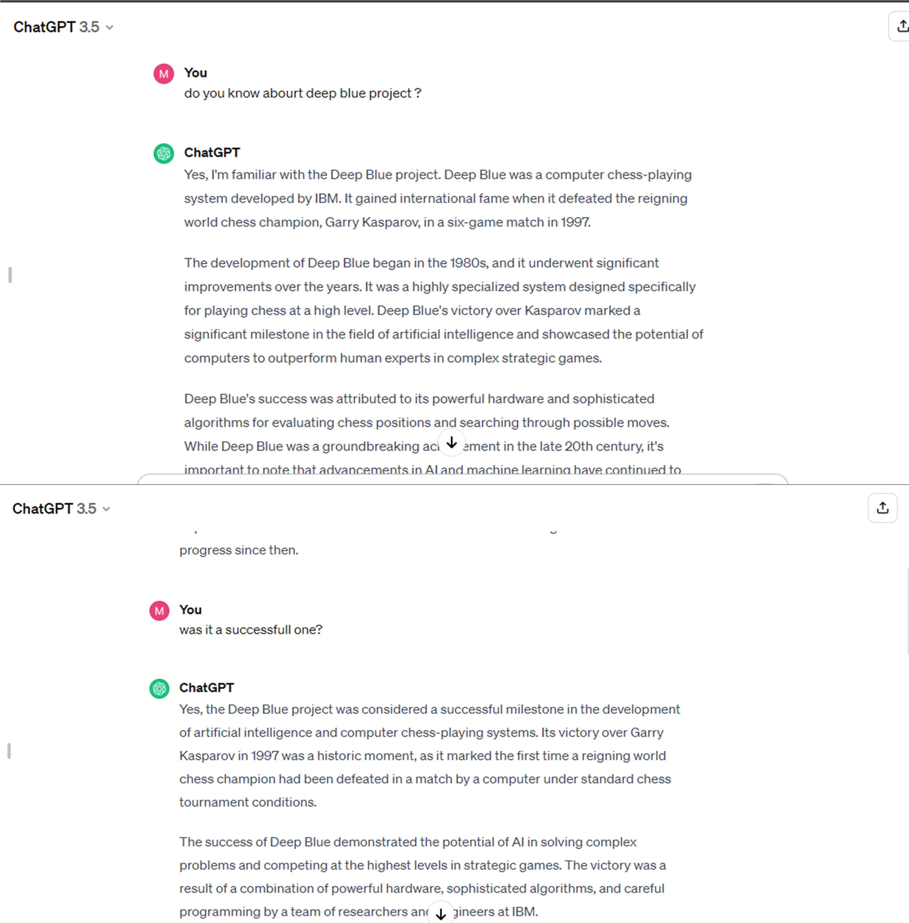

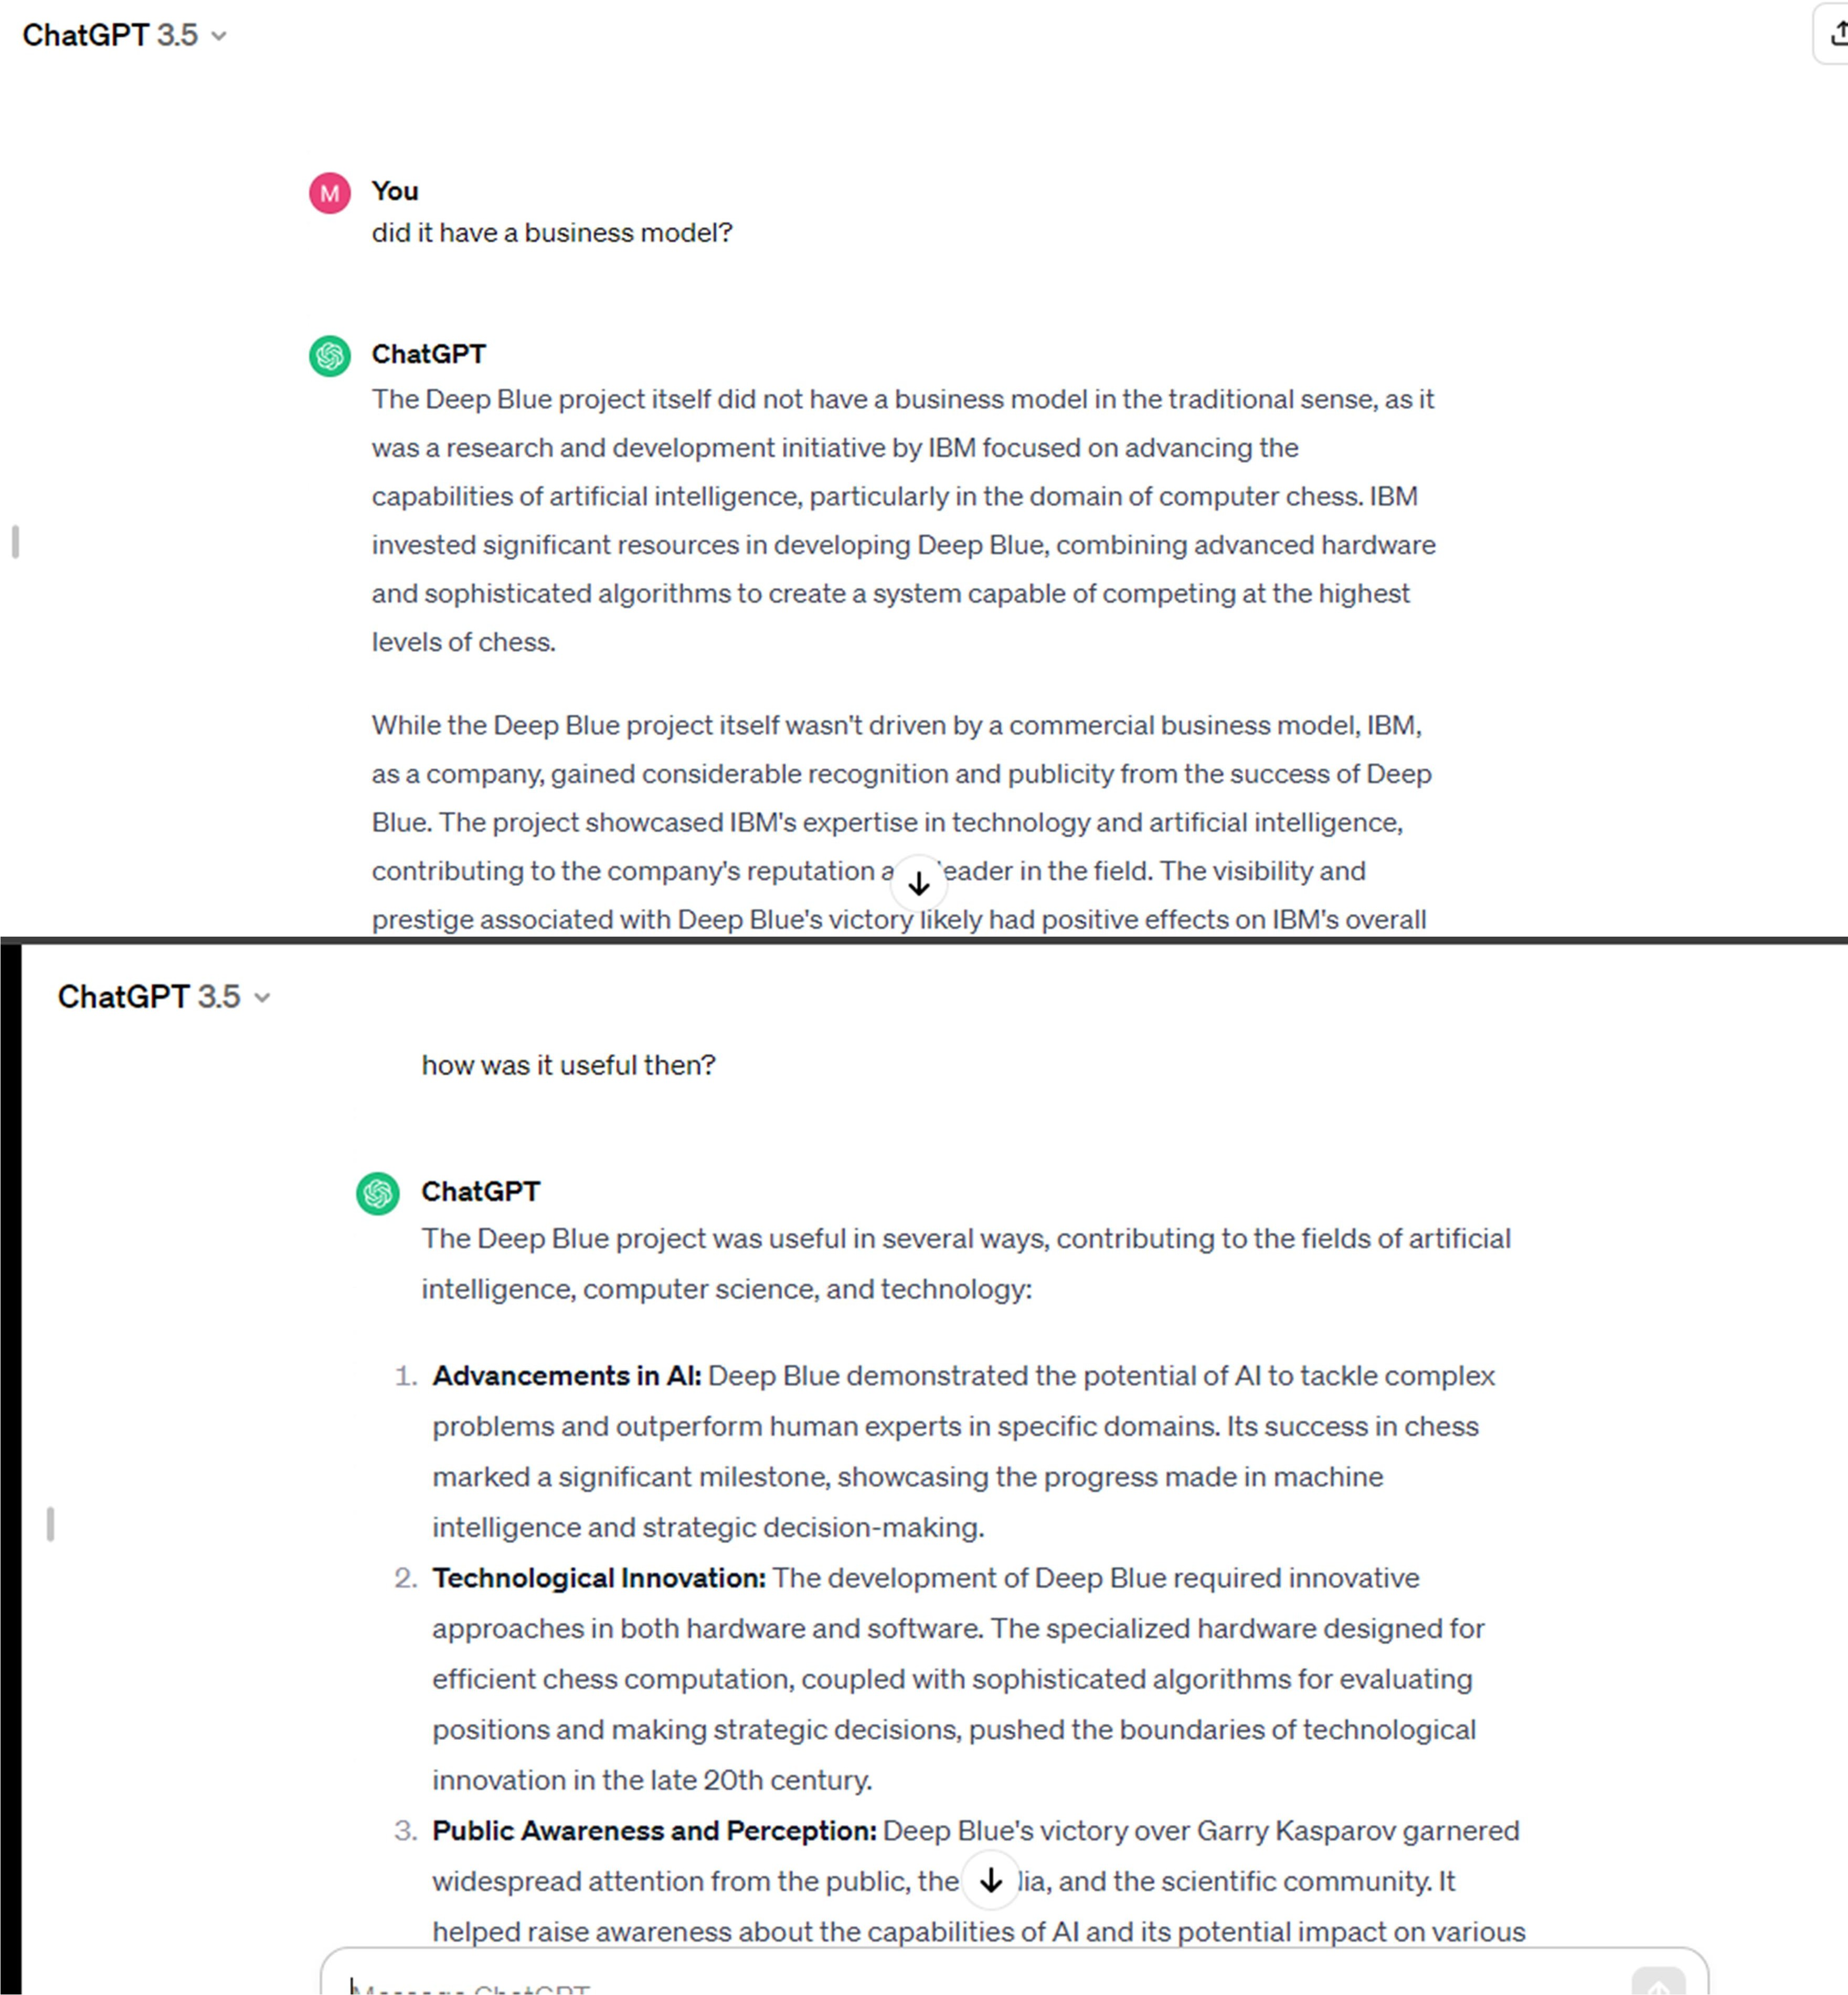

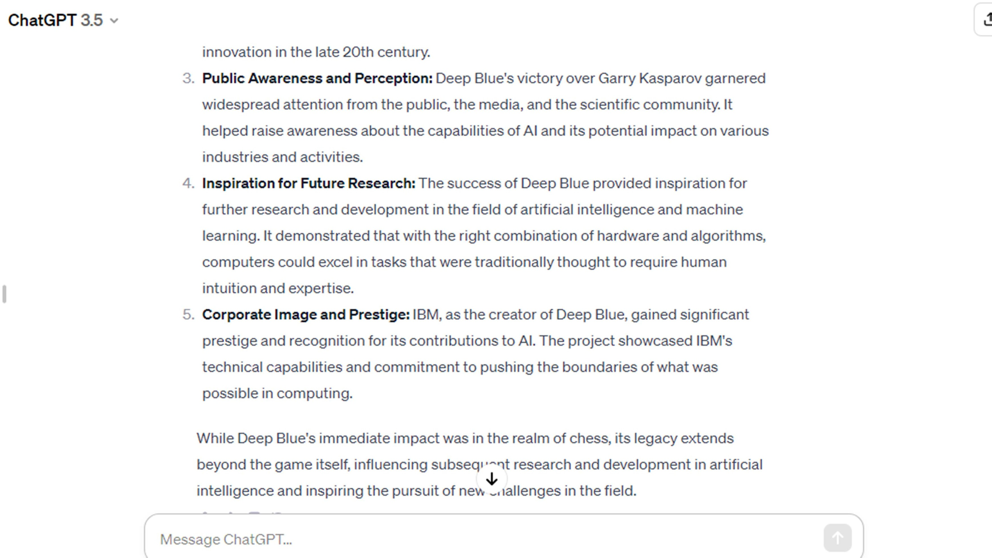

**Post Lab Descriptive Questions:**

# 1 is called the father of AI.

1. James C Gosling
2. Dennis Ritchie

# Alan Turing

1. Isaac Newton
2. **In AI** **is a combination of data structures and interpretive**

**procedures.**

* 1. **Knowledge**
  2. Meta-knowledge
  3. Artificial Knowledge
  4. Performance

**Post Lab Descriptive Questions:**

# Define Artificial Intelligence in terms of human performance.

Artificial Intelligence (AI) refers to the development of computer systems capable of performing tasks that typically require human intelligence. This includes learning from experience, problem-solving, understanding natural language, and adapting to new situations, aiming to mimic or surpass human cognitive abilities.

# What is a Turing test?

The Turing test, proposed by Alan Turing, assesses a machine's ability to exhibit intelligent behavior indistinguishable from that of a human. If a human evaluator cannot reliably distinguish between the machine and a human based on their responses to questions, the machine is considered to have passed the Turing test.

# Define an Omniscient agent. Are intelligent agents Omniscient?

An Omniscient agent possesses complete knowledge, knowing every possible fact about the past, present, and future. Intelligent agents, including AI, are not Omniscient. They operate based on available data and may lack information, learning from experience and making decisions within the scope of their knowledge.

# What can today’s AI systems do?

Today's AI systems excel in various tasks, including natural language processing, image and speech recognition, recommendation systems, and playing strategic games. They are used in autonomous vehicles, healthcare diagnostics, and aiding in complex decision-making processes.

# What can today’s AI systems not do?

Current AI systems struggle with nuanced understanding, common-sense reasoning, and tasks requiring deep contextual comprehension. They lack true emotional intelligence and ethical reasoning. Creativity, abstract thinking, and holistic understanding, which humans excel at, remain challenging for AI systems.

# Design ten questions to pose to a man or a machine that is taking a Turing test.

Describe a childhood memory in vivid detail.

Explain the concept of love and its significance in human life. Solve a complex mathematical problem requiring creative insight. Share a personal opinion on a controversial social or political issue. Describe how you would approach learning a new skill or language.

Provide a summary of a recent news article, including your perspective. Elaborate on the emotional impact of a specific piece of art or music.

Describe a situation where you faced a moral dilemma and how you resolved it. Discuss your aspirations and long-term goals in life.

Convey your reaction to a surprising and unexpected event.