**K. J. Somaiya College of Engineering, Mumbai-77**

**Department of Computer Engineering**

**Batch: A2 Roll No.:**

**Experiment No. 5**

**Grade: AA / AB / BB / BC / CC / CD /DD**

**Signature of the Staff In-charge with date**

|  |  |
| --- | --- |
|  |  |
| **Title:** | **Private Blockchain (Truffle Ganache)** |

**Implementation Details:**

|  |
| --- |
| // HelloWorld.sol pragma solidity ^0.8.0;    contract HelloWorld { string public greeting;    constructor() { greeting = "Hello, World!";  }    function setGreeting(string memory _greeting) public { greeting = _greeting;  }    function getGreeting() public view returns (string memory) { return greeting; |

Department of Computer Engineering BCT Sem-VI (Honors) – July-Nov 2023 Page - 1

**K. J. Somaiya College of Engineering, Mumbai-77**

**Department of Computer Engineering**

}

}

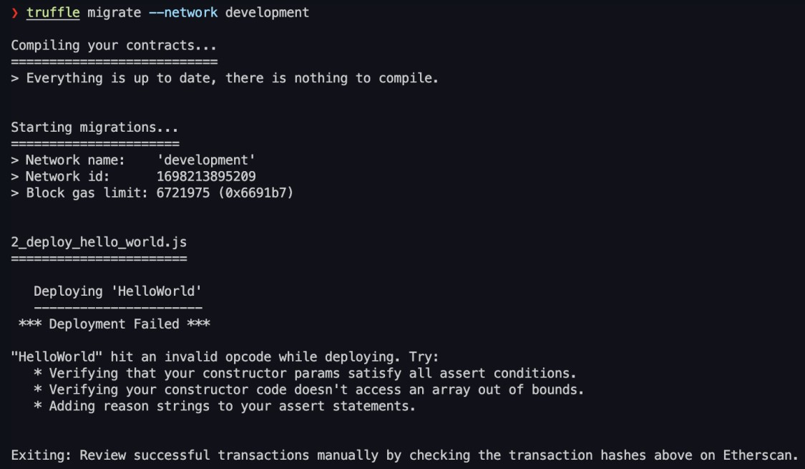

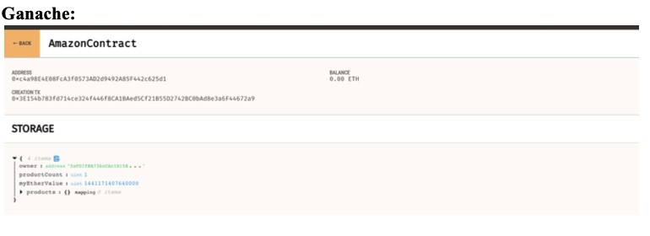

**Conclusion:-**

In this experiment, we learnt about how to use Truffle and Ganache for a local testnet for practicing smart contracts.

Department of Computer Engineering BCT Sem-VI (Honors) – July-Nov 2023 Page - 2