**Batch: A2 Roll No.:**

**Experiment No. 6**

**Grade: AA / AB / BB / BC / CC / CD /DD**

**Signature of the Staff In-charge with date**

|  |  |
| --- | --- |
|  |  |
| **Title:** | **Implementation of Blockchain platform Ethereum using Geth.** |

**Implementation Details:**

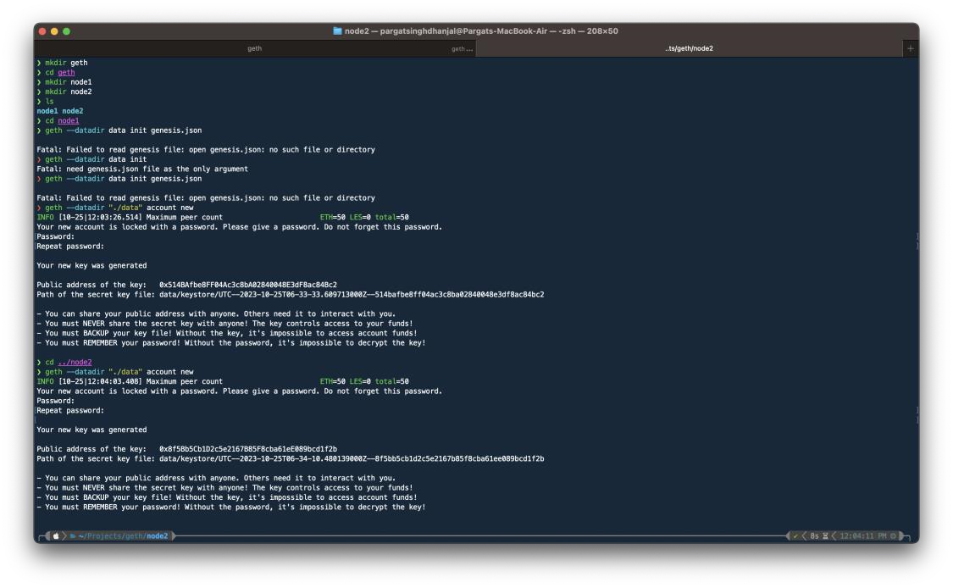

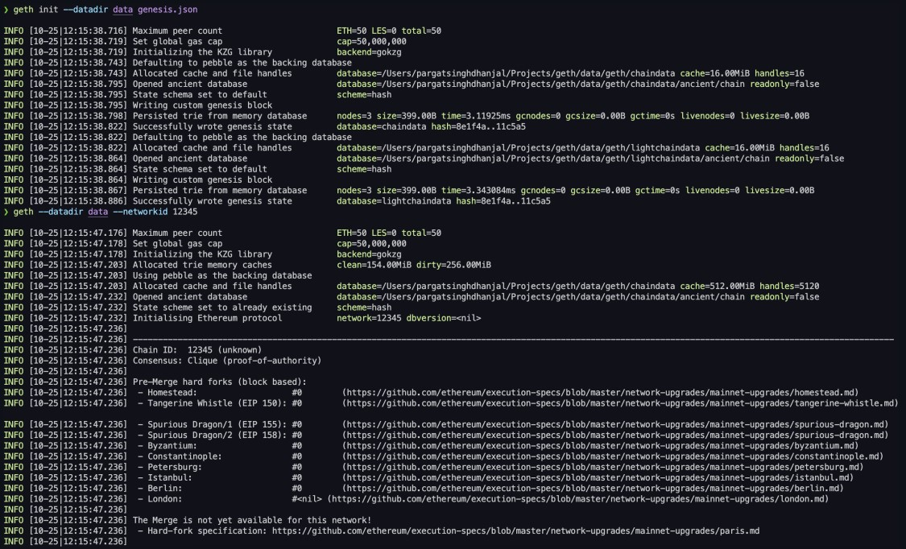

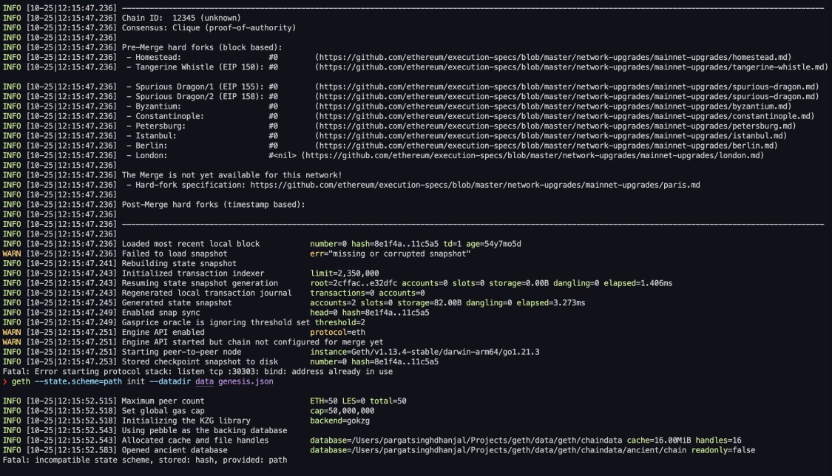

|  |
| --- |
| {  "config": {  "chainId": 12345,  "homesteadBlock": 0,  "eip150Block": 0,  "eip155Block": 0,  "eip158Block": 0,  "byzantiumBlock": 0,  "constantinopleBlock": 0,  "petersburgBlock": 0,  "istanbulBlock": 0,  "berlinBlock": 0,  "clique": {  "period": 5,  "epoch": 30000  }  },  "difficulty": "1",  "gasLimit": "8000000", "extradata":  "0x000000000000000000000000000000000000000000000000000000000000000 |

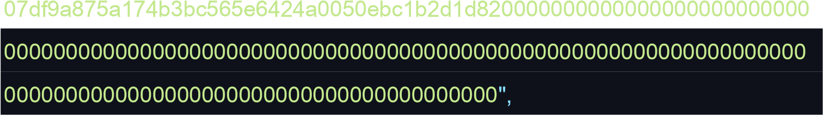 "alloc": {

"7df9a875a174b3bc565e6424a0050ebc1b2d1d82": { "balance": "300000" },

"f41c74c9ae680c1aa78f42e5647a62f353b7bdde": { "balance": "400000" }

}

}

**Conclusion:-**

In this experiment, we learnt about how to use Geth to create a private blockchain on our local machine, and created 2 nodes on this blockchain.