**Batch: A2 Roll No.: 16010121045**

**Experiment No. 7**

**Title:** Hyperledger

**Title: Hyperledger Besu**

**Introduction:**

Hyperledger Besu is an open-source Ethereum client developed under the Hyperledger project, designed specifically for enterprise-level blockchain development. This report explores the key features and applications of Hyperledger Besu in enterprise blockchain scenarios, outlining its benefits and providing a step-by-step implementation guide.

**Statement of Case Study:**

The supply chain industry is riddled with complexities, ranging from multi-party collaboration, data integrity concerns, transparency issues, and challenges related to traceability and provenance. In this case study, we examine how Hyperledger Besu, as an enterprise-grade blockchain solution, can address the intricate demands of a supply chain management system.

Main challenges in the supply chain:

* *Multi-Stakeholder Collaboration:* Supply chains involve multiple stakeholders, including manufacturers, suppliers, distributors, and retailers. Each entity has its own set of data that needs to be shared selectively, securely, and transparently with others. Coordinating and maintaining data consistency across this diverse ecosystem is a challenge.
* *Data Integrity and Provenance:* Ensuring the integrity of data at various stages

of the supply chain is vital. Participants need to verify the authenticity and

provenance of products, tracking them from their origin to the end consumer, which can be challenging in traditional supply chain systems.

* *Transparency:* In today's world, consumers demand transparency. They want to know where their products come from and how they were produced. Achieving this level of transparency in the supply chain can be complex and requires a system that ensures immutable and auditable records.

**Application in Development:**

Hyperledger Besu offers various advantages for enterprise blockchain development:

* *Compatibility with Ethereum:* It is fully compatible with the Ethereum mainnet and various testnets, enabling developers to leverage Ethereum's ecosystem and tools.
* *Privacy and Permissioning:* Hyperledger Besu provides robust privacy features, including permissioning for network participants. This is essential in a supply chain system to control who can access and update information.
* *Pluggable Consensus Mechanisms:* It supports multiple consensus mechanisms, allowing customization based on the specific use case's requirements.
* *Smart Contract Support:* Hyperledger Besu supports Ethereum's smart contracts, enabling the execution of complex business logic on the blockchain.
* *EVM Compatibility:* It is fully Ethereum Virtual Machine (EVM) compatible, allowing existing Ethereum applications to run on the Hyperledger Besu network.

**Implementation/Working with Stepwise:**

1. Setting up a Hyperledger Besu Network:

* Install Hyperledger Besu on the desired machines.
* Configure the network by defining nodes and their permissions.
* Set consensus mechanisms, either PoA (Proof of Authority) or others.
* Start the network.

2. Smart Contract Development:

* Develop smart contracts using Solidity or Vyper.
* Compile the smart contracts.
* Deploy them to the Hyperledger Besu network.

3. DApp Development:

* Build a decentralized application (DApp) using web3 libraries or tools like Truffle.
* Connect the DApp to the Hyperledger Besu network.

1. Permission Management:
   * Define and manage permissions for network participants.
   * Ensure only authorized parties can access and interact with specific smart contracts or data.
2. Testing and Monitoring:

* Conduct thorough testing to ensure the system's integrity and security.
* Monitor the network's performance and health.

**Conclusion/Result Screenshots:**

Hyperledger Besu is a powerful tool for enterprise blockchain development. In our supply chain management case study, we found that it can effectively address the needs of multiple stakeholders, ensuring data integrity, privacy, and secure collaboration. It does this by tackling main challenges of supply chain in the following ways:

* *Permissioned Network:* Hyperledger Besu allows for the creation of permissioned blockchain networks, where access is strictly controlled. In a supply chain system, this ensures that only authorized parties have access to relevant data, enhancing security and privacy.
* *Smart Contracts:* The use of Ethereum-compatible smart contracts on Hyperledger Besu enables the automation of various supply chain processes, including payment settlements, product tracking, and even quality control checks. These smart contracts can execute business logic in a trustless and decentralized manner.
* *Provenance and Traceability:* By recording every transaction on the blockchain, Hyperledger Besu provides an immutable history of every product's journey through the supply chain. This enables stakeholders to trace the origin and movement of goods efficiently and verify their authenticity.
* *Privacy and Confidentiality:* Hyperledger Besu's support for private transactions and zero-knowledge proofs ensures that sensitive supply chain information can be kept confidential while still being recorded on the blockchain for transparency and traceability.
* *Custom Consensus Mechanisms:* Hyperledger Besu allows for various consensus mechanisms to be implemented, including Proof of Authority (PoA) or customdesigned mechanisms. This flexibility is crucial for tailoring the supply chain blockchain to specific needs, such as speed and security.
* *Interoperability:* Hyperledger Besu's compatibility with Ethereum means that it can seamlessly integrate with existing Ethereum-based systems and tools, which is advantageous for supply chain stakeholders using Ethereum.

**Result Screenshots (if applicable):**

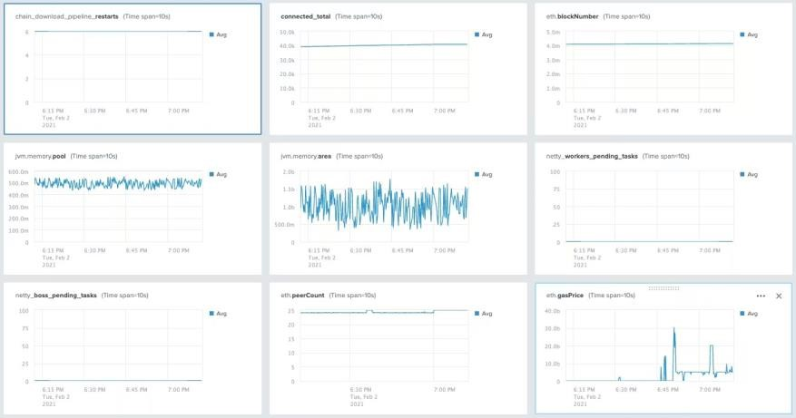

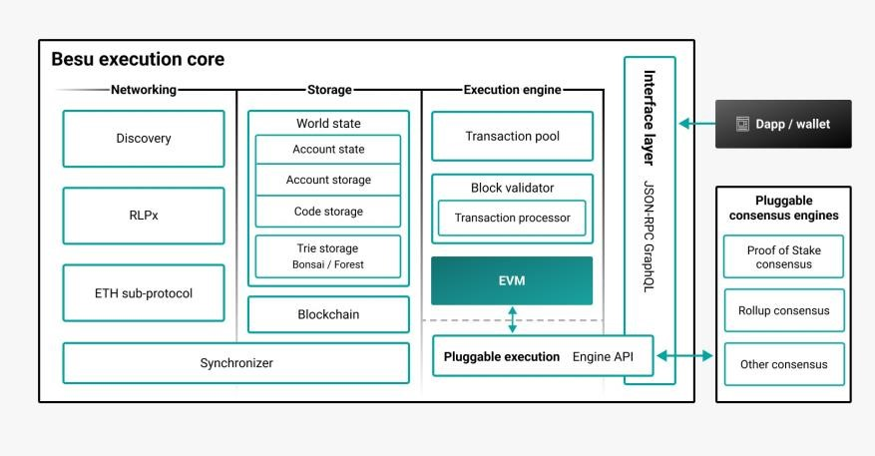

**References:**

1. Hyperledger Besu Website - https://besu.hyperledger.org/
2. Hyperledger Foundation - https://www.hyperledger.org/
3. Ethereum Documentation - https://ethereum.org/en/developers/docs/
4. Solidity Documentation - https://docs.soliditylang.org/en/v0.8.21/