

**Roll**

**No.:160101**

**210**

**45**



**Experiment**

**No.**

**9**

**Signature**

**of**

**the**

**Staff**

**In**

**-**

**charge**

**with**

**TITLE:** Implementation of Memory Allocation Algorithms

**AIM:** To learn about various Memory Allocation Algorithms

**Expected Outcome of Experiment:**

**CO 5.** Understand Storage management with allocation, segmentation & virtual memory concepts

**Books/ Journals/ Websites referred:**

1. **Silberschatz A., Galvin P., Gagne G. “Operating Systems Principles”, Willey Eight edition.**
2. **Achyut S. Godbole , Atul Kahate “Operating Systems” McGraw Hill Third Edition.**
3. **William Stallings, “Operating System Internal & Design Principles”, Pearson.**
4. **Andrew S. Tanenbaum, “Modern Operating System”, Prentice Hall.**

**Pre Lab/ Prior Concepts:**

**Knowledge of types of memory :**

Memory can be divided into primary and secondary memory; moreover, there are numerous types of memory when discussing just primary memory. Some types of primary memory include the following

* **Cache memory.** This temporary storage area, known as a cache, is more readily available to the processor than the computer's main memory source. It is also called *CPU memory* because it is typically integrated directly into the CPU chip or placed on a separate chip with a bus interconnect with the CPU.
* **RAM.** The term is based on the fact that any storage location can be accessed directly by the processor.
* **Dynamic RAM.** DRAM is a type of semiconductor memory that is typically used by the data or program code needed by a computer processor to function.
* **Static RAM.** SRAM retains data bits in its memory for as long as power is supplied to it. Unlike DRAM, which stores bits in cells consisting of a capacitor and a transistor, SRAM does not have to be periodically refreshed.
* **Double Data Rate SDRAM.** DDR SRAM is SDRAM that can theoretically improve memory clock speed to at least 200 MHz.
* **Double Data Rate 4 Synchronous Dynamic RAM.** DDR4 RAM is a type of DRAM that has a high-bandwidth interface and is the successor to its previous DDR2 and DDR3 versions. DDR4 RAM allows for lower voltage requirements and higher module density. It is coupled with higher data rate transfer speeds and allows for dual in-line memory modules (DIMMS) up to 64 GB.
* **Rambus Dynamic RAM.** DRDRAM is a memory subsystem that promised to transfer up to 1.6 billion bytes per second. The subsystem consists of RAM, the RAM controller, the bus that connects RAM to the microprocessor and devices in the computer that use it.

* **Read-only memory.** ROM is a type of computer storage containing nonvolatile, permanent data that, normally, can only be read and not written to. ROM contains the programming that enables a computer to start up or regenerate each time it is turned on.
* **Programmable ROM.** PROM is ROM that can be modified once by a user. It enables a user to tailor a microcode program using a special machine called a *PROM programmer*.

* **Erasable PROM.** EPROM is programmable read-only memory PROM that

can be erased and re-used. Erasure is caused by shining an intense ultraviolet light through a window designed into the memory chip.

* **Electrically erasable PROM.** EEPROM is a user-modifiable ROM that can be erased and reprogrammed repeatedly through the application of higher than normal electrical voltage. Unlike EPROM chips, EEPROMs do not need to be removed from the computer to be modified. However, an EEPROM chip must be erased and reprogrammed in its entirety, not selectively.
* **Virtual memory.** A memory management technique where secondary memory can be used as if it were a part of the main memory. Virtual memory uses hardware and software to enable a computer to compensate for physical memory shortages by temporarily transferring data from RAM to disk storage.

# Algorithms Used-

1. Input memory blocks with size and processes with size.
2. Initialize all memory blocks as free.
3. Start by picking each process and check if it can be assigned to current block.
4. If size-of-process <= size-of-block if yes then assign and check for next process.
5. If not then keep checking the further blocks.

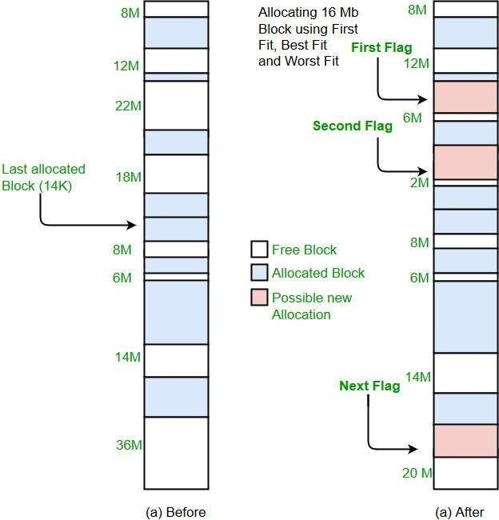

**Implementation details:** (printout of code)

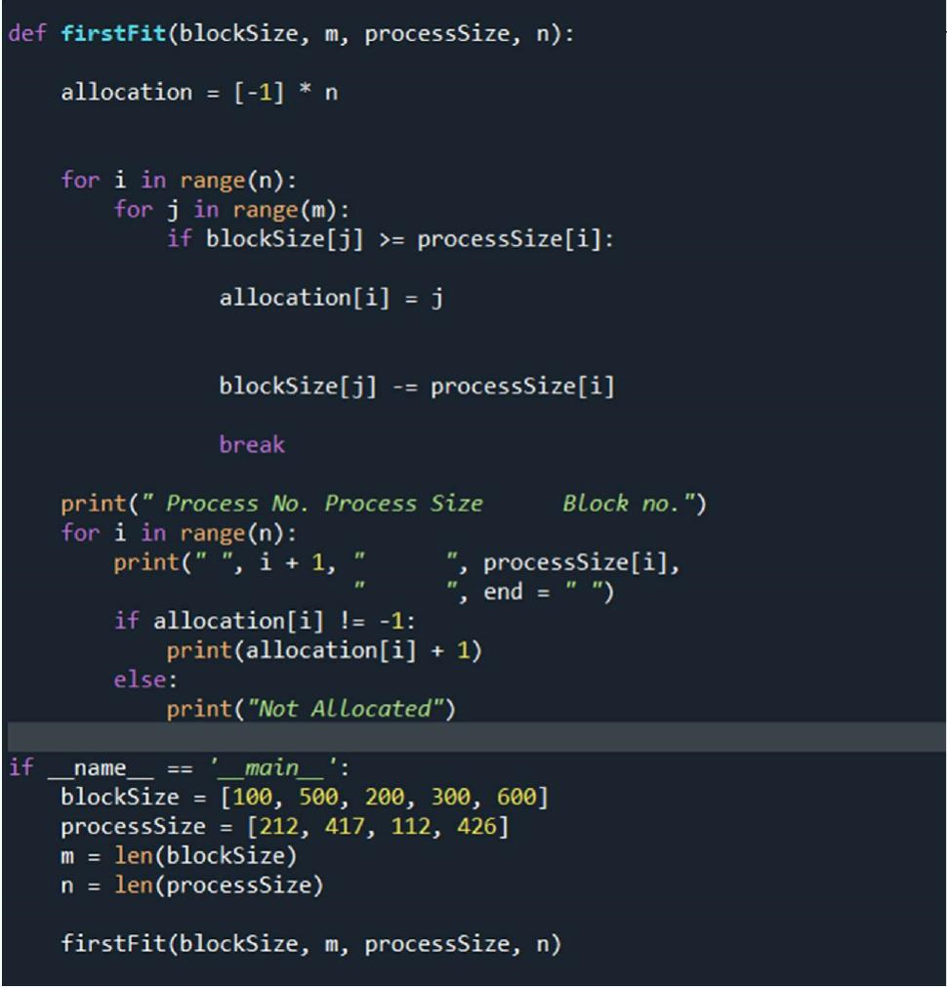

# Output-

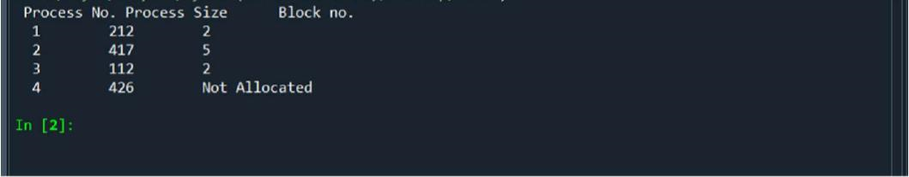

**Conclusion:**

When it is time to load a process into the main memory and if there is more than one free block of memory of sufficient size then the OS decides which free block to allocate. We got to know about different placement algorithm ie. First fit , best fit ,worst fit and next fit.

**Date: 27-10-2023 Signature of faculty in-charge**