**Batch: B1 Roll No: 16010121045**

**Experiment No. 6**

|  |
| --- |
| **Title:** Implement contrast stretching of a digital image. |

**Objective:** To learn & understand contrast stretching.

**Expected Outcome of Experiment:**

|  |  |
| --- | --- |
| **CO** | **Outcome** |
| **CO4** | Design & implement algorithms for digital image enhancement, segmentation & restoration. |

**Books/ Journals/ Websites referred:**

1. http://www.mathworks.com/support/
2. www.math.mtu.edu/~msgocken/intro/intro.html.
3. R. C.Gonsales R.E.Woods, “Digital Image Processing”, Second edition, Pearson Education
4. S.Jayaraman, S Esakkirajan, T Veerakumar “Digital Image Processing “Mc Graw Hill.
5. S.Sridhar,”Digital Image processing”, oxford university press, 1st edition."

**Pre Lab/ Prior Concepts:**

Contrast stretching (often called normalization) is a simple image enhancement technique that attempts to improve the contrast in an image by `stretching' the range of intensity values it contains to span a desired range of values, e.g. the the full range of pixel values that the image type concerned allows. It differs from the more sophisticated histogram equalization in that it can only apply a linear scaling function to the image pixel values. As a result the `enhancement' is less harsh.

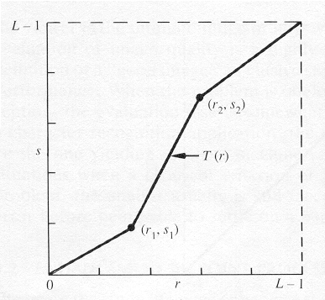

The locations of (r1,s1) and (r2,s2) control the shape of the transformation function.

* If r1= s1 and r2= s2 the transformation is a linear function and produces no changes.
* If r1=r2, s1=0 and s2=L-1, the transformation becomes a thresholding function that creates a binary image.
* Intermediate values of (r1,s1) and (r2,s2) produce various degrees of spread in the gray levels of the output image, thus affecting its contrast.

Generally, r1≤r2 and s1≤s2 is assumed.

**Implementation steps with screenshots:**

clc;

c = imread('img.png');

c_gray = rgb2gray(c);

c_final = c_gray;

alpha = 0.4;

beta = 5.5;

gamma = 0.5;

for i = 1:length(c_gray)

for j = 1:height(c_gray)

if c_gray(j,i) < 50

c_final(j,i) = c_final(j,i)*alpha;

elseif 50 < c_gray(j,i) && c_gray(j,i) < 150

c_final(j,i) = c_final(j,i)*beta;

else

c_final(j,i) = c_final(j,i)*gamma;

end

end

end

subplot(2, 3, 1);

imshow(c);

title('Original Image');

subplot(2, 3, 2);

imshow(c_gray);

title('Gray Image');

subplot(2, 3, 3);

imshow(c_final);

title('Final Image');

**Conclusion:-**

Implemented contrast stretching of a digital image.

**Post Lab Descriptive Questions**

1. Thresholding function in contrast stretching creates
2. binary image
3. high quality image
4. enhanced image
5. low quality image
6. When is the contrast stretching transformation a linear function, for r and s as gray-value of image before and after processing respectively?

a) r1 = s1 and r2 = s2

b) r1 = r2, s1 = 0 and s2 = L – 1, L is the max gray value allowed

c) r1 = 1 and r2 = 0

d) None of the mentioned

3. Which gray-level transformation increase the dynamic range of gray-level in the image?

a) Power-law transformations

b) Negative transformations

c) Contrast stretching

d) None of the mentioned

4. When is the contrast stretching transformation a thresholding function, for r and s as gray-value of image before and after processing respectively?

a) r1 = s1 and r2 = s2

b) r1 = r2, s1 = 0 and s2 = L – 1, L is the max gray value allowed

c) r1 = 1 and r2 = 0

d) None of the mentioned

5. What condition prevents the intensity artifacts to be created while processing with contrast stretching, if r and s are gray-values of image before and after processing respectively?

a) r1 = s1 and r2 = s2

b) r1 = r2, s1 = 0 and s2 = L – 1, L is the max gray value allowed

c) r1 = 1 and r2 = 0

d) r1 ≤ r2 and s1 ≤ s2