**Project Title:**

PASSWORD WALLET

**Team Details:**

FY- A2 – Computer Engineering

* 16010121033 - Nupur Chaudhari
* 16010121043 - Vishrut Deshmukh
* 16010121045 - Pargat Singh Dhanjal

**Problem Statement**

Create a password manager using the module Cryptography that encrypts passwords that are taken as inputs from the user and stores them all at one place. Create a Graphical User Interface (GUI) using Tkinter- Standard Python interface, to handle them.

The system can accept new user accounts, login to existing accounts, and is able to add, store and view site name and their passwords entered by the users.

Hence, making it really accessible to handle and manage numerous passwords at once without having the fear of forgetting it. The encryption makes it less vulnerable to hacking which ensures security of the passwords.

**Objective:**

We live in a world where we have passwords for every single app and site, be it games/shopping/booking/finance/user accounts etc.

And remembering all of them is but obviously a herculean task! This results in users creating weak passwords and major security problems.

Hence, we came up with such a system that would encrypt all passwords and store them in one place assuring both memory and security of the passwords to the users.

**System****architecture**

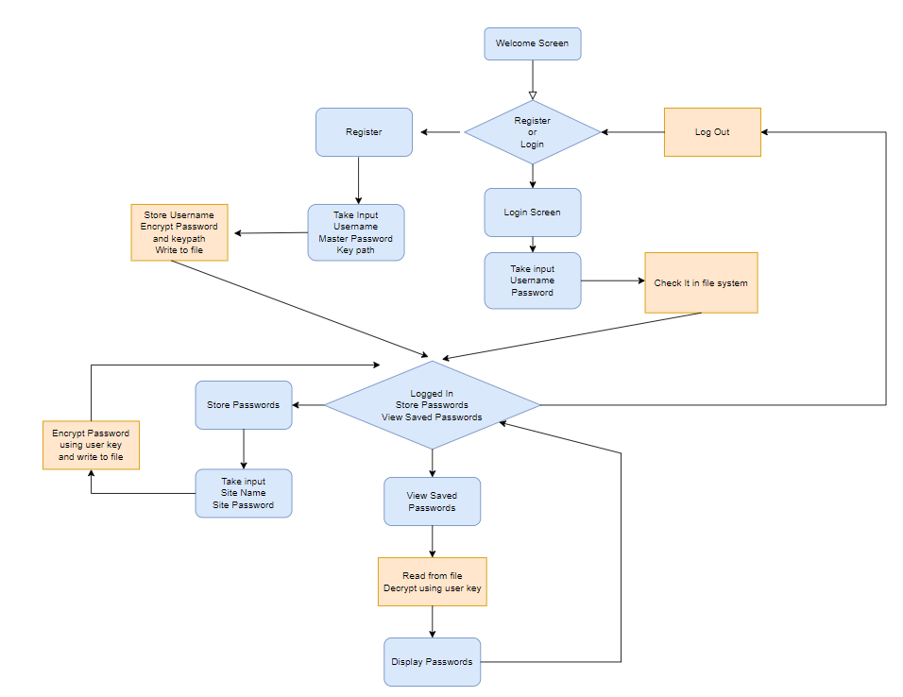

**Features of the system**

* Easy and Friendly User Interface
* Master password encryption
* URL-safe base64-encoded 32-byte key for encryption
* Runs and stores passwords locally on your machine
* Cross platform
* Multi-User support
* Open Source Project

**Results & Outputs** 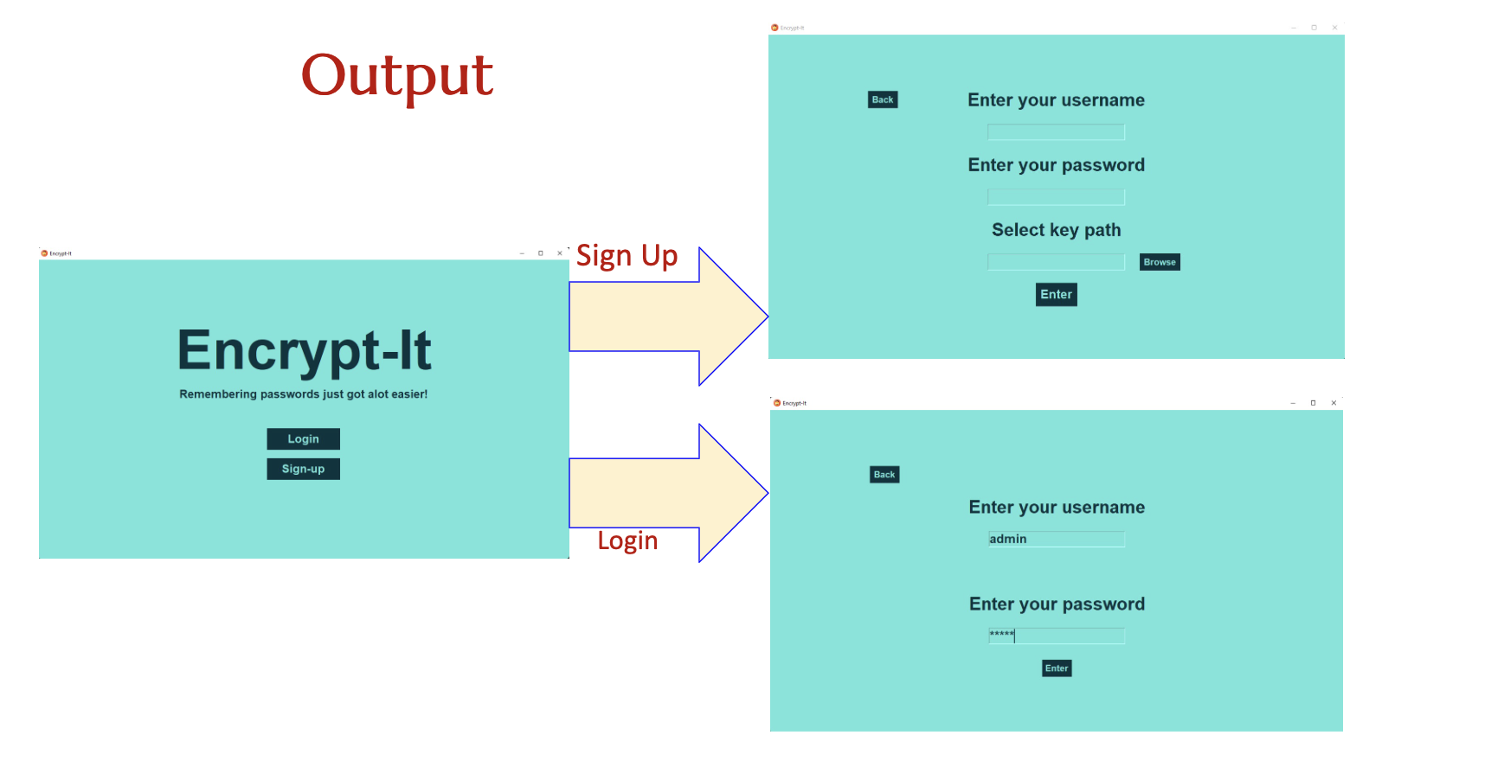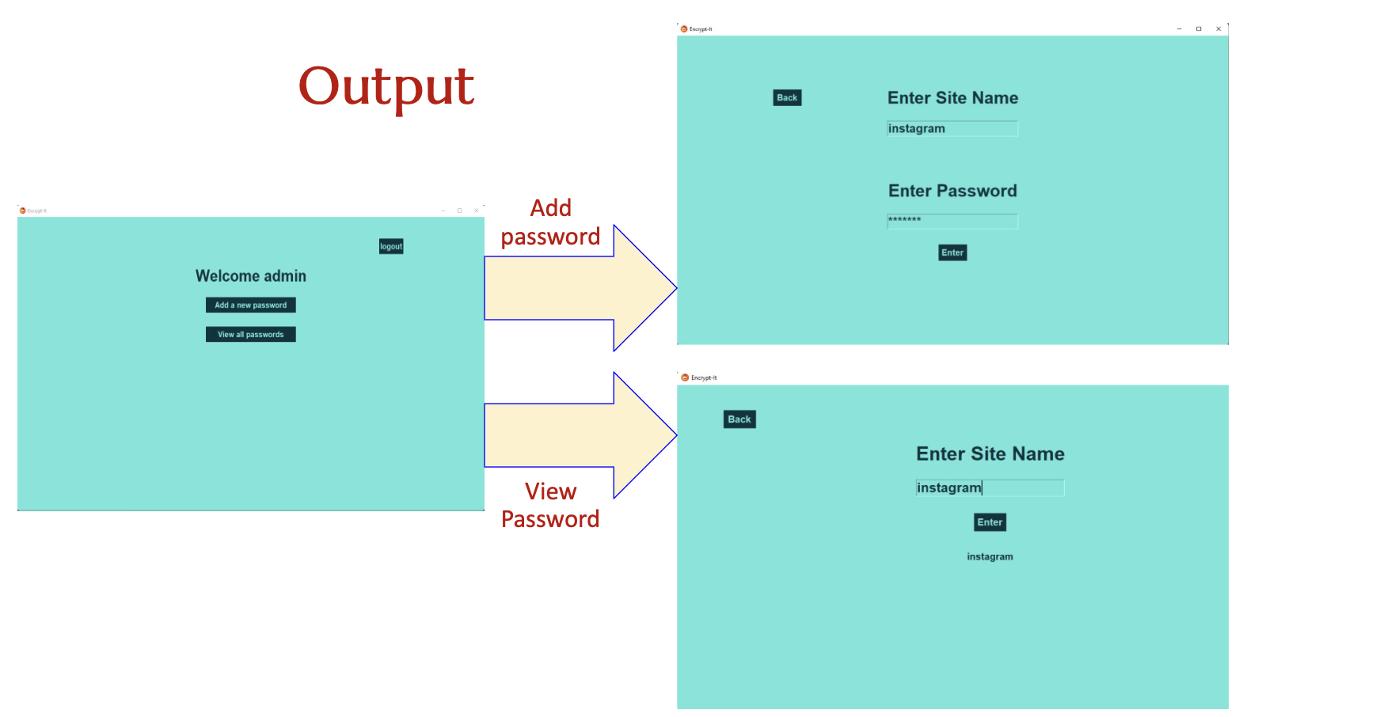

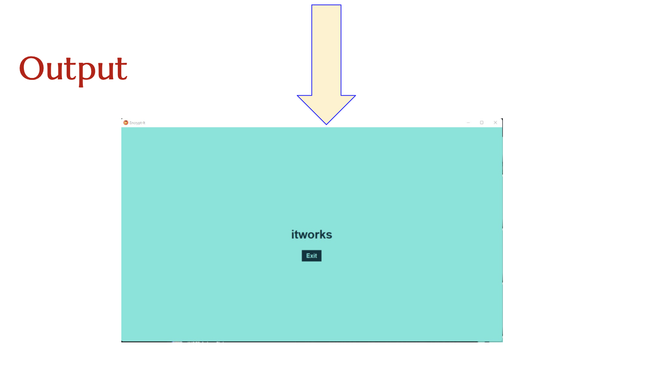

**Conclusion**

* We tried to apply our in-class developed knowledge about python as a language in solving a simple real life problem faced by many of us.
* We learnt how to use Cryptography module in the backend and Tkinter module as GUI in the frontend of the mini-project and many other aspects of programming and program organizing.
* The project not only taught us logic building but also team-coordination and time management habits.

**References**

* [Python Tkinter GUI 🐍【𝙁𝙧𝙚𝙚】](https://youtu.be/TuLxsvK4svQ)
* <https://www.lastpass.com/get-premium?sdfc_id=7014P000001rVliQAM&sfdc_id=7014P000001rVIiQAM&gclid=Cj0KCQjwn4qWBhCvARIsAFNAMiiYS4Q8Bwy7G9sokFAsV8aEf5HFNGOyYdv0sxv3t1I2MlnWRKfpqy8aAieqEALw_wcB&gclsrc=aw.ds%E2%80%8B>
* <https://docs.python.org/3/library/tkinter.html>
* <https://pypi.org/project/cryptography/>

**Acknowledgements**

Special thanks to Prof. Vaibhav Vasani Sir, Prof. Pradnya Bhangale Mam, Prof. Swapnil Pawar Sir for giving us this opportunity. It is their guidance and teachings that led to the successful execution of this project.

We would also like to thank our fellow teammates for their determination and other classmates for their support.