In the name of God


UNIVERSITY OF TEHRAN

Artificial Intelligence
Parham Javan
ID: 810800008
CA 5
Questions

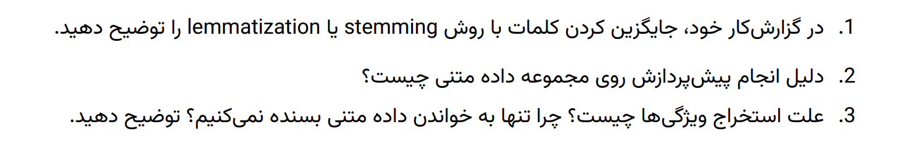
1. Stemming vs. Lemmatization
- Stemming: Reduces words to their root form without considering the context or meaning. For example, "running" becomes "run" and "flies" becomes "fli." It is a fast, rule-based approach.
- Lemmatization: Converts words to their base or dictionary form by considering the word’s meaning and part of speech. For example, "running" becomes "run" and "better" becomes "good." It is more accurate but slower than stemming.
- Use in Clustering: Lemmatization is preferred for better semantic understanding, while stemming can be used for faster processing in applications where exact word meaning is less important.

2. Why is Preprocessing Necessary?
Preprocessing cleans and standardizes text data for better model performance:
- Removes Noise: Unnecessary characters, stopwords, and formatting elements (e.g., "\n", "\r") are eliminated.
- Reduces Complexity: Normalization (e.g., lowercase conversion, stemming) simplifies words and reduces redundancy in the data.
- Improves Model Accuracy: It ensures the focus is on meaningful words, improving clustering or classification performance.

3. Why Extract Features? Why Not Just Use Text?
- Text Data is Unstructured: Machine learning algorithms can’t directly process raw text.
- Feature Extraction Converts Text to Numerical Data: Tools like TF-IDF or Sentence Transformers convert text into vectors representing semantic meanings or word frequencies.
- Improves Algorithm Performance: Numerical representations enable algorithms to understand relationships and patterns in the data.

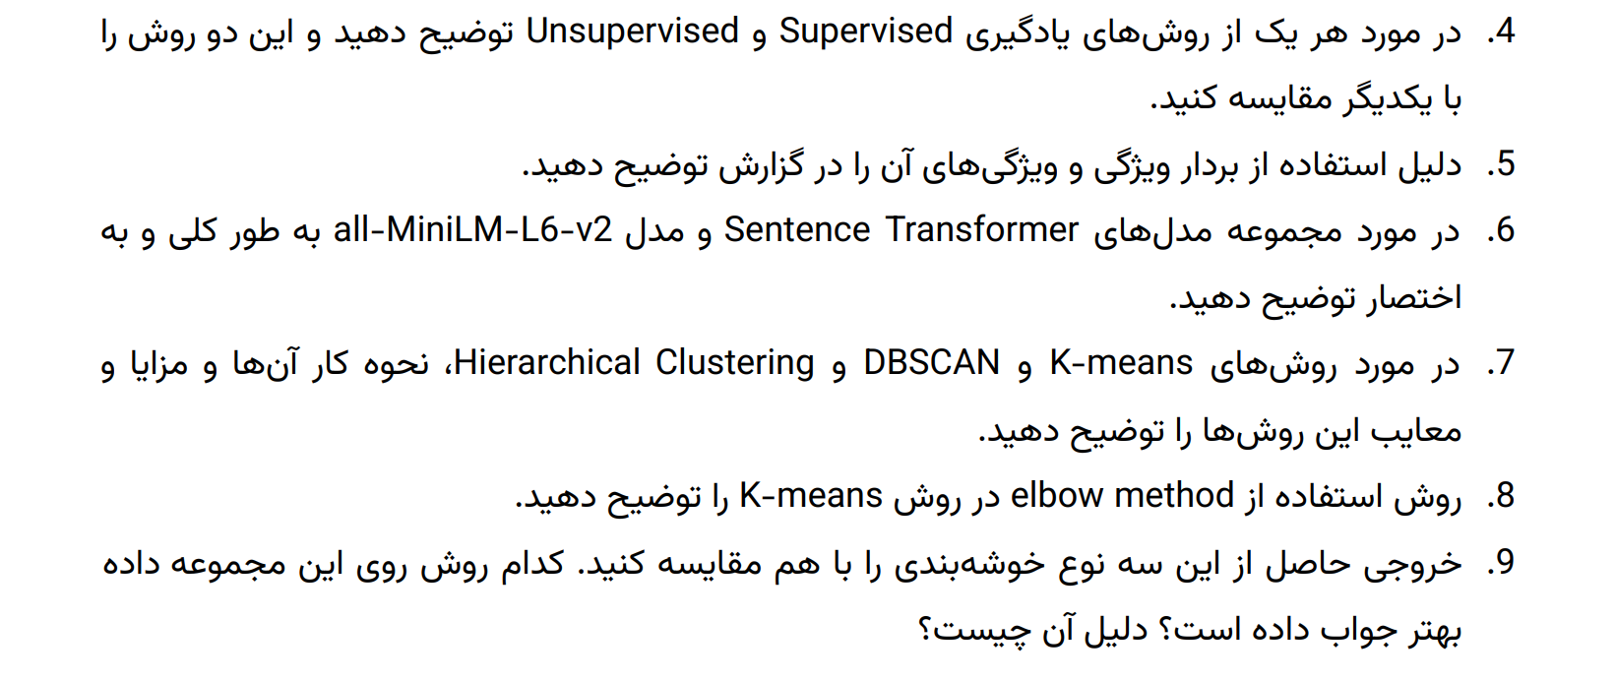
4. Supervised vs. Unsupervised Learning
- Supervised Learning:
  - Definition: Algorithms learn from labeled data (input-output pairs).
  - Examples: Classification, regression.
  - Advantages: Higher accuracy due to labeled data.
  - Disadvantages: Requires significant labeled data, which can be costly.
- Unsupervised Learning:
  - Definition: Finds hidden patterns in unlabeled data.
  - Examples: Clustering, dimensionality reduction.
  - Advantages: No need for labeled data.
  - Disadvantages: Results can be less interpretable.
- Comparison: Supervised learning is more precise but resource-intensive, while unsupervised learning is exploratory and suitable for unlabeled datasets.

5. Why Use Feature Vectors?
- Feature Vectors: Represent text in numerical form, capturing semantic and contextual meaning.
- Benefits:
  - Make the data usable by clustering algorithms.
  - Preserve relationships between words or documents.
  - Enable dimensionality reduction and visualization.

6. Sentence Transformers and all-MiniLM-L6-v2
- Sentence Transformers: A framework to generate sentence embeddings, which represent sentences or documents as dense vectors.
- all-MiniLM-L6-v2:
  - Description: A lightweight, fast model optimized for semantic similarity tasks.
  - Benefits: Produces high-quality embeddings suitable for clustering tasks.
  - Use Case: Converts each document into a vector capturing its semantic meaning.

7. Comparison of Clustering Methods
- K-Means:
  - Advantages: Fast and scalable, performs well on spherical clusters.
  - Disadvantages: Sensitive to outliers and requires specifying the number of clusters (K).
- DBSCAN:
  - Advantages: Handles arbitrary cluster shapes and noise well.
  - Disadvantages: Sensitive to eps and min_samples parameters; struggles with varying density.
- Hierarchical Clustering:
  - Advantages: Does not require specifying the number of clusters initially, provides a dendrogram.
  - Disadvantages: Computationally expensive for large datasets.

8. Elbow Method in K-Means
- Steps:
  - Run K-Means with different values of K.
  - Plot the sum of squared distances (inertia) for each K.
  - Identify the "elbow point" where inertia decreases at a slower rate.
- Purpose: Determines the optimal number of clusters by balancing accuracy and simplicity.

9. Comparing Clustering Results
- K-Means: Produced compact clusters but struggled with overlapping clusters (low silhouette score).
- DBSCAN: Identified noise but failed to cluster effectively (negative silhouette score).
- Hierarchical: Similar performance to K-Means with slightly overlapping clusters.
- Best Method: K-Means is preferred for simplicity and moderate performance, but parameter tuning for DBSCAN could yield better results.
10. What is PCA?
- Principal Component Analysis (PCA):
  - Purpose: Reduces the dimensionality of data while retaining most of the variance.
  - How It Works:
    - Identifies directions of maximum variance in the data (principal components).
    - Projects the data onto a lower-dimensional space.
  - Benefits: Simplifies data for visualization and speeds up clustering.

What is PCA?
Principal Component Analysis (PCA) is a dimensionality reduction technique that projects high-dimensional data into a lower-dimensional space. It works by:
Identifying the directions (principal components) in the data where variance is maximized.
Transforming the data into a new coordinate system based on these principal components, while preserving as much variance as possible.
This is especially useful for visualizing high-dimensional data in 2D or 3D.
PCA Functionality
- How it works: PCA reduces the dimensionality of data by projecting it onto the directions of maximum variance (principal components).
- Benefits: Allows visualization of high-dimensional data in 2D/3D while retaining most of the data's structure.
Comparison of Algorithms
- K-Means: Generally forms compact, spherical clusters.
- DBSCAN: Handles noise and discovers clusters of arbitrary shapes but may leave some points unclustered.
- Hierarchical: Captures nested clusters and is useful for dendrogram analysis but can be computationally expensive.
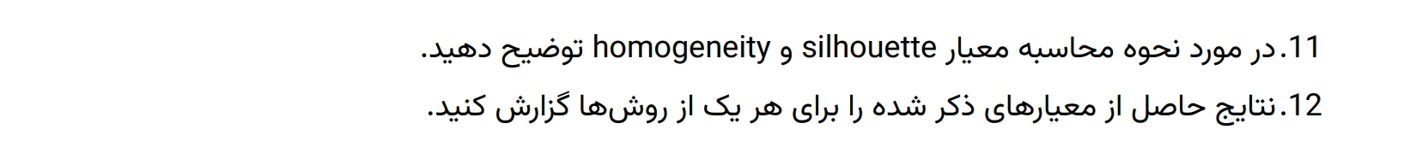
11. Silhouette and Homogeneity Metrics
- Silhouette Score:
  - Measures how well clusters are separated and how cohesive they are.
  - Ranges from -1 to 1 (higher is better).
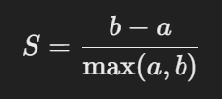
  - Formula:

    - aa = mean intra-cluster distance.
    - bb = mean nearest-cluster distance.
- Homogeneity Score:
  - Measures whether all data points in a cluster have the same true label.
  - Ranges from 0 to 1 (higher is better). (we don’t have true label here so its impractical)

12. Results of Metrics
- Silhouette Scores:
  - K-Means: 0.091 (moderate but poor cluster separation).
  - DBSCAN: 0.041 (poor clustering, likely due to noise).
  - Hierarchical: 0.085 (similar to K-Means).
- Homogeneity Scores:
  - Requires true labels.
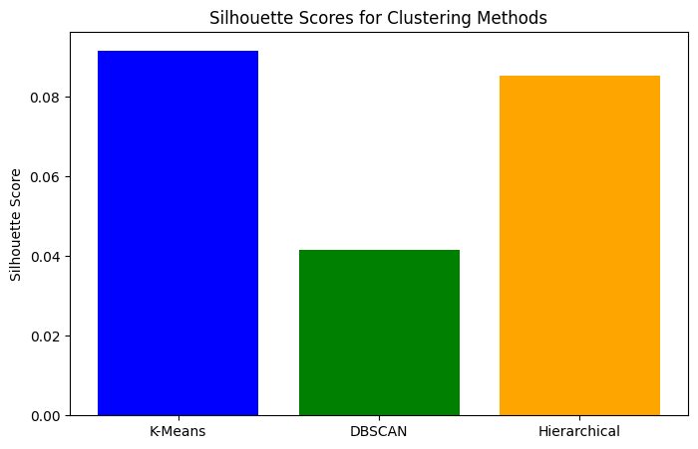

The discrepancy between good clustering in scatter plots and a low silhouette score can arise due to several factors.
Why Does This Happen?
- High Dimensionality of Data:
  - The silhouette score is computed based on distances between points in the original high-dimensional feature space.
  - However, when you reduce the dimensions for visualization (e.g., PCA to 2D), the apparent clustering may not reflect the true separations in the high-dimensional space.
  - Effect: Good visual clusters in 2D may still result in low silhouette scores in the original space.
- Overlapping Clusters:
  - If clusters overlap or have points close to the boundaries in the original space, the silhouette score will drop.
  - This is common in text data, where similar documents might share words and features but belong to different clusters.
- Cluster Shapes:
  - The silhouette score assumes clusters are spherical and well-separated, which works best for algorithms like K-Means.
  - For algorithms like DBSCAN or Hierarchical Clustering, which can form irregularly shaped clusters, silhouette scores might not reflect clustering quality accurately.
- Density-Based Clusters:
  - DBSCAN often leaves noise points unclustered (labeled -1), which can skew the silhouette score.
- Scaling Issues:
  - If features in the original data are not scaled properly, the distance calculations used in silhouette score may not represent true relationships.

Why Can Silhouette Score Be Low Even If Clusters Look Good?
- Silhouette score depends heavily on distances between points in the high-dimensional space. If clusters are well-separated in 2D but overlap in the original feature space, the silhouette score will reflect the overlap.
- Textual data often lies on a manifold in high-dimensional space, making the clusters appear closer than they actually are.

Conclusion
- Continue relying on scatter plots and qualitative evaluation (extracting samples) to verify cluster quality.
- Use domain-specific knowledge to interpret results, as silhouette score alone may not fully capture the clustering quality for irregular or high-dimensional data.

