Assignment 2: UI / UX Design and Front-End Implementation

QueueSmart — Smart Queue Management Application
Team: Parham Ebrahimi, Mustafa Ahmed, Kevin Santhosh, Andrew Andari
Application: QueueSmart (front-end only; mock data)
Date: October 3, 2026

1. GitHub Repository Link
The front-end is maintained at:
https://github.com/Parham-Ebrahimi/QueueSmart
TAs can validate individual contributions from the commit history on main. Authorship is visible on each commit (Parham-Ebrahimi, Mustafa Ahmed / TheRealMufasa, kevinsorts, wynetyme).

2. Design and Development Methodology
Our methodology has not changed since Assignment 1. We still work in a short, screen-first cycle:
- Agree on the information architecture and visual system from A1 (teal workspace, sidebar navigation, card-based status).
- Split the required screens among four people so each person owns a coherent slice of the product.
- Implement the front end with mock data, then review navigation, validation, and visual consistency together.
We did not switch process because A2 is the implementation of the A1 design, not a new problem. The only adjustment was practical: later screens (History, Notifications, Queue Management) consume the same mock services as the earlier dashboards, so we added a shared localStorage layer instead of each person inventing a separate fake data set. That keeps the UI consistent for Assignments 3 and 4.
Work was divided by role and screen:
- Person 1 — Authentication / UI foundation: login, registration, validation, navigation, shared CSS and components.
- Person 2 — User interface: user dashboard, join queue, queue status, mock queue interactions.
- Person 3 — Admin services: admin dashboard, service management, create/edit form, open/close queue.
- Person 4 — Queue administration: queue management (reorder / remove / serve next), history, notifications, and remaining A2 form-spec gaps.
Everyone was responsible for regular GitHub commits, checking navigation between pages, keeping styling consistent, capturing screenshots of their screens, writing contribution notes, and reviewing this document.

3. Front-End Technologies and Responsibilities
QueueSmart is a single-page web app. We chose a small, conventional front-end stack so the A1 layout could be implemented quickly and reused in later assignments.
Technology | Why we used it
React 19 | Component-based screens that map one-to-one to the A1 design. Client-side state is enough for mock queues, history, and notifications. No backend is required for A2.
Vite 6 | Fast local development and a one-command production build (npm run dev / npm run build).
React Router 7 | Real routes for login, registration, user pages, and admin pages. Role-aware navigation is part of the UX.
lucide-react | A consistent icon set that matches the teal / coral A1 palette without a full UI kit.
Plain CSS | Keeps the A1 look (DM Sans + Manrope, 7–8px radii, teal #137c75) without fighting a component library.
Browser localStorage | Mock persistence for the session, services, active queue, history, and notifications. Acceptable for A2; replaceable with APIs in A3.

How to run: npm install, then npm run dev, and open http://127.0.0.1:5173. Register or sign in with any valid email and a password of at least 8 characters. Choose User or Administrator before submitting.

Who worked on which screens
Group member | GitHub | Screens / features
Parham Ebrahimi | Parham-Ebrahimi | Login, Registration, client-side auth validation, sidebar / top bar, shared components (Brand, FormField, AppShell) and base CSS.
Mustafa Ahmed | TheRealMufasa | User Dashboard, Join Queue, Queue Status, mock join / leave / simulate-next interactions, Account Settings.
Kevin Santhosh | kevinsorts | Admin Dashboard, Service Management (create / edit / delete), open / close queue controls, initial service-form validation.
Andrew Andari | wynetyme | Queue Management (reorder, remove, serve next), History, in-app Notifications, service-form spec fields, shared persisted mock data, and this submission document.

4. Screenshots of the Front End
Each required screen is labeled below. Additional validation, History, and Notifications captures are included because the assignment also requires those features.
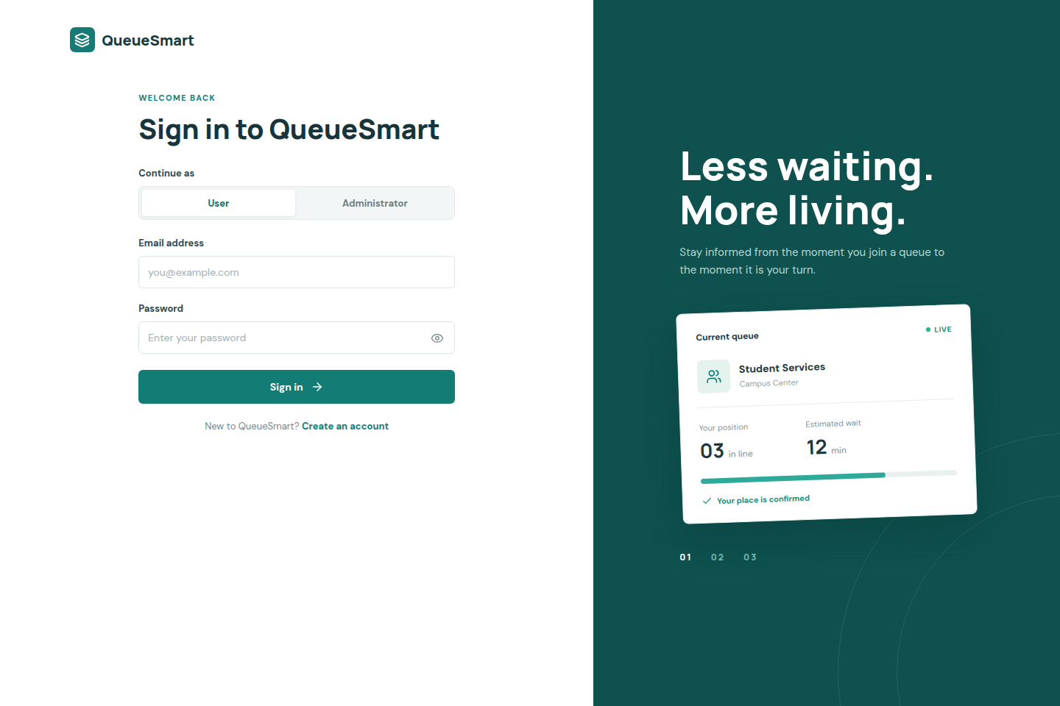
Figure 1. Login. Email (used as username), password, User / Administrator role picker, and a sign-in action.

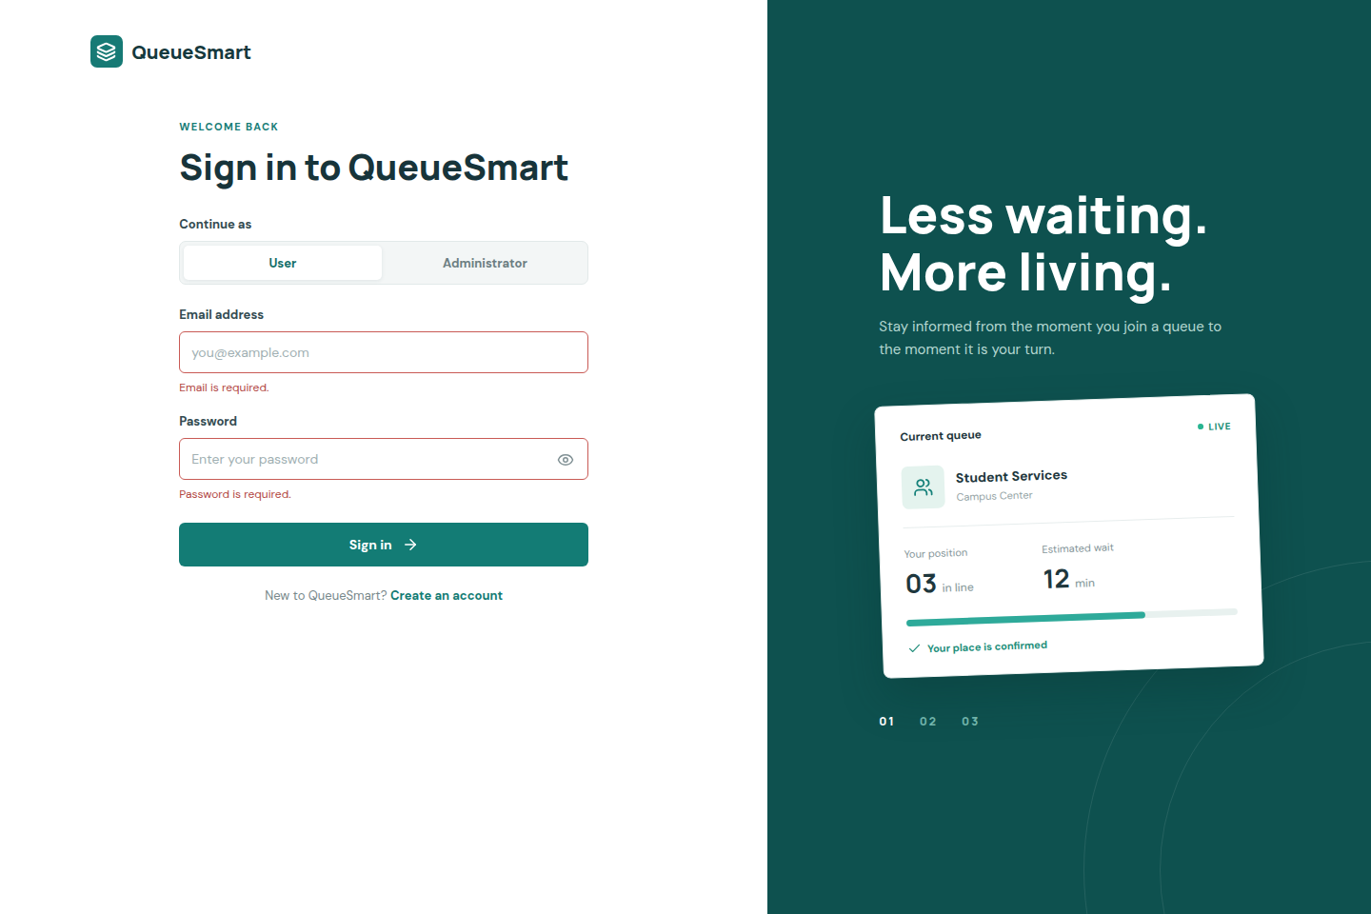
Figure 1b. Login validation. Required email and password, email format, and an 8–128 character password rule.

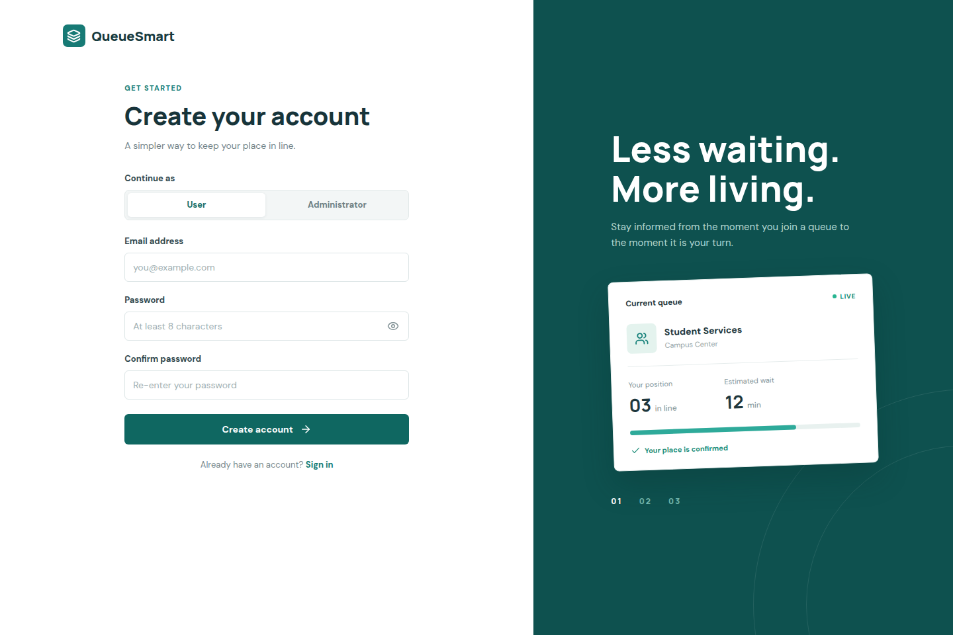
Figure 2. Registration. Email, password, confirm password, and role selection.

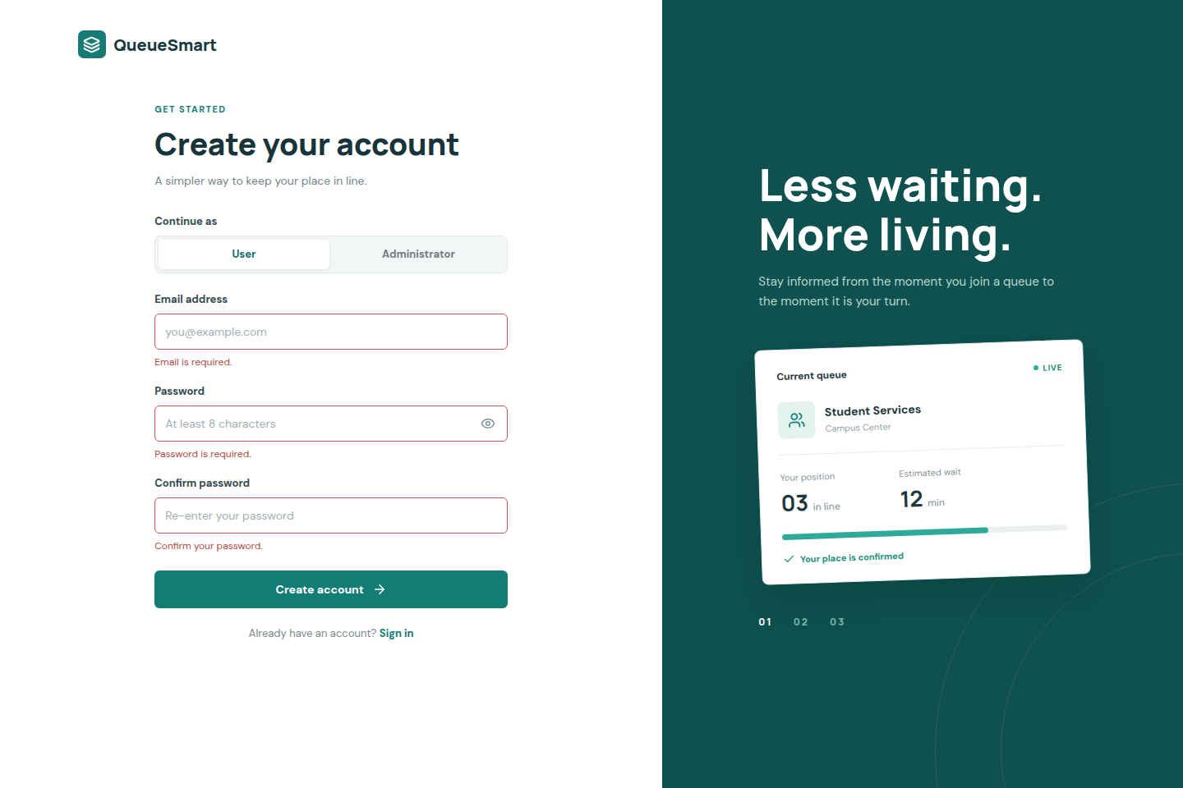
Figure 2b. Registration validation. Required fields, email type, password length, and matching confirm password.

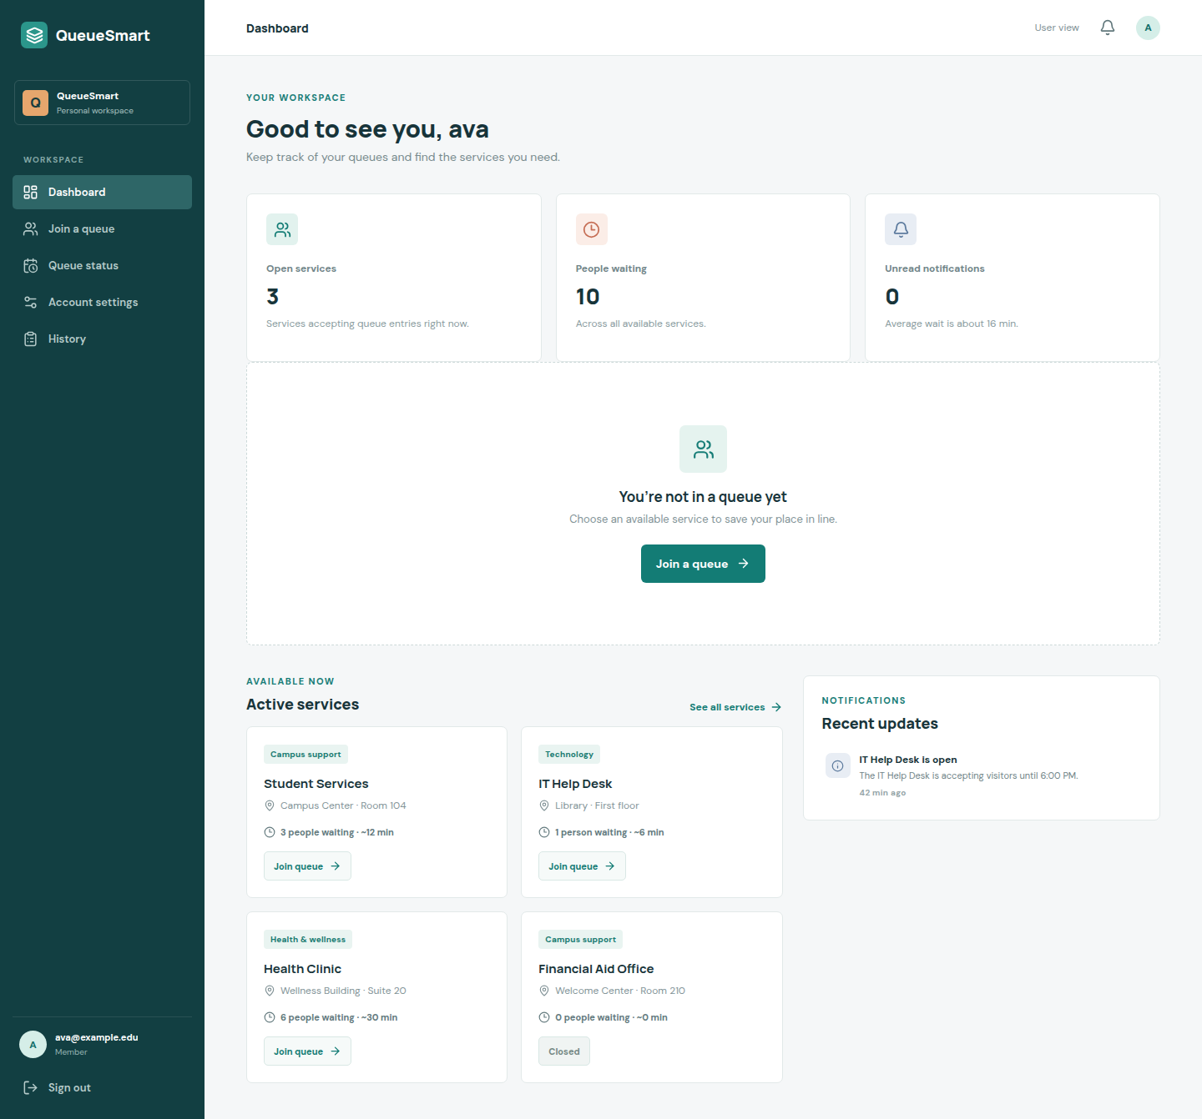
Figure 3. User Dashboard. Overview of open services and people waiting, current queue or empty state, active services, and a notifications summary.

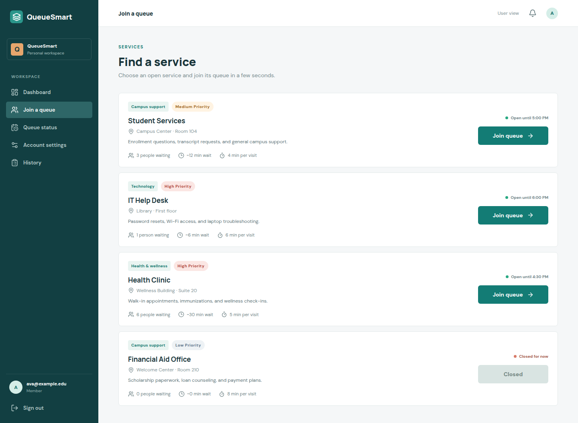
Figure 4. Join Queue. Select a service, see estimated wait time, and join or leave. Closed services cannot be joined.

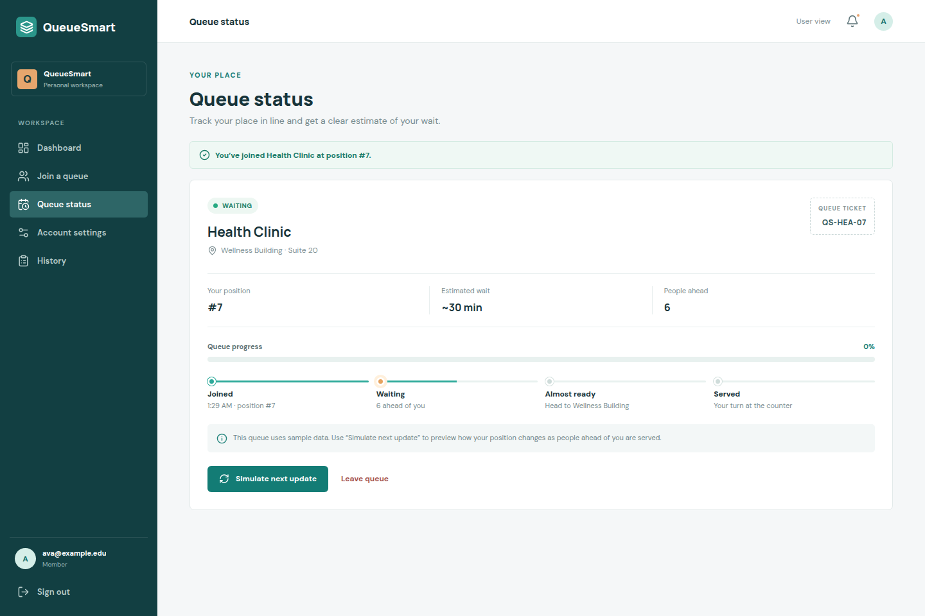
Figure 5. Queue Status. Current position, estimated wait, people ahead, ticket number, and status updates (Waiting, Almost Ready, Served).

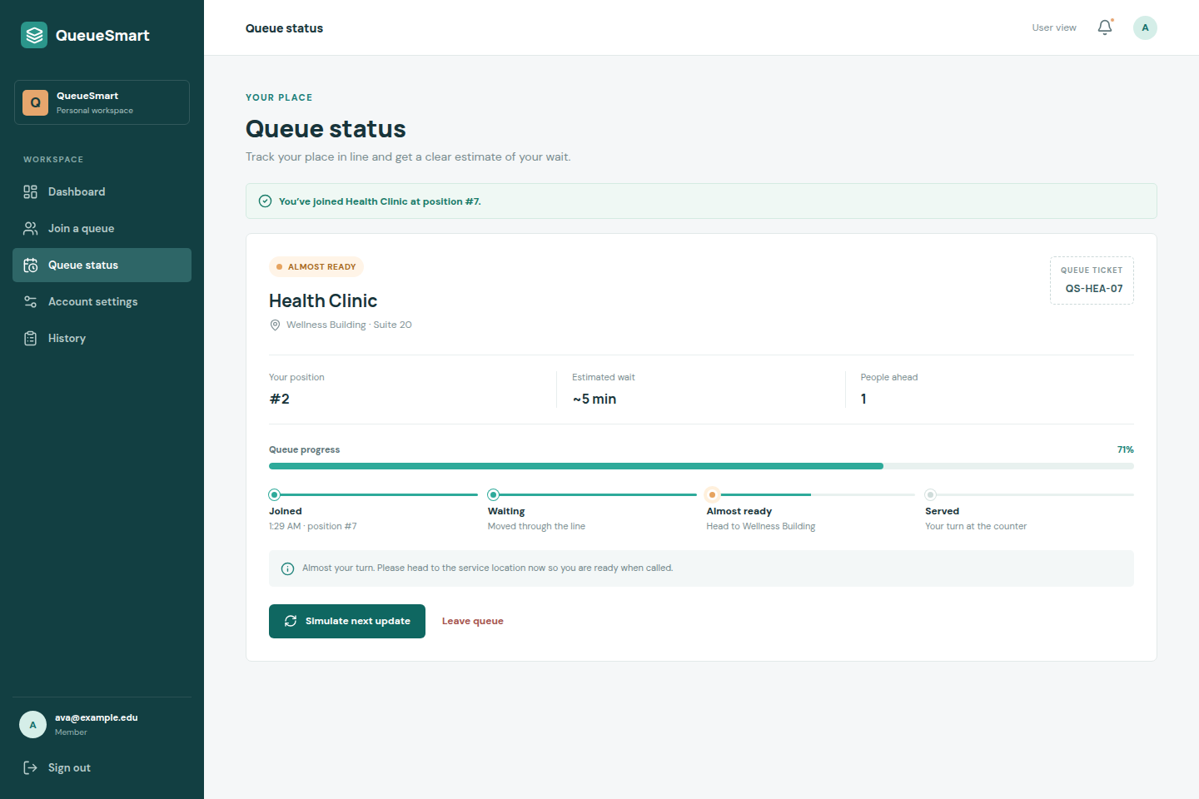
Figure 5b. Queue Status — Almost Ready. Status badge, progress, and timeline near the front of the line.

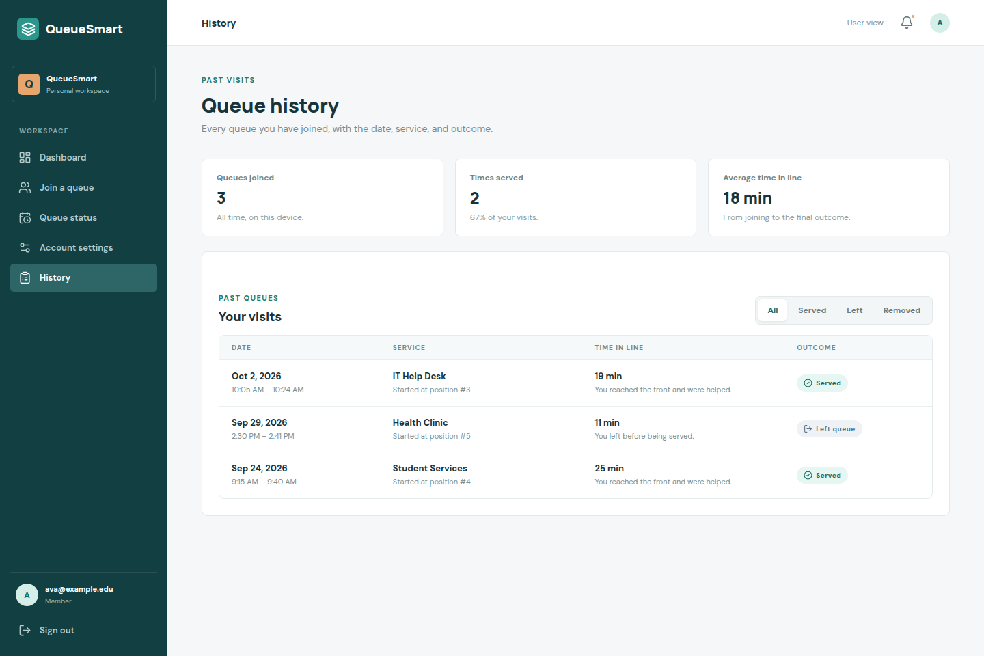
Figure 6. History. Past queues with date, service name, time in line, and outcome (Served, Left queue, Removed).

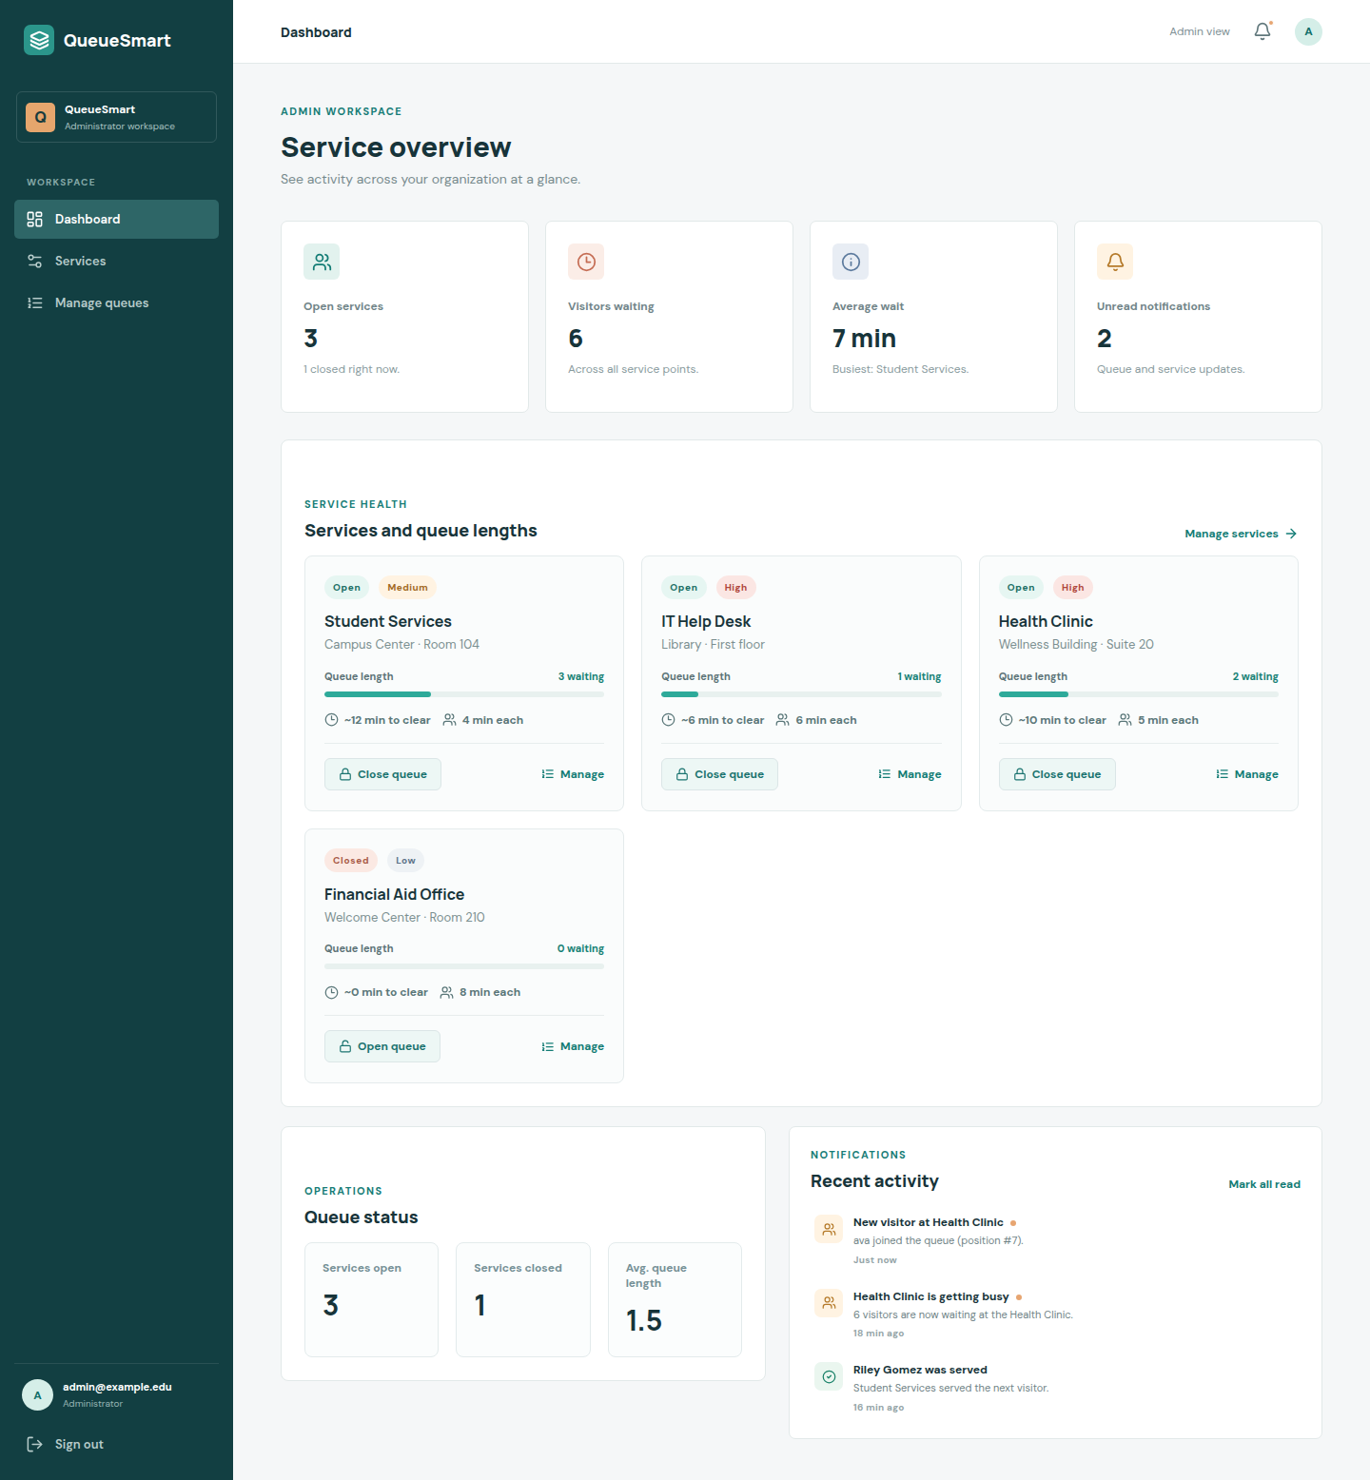
Figure 7. Admin Dashboard. List of services, current queue lengths, and quick actions to open or close a queue.

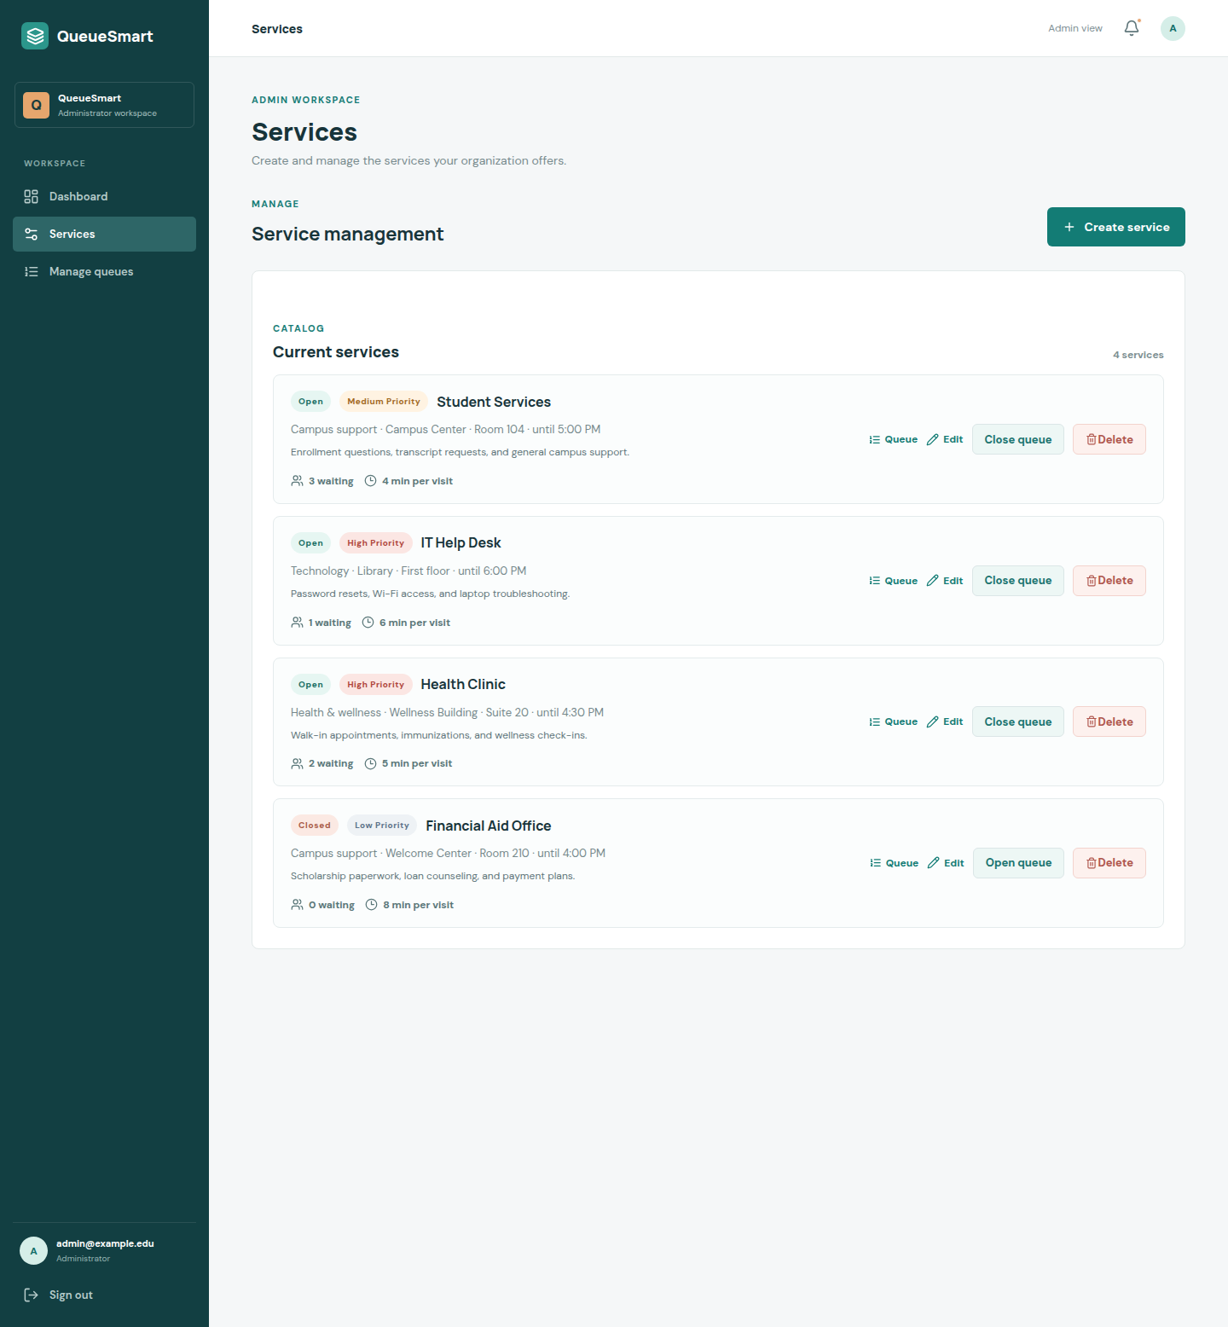
Figure 8. Service Management. Admins can create, edit, open/close, or delete services.

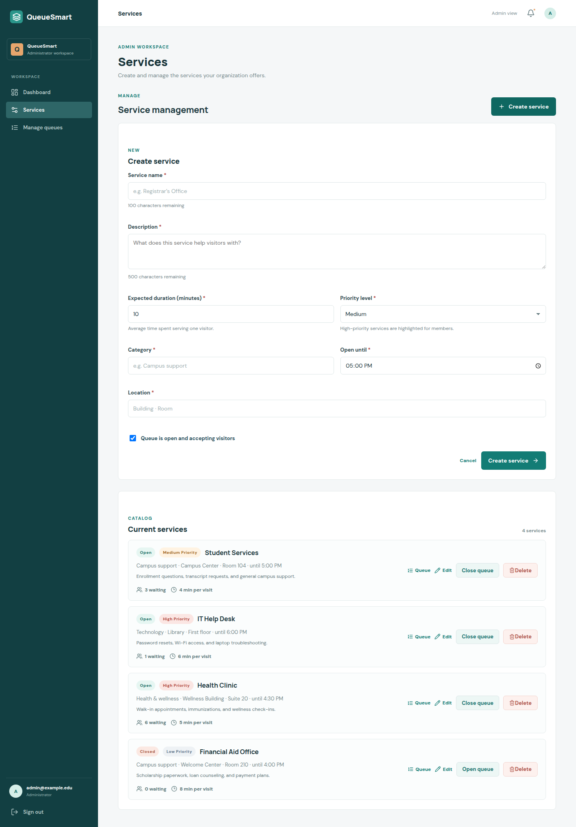
Figure 8b. Create / Edit Service form. Service Name (required, max 100), Description (required), Expected Duration (minutes, required), Priority (low / medium / high).

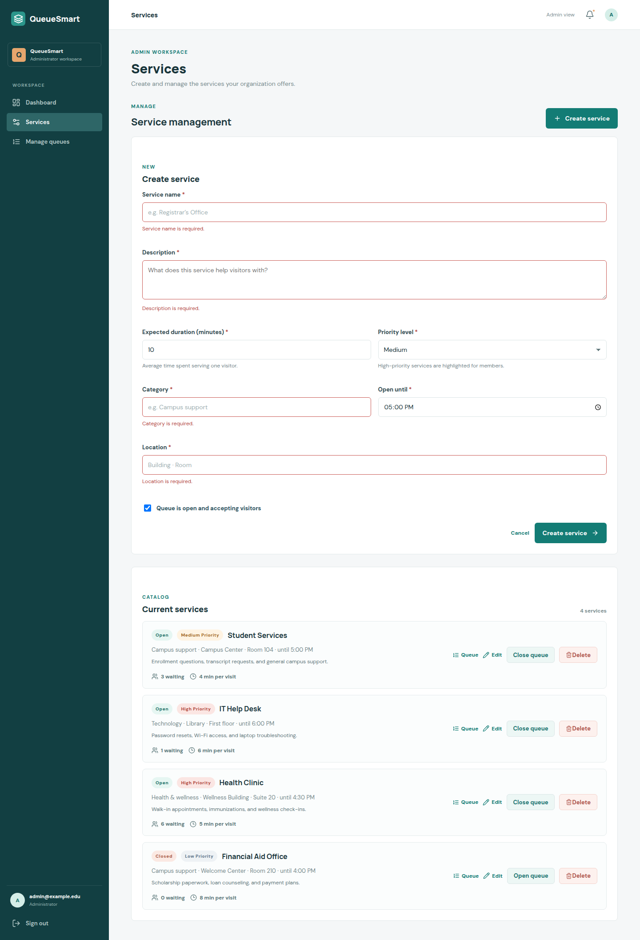
Figure 8c. Service form validation. Required fields, length limits, numeric duration, and a time input for Open until.

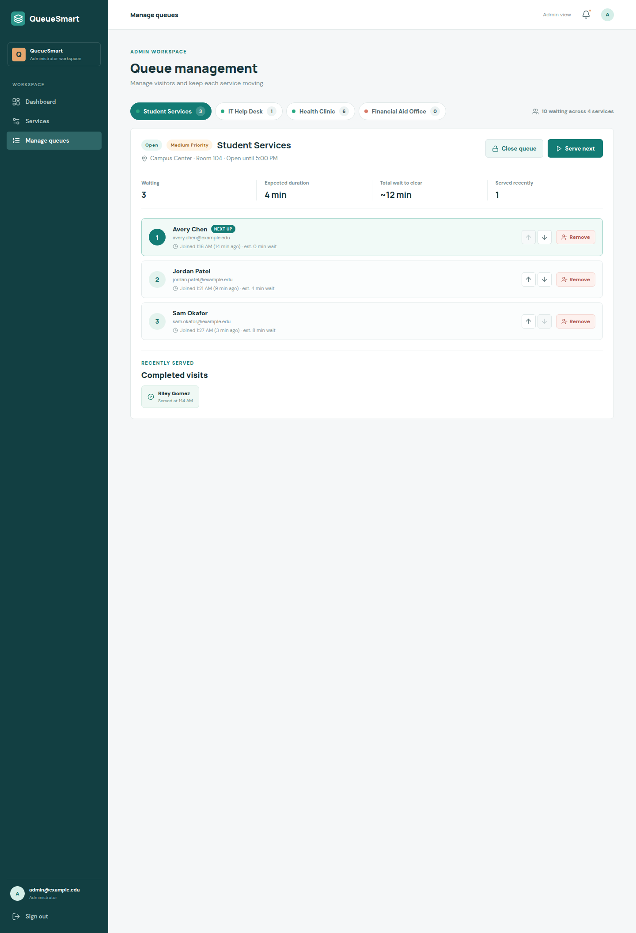
Figure 9. Queue Management. View the queue for a selected service. Reorder, remove (UI only), and serve the next user.

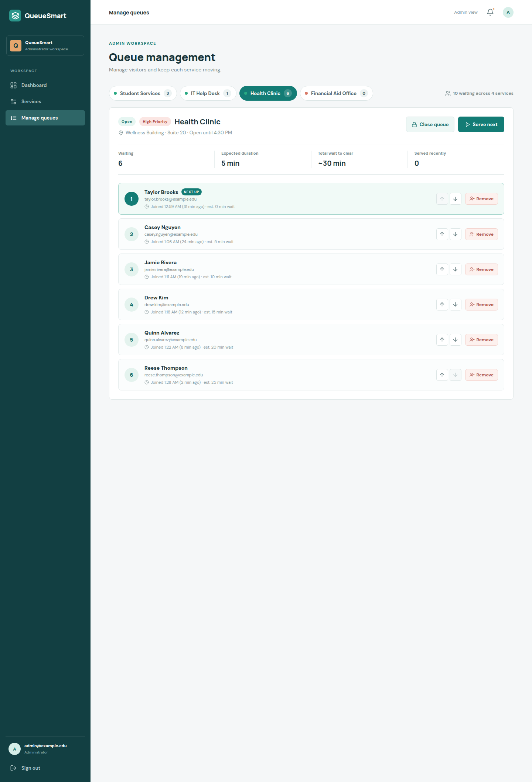
Figure 9b. Queue Management — selected service. Health Clinic line with live counts and actions.

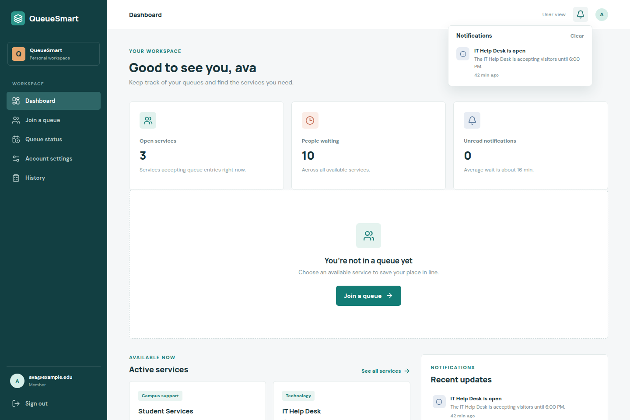
Figure 10. Notifications (in-app). Queue updates and status changes in the top-bar notification center.

5. Team Contribution Table
TAs can confirm the rows below against GitHub commit history on https://github.com/Parham-Ebrahimi/QueueSmart.
Group member name | What is your contribution? | Discussion notes
Parham Ebrahimi | Authentication screens (login and registration), email/password validation, shared navigation and sidebar, base layout and CSS, shared Brand and FormField components. | Owned the UI foundation so later screens could reuse one visual system. Established the User vs Administrator workspace split.
Mustafa Ahmed | User Dashboard, Join Queue, Queue Status, mock queue join/leave/simulate-next, account settings, and the first mock service data. | Implemented the member journey from not in a queue through waiting, almost ready, and served.
Kevin Santhosh | Admin Dashboard, Service Management (create / edit / delete), open and close queue controls, and the first pass of service-form validation. | Built the administrator catalog so services exist for both dashboards. Open/close is available from the dashboard and the service list.
Andrew Andari | Queue Management (reorder, remove, serve-next), History, in-app notifications, service-form spec alignment (description, priority, 100-character name, expected duration), shared mock-data layer, labeled screenshots, and this submission document. | Finished the remaining A2 screens and connected user and admin views to one mock source of truth. Commits authored as wynetyme.

Appendix — Assignment scope checklist
Required item | Status
Login and registration, email as username, password, client-side validation | Complete
User Dashboard (queue overview, active services, notifications summary) | Complete
Join Queue (select service, estimated wait, join / leave) | Complete
Queue Status (position, wait, Waiting / Almost Ready / Served) | Complete
History (date, service, outcome) | Complete
Admin Dashboard (services, queue lengths, open/close) | Complete
Service Management (name, description, expected duration, priority) | Complete
Queue Management (view line, reorder / remove, serve next) | Complete
In-app notifications for queue updates and status changes | Complete
Client-side validations (required, length, email, numbers, time) | Complete
This PDF / Word document for Canvas (code stays on GitHub only) | This file

Backend functionality is intentionally not implemented. Mock data is stored in the browser and is acceptable for Assignment 2. The same UI is intended for reuse in Assignment 3 (API integration) and Assignment 4 (data design).

