🔐
CYBERSECURITY LAB REPORT
Windows Password Bypass via WinRE & Utilman.exe Exploitation
Attack Execution, Detection via Wazuh SIEM & Remediation

Experiment Type: Offensive Security / Privilege Escalation
Target OS: Windows 10 / Windows 11
Attack Vector: Physical Access + WinRE CMD (Pre-Authentication)
Tools Used: WinRE, CMD.exe, control userpasswords2, Wazuh SIEM
MITRE ATT&CK Technique: T1546.008 — Accessibility Features
Risk Level: 🔴 CRITICAL
Report Date: 06 August 2026
Classification: Educational / Authorized Lab Use Only

⚠ FOR EDUCATIONAL AND AUTHORIZED TESTING PURPOSES ONLY ⚠

1. Executive Summary
This report documents a critical Windows security vulnerability that allows an attacker with physical access to bypass the login screen entirely — without knowing any user credentials — by exploiting the Windows Recovery Environment (WinRE) and the Accessibility Features (Ease of Access) mechanism on the lock screen.
The attack replaces the legitimate accessibility binary (utilman.exe) with cmd.exe in the System32 directory using WinRE's command prompt — which runs at SYSTEM-level privilege before any user authenticates. Once rebooted into Windows, clicking the Ease of Access button on the lock screen spawns a SYSTEM-level command prompt, enabling full account takeover.
The report also covers detection using Wazuh SIEM, and the steps required to restore the system and harden it against this attack.
MITRE ATT&CK Maps this to T1546.008 (Event Triggered Execution: Accessibility Features). This is a well-known persistence and privilege escalation technique used in real-world red team engagements and APT campaigns.

2. Vulnerability Background

2.1 What is utilman.exe?
utilman.exe (Utility Manager) is the Windows Ease of Access executable, launched when a user clicks the Accessibility icon on the Windows login/lock screen. It runs BEFORE any user is authenticated, which means it runs in SYSTEM context — the highest privilege level in Windows.
Location: C:\Windows\System32\utilman.exe
Because it executes pre-authentication in SYSTEM context, replacing it with any shell or binary gives an attacker unrestricted SYSTEM-level access without credentials.

2.2 What is WinRE?
Windows Recovery Environment (WinRE) is a minimal Windows environment that boots from a dedicated partition. Its Command Prompt runs outside the normal OS context, meaning:
- It bypasses Windows login requirements
- It bypasses NTFS permission enforcement in many cases
- It has access to the main Windows partition filesystem
- It can rename / replace system files like utilman.exe

2.3 Why This Works
The attack exploits the intersection of two design decisions:
- WinRE CMD runs with elevated permissions to allow system repairs
- utilman.exe is called pre-authentication at SYSTEM privilege
Combining these two gives an attacker a clean path: modify the system in WinRE → trigger the modification from the lock screen → get SYSTEM shell → reset any password.

2.4 MITRE ATT&CK Reference
Technique ID: T1546.008
Tactic: Persistence, Privilege Escalation
Sub-technique: Event Triggered Execution: Accessibility Features
Platform: Windows
Required Access for Setup: Physical Access + WinRE (no credentials needed on unencrypted drives)
Result: SYSTEM-level shell pre-authentication → Full account takeover

3. Lab Prerequisites & Setup

3.1 Requirements
- A Windows 10 or Windows 11 machine (physical or VM)
- Physical access OR VMware/VirtualBox console access
- BitLocker must be DISABLED (encrypted drives block WinRE write access)
- Wazuh SIEM (for detection phase)
- Authorized environment only — personal lab or test VM

3.2 Understand Before You Begin
This attack WILL NOT work if BitLocker drive encryption is enabled. WinRE can access the drive but Windows will block modifications to encrypted volumes. This is why BitLocker is a core defense against this attack.
Important file locations involved:
C:\Windows\System32\utilman.exe → Target binary (Ease of Access)
C:\Windows\System32\cmd.exe → Payload (Command Prompt)
C:\Windows\System32\utilman1.exe → Our backup of the original utilman

4. Attack Walkthrough — Step by Step

Step 1: Boot into Windows Recovery Environment (WinRE)
Hold Shift and click Restart from the Windows Start menu or sign-in screen. The system will boot into the WinRE environment instead of the normal OS.
Alternatively, on physical machines you can force WinRE by interrupting the boot process 2–3 times (e.g., holding the power button during startup). Many OEMs also provide a boot menu key (F12, F8, F2 etc.).
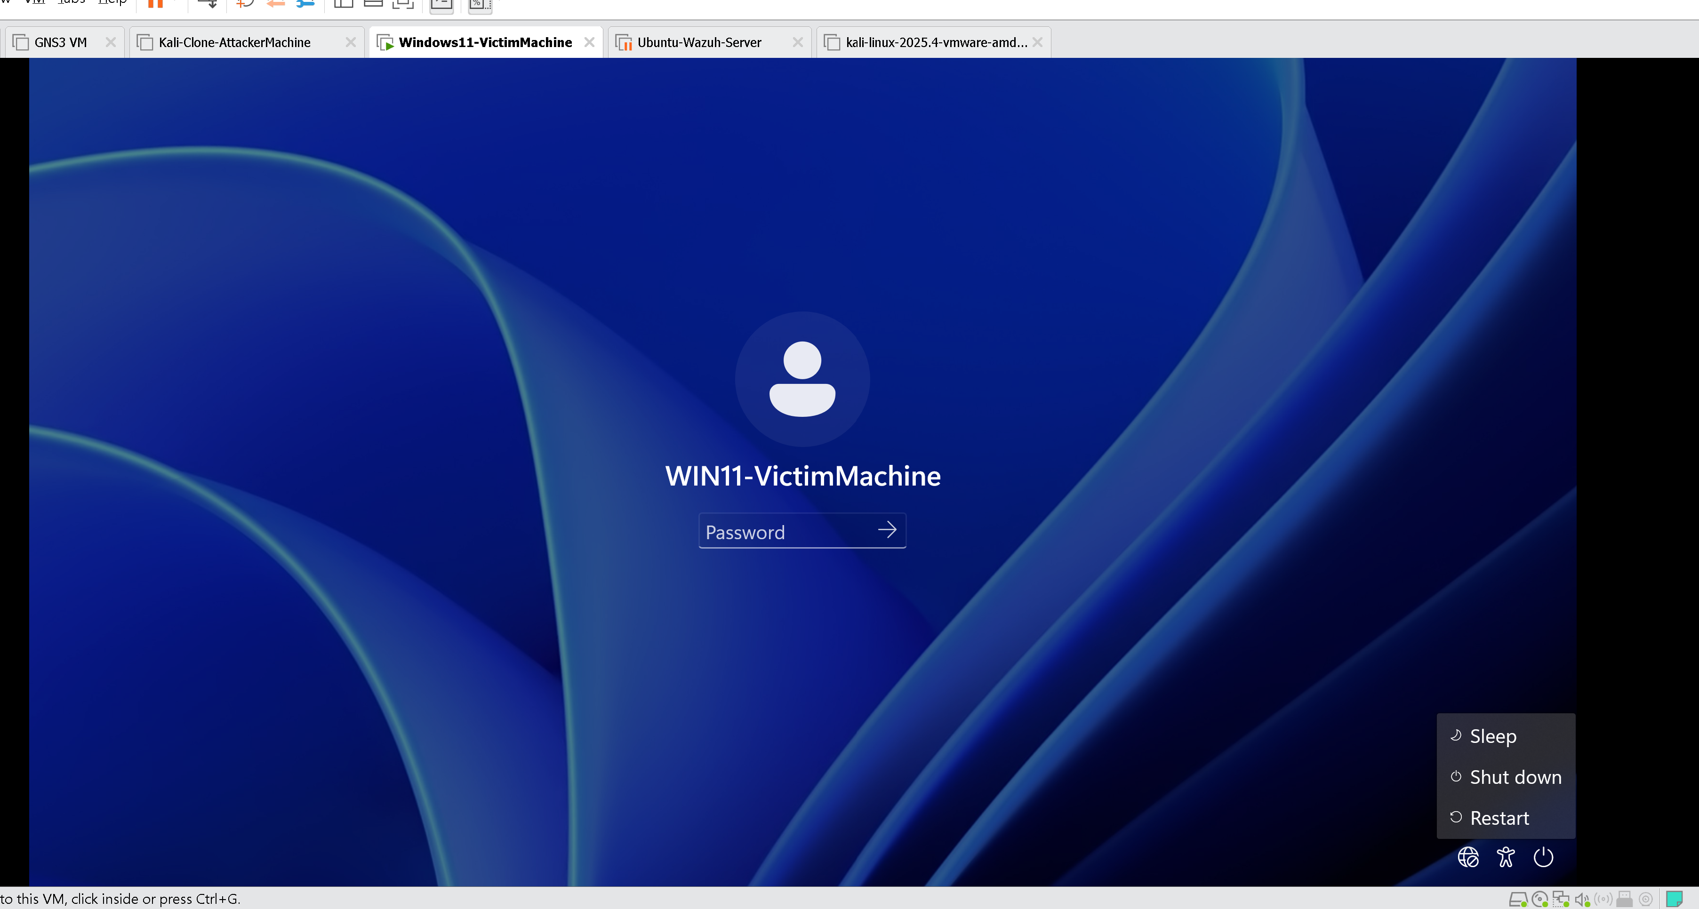
Figure 1 – Shift + Restart to enter Windows Recovery Environment

Step 2: Navigate to Troubleshoot
From the blue recovery screen, click Troubleshoot.
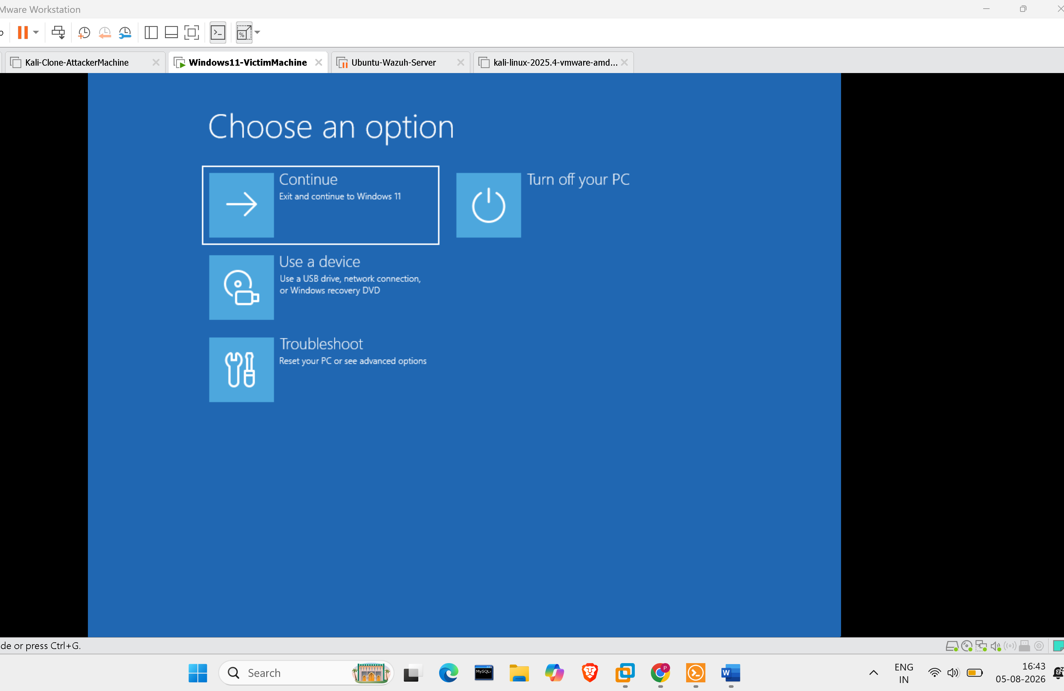
Figure 2 – Choose Your Option screen → Select Troubleshoot

Step 3: Open Advanced Options
Inside Troubleshoot, select Advanced options to access system-level recovery tools.
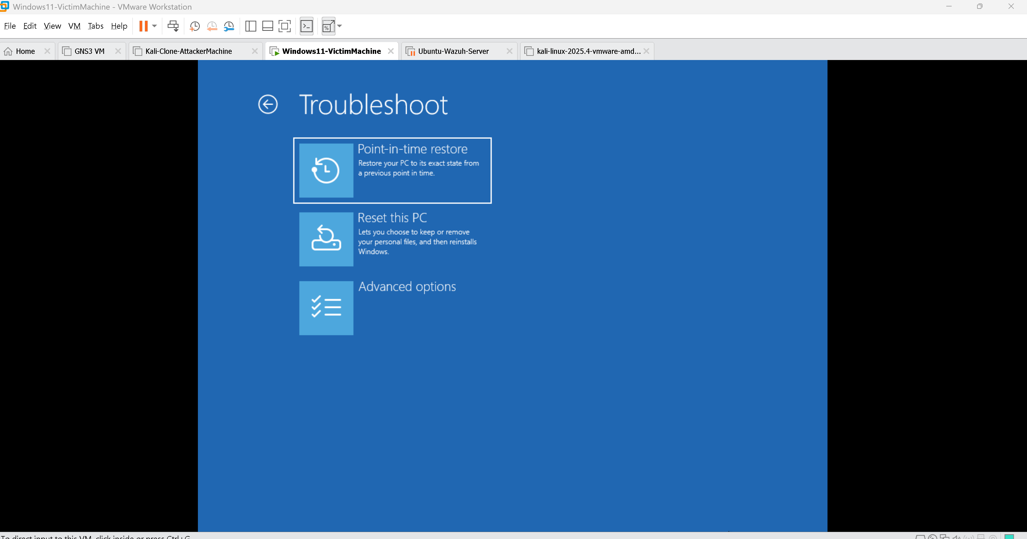
Figure 3 – Advanced Options menu in WinRE

Step 4: Open Command Prompt in WinRE
Click Command Prompt. If prompted, select your Windows installation. The CMD that opens here runs at SYSTEM privilege on the recovery partition.
You may be asked to choose a recovery account and enter its password — on many home/lab systems no password is set. On domain machines, you need local admin credentials for the WinRE CMD.
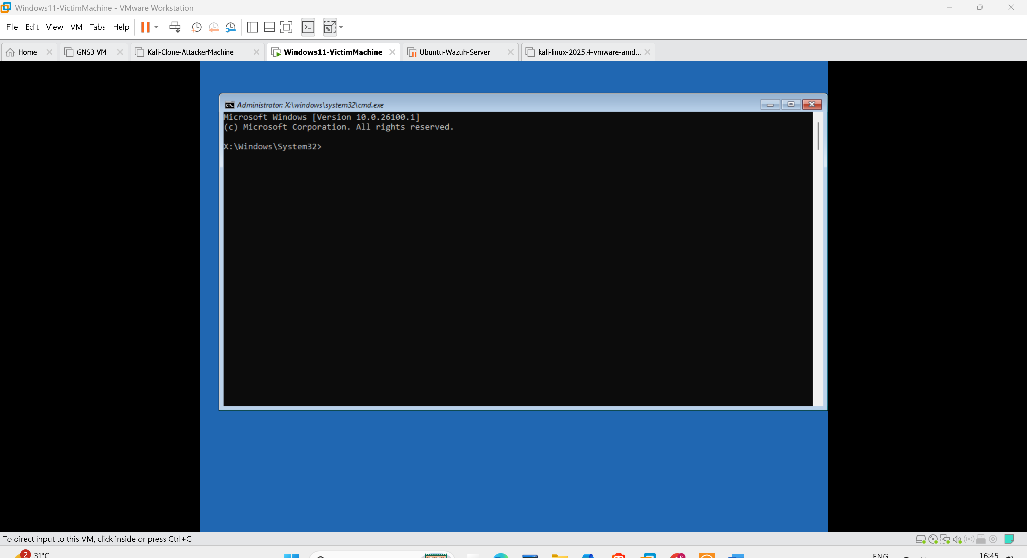
Figure 4 – Launching Command Prompt from WinRE Advanced Options

Step 5: Identify the Windows Drive Letter
Inside WinRE, drive letters may differ from the normal Windows session. The main Windows partition is often D: or C: in WinRE.
dir C:\
dir D:\
Check which drive shows the Windows, Users, and Program Files folders — that's your target drive.
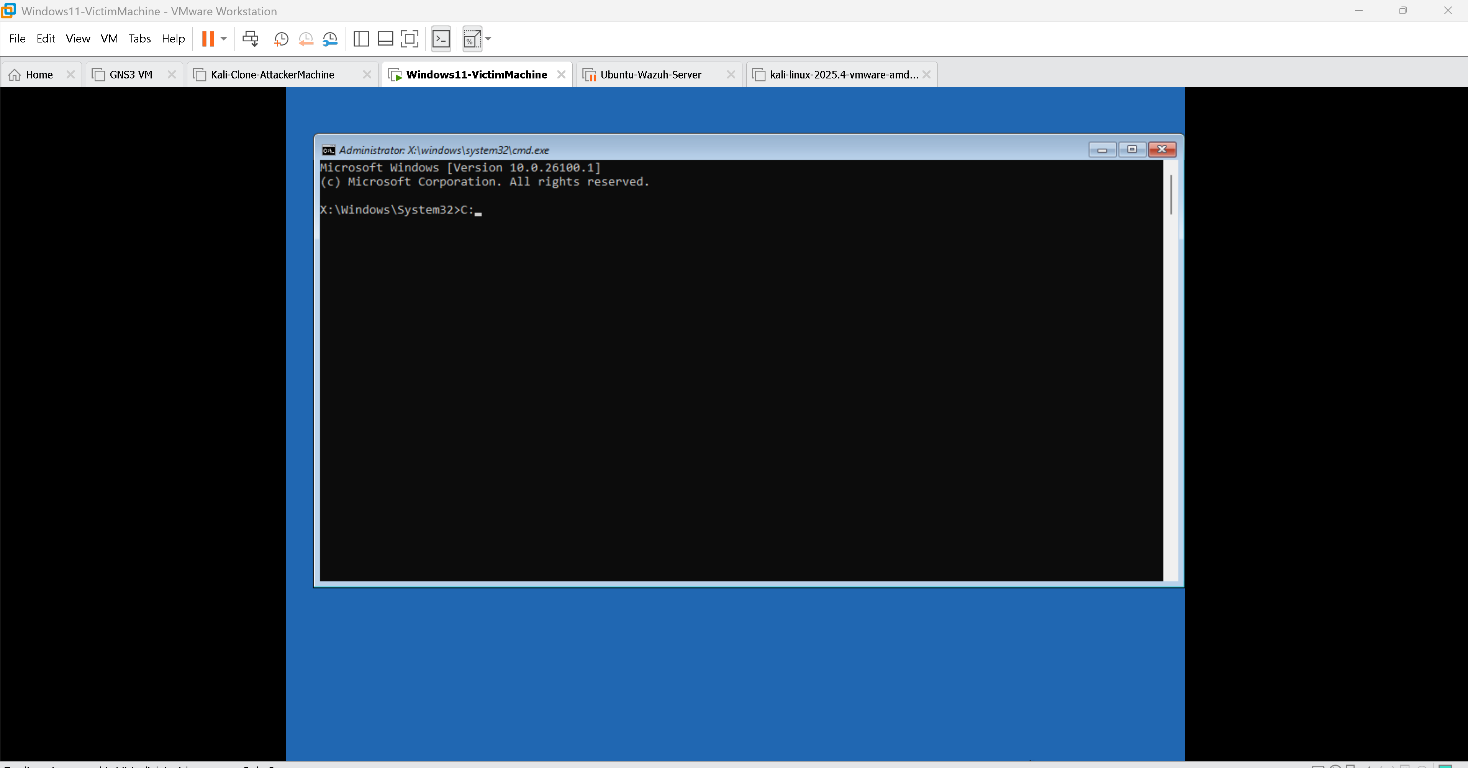
Figure 5 – Checking drive letters in WinRE CMD
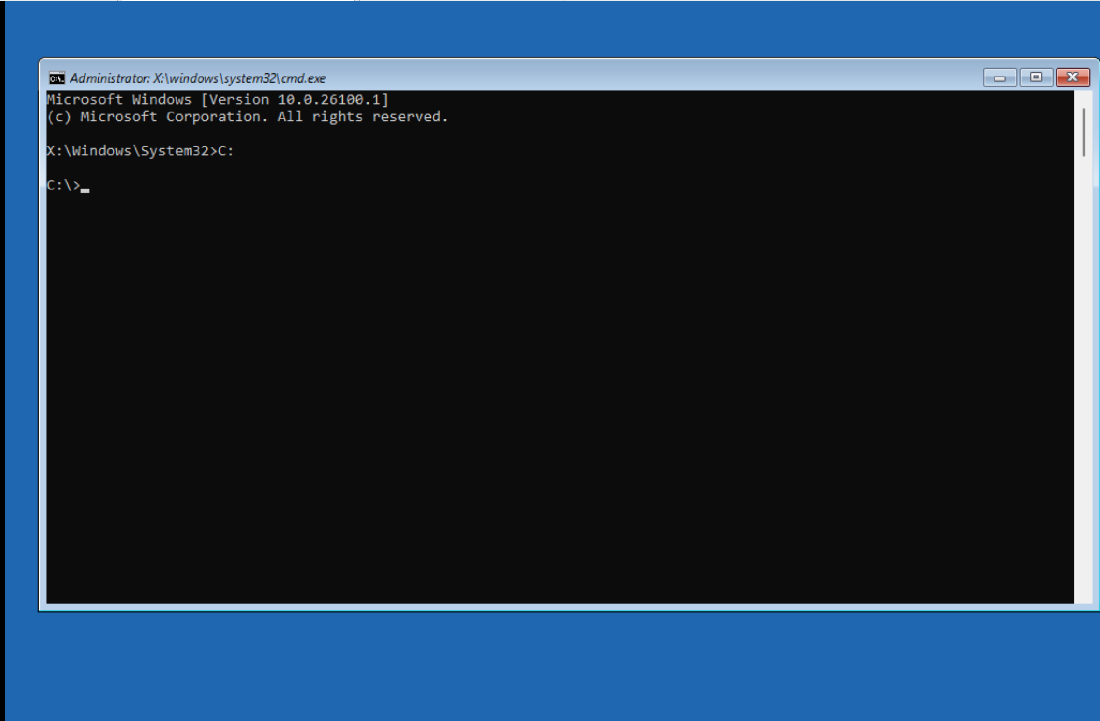
Figure 6 – Identifying the correct Windows drive

Step 6: Navigate to System32
Once you know the correct drive letter (assume C: here), navigate to System32:
C:
cd Windows
cd System32
You should now be at: C:\Windows\System32
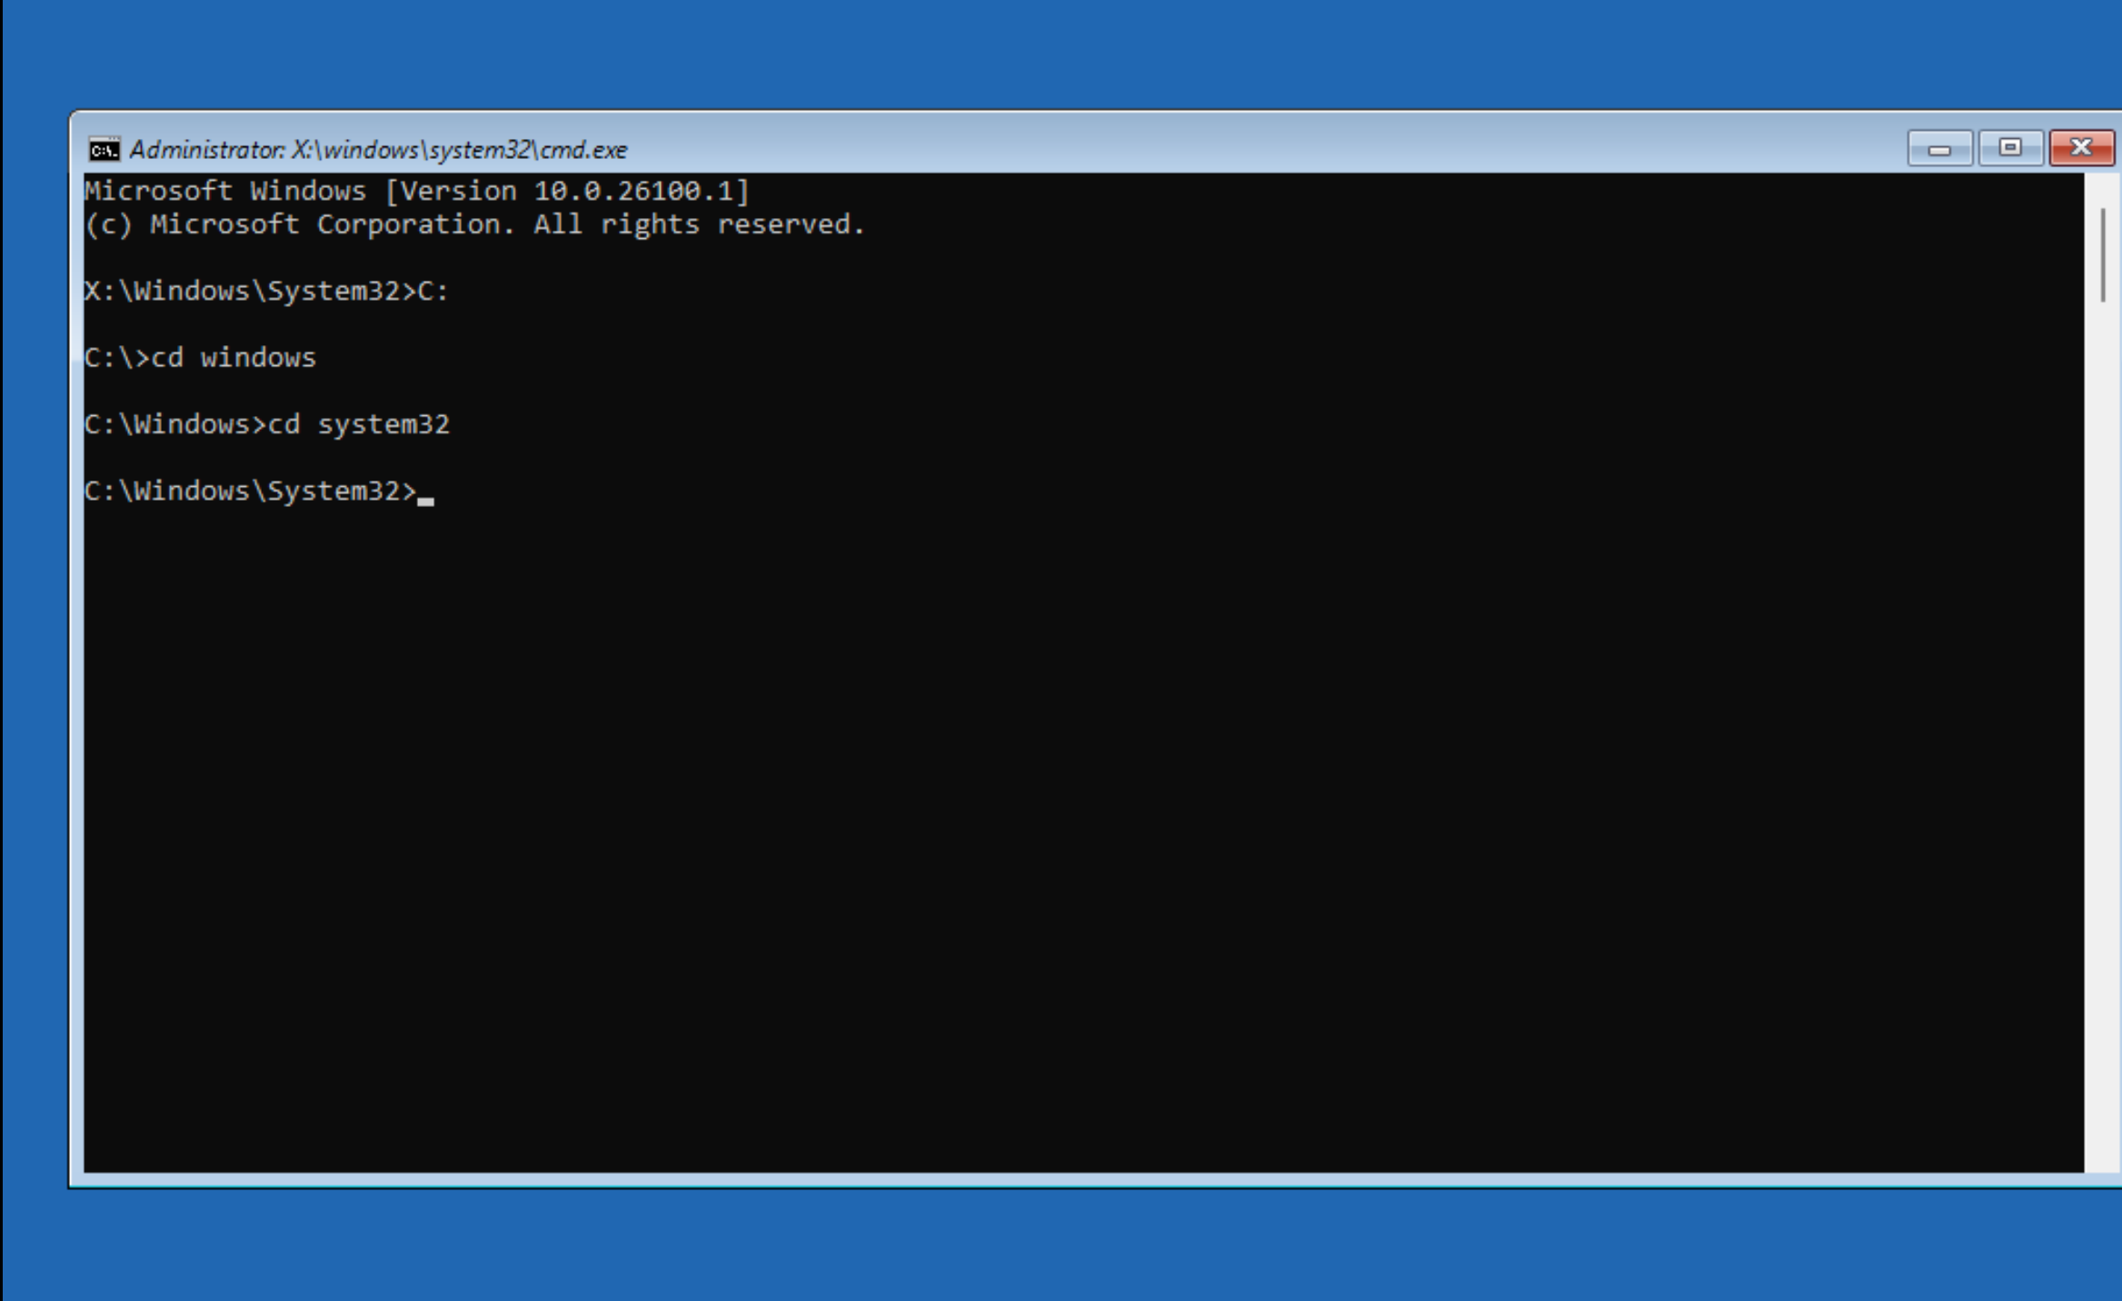
Figure 7 – Navigating to C:\Windows\System32

Step 7: Back Up the Original utilman.exe
Before replacing it, rename the original utilman.exe to preserve it for restoration:
ren utilman.exe utilman1.exe
IMPORTANT: Always back up before replacing. If you skip this, you won't be able to restore the system properly.
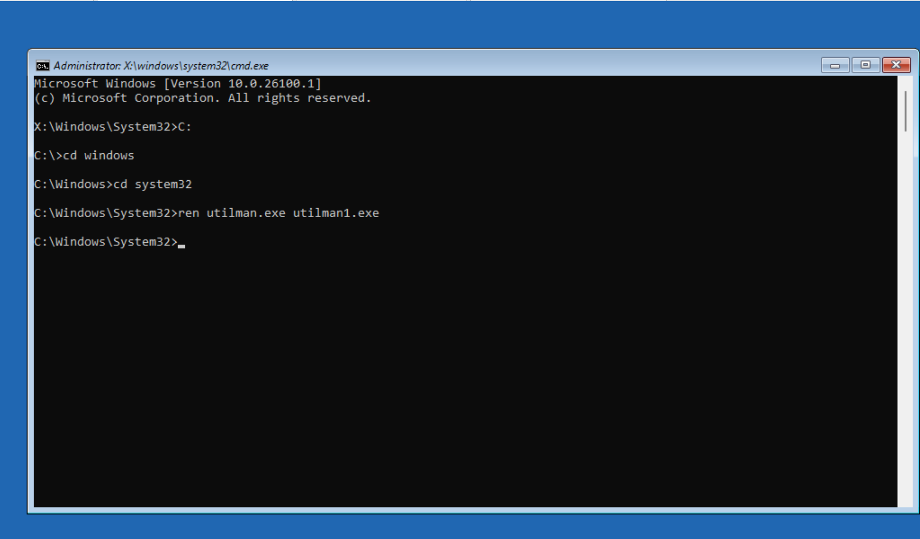
Figure 8 – Renaming utilman.exe to utilman1.exe as backup

Step 8: Replace utilman.exe with cmd.exe
Now copy cmd.exe and rename it as utilman.exe. We use copy instead of rename to keep cmd.exe intact:
copy cmd.exe utilman.exe
(Alternatively: ren cmd.exe utilman.exe — but this removes cmd.exe from System32, which can cause issues. Using copy is safer in lab environments.)
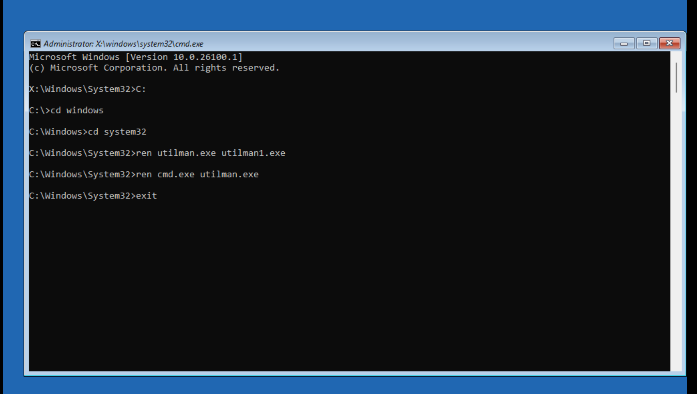
Figure 9 – Replacing utilman.exe with cmd.exe
Now type exit and close the WinRE CMD.

Step 9: Boot Back into Windows
From the WinRE screen, click Continue — Exit and continue to Windows. The system will reboot into the normal Windows login screen.
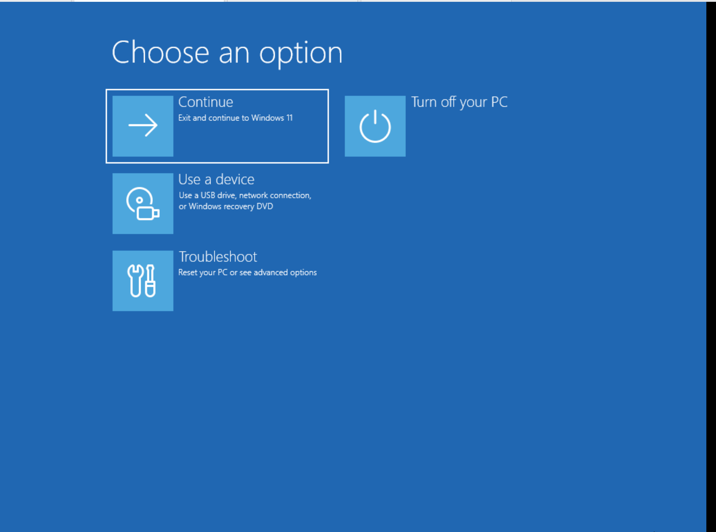
Figure 10 – Continue to reboot into normal Windows

Step 10: Trigger the Backdoor from the Login Screen
On the Windows login screen (where you are NOT yet authenticated), click the Accessibility / Ease of Access icon (bottom-right corner). Instead of opening the accessibility menu, cmd.exe (now masquerading as utilman.exe) will launch.
This CMD window runs as SYSTEM — the highest privilege on Windows. You have full control of the machine WITHOUT entering any password.
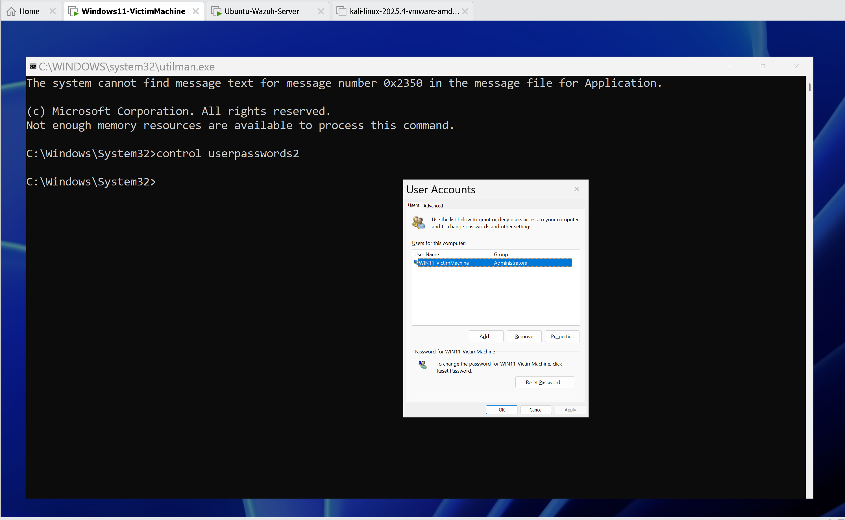
Figure 11 – Clicking Ease of Access icon on the lock screen

Step 11: Open User Account Control Panel
In the SYSTEM-level CMD that appeared, run:
control userpasswords2
This opens the classic User Accounts control panel, which allows password management for all local accounts.
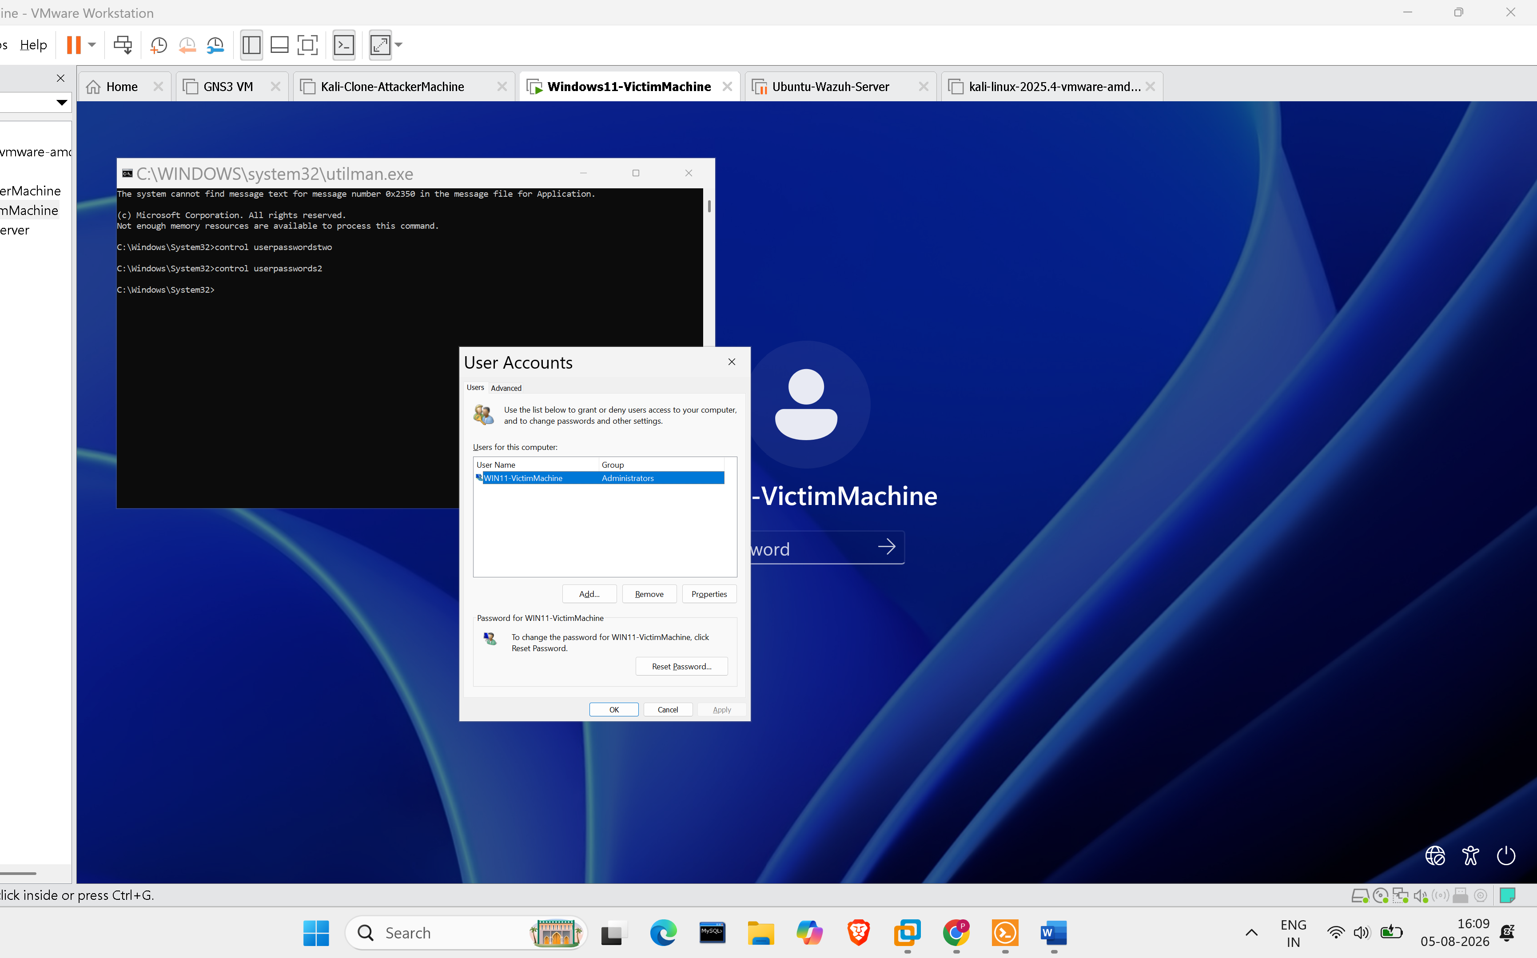
Figure 12 – SYSTEM CMD running control userpasswords2

Step 12: Select Account & Reset Password
In the User Accounts window, select the account whose password you want to reset, then click Reset Password.
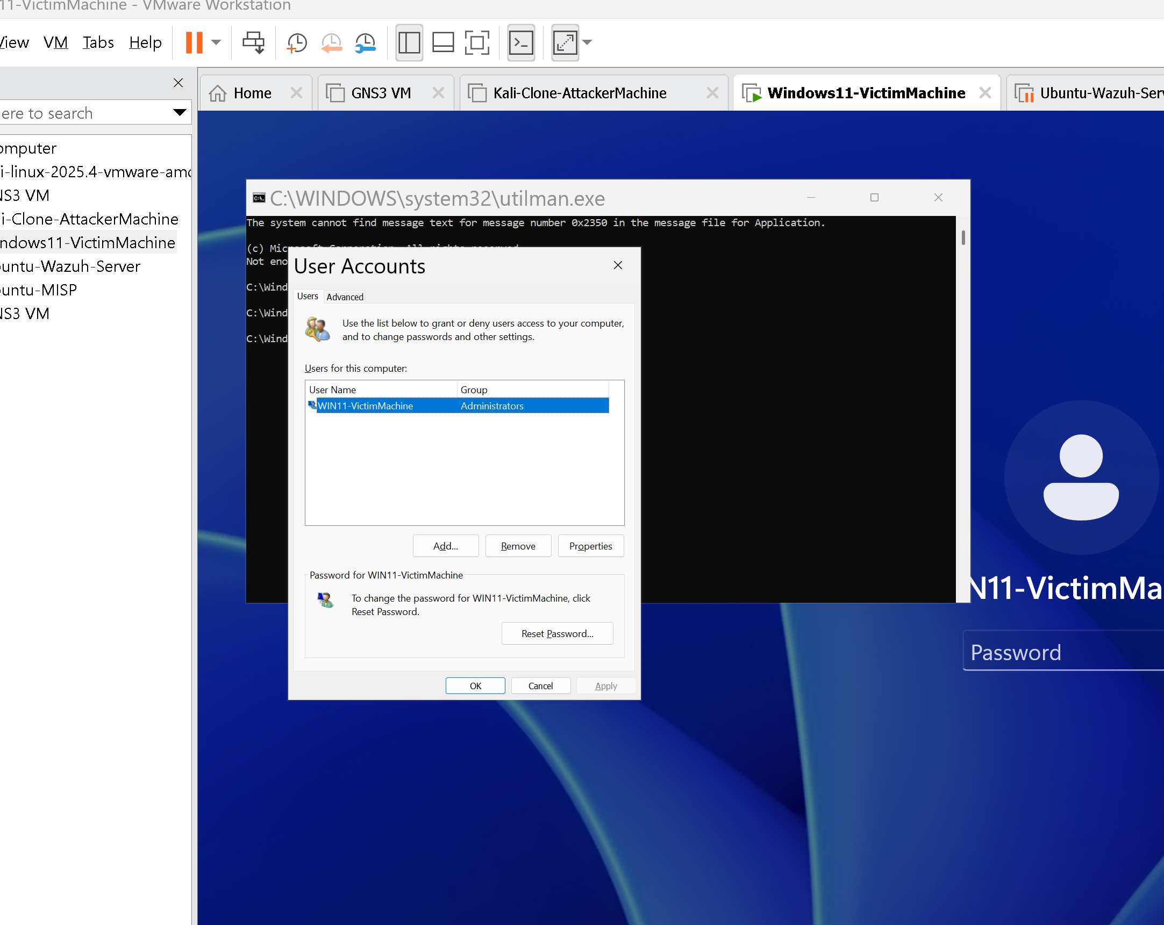
Figure 13 – User Accounts panel showing available accounts

Step 13: Set the New Password
Enter a new password and confirm it. Click OK. The password is now changed without knowing the original password.
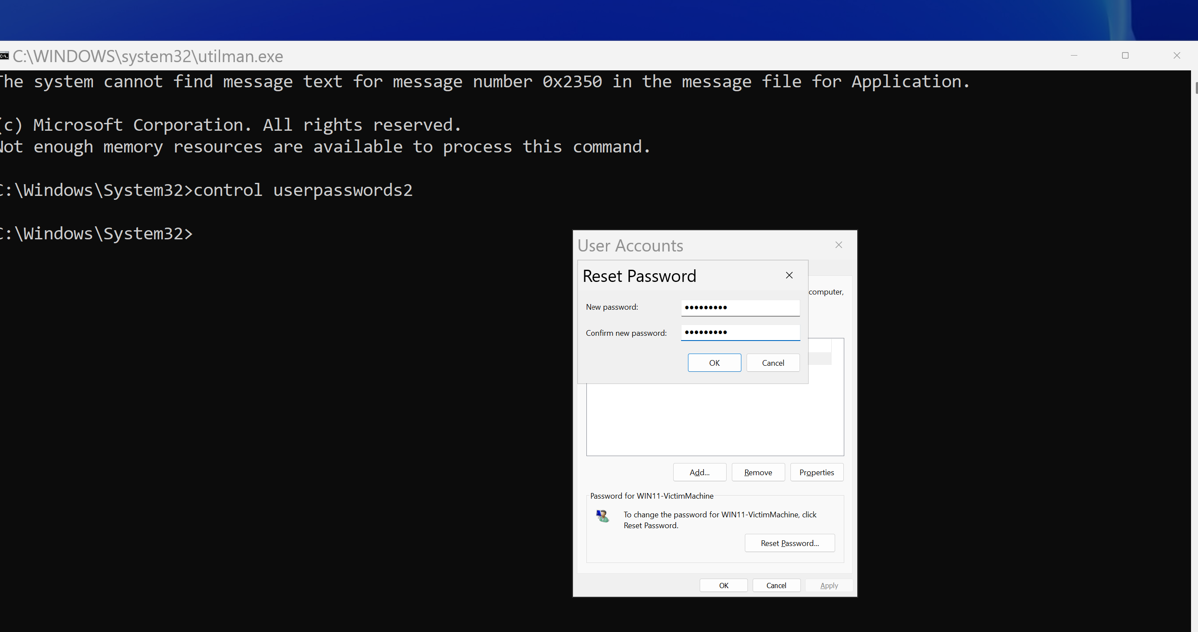
Figure 14 – Setting the new password for the selected account

Step 14: Advanced User Management via Local Users and Groups
From the Advanced tab in User Accounts → click Advanced → this opens lusrmgr.msc (Local Users and Groups). From here you can:
- Create brand new user accounts
- Add users to the Administrators group
- Unlock or enable the built-in Administrator account
- Disable accounts or change account properties
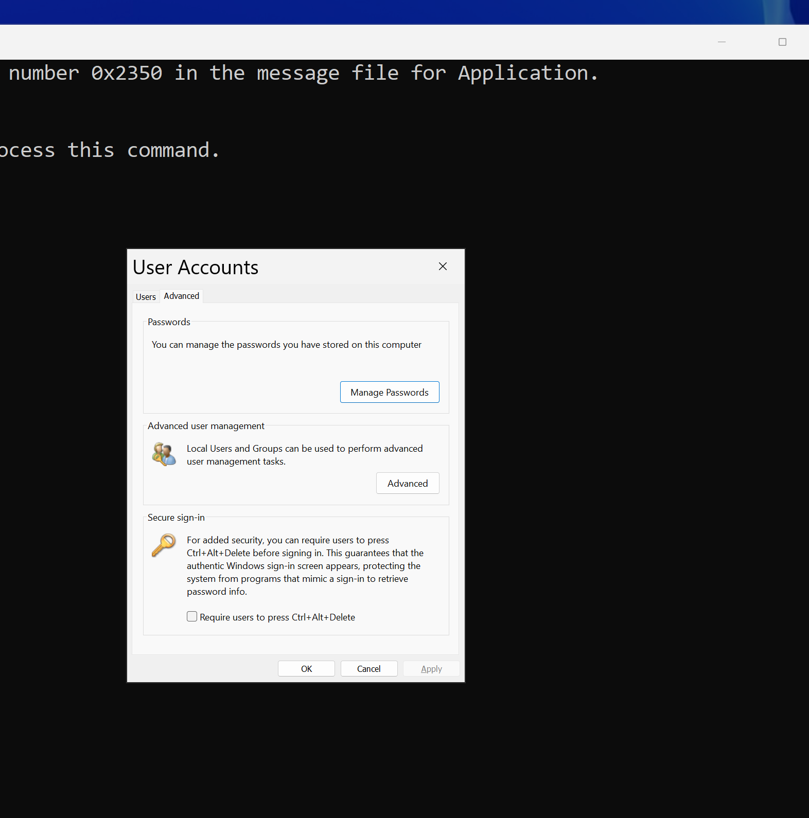
Figure 15 – Advanced tab in User Accounts
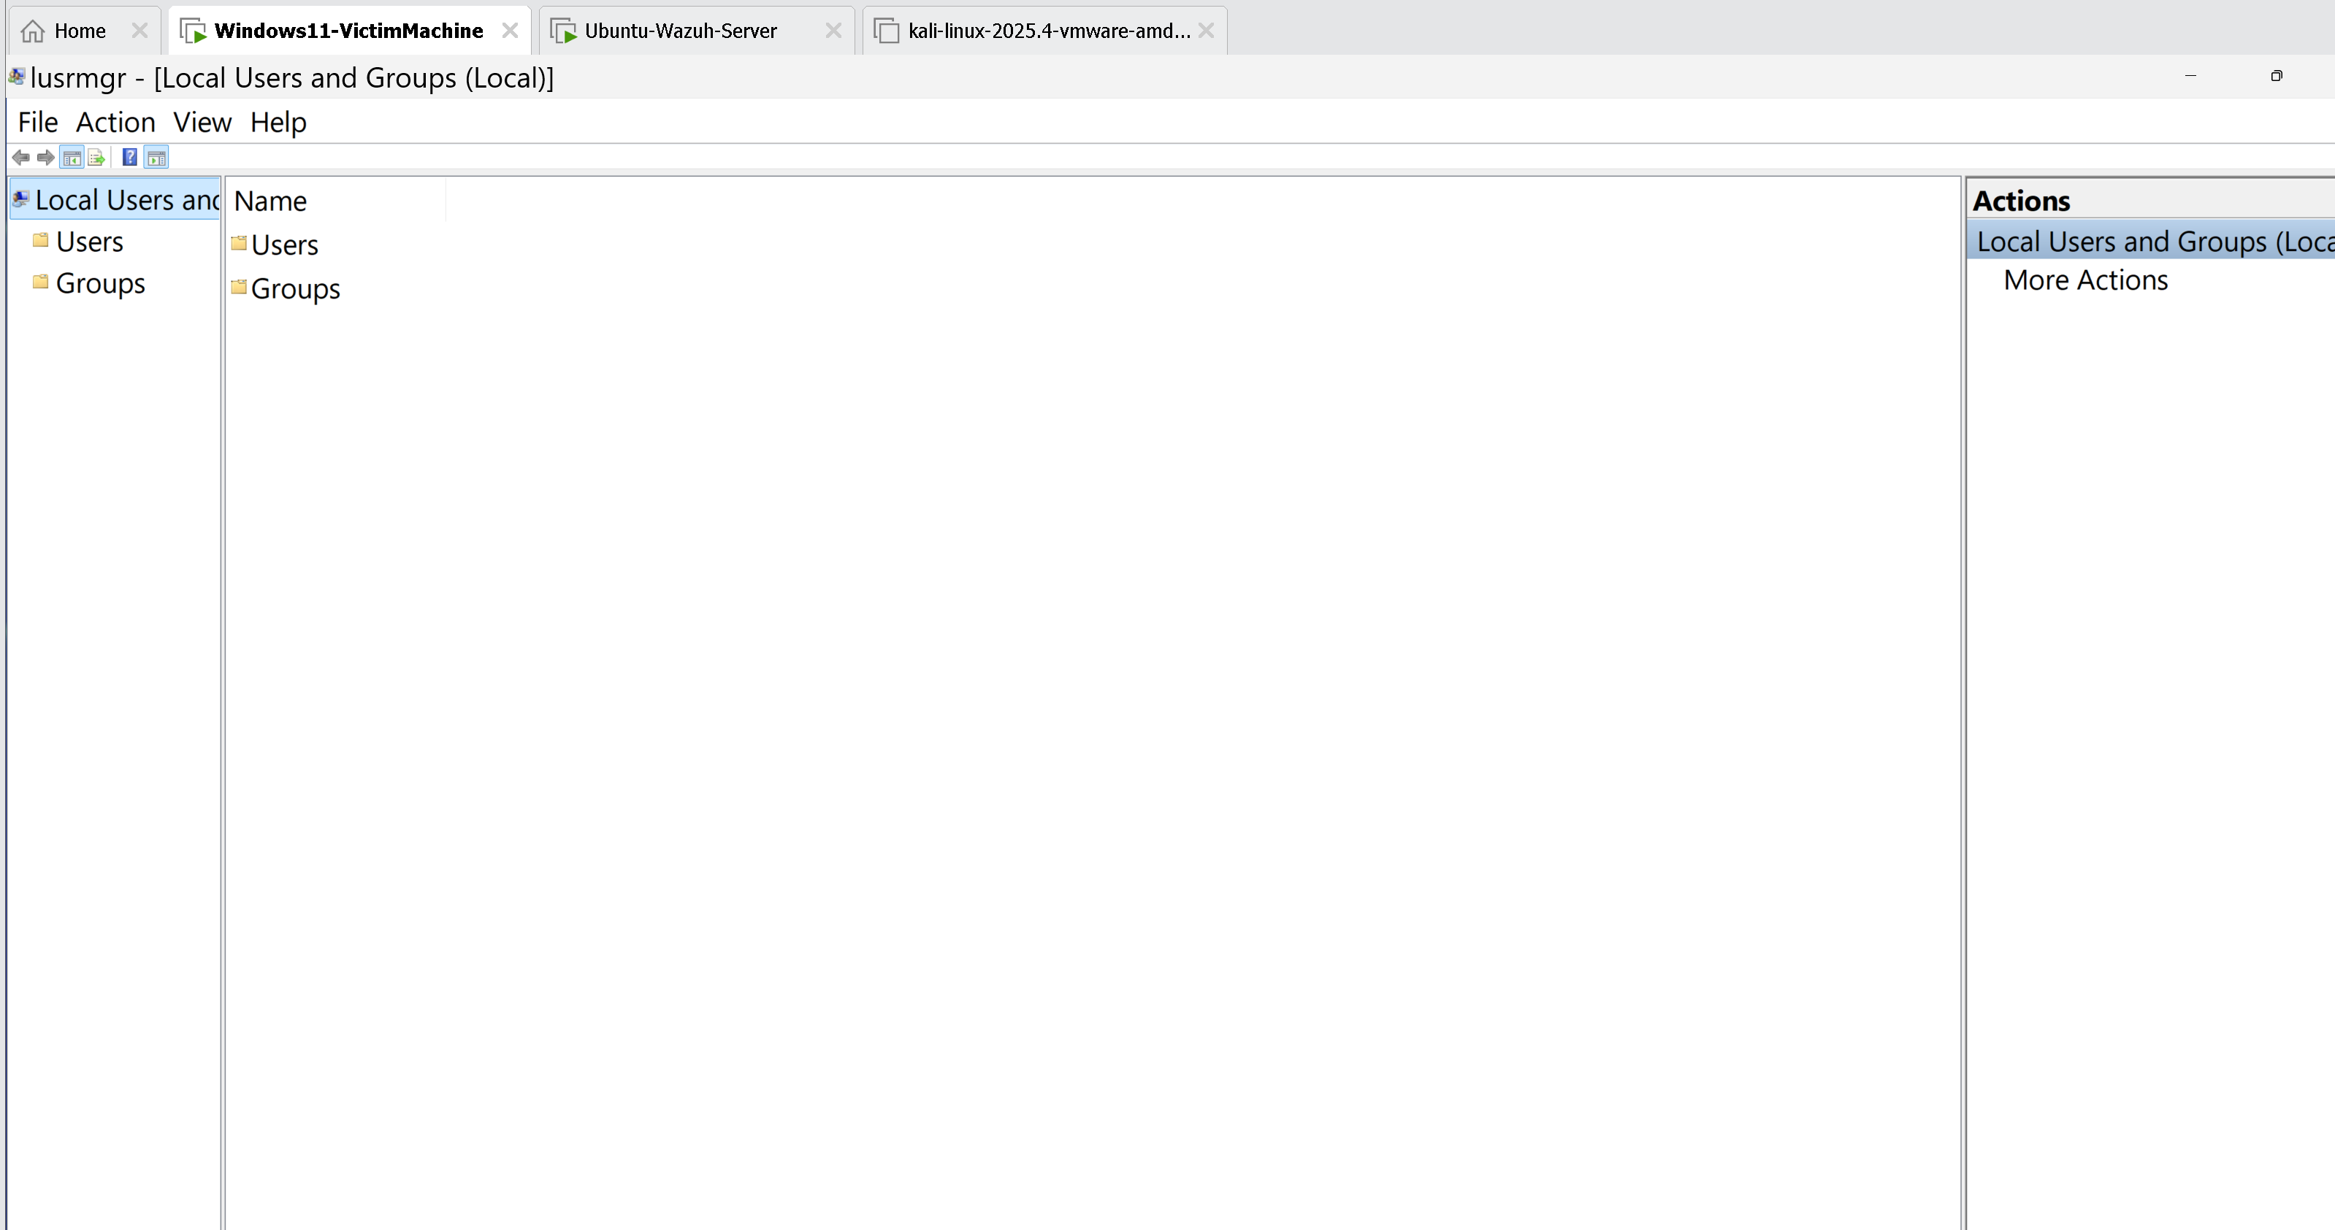
Figure 16 – Local Users and Groups management console (lusrmgr.msc)
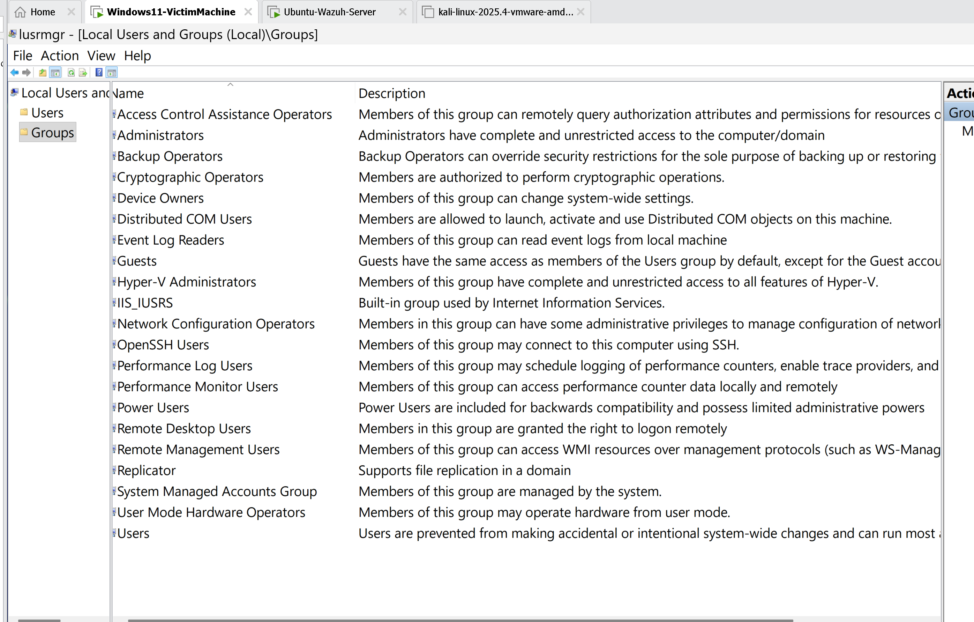
Figure 17 – User accounts listed in Local Users and Groups
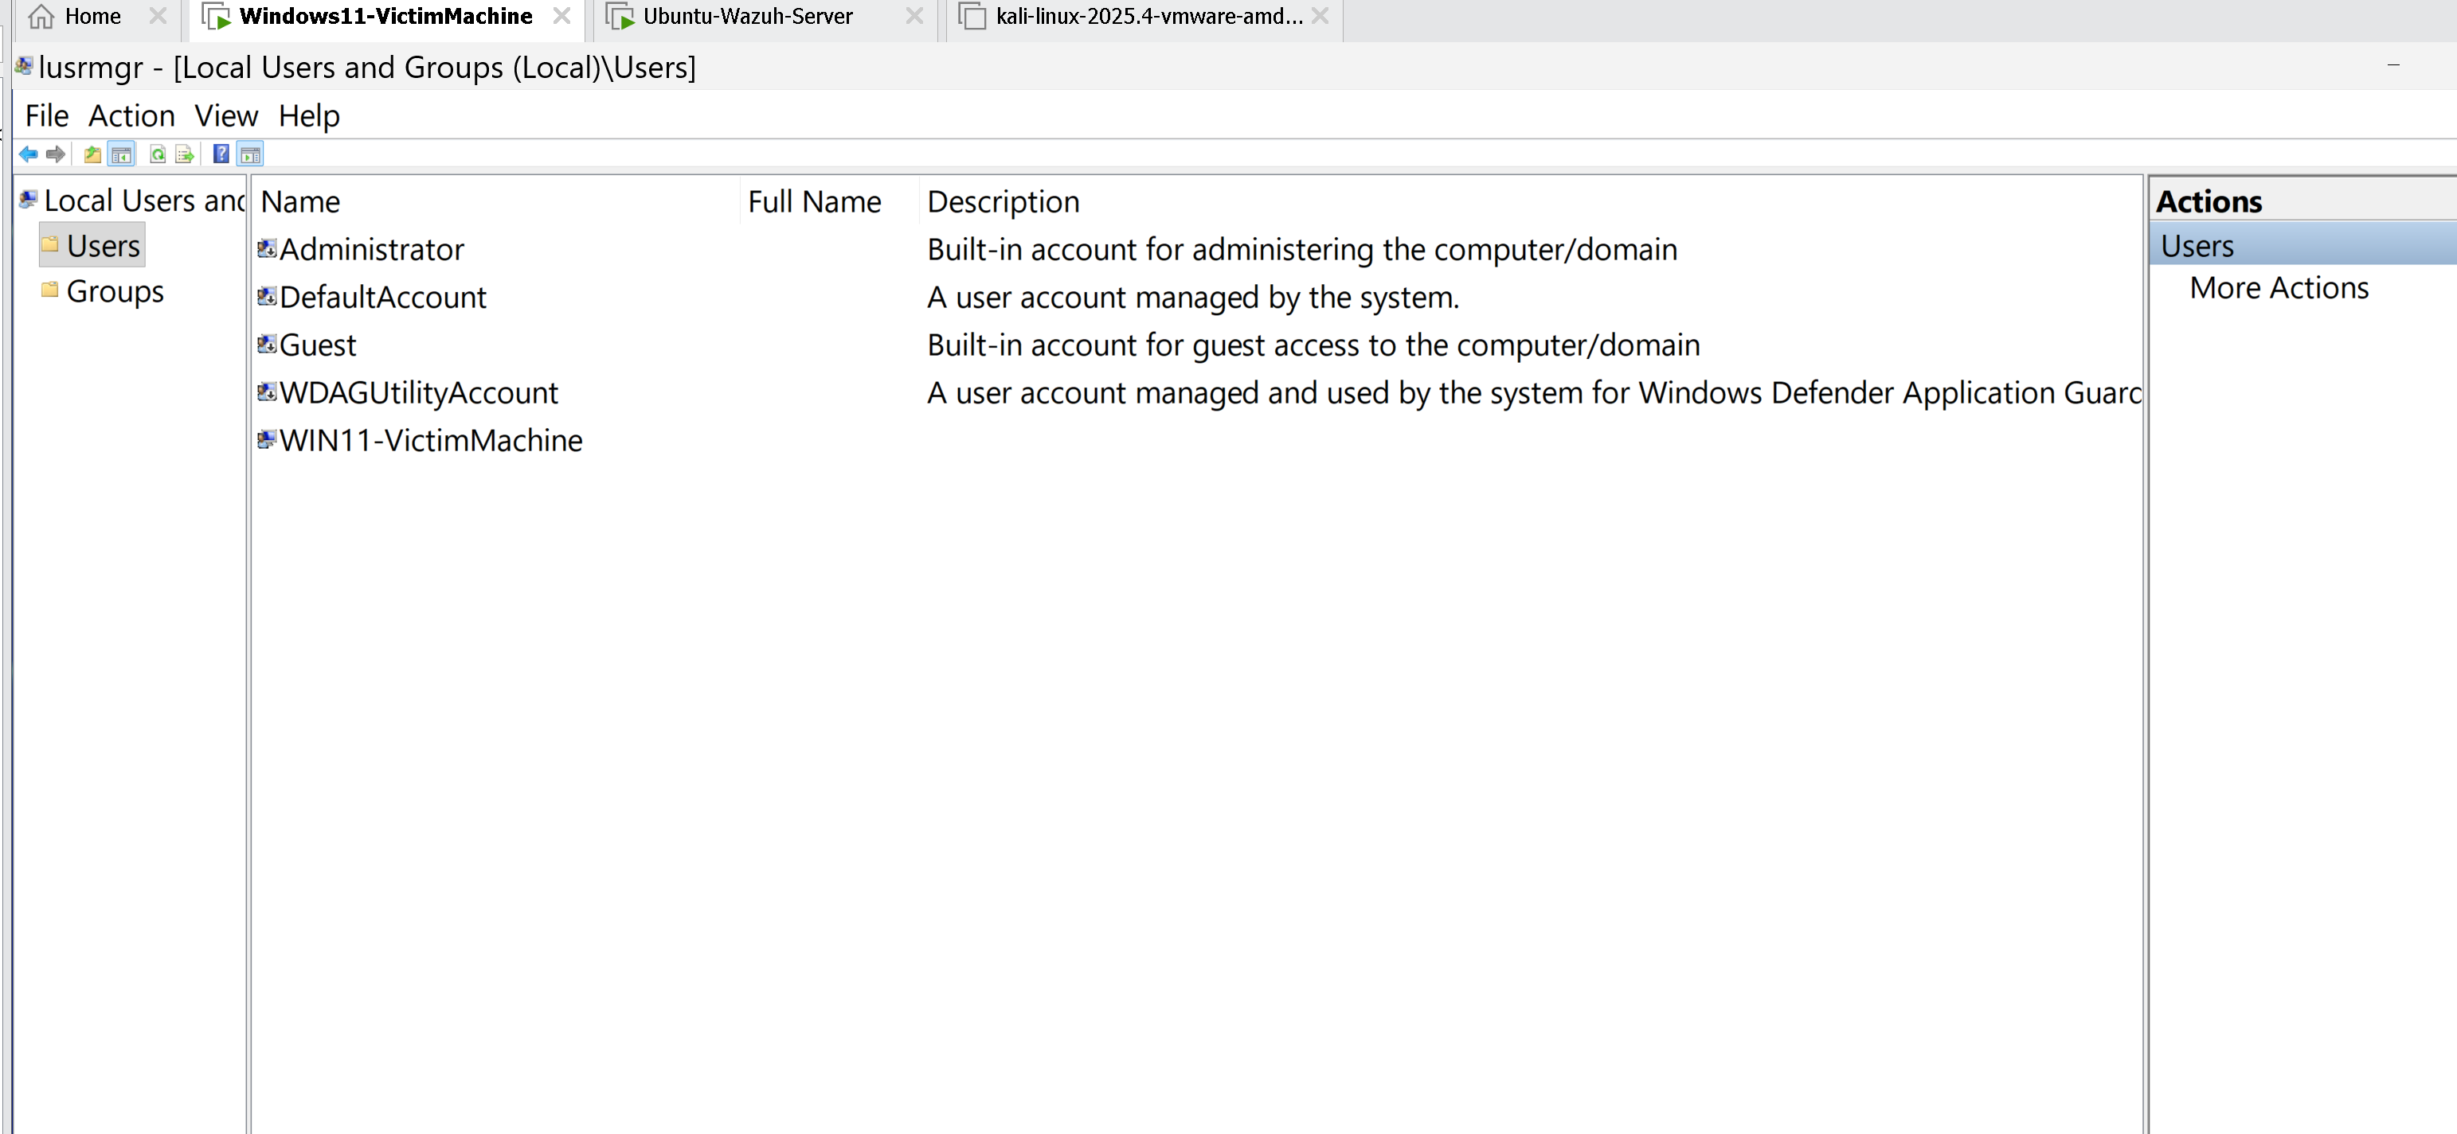
Figure 18 – Group memberships and Administrators group
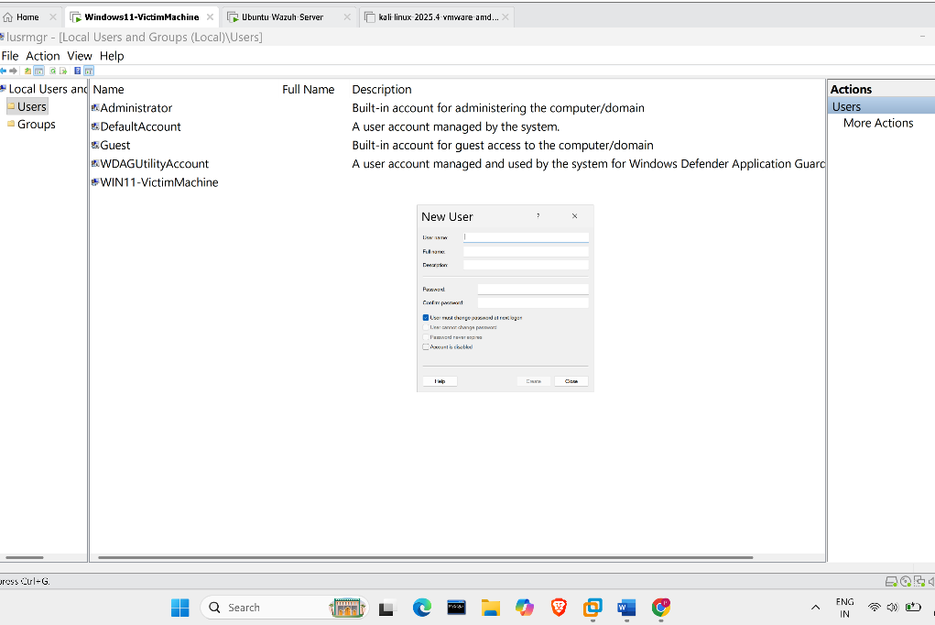
Figure 19 – Account properties and password options
At this point the attacker has full control: they can reset passwords, create backdoor admin accounts, extract credentials, or install malware — all from the lock screen.

5. Detection via Wazuh SIEM

5.1 What is Wazuh?
Wazuh is an open-source Security Information and Event Management (SIEM) and Extended Detection and Response (XDR) platform. It collects, correlates, and analyzes security events from endpoints, helping detect attacks like the utilman.exe replacement in real time or during forensic investigation.

5.2 What Events This Attack Generates
The utilman.exe replacement generates several detectable Windows Security Event Log entries:
Event ID | Event Name | Why It's Relevant
4663 | File Access Attempt | Access to utilman.exe or cmd.exe in System32
4670 | Permissions Changed on File | Modification of system binary permissions
4656 | Object Handle Requested | Handle opened for utilman.exe before rename
4688 | New Process Created | cmd.exe spawned as utilman.exe (parent: winlogon.exe)
4732 | User Added to Privileged Group | If attacker adds a new admin account via lusrmgr

The most critical alert is Event 4688: cmd.exe (or suspicious binary) launched with parent process winlogon.exe from the lock screen. Wazuh can detect this with built-in Windows rules.

5.3 Wazuh Dashboard — Attack Detection
The Wazuh dashboard shows security alerts generated by the agent installed on the Windows target machine. After performing the utilman.exe replacement and triggering it on the lock screen, Wazuh logs correlated alerts:
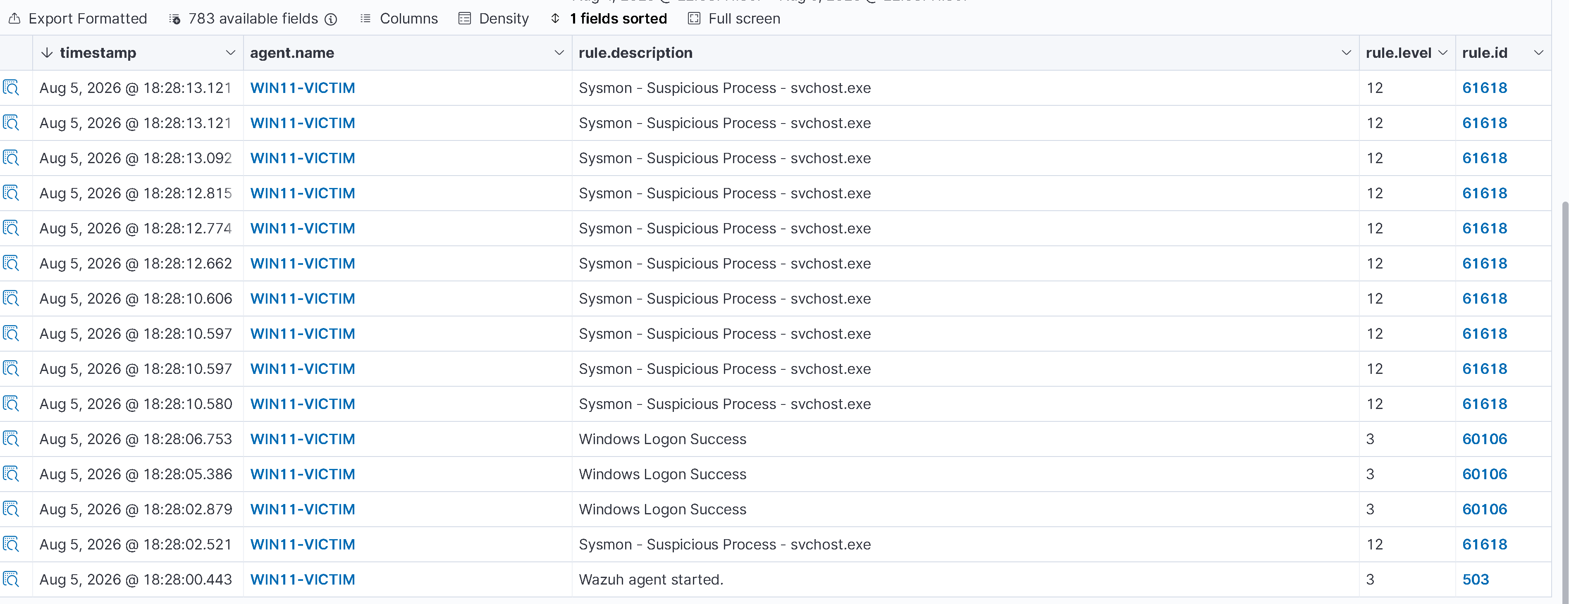
Figure 20 – Wazuh Dashboard overview showing security alerts
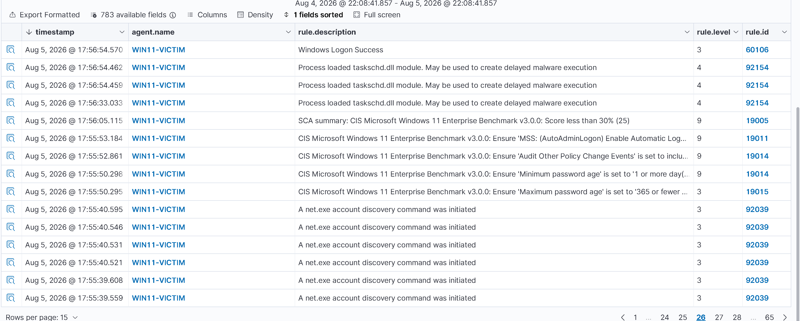
Figure 21 – Alert events generated during the attack
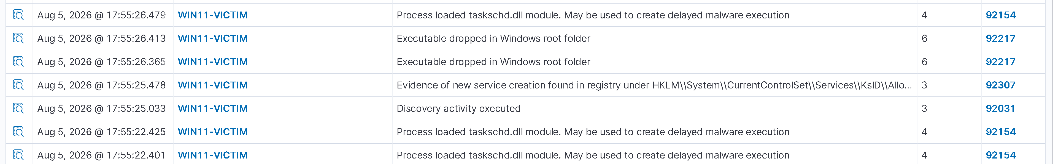
Figure 22 – Rule match: suspicious system binary modification or execution
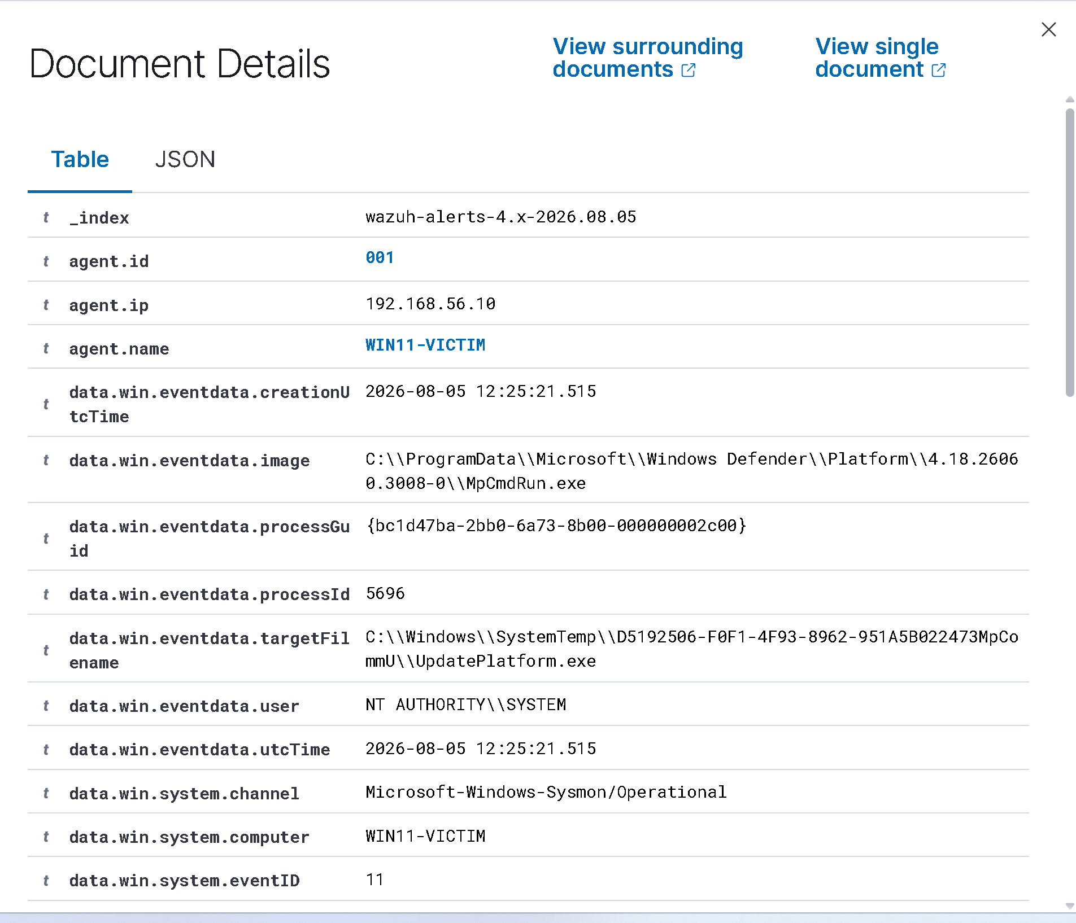
Figure 23 – Alert details: Event triggered from lock screen context
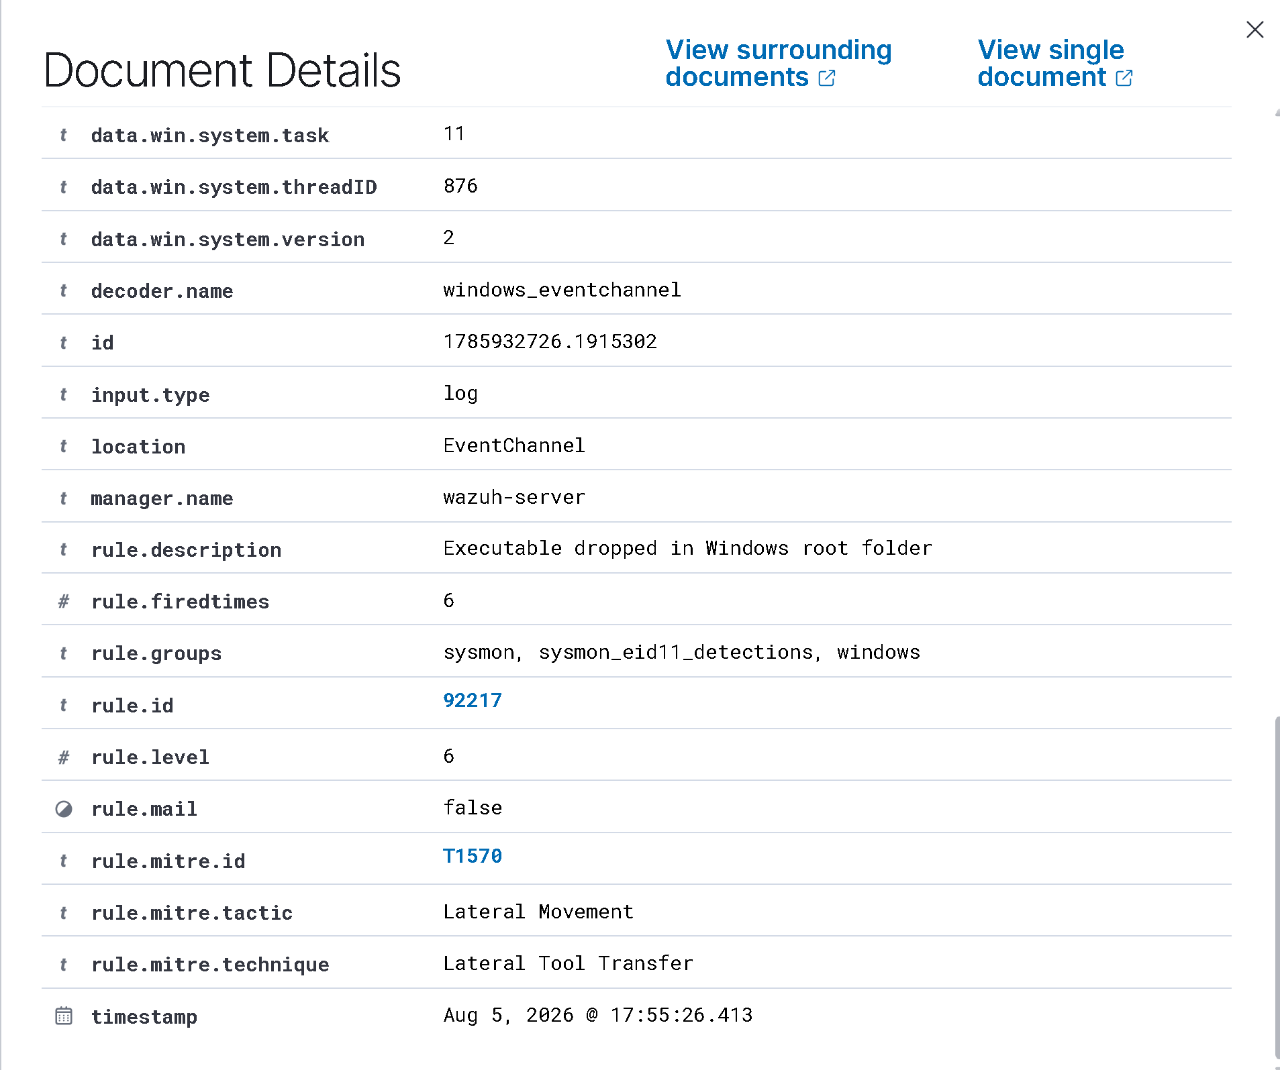
Figure 24 – Process tree showing cmd.exe spawned from winlogon.exe
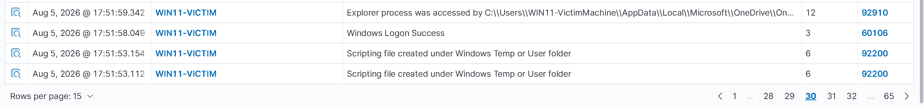
Figure 25 – Wazuh rule ID and description matching the attack pattern
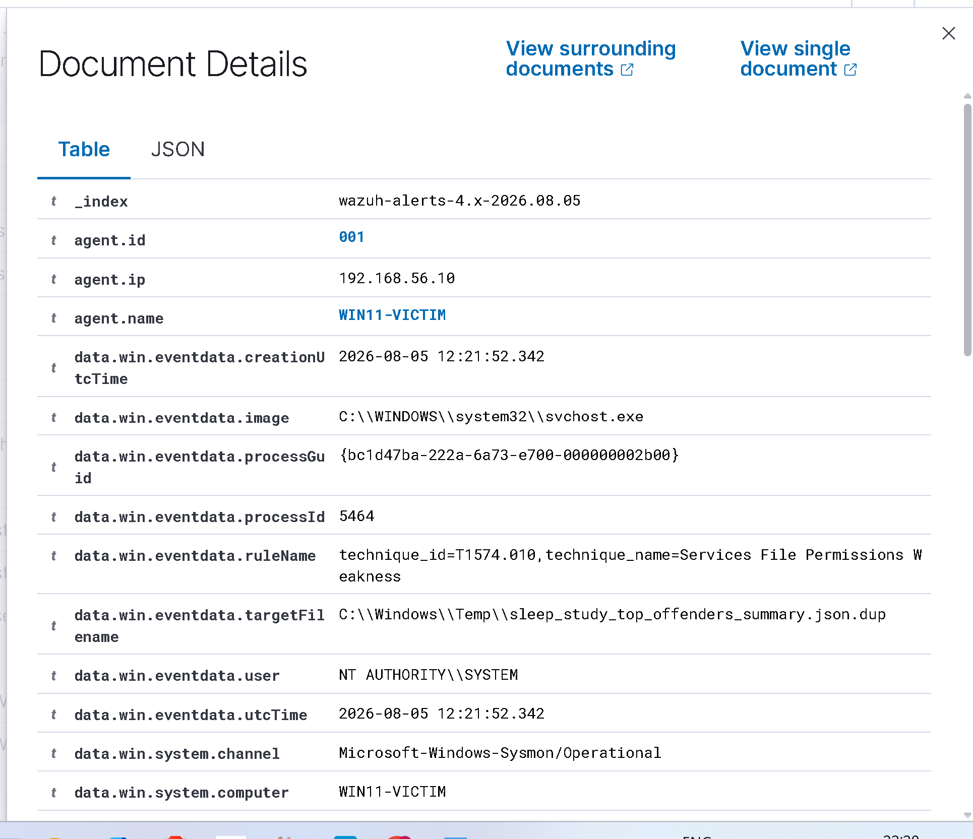
Figure 26 – File integrity monitoring alert on utilman.exe change
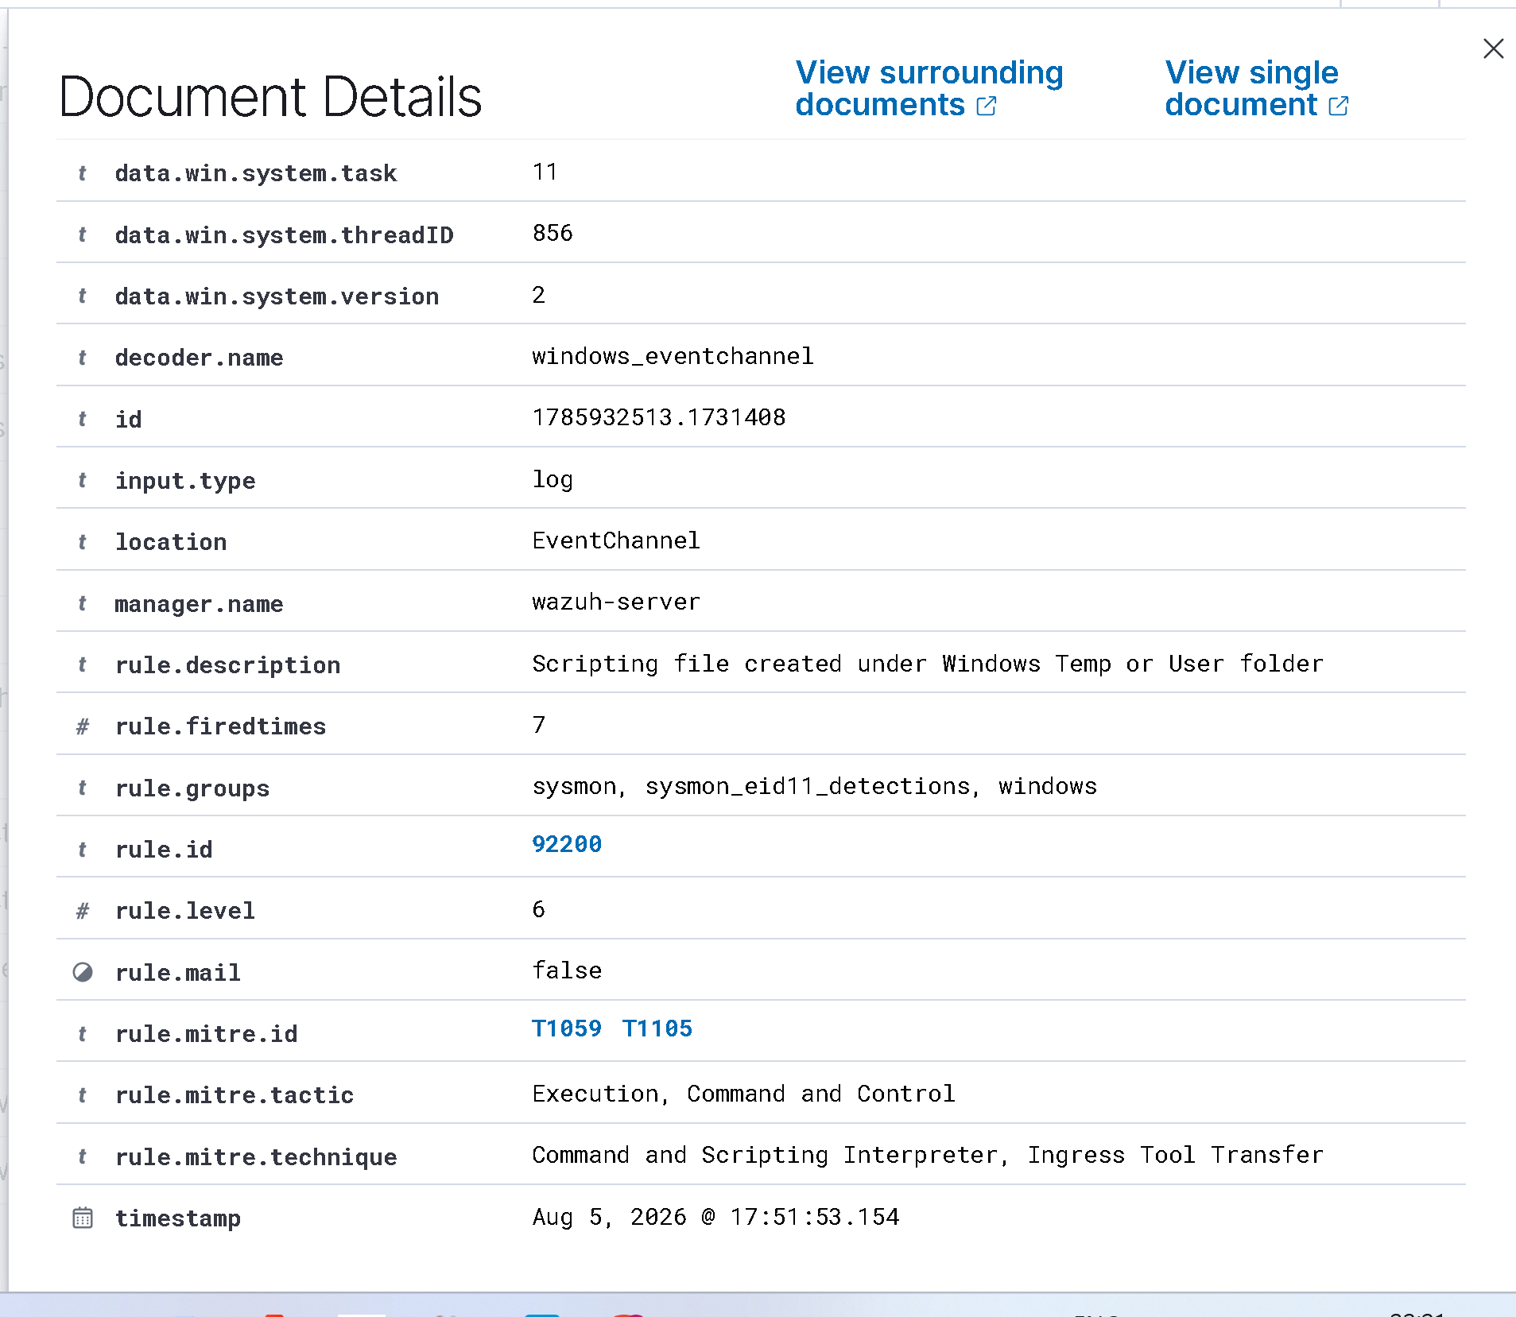
Figure 27 – Wazuh FIM detecting the rename/replace of utilman.exe
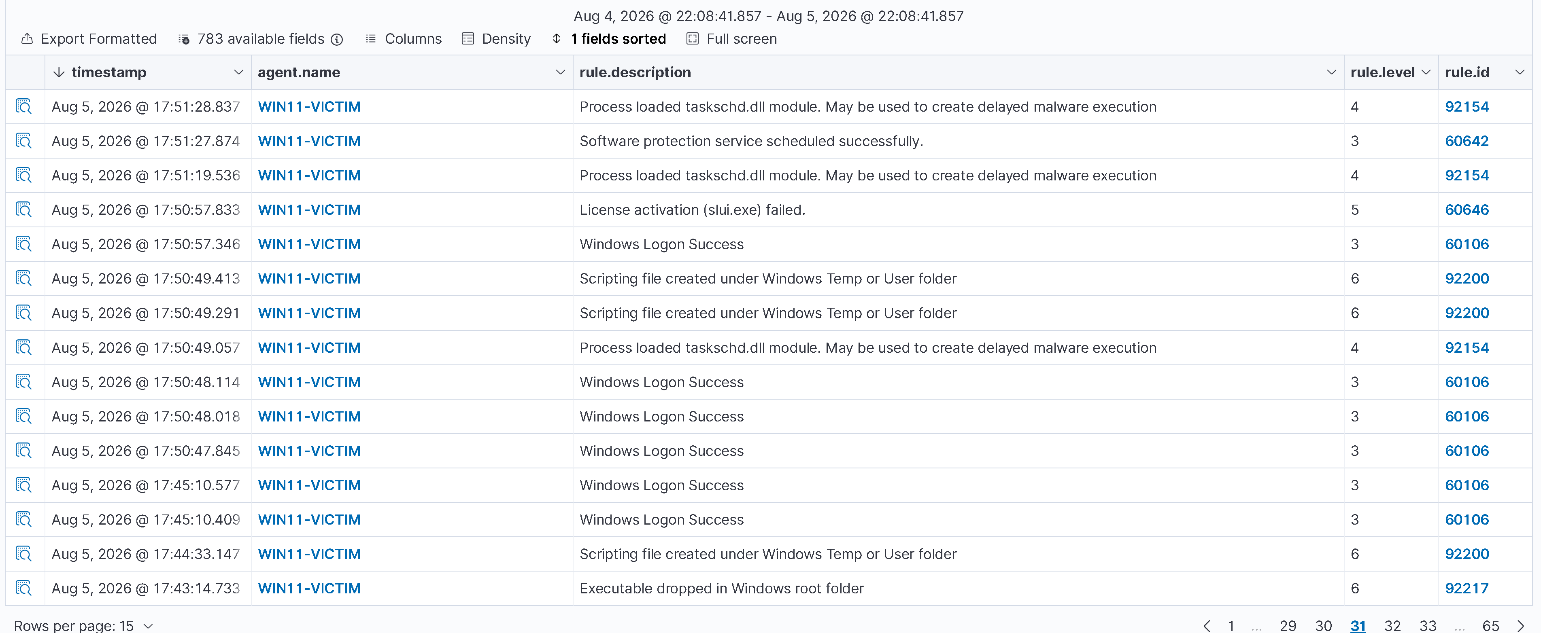
Figure 28 – Full alert timeline showing attack progression

5.4 Key Wazuh Detection Rules Triggered
The following Wazuh rules are relevant to detecting this attack:
- Rule 592 / 594 — Windows File Integrity Monitoring: detects modification to system binaries in System32
- Rule 60103 / 60144 — Windows Event: Suspicious process creation from winlogon.exe context
- Rule 60290 — Accessibility feature binary replaced (utilman.exe, sethc.exe, osk.exe)
- Rule 91702 — New local administrator account created

5.5 Wazuh FIM (File Integrity Monitoring)
Wazuh's FIM module can be configured to monitor the System32 directory and alert on any changes to critical binaries. Add to ossec.conf on the agent:
<syscheck>
<directories realtime="yes" report_changes="yes" check_all="yes">
C:\Windows\System32
</directories>
<frequency>300</frequency>
</syscheck>
When utilman.exe is replaced, Wazuh FIM will generate an alert with the MD5/SHA256 hash change, file size change, and modification timestamp — creating a forensic trail.

6. Restoration — Undoing the Attack
After completing the lab, it is critical to restore the system to its original state. Failure to do so leaves a permanent SYSTEM-level backdoor on the login screen.

Step-by-Step Restoration
1. Reboot the machine and hold Shift + Restart → Enter WinRE again.
2. Open Command Prompt from Advanced Options.
3. Navigate to System32:
C:
cd Windows\System32
4. Remove the fake utilman.exe (which is actually cmd.exe) and restore the backup:
del utilman.exe
ren utilman1.exe utilman.exe
5. Verify:
dir utilman*
You should see only utilman.exe (the original). No utilman1.exe should remain.
6. Type exit and click Continue to reboot into Windows.
7. Test: Click the Ease of Access icon on the lock screen — it should open the normal Accessibility menu, not a CMD window.
If you used copy cmd.exe utilman.exe (recommended), cmd.exe is still intact in System32. If you used ren cmd.exe utilman.exe, you also need to restore cmd.exe (copy from another Windows machine or extract from the Windows installation media).

7. Defences & Hardening

7.1 Enable BitLocker Drive Encryption
This is the most effective single defence. If the drive is encrypted with BitLocker, WinRE cannot write to the Windows partition without the recovery key. Even with physical access, the attacker cannot replace utilman.exe.
manage-bde -on C: -recoverypassword # Enable BitLocker from admin CMD

7.2 Disable WinRE (Not Recommended for End Users)
WinRE can be disabled, though this also disables legitimate recovery options:
reagentc /disable # Disables WinRE
reagentc /info # Check WinRE status

7.3 Enable UEFI Secure Boot + BIOS Password
Prevent booting from external media and restrict access to recovery options via BIOS/UEFI firmware password. This stops attackers from booting a live Linux USB to mount and modify the drive directly.

7.4 Enable Windows Defender Credential Guard
Credential Guard uses Virtualization-Based Security (VBS) to protect LSASS and credential stores, making post-exploitation harder even if an attacker gets SYSTEM.

7.5 Monitor with Wazuh FIM + SIEM Alerting
Deploy Wazuh with FIM on System32 to detect any modification to accessibility binaries (utilman.exe, sethc.exe, osk.exe, narrator.exe, magnify.exe).

7.6 Software Restriction Policies / AppLocker
Use AppLocker or Windows Defender Application Control to prevent unauthorized executables from running in SYSTEM context from the lock screen.

7.7 Defence Summary Table
Defence Measure | Effectiveness | Notes
BitLocker Encryption | 🔴 Blocks Attack | WinRE cannot write to encrypted partition
Wazuh FIM on System32 | 🟡 Detects Attack | Post-change alert; needs monitoring
UEFI Secure Boot + BIOS Password | 🟡 Partial Block | Prevents USB boot, not WinRE built-in
Disable WinRE | 🟡 Partial Block | Breaks recovery capability
AppLocker / WDAC | 🟡 Detects/Limits | Prevents certain post-exploitation actions
Credential Guard | 🟢 Hardens Post-Exploit | Doesn't block the attack, limits damage
Network-based MFA | 🟢 Compensating Control | Useful for domain accounts, not local

8. Forensic Investigation Notes

8.1 How to Detect If This Was Done on a System
If you are investigating a potentially compromised Windows machine, check the following:

Check utilman.exe Hash
Compare the hash of utilman.exe to a known-good value from a clean system:
Get-FileHash C:\Windows\System32\utilman.exe -Algorithm SHA256
# Expected clean SHA256 differs by Windows version — compare with a reference

Check for Backup File
dir C:\Windows\System32\utilman1.exe
# If this file exists, the attack was performed and not cleaned up

Check File Metadata
Get-Item C:\Windows\System32\utilman.exe | Select-Object CreationTime, LastWriteTime, Length
# Compare timestamps — utilman.exe should NOT have been modified recently

Check Windows Event Logs
Get-WinEvent -LogName Security | Where-Object {$_.Id -eq 4688} | Format-List
# Look for cmd.exe launched as utilman.exe from winlogon.exe parent

8.2 Persistence Analysis
Once the attacker resets the password or adds an account, additional persistence indicators may include:
- New local admin account created (check lusrmgr.msc or Event ID 4720)
- Scheduled tasks created (schtasks /query)
- Registry run keys modified (HKLM\SOFTWARE\Microsoft\Windows\CurrentVersion\Run)
- Remote access tools installed (check recently installed programs or netstat -an)

9. Conclusion
The Utilman.exe accessibility bypass is a classic and highly effective technique that exploits the trust placed in WinRE and pre-authentication accessibility features on Windows systems. It requires no special tools, no network access, and no knowledge of any user's password — only physical or console access and an unencrypted drive.
In a real-world attack scenario, this technique can be executed in under 5 minutes on an unprotected machine, giving an adversary complete SYSTEM-level access — the highest privilege tier in Windows.
From a Blue Team and SOC perspective, Wazuh SIEM with File Integrity Monitoring provides the best visibility into this attack — detecting the binary replacement before or when it is triggered. BitLocker remains the strongest preventative control.

9.1 Key Takeaways
- Physical access = full control on unencrypted Windows systems
- WinRE CMD runs at SYSTEM level and bypasses OS-level permission checks
- utilman.exe is called pre-authentication → perfect hijack target
- Wazuh FIM + Event Log monitoring can detect this attack
- BitLocker is the #1 defence — without it, no software-only control can fully stop this
- Always restore modified binaries after testing — leaving the backdoor open is a serious risk

9.2 Real-World Relevance
This technique is used by penetration testers, red teams, and has been observed in real APT campaigns (notably in targeted attacks against Windows workstations with physical access). It appears on the OSCP exam, CEH practicals, and is referenced in multiple SANS courses. Understanding both the attack and the detection is essential for any cybersecurity professional.

— END OF REPORT —
This report is intended for educational and authorized security testing purposes only.

