Version 2 – Tailored Report

1. Vessel Specification and Calibration
- MARUS Coordinate Convention: +Z forward (surge), +X starboard, +Y up.
- Heading Convention: Unity yaw decreases for starboard; ITTC convention is starboard = positive. The scripts and the matric-extraction notebook use the relation relPsiNautical = −(ψ- ψ0).
- MARUS Vessels Specifications:

Table A. MARUS boat specifications.
Length (≈ LPP along +Z) [m] | Beam (≈ width along +X) [m] | Draft (≈ height along +Y) [m]
2.952 | 1.468 | 1.361
- Throughout this report, L and LPP have been used interchangeably.
- Calibration & Target Speeds: The vessel was calibrated using the standard 85% Maximum Continuous Rating (MCR) approach to determine the benchmark operational speed (V_85).

Table B. Speed calibration summary
Steady speed at 85% MCR, V_85 [m/s] | Target IMO test speed (≈ 90% of V_85), V_target [m/s]
0.923496 | 0.831147

2. Manoeuvre Automation
The MARUS boat model used here does not have a physical rudder. Therefore, the maneuvers are executed via a rudder‑equivalent command δ̂ realized via differential thrust (port/starboard). For the sake of traceability, two rudder signals are logged:
- Ordered δ̂_cmd (deg): the maneuver definition (±35° hard‑over for turning circle or ±10°/±20° per zig-zag leg)
- Executed δ̂_exec (deg): inferred from applied thrust differential (ratio-based)

3. Speed Configurations and PID Control
To satisfy ITTC standards, the vessel must maintain a steady approach speed and shaft RPM before the rudder execute command is issued. Therefore, the Turning Circle (TC) and Zig-Zag (ZZ) implementations use a SpeedHold control mode based on a PID controller.
- Speed PID Settings: K_p=0.8, K_i=0.05, K_d=0.0
- Targeting Logic: The script holds the vessel at 0.8311 m/s for a minimum of 120 seconds.
- Steady Window: The manoeuvre only triggers once the Yaw Rate (r) is < 0.3°/s and the Speed Error is < 0.05 m/s for 10 consecutive seconds.

4. TurningCircleTest: stages and stop conditions
Phases:
A) Establishing the ITTC/IMO Initial Condition: straight run until steady yaw rate, and steady speed (SpeedHold) over a steady window.
B) Turn: automatically applies a hard-over command of δ̂_cmd = ±35° via a differential thrust proxy.
C) Pull Out: returns ordered δ̂_cmd to 0 for 10 seconds to evaluate directional stability.
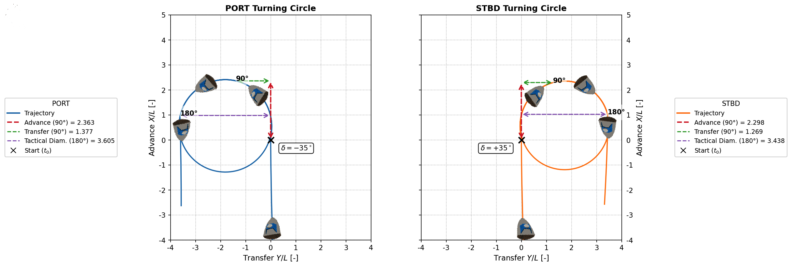
D) End Criteria: The test terminates after a heading change of 540° (1.5 circles), ensuring enough steady-state data for accurate System Identification (SI). Safety caps have also been integrated for the ending criteria: maxHeadingChangeDeg = 720° and maxTestTimeSeconds = 1200 s.
Figure 1: Turning Circle Trajectory Plots

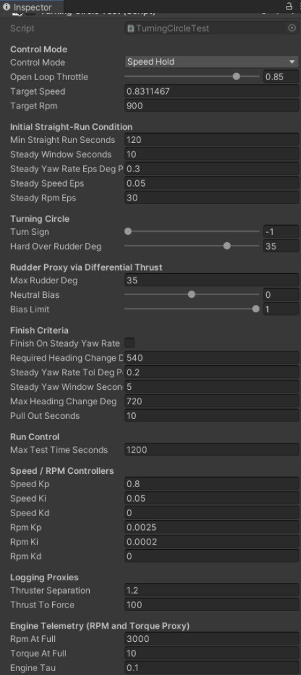

Figure 2:. The TurningCircleTest inspector configuration used for port/starboard turning circle runs.

5. Extracted TC Metrics:

Turning circle: 1. Advance (Ad) at 90°, 2. Transfer (Tr) at 90°, 3. Tactical Diameter (Dt) at 180°, and a 4. steady diameter (D) estimate, 5. & 6. elapsed time from execute until reaching 90° and 180° heading change in seconds, and 7. maximum yaw rate in degrees per second.

Table C. Turning Circle core metrics
Run | Turn | 1.Advance Ad/L | 2.Transfer Tr/L | 3.Tactical Diameter Dt/L | 4.Steady Diameter* D/L | 5. t90  (s) | 6.t180 (s) | 7.Max Yaw Rate (deg/s)
TC_PT.csv | PORT | 2.298 | 1.269 | 3.441 | 3.544 | 14.220 | 28.340 | 6.445
TC_SB.csv | STBD | 2.365 | 1.385 | 3.609 | 3.695 | 14.880 | 29.560 | 6.185

Table D. Turning Circle criteria evaluation
Run | Advance  Ad/L | IMO MSC.137 Criteria  Ad/L ≤ 4.5 | Tactical Diameter  Dt/L | IMO MSC.137 Criteria  Dt/L ≤ 5.0
TC_PT.csv | 2.298 | PASS | 3.441 | PASS
TC_SB.csv | 2.365 | PASS | 3.609 | PASS

Table E. Turning Circle cross-track (XTE) diagnostics
Run | Turn | XTE* at 360°  (m) | XTE at 360° /L
TC_PT.csv | PORT | 0.027 | 0.009
TC_SB.csv | STBD | 0.034 | 0.012
*XTE @360°: cross‑track displacement at 360° heading change.

Table F. Turning Circle velocity profiles
Run | Turn | U0*  (m/s) | Froude Number* | V90 *​/U0​ (Speed Loss) | Max Yaw Rate (deg/s)
TC_PT.csv | PORT | 0.833 | 0.155 | 0.678 | 6.445
TC_SB.csv | STBD | 0.833 | 0.155 | 0.684 | 6.184
* U0: the median approach speed immediately before execution.
* Froude number based on LPP
* V90​/U0​: ratio of speed at 90° heading change to approach speed

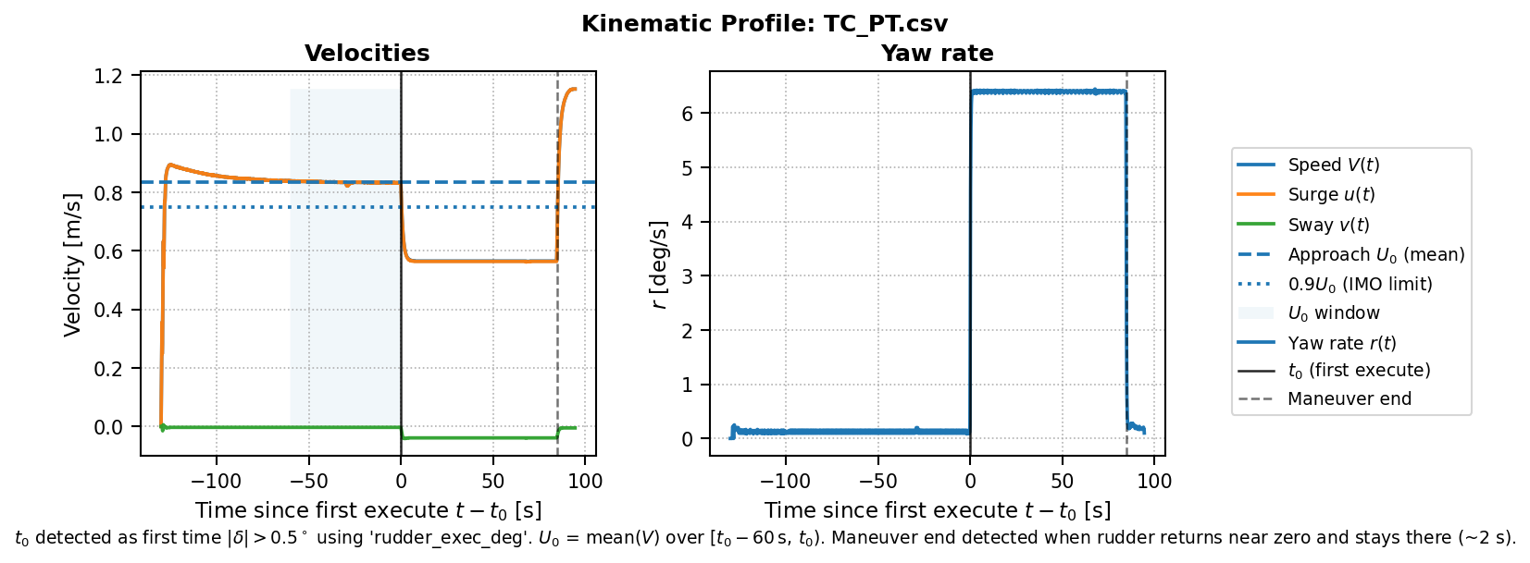
Figure 3: TC Port Velocity Profiles
Figure 4: TC STBD Velocity Profiles
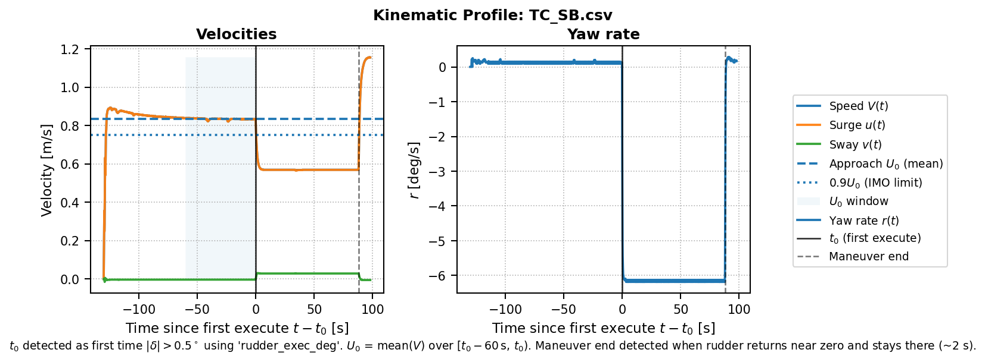

6. ZigZagManeuver: stages and stop conditions
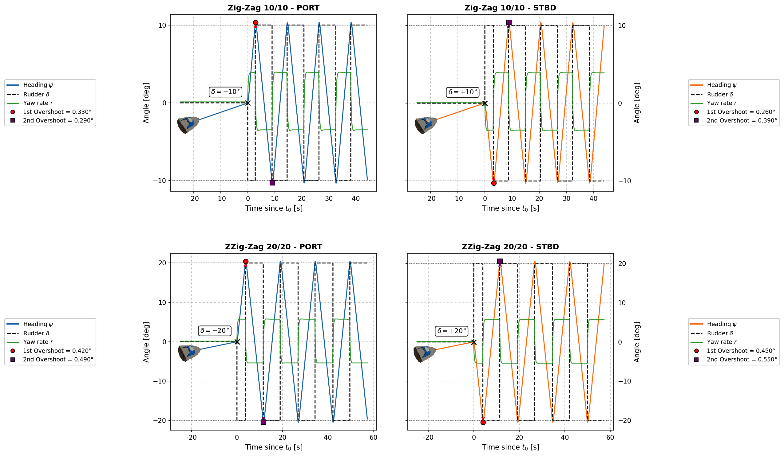
Phases:
A) Establishing the ITTC/IMO Initial Condition: straight run until steady yaw rate, and steady speed (SpeedHold) over a steady window; same as TC.
B) Zig Zag: apply ordered δ̂_cmd = ±cmdAngleDeg of either 10/10 or 20/20. When the heading deflection reaches |Δψ| = cmdAngleDeg (within deadband), reverse sign.
C) End Criteria: stop after headingCrossingsToRun crossings (default 4 according to ITTC/IMO) or time cap of 1200 seconds.
Figure 6: ZigZagManeuver inspector configuration used for ZZ10/10 and ZZ20/20 runs.

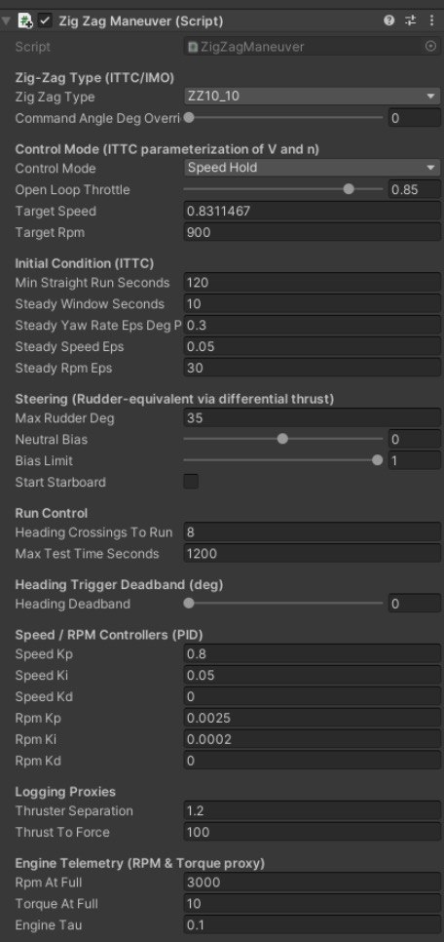

Figure 5: Zig-zag Trajectory Plots
Figure 6:ZigZagManeuver inspector configuration used for ZZ10/10 and ZZ20/20 runs.
Figure 7: ZigZagManeuver inspector configuration used for ZZ10/10 and ZZ20/20 runs.

7. Extracted ZZ Metrics:

Zig‑zag: Initial turning ability (distance to 10° heading change), 1st/2nd overshoot (excess beyond cmd), and peak times.

Table G. Zig‑zag core metrics
Run | Type | First-leg direction | Initial turning distance to 10° heading change/L | 1st overshoot (deg) | 2nd overshoot (deg) | Max yaw rate (deg/s) | Time to 1st peak heading (s) | Time to 2nd peak heading  (s)
ZZ10_PT.csv | 10/10 | PORT | 0.768 | 0.330 | 0.290 | 3.962 | 2.880 | 9.100
ZZ10_SB.csv | 10/10 | STBD | 0.855 | 0.260 | 0.390 | 3.962 | 3.220 | 8.780
ZZ20_PT.csv | 20/20 | PORT | 0.494 | 0.420 | 0.490 | 5.777 | 3.780 | 11.660
ZZ20_SB.csv | 20/20 | STBD | 0.517 | 0.450 | 0.550 | 5.777 | 4.100 | 11.560

Table H. Zig‑zag criteria evaluation
Run | Type | Initial turning distance to 10° heading change/L | MSC.137 Criteria  ≤ 2.5 | 1st overshoot (deg) | Limit* | PASS | 2nd overshoot  (deg) | Limit* | PASS
ZZ10_PT.csv | 10/10 | 0.768 | PASS | 0.330 | 10.000 | PASS | 0.290 | 25.000 | PASS
ZZ10_SB.csv | 10/10 | 0.855 | PASS | 0.260 | 10.000 | PASS | 0.390 | 25.000 | PASS
ZZ20_PT.csv | 20/20 | 0.494 | PASS | 0.420 | 25.000 | PASS | 0.490 | 40.000 | PASS
ZZ20_SB.csv | 20/20 | 0.517 | PASS | 0.450 | 25.000 | PASS | 0.550 | 40.000 | PASS
*IMO (MSC.137) criteria used for evaluation:
• 10°/10°: 1st overshoot ≤ 10°, 2nd overshoot ≤ 25°
• 20°/20°: 1st overshoot ≤ 25°. 2nd overshoot is reported for completeness ≤ 40°.

Table I. Zig‑zag XTE
Rn | Type | Max XTE*  (m) | Max XTE /L
ZZ10_PT.csv | 10/10 | 0.483 | 0.163
ZZ10_SB.csv | 10/10 | 0.616 | 0.209
ZZ20_PT.csv | 20/20 | 0.973 | 0.330
ZZ20_SB.csv | 20/20 | 1.208 | 0.409
Run | Type | U0*  (m/s) | Froude Number* | Normalized speed at 1st peak | Normalized speed at 2nd peak | Max Yaw Rate (deg/s)
ZZ10_PT.csv | 10/10 | 0.833 | 0.155 | 0.957 | 0.957 | 3.962
ZZ10_SB.csv | 10/10 | 0.833 | 0.155 | 0.959 | 0.954 | 3.962
ZZ20_PT.csv | 20/20 | 0.833 | 0.155 | 0.761 | 0.758 | 5.777
ZZ20_SB.csv | 20/20 | 0.833 | 0.155 | 0.763 | 0.752 | 5.777
* U0: the median approach speed immediately before execution.
*Max XTE (m): Maximum absolute cross-track displacement during the zig-zag run, computed by projecting the vessel’s position onto the initial starboard-positive perpendicular axis defined at manoeuvre start.
Table J. Zig‑zag velocity profiles

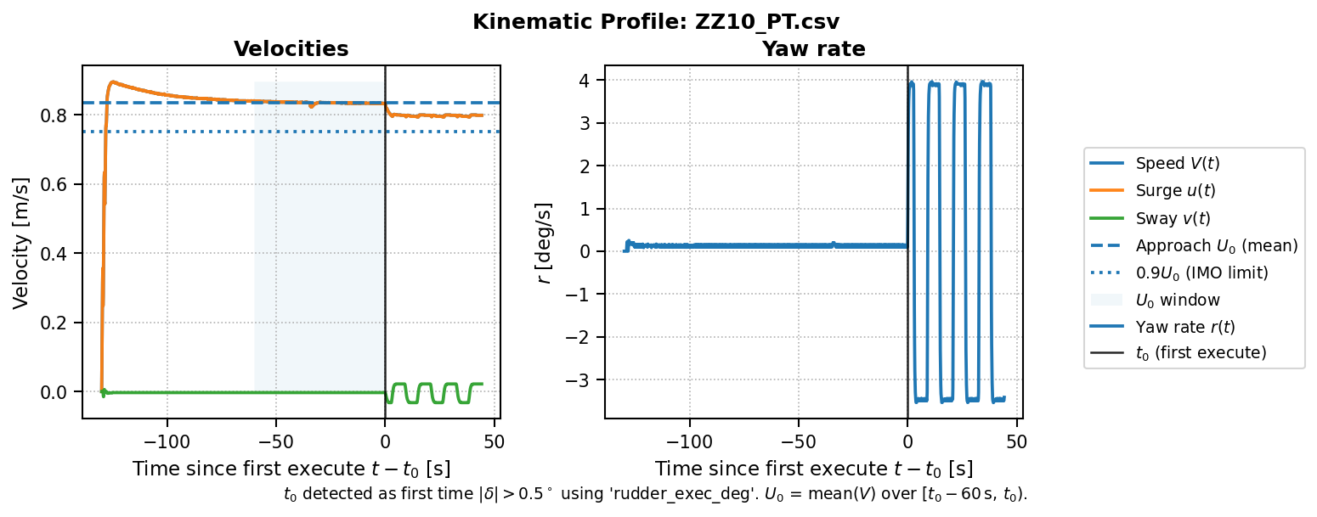
Figure 7: ZZ Velocity Profiles in the order: 1. ZZ10/10 Port 2. ZZ10/10 STBD 3. ZZ20/20 Port 4.ZZ20/20 STBD

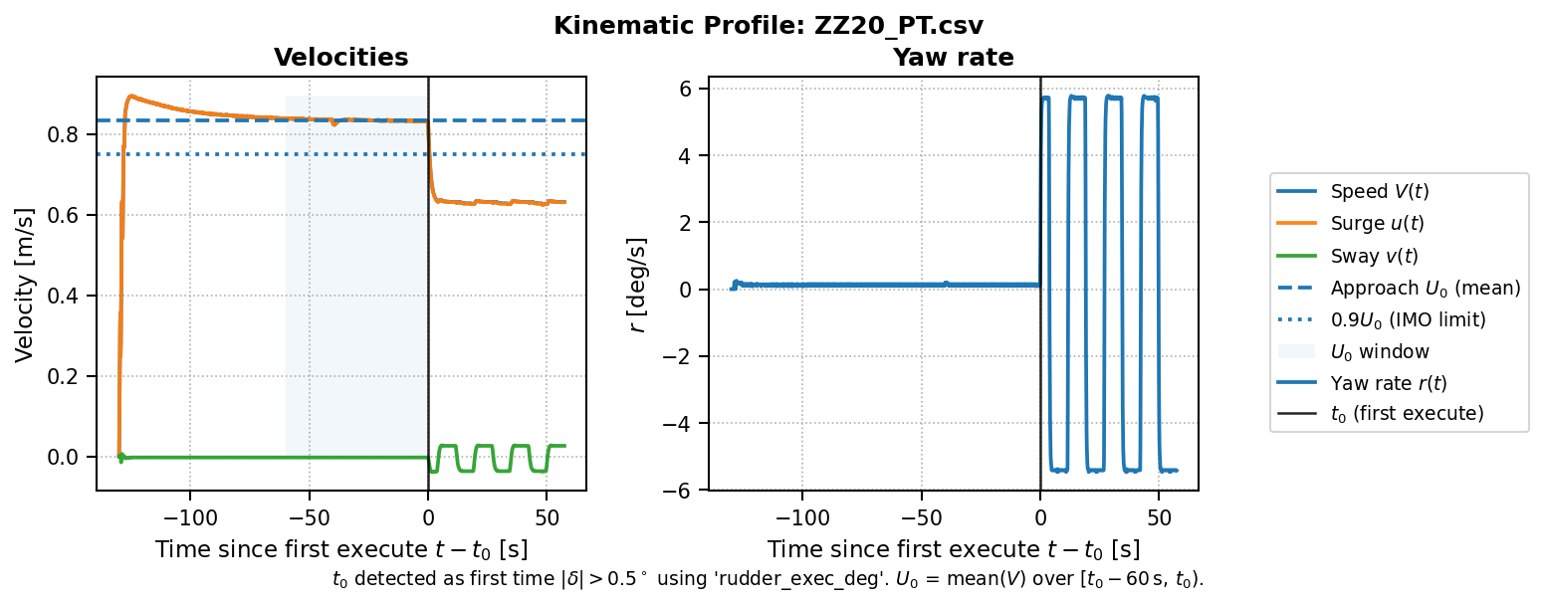
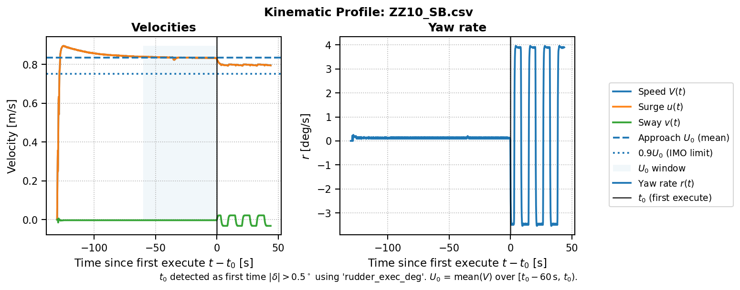
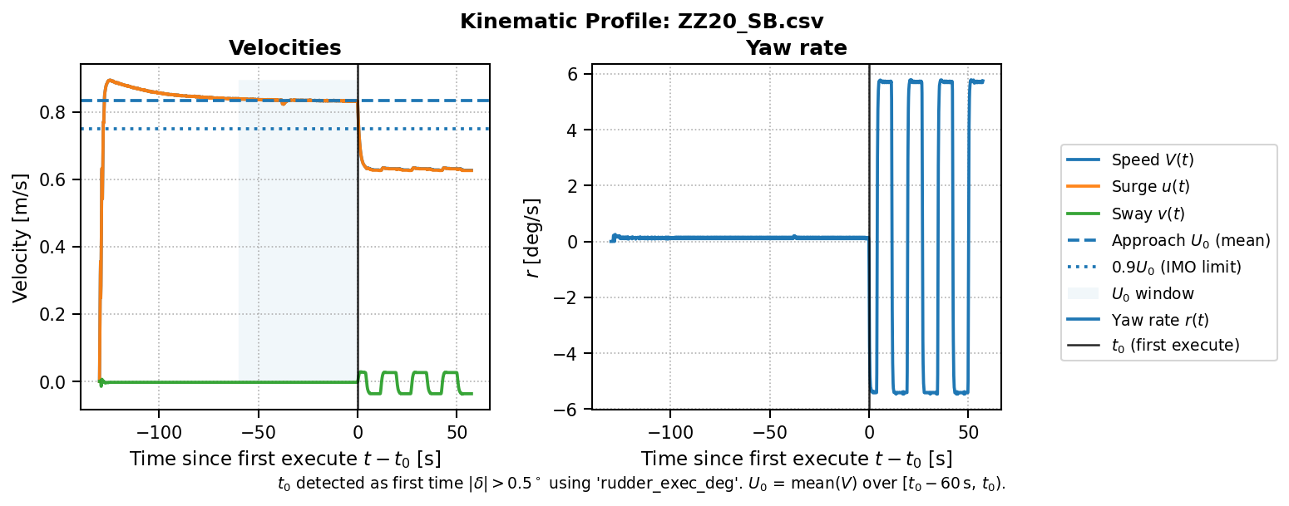

References

- International Towing Tank Conference. (n.d.). Recommended procedures and guidelines: Manoeuvring – Turning circle and zig-zag tests (Procedure No. 7.5-02-06-03)
- International Maritime Organization. (2002). Resolution MSC.137(76): Standards for ship manoeuvrability

