**Data, Data Source and Usage:**

**Choice of City: New York**

**Following data will be used for the project. Their sources and usage is also mentioned:**

1. **New York City geographical/neighbourhood data :** This is the most important data set.Following data points related to neighbourhood can be extracted from the link:

* Borough Names
* Latitudes
* Longitudes

[**https://geo.nyu.edu/catalog/nyu_2451_34572**](https://geo.nyu.edu/catalog/nyu_2451_34572)

**Usage:**  This Geographical data will be used as an input for Foursquare API to access venues information like:

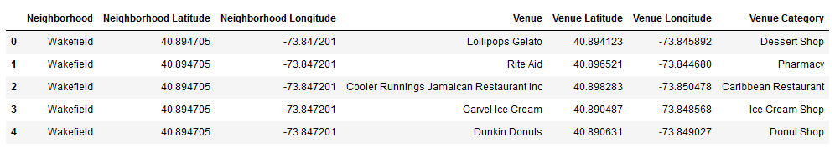

1. **Supplier Location Details:** A good neighbourhood should not be far away from raw material and packaging material suppliers. To identify such venues we will require following source:
   1. [**https://data.cityofnewyork.us/dataset/DOHMH-Farmers-Markets-and-Food-Boxes/8vwk-6iz2**](https://data.cityofnewyork.us/dataset/DOHMH-Farmers-Markets-and-Food-Boxes/8vwk-6iz2)
   2. [**https://www.grownyc.org/greenmarketco/foodbox**](https://www.grownyc.org/greenmarketco/foodbox)

**Usage:** To identify nearby suppliers of raw and packaging materials in different neighbourhoods so that it can reduce overall cost of transportation and inventory for the restaurant. Raw material could be the fresh fruits, vegetables, spices, etc. which would be required on regular basis in the restaurant. Hence any near by market would be of great help for the restaurant.

Similarly, a lot of vendors should be present near by from whom packaging materials can be easily procured. A lot of customers prefer take-away instead of dine in option. For serving such customers this data would be very useful.

1. **Customer Base Data Set:**  A lot of information would be required about population in general so that we can identify what type of customers would be easy to target or good for business. Such data points include population count, income levels, age, gender, food preferences, local cuisines etc.

All such data points can be accessed from following links:

<https://en.wikipedia.org/wiki/New_York_City>  
<https://en.wikipedia.org/wiki/Economy_of_New_York_City>  
<https://en.wikipedia.org/wiki/Portal:New_York_City>  
<https://en.wikipedia.org/wiki/Cuisine_of_New_York_City>  
<https://en.wikipedia.org/wiki/List_of_Michelin_starred_restaurants_in_New_York_City>

**Data might look like:**

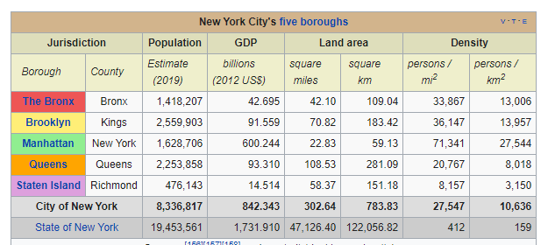

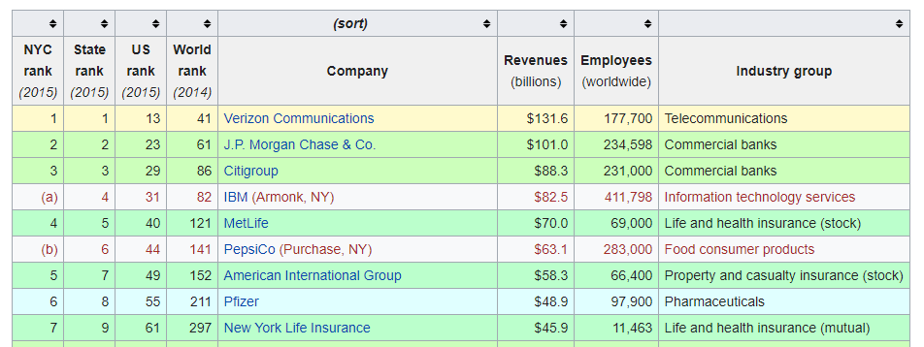

**Usage:** This data set will help in understanding New York population, type of food they want, what is the gap and hence to decide what customers can be targeted. Once target customers are identified, rest all preparations would follow the same cue like menu, interiors, pricing etc.