JAYPEE INSTITUTE OF INFORMATION AND TECHNOLOGY SECT-128, NOIDA

BTECH 2 SEMESTER

PROJECT SYNOPSIS

TITLE OF PROJECT
ONLINE SHOPPING CART SYSTEM

UNDER SUPERVISION OF | SUBMITTED BY:
LAB FACULTY NAME :  PROF. NOOR MOHAMMAD | Enrollment No. | Name
 | 992501030133 | PARIDHA SHARMA
 | 992501030126 | CHANDINI JAIN
 | 992501030134 | PRISHA BHATIA

ABSTRACT
The Online Shopping Cart Management System is a C++ based mini project that simulates a simple online shopping platform. The system allows users to view available products, add items to a shopping cart, remove items, and complete a checkout process. The project uses object-oriented programming concepts such as classes, inheritance, and polymorphism to organize different product types. The cart manages selected products and calculates the total cost based on quantity and product type. File handling is used to generate and store a receipt after checkout, creating a simple record of purchases. This project helps demonstrate how C++ programming concepts can be applied to build a practical system that represents real-world online shopping behavior.

TOPICS OF SDF-II USED
- Classes and Objects
- Inheritance
- Polymorphism
- Operator Overloading
- File Handling
- Exception Handling
- STL containers (map, vector)
- Menu Driven Programming

DESIGN OF THE PROJECT (FLOWCHART)
The following flowchart represents the working process of the Online Shopping Cart system.

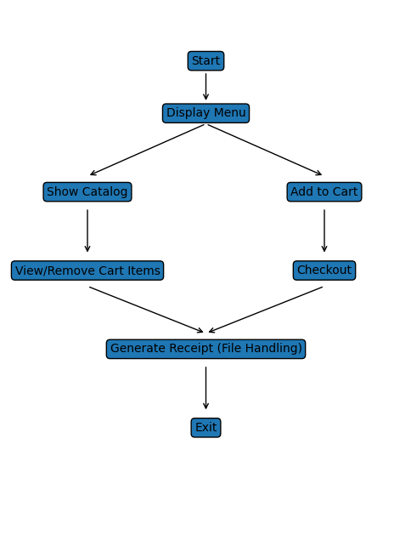

REFERENCES

- C++ Programming Documentation
- Object Oriented Programming course notes
- Online tutorials for STL and file handling

