

Database Management System Lab (BTCS203P)
B. TECH AI&ML, CYBER SECURITY, Data Science 3 RD Semester (Session 2026-2025)
Objective:
To understand and practice SQL Functions.
Prerequisites:
1. Basic knowledge of SQL.
2. MySQL installed and set up.
Lab Sheet 2: SQL Functions
DROP DATABASE IF EXISTS DBMS_Lab3;

CREATE DATABASE DBMS_Lab3;

USE DBMS_Lab3;
CREATE TABLE Students (
student_id INT PRIMARY KEY,
first_name VARCHAR(50),
last_name VARCHAR(50),
age INT,
branch VARCHAR(50),
dob DATE
);
INSERT INTO Students
(student_id, first_name, last_name, age, branch, dob)
VALUES
(1, 'Rahul', 'Sharma', 20, 'Data Science', '2005-04-15'),
(2, 'Priya', 'Verma', 21, 'AI & ML', '2004-07-22'),
(3, 'Aman', 'Gupta', 20, 'Cyber Security', '2005-01-10'),
(4, 'Neha', 'Singh', 19, 'Data Science', '2006-09-05'),
(5, 'Riya', 'Mehta', 21, 'AI & ML', '2004-12-18');

CREATE TABLE Employees (
employee_id INT PRIMARY KEY,
first_name VARCHAR(50),
last_name VARCHAR(50),
salary DECIMAL(10,2),
joining_date DATE
);
INSERT INTO Employees
(employee_id, first_name, last_name, salary, joining_date)
VALUES
(101, 'Amit', 'Kumar', 45678.50, '2022-03-15'),
(102, 'Sneha', 'Sharma', 52345.75, '2021-07-20'),
(103, 'Rohit', 'Verma', 38999.40, '2023-01-10'),
(104, 'Pooja', 'Gupta', 61500.25, '2020-11-05'),
(105, 'Karan', 'Singh', 47500.80, '2022-09-18');

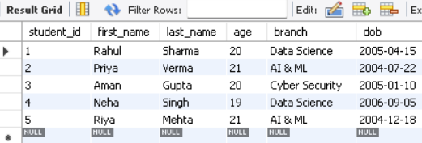

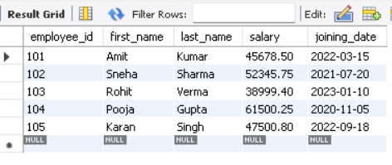
A. Number Functions
1. Demonstrate ABS() with suitable examples.
SELECT ABS(-25) AS Absolute_Value;

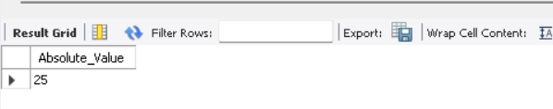
- Demonstrate ROUND() with suitable examples.
SELECT ROUND(123.4567, 2) AS Rounded_Value;
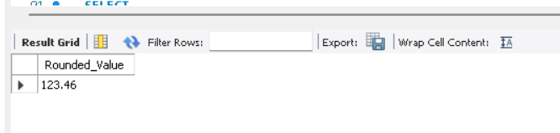
- Demonstrate CEIL() and FLOOR().
SELECT
CEIL(12.34) AS Ceiling_Value,
FLOOR(12.89) AS Floor_Value;
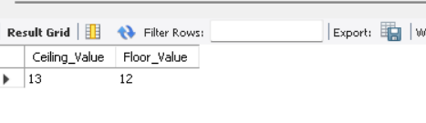
- Demonstrate MOD() with suitable examples.
SELECT MOD(17, 5) AS Remainder;

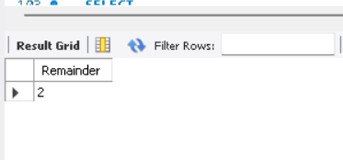
- Calculate the rounded salary of employees.
SELECT
employee_id,
first_name,
salary,
ROUND(salary) AS Rounded_Salary
FROM Employees;

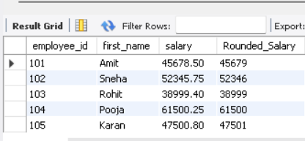

B. Aggregate Functions
6. Find the total number of students using COUNT().
SELECT COUNT(*) AS Total_Students
FROM Students;
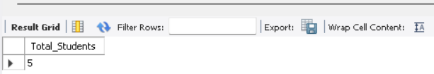

7.Find the total salary of all employees using SUM().
SELECT SUM(salary) AS Total_Salary
FROM Employees;
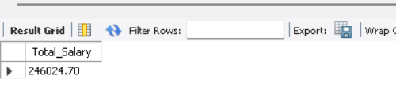
8.Find the average salary using AVG().
SELECT ROUND(AVG(salary), 2) AS Average_Salary
FROM Employees;
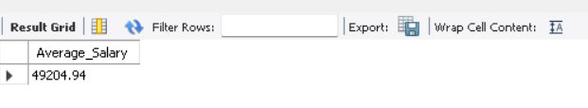9. Find the highest salary using MAX().
SELECT MAX(salary) AS Highest_Salary
FROM Employees;

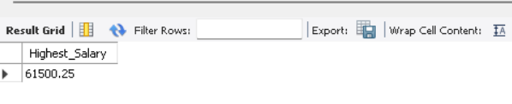
- Find the lowest salary using MIN().
SELECT MIN(salary) AS Lowest_Salary
FROM Employees;
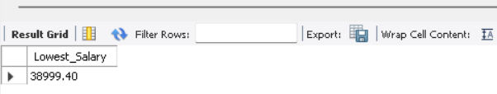

C. Character Functions
11. Demonstrate UPPER() on student names.
SELECT
first_name,
UPPER(first_name) AS Uppercase_Name
FROM Students;
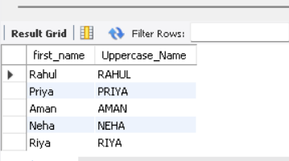

12.Demonstrate LOWER() on student names.
SELECT
first_name,
LOWER(first_name) AS Lowercase_Name
FROM Students;
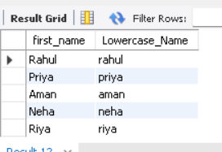

- Demonstrate LENGTH() on student names.
SELECT
first_name,
LENGTH(first_name) AS Name_Length
FROM Students;
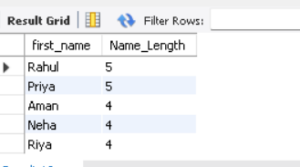

- Demonstrate CONCAT() using first and last names.
SELECT
first_name,
last_name,
CONCAT(first_name, ' ', last_name) AS Full_Name
FROM Students;
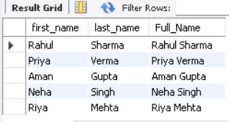

- Demonstrate SUBSTRING()/SUBSTR() with suitable examples.
SELECT
first_name,
SUBSTRING(first_name, 1, 3) AS First_Three_Characters
FROM Students;
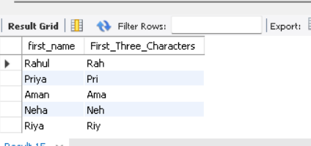

D. Conversion Functions
16. Convert a number into a character/string value.
SELECT
CAST(12345 AS CHAR) AS Number_As_String;
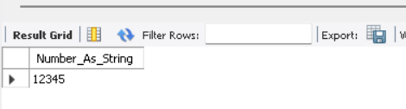

17.convert a string into a numeric value.
SELECT
CAST('12345' AS UNSIGNED) AS String_As_Number;
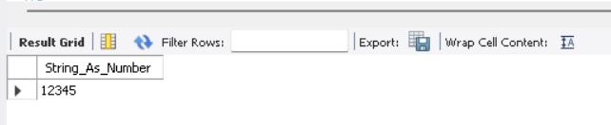

- Convert a date value into a different format.
SELECT
joining_date,
DATE_FORMAT(joining_date, '%d-%m-%Y') AS Formatted_Date
FROM Employees;
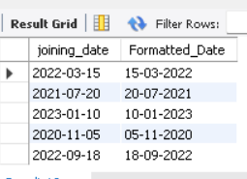

- Demonstrate CAST() with suitable examples.
SELECT
CAST(125.75 AS DECIMAL(10,2)) AS Casted_Value;
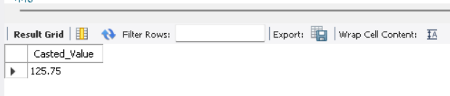
- Demonstrate CONVERT() where supported by the DBMS.
SELECT
CONVERT('2026-10-04', DATE) AS Converted_Date;

E. Date Functions
21. Display the current date using a suitable date function.
SELECT
CURDATE() AS Current_Date;

- Extract the year, month and day from a date.
SELECT
joining_date,
YEAR(joining_date) AS Joining_Year,
MONTH(joining_date) AS Joining_Month,
DAY(joining_date) AS Joining_Day
FROM Employees;
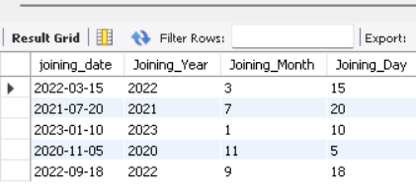

23.Find the difference between two dates.
SELECT
first_name,
joining_date,
DATEDIFF(CURDATE(), joining_date) AS Days_Difference
FROM Employees;
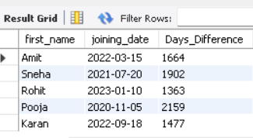

- Add a specified number of days to a date.
SELECT
joining_date,
DATE_ADD(joining_date, INTERVAL 30 DAY) AS Date_After_30_Days
FROM Employees;

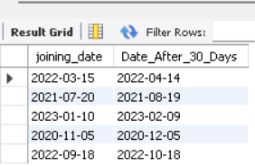
- Display employees' joining dates in a required date format.
SELECT
employee_id,
CONCAT(first_name, ' ', last_name) AS Employee_Name,
joining_date,
DATE_FORMAT(joining_date, '%d-%m-%Y') AS Required_Date_Format
FROM Employees;
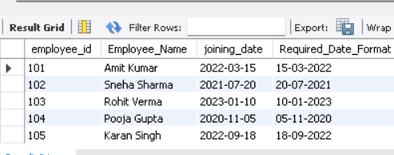

Note: Function names can vary slightly between MySQL, Oracle and SQL Server. Since
you use MySQL Workbench, these can be framed specifically for MySQL.
Submission:
1. Take screenshots of each step's output.
2. Save the SQL scripts in a text file.

