Jenkins :
Jenkins is a free, open-source tool that helps developers automate the process of building, testing, and deploying code. It is written in Java and runs on the Java platform. By using Jenkins, we can make a continuous integration of projects(jobs) or end-to-end automation.
important concepts :
- Jenkins controller(master): he Jenkins Controller serves as the central system for managing a Jenkins instance, often referred to as its "heart." It oversees agents and their connections, determining the tasks they should perform. Additionally, the Jenkins Controller loads plugins and ensures that jobs run in the correct sequence.
- Jenkins agent(slave):Jenkins Agent is a machine that performs tasks like running scripts, executing tests, or building components, etc. These tasks are assigned by the Jenkins Controller. Each agent can have its setup, like different operating systems, software, or hardware. This helps Jenkins handle many types of tasks and work faster by spreading the load.
There are two main types of agents:
Permanent Agents: These are always ready and connected to Jenkins.
Ephemeral Agents: These are temporary. Jenkins starts them only when needed, usually in the cloud or using tools like Docker.
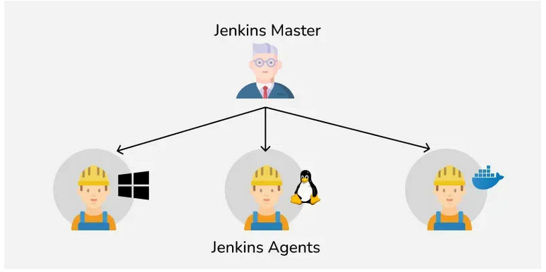

3. Jenkins Node:A Jenkins Node is a term that is used in Jenkins 2.0 to mean any system that can run Jenkins jobs. This is mainly used in Controllers and Agents and sometimes used instead of those terms. A node is a machine that Jenkins uses to run jobs like building and testing projects
4. Jenkins job:Jenkins jobs are used to perform the work in the Jenkins system. A jenkins jobs is an automated job that you set up in jenkins to do things like build, test or deploy your code. Instead of doing these steps manually every time.
5. Jenkins pipeline: pipelines can automate the processes like building, testing, and deploying the application. With the help of Continuous Integration / Continuous Deployment (CI/CD) Pipeline scripts we can automate the whole process which will increase productivity and save lots of time for the organization
6. jenkins plugins: provides 2000+ community contributed Jenkins plugins which developers can use for building, deploying and automating any project.

Jenkins Declarative Pipeline
A Jenkins Declarative Pipeline is a structured and simplified approach to defining your continuous integration and continuous delivery (CI/CD) pipelines in Jenkins.
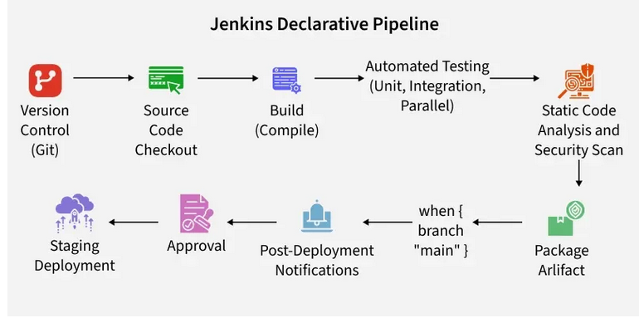

Syntax of jenkins declarative pipeline to build & push docker imageThe following Declarative Pipeline can be used to build and docker push the docker image to DockerHub.

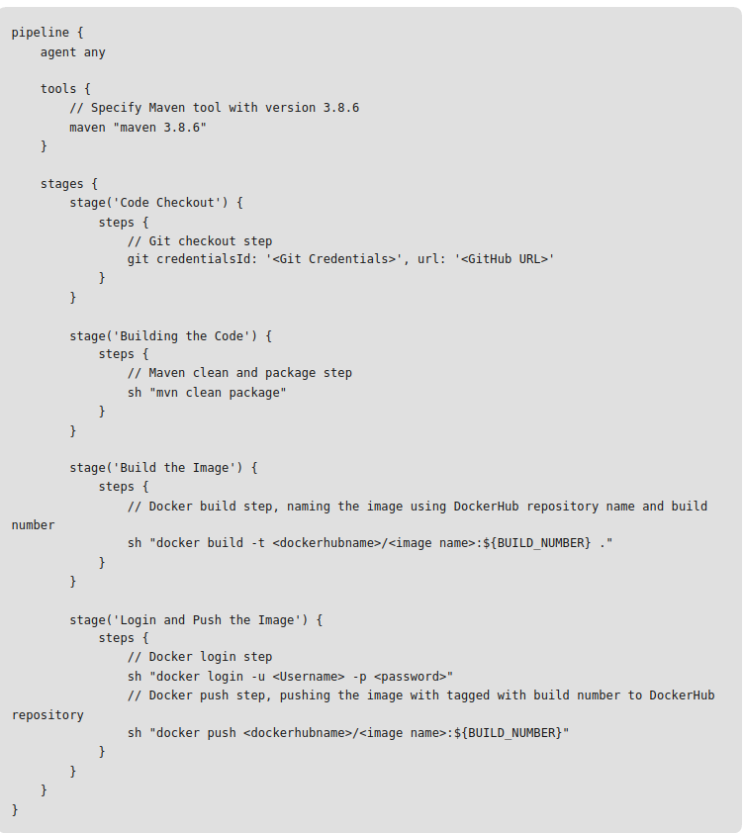
agent any: This specifies that the pipeline can run on any available agent.
tools: This block defines the tools required for the pipeline. Here, Maven is specified with version 3.8.6.
stages: This block defines the different stages of the pipeline.

Why Use Jenkins Declarative Pipeline?

Simplified Syntax: Declarative Pipeline uses a cleaner, more readable syntax, which reduces the complexity.
Built-in Error Handling: Error handling is simplified with Declarative Pipelines. The pipeline stops execution automatically when an error occurs,
mproved Maintainability: Due to its structured approach, Jenkins Declarative Pipeline is easier to maintain.
Consistency: Declarative Pipelines enforce consistency across different pipeline jobs, ensuring that all pipelines follow the same structure.

