TECH PRODUCT MANAGEMENT
Final Prototype Submission

LinkedIn Learning
Skills Prototype
Closing the Skills-to-Career Gap

SUBMITTED BY
Parikshit Ambhore
Spring 2026

PROTOTYPE OVERVIEW
About the Prototype
LinkedIn Skills is a personalized career-intelligence hub built directly into the LinkedIn home page. Instead of burying LinkedIn Learning behind multiple clicks and generic recommendations, this prototype introduces a dedicated Skills widget in the top navigation bar and left sidebar. From there, users can take a 3-minute skill assessment, see real job match percentages against roles like Product Manager, Data Analyst, and UX Research Lead, and receive course recommendations tailored to close their specific skill gaps.
The prototype covers an 8-screen interactive flow: Home → Dashboard → Assessment Intro → Quiz → Results → Gap Analysis → Courses → Course Detail. It includes animated counters, a skill radar chart, before/after gap analysis with visualized match-score improvements, and personalized Learning Paths that bundle related courses for bigger career outcomes.
The goal is to directly address two validated user pain points: low awareness of LinkedIn Learning, and a lack of clear connection between courses and real career outcomes. By making skills, jobs, and learning visible in one integrated experience, we aim to drive awareness, engagement, and long-term retention on LinkedIn Learning.
LIVE INTERACTIVE PROTOTYPE
https://parikshit7319.github.io/li-skills-prototype/
Works on desktop, tablet, and mobile. No login required.
IN THIS DOCUMENT
Screens 1 – 8 of the complete interactive prototype, each shown on its own page with a short description of what it does and why it matters.

SCREEN 01
LinkedIn Home Feed
The new "Skills" widget appears in the left sidebar and top navigation bar with a "NEW" badge. A promo card in the feed reinforces discovery of the personalized learning experience.
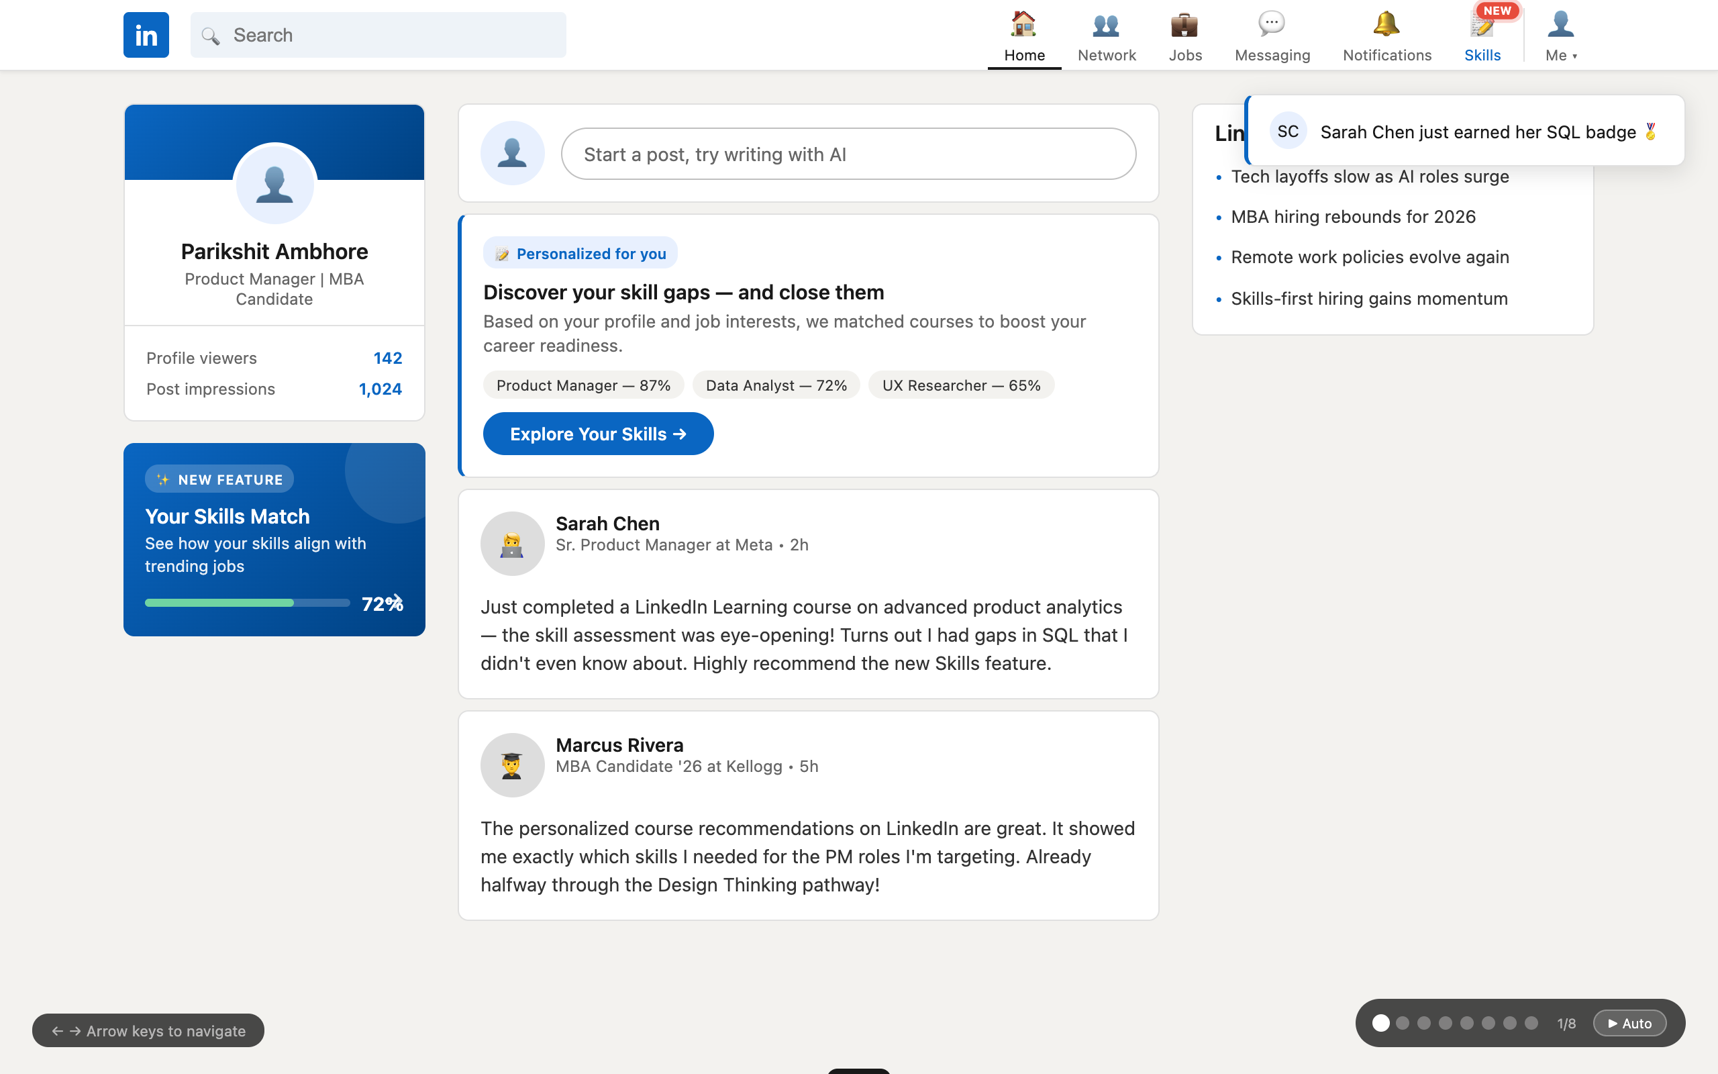
Figure 1. LinkedIn Home Feed — live URL: parikshit7319.github.io/li-skills-prototype/

SCREEN 02
Skills Dashboard
Personalized skill profile with strength bars and top job matches (Google, Meta, Spotify, Stripe). Job match percentages make career impact immediately visible.
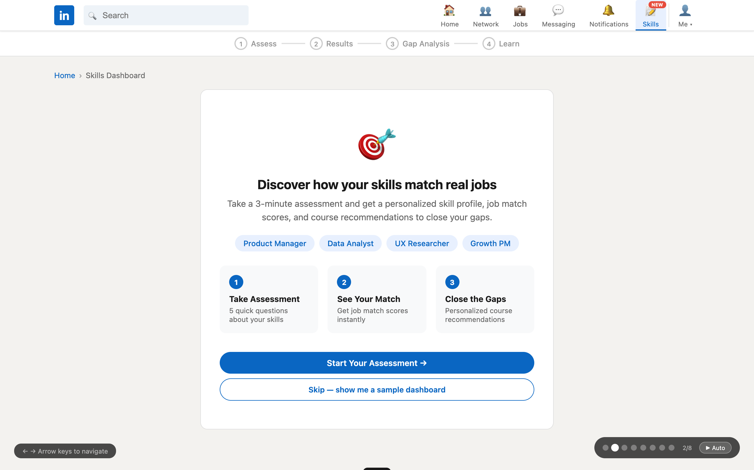
Figure 2. Skills Dashboard — live URL: parikshit7319.github.io/li-skills-prototype/

SCREEN 03
Assessment Introduction
Role-based onboarding. Users identify themselves as a Job Seeker, Upskilling Professional, or Career Switcher to personalize their assessment.
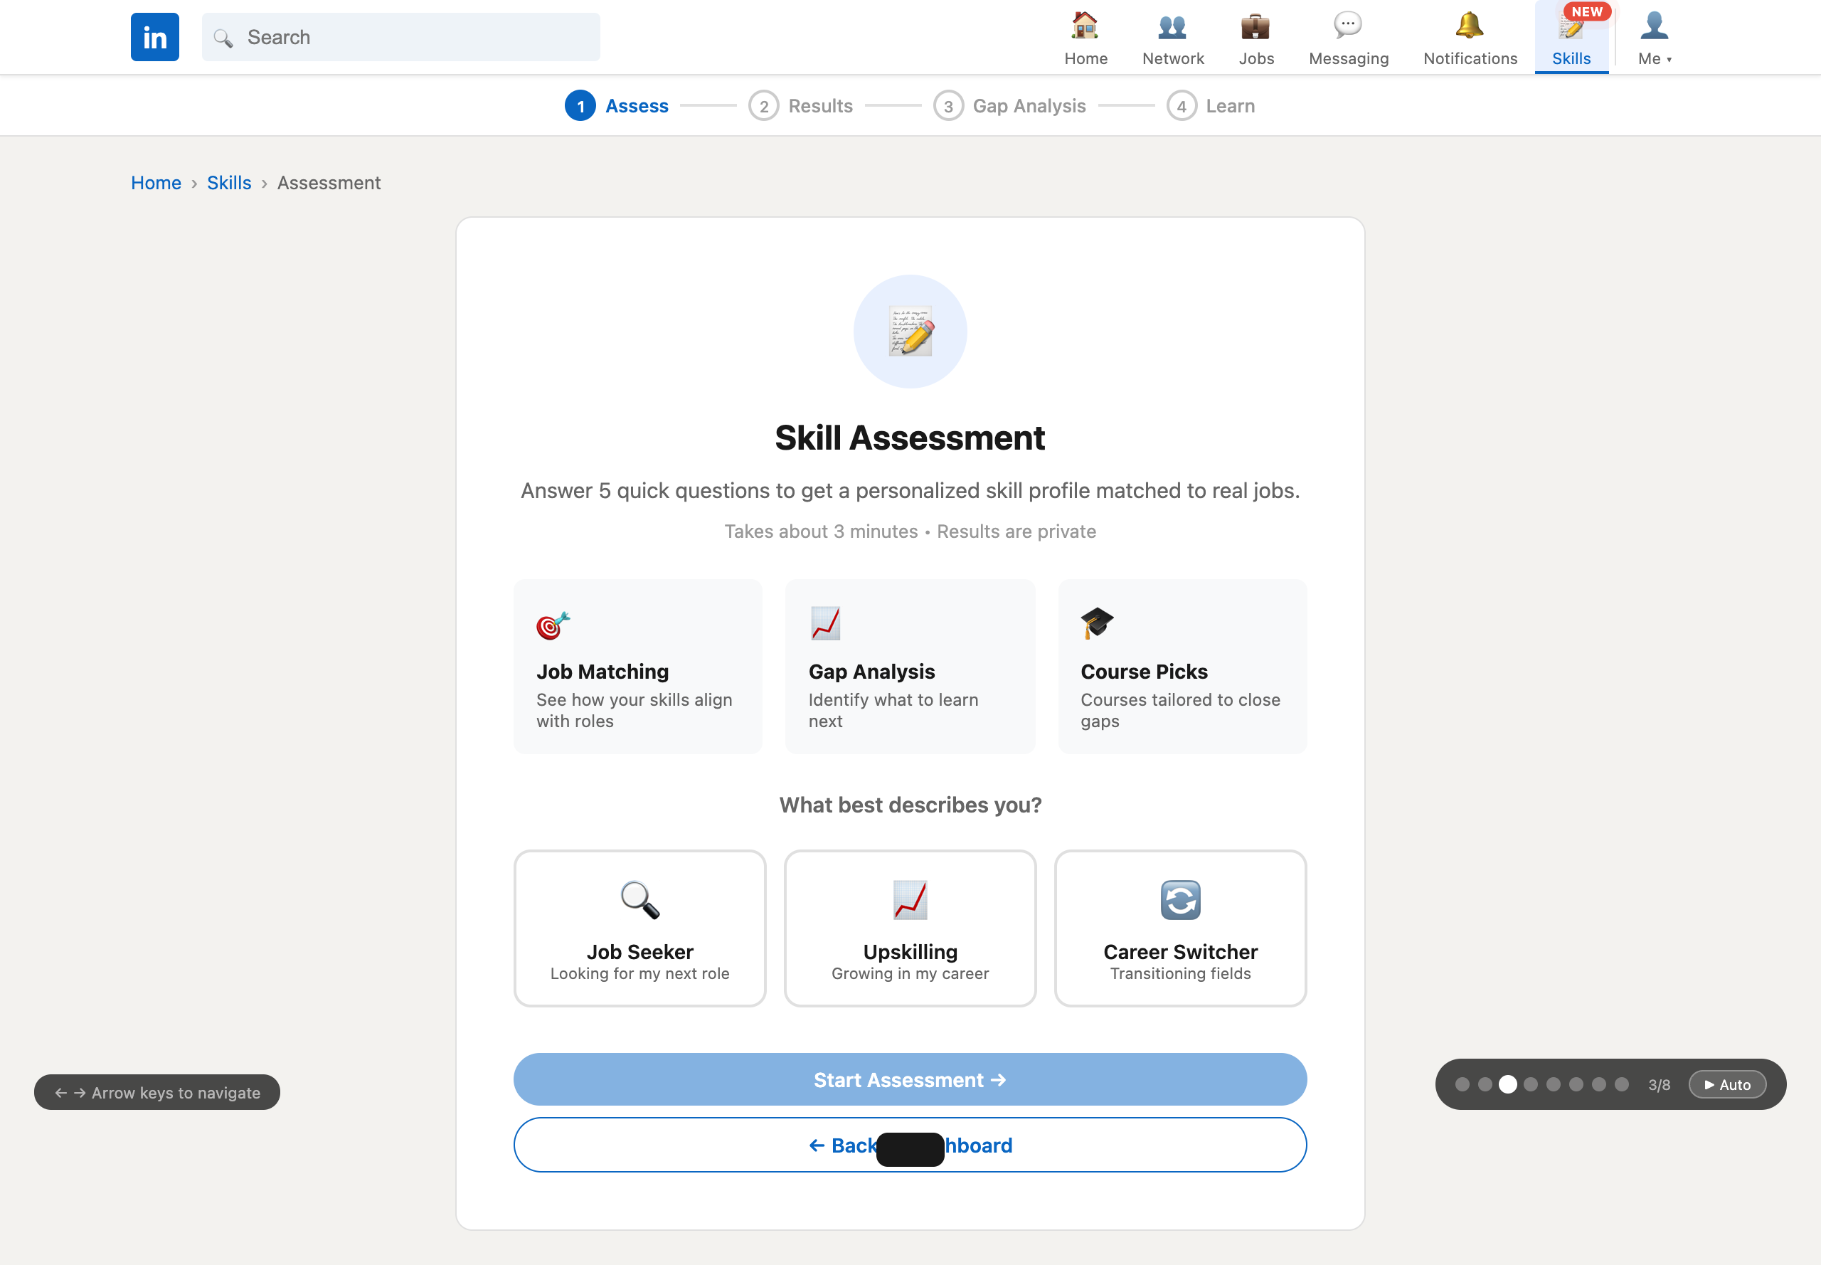
Figure 3. Assessment Introduction — live URL: parikshit7319.github.io/li-skills-prototype/

SCREEN 04
Skill Assessment Quiz
5 short questions with real-time, encouraging feedback after each answer. Progress bar, skip option, and category tags make the experience friction-free.
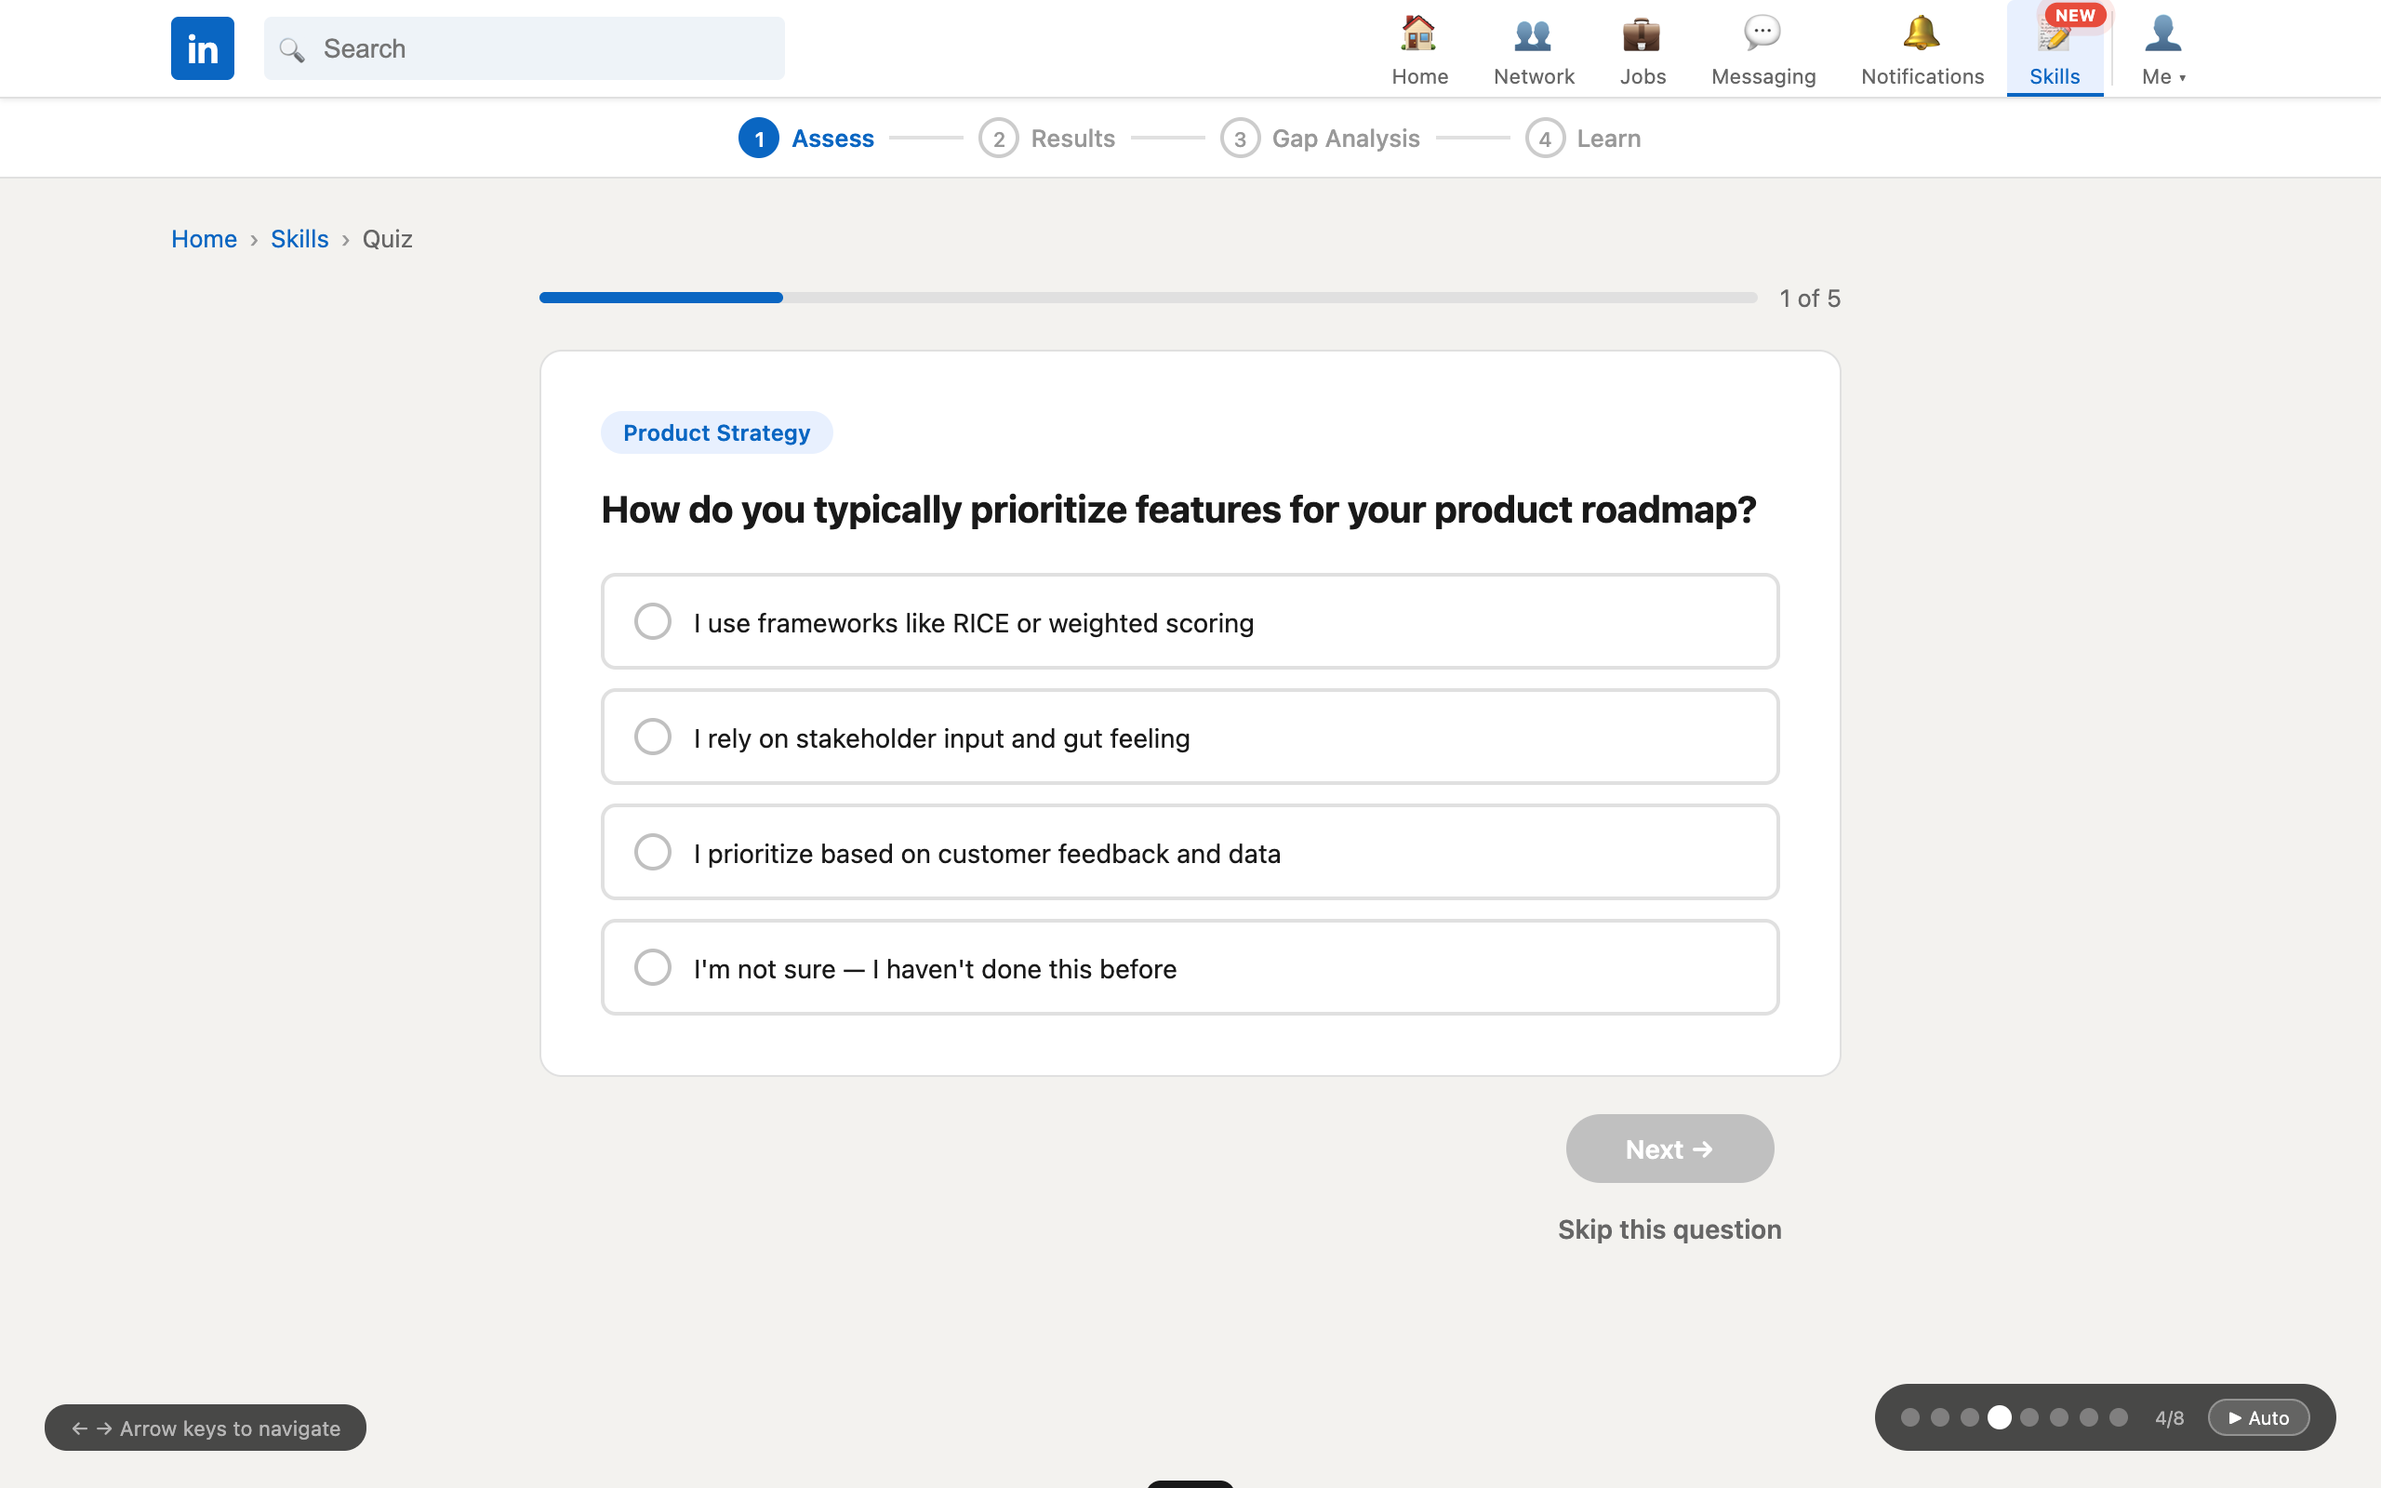
Figure 4. Skill Assessment Quiz — live URL: parikshit7319.github.io/li-skills-prototype/

SCREEN 05
Assessment Results
Animated score circles, a skill radar chart showing your unique skill "shape," and a "You vs. Average PM Candidate" comparison. Confetti celebrates completion.
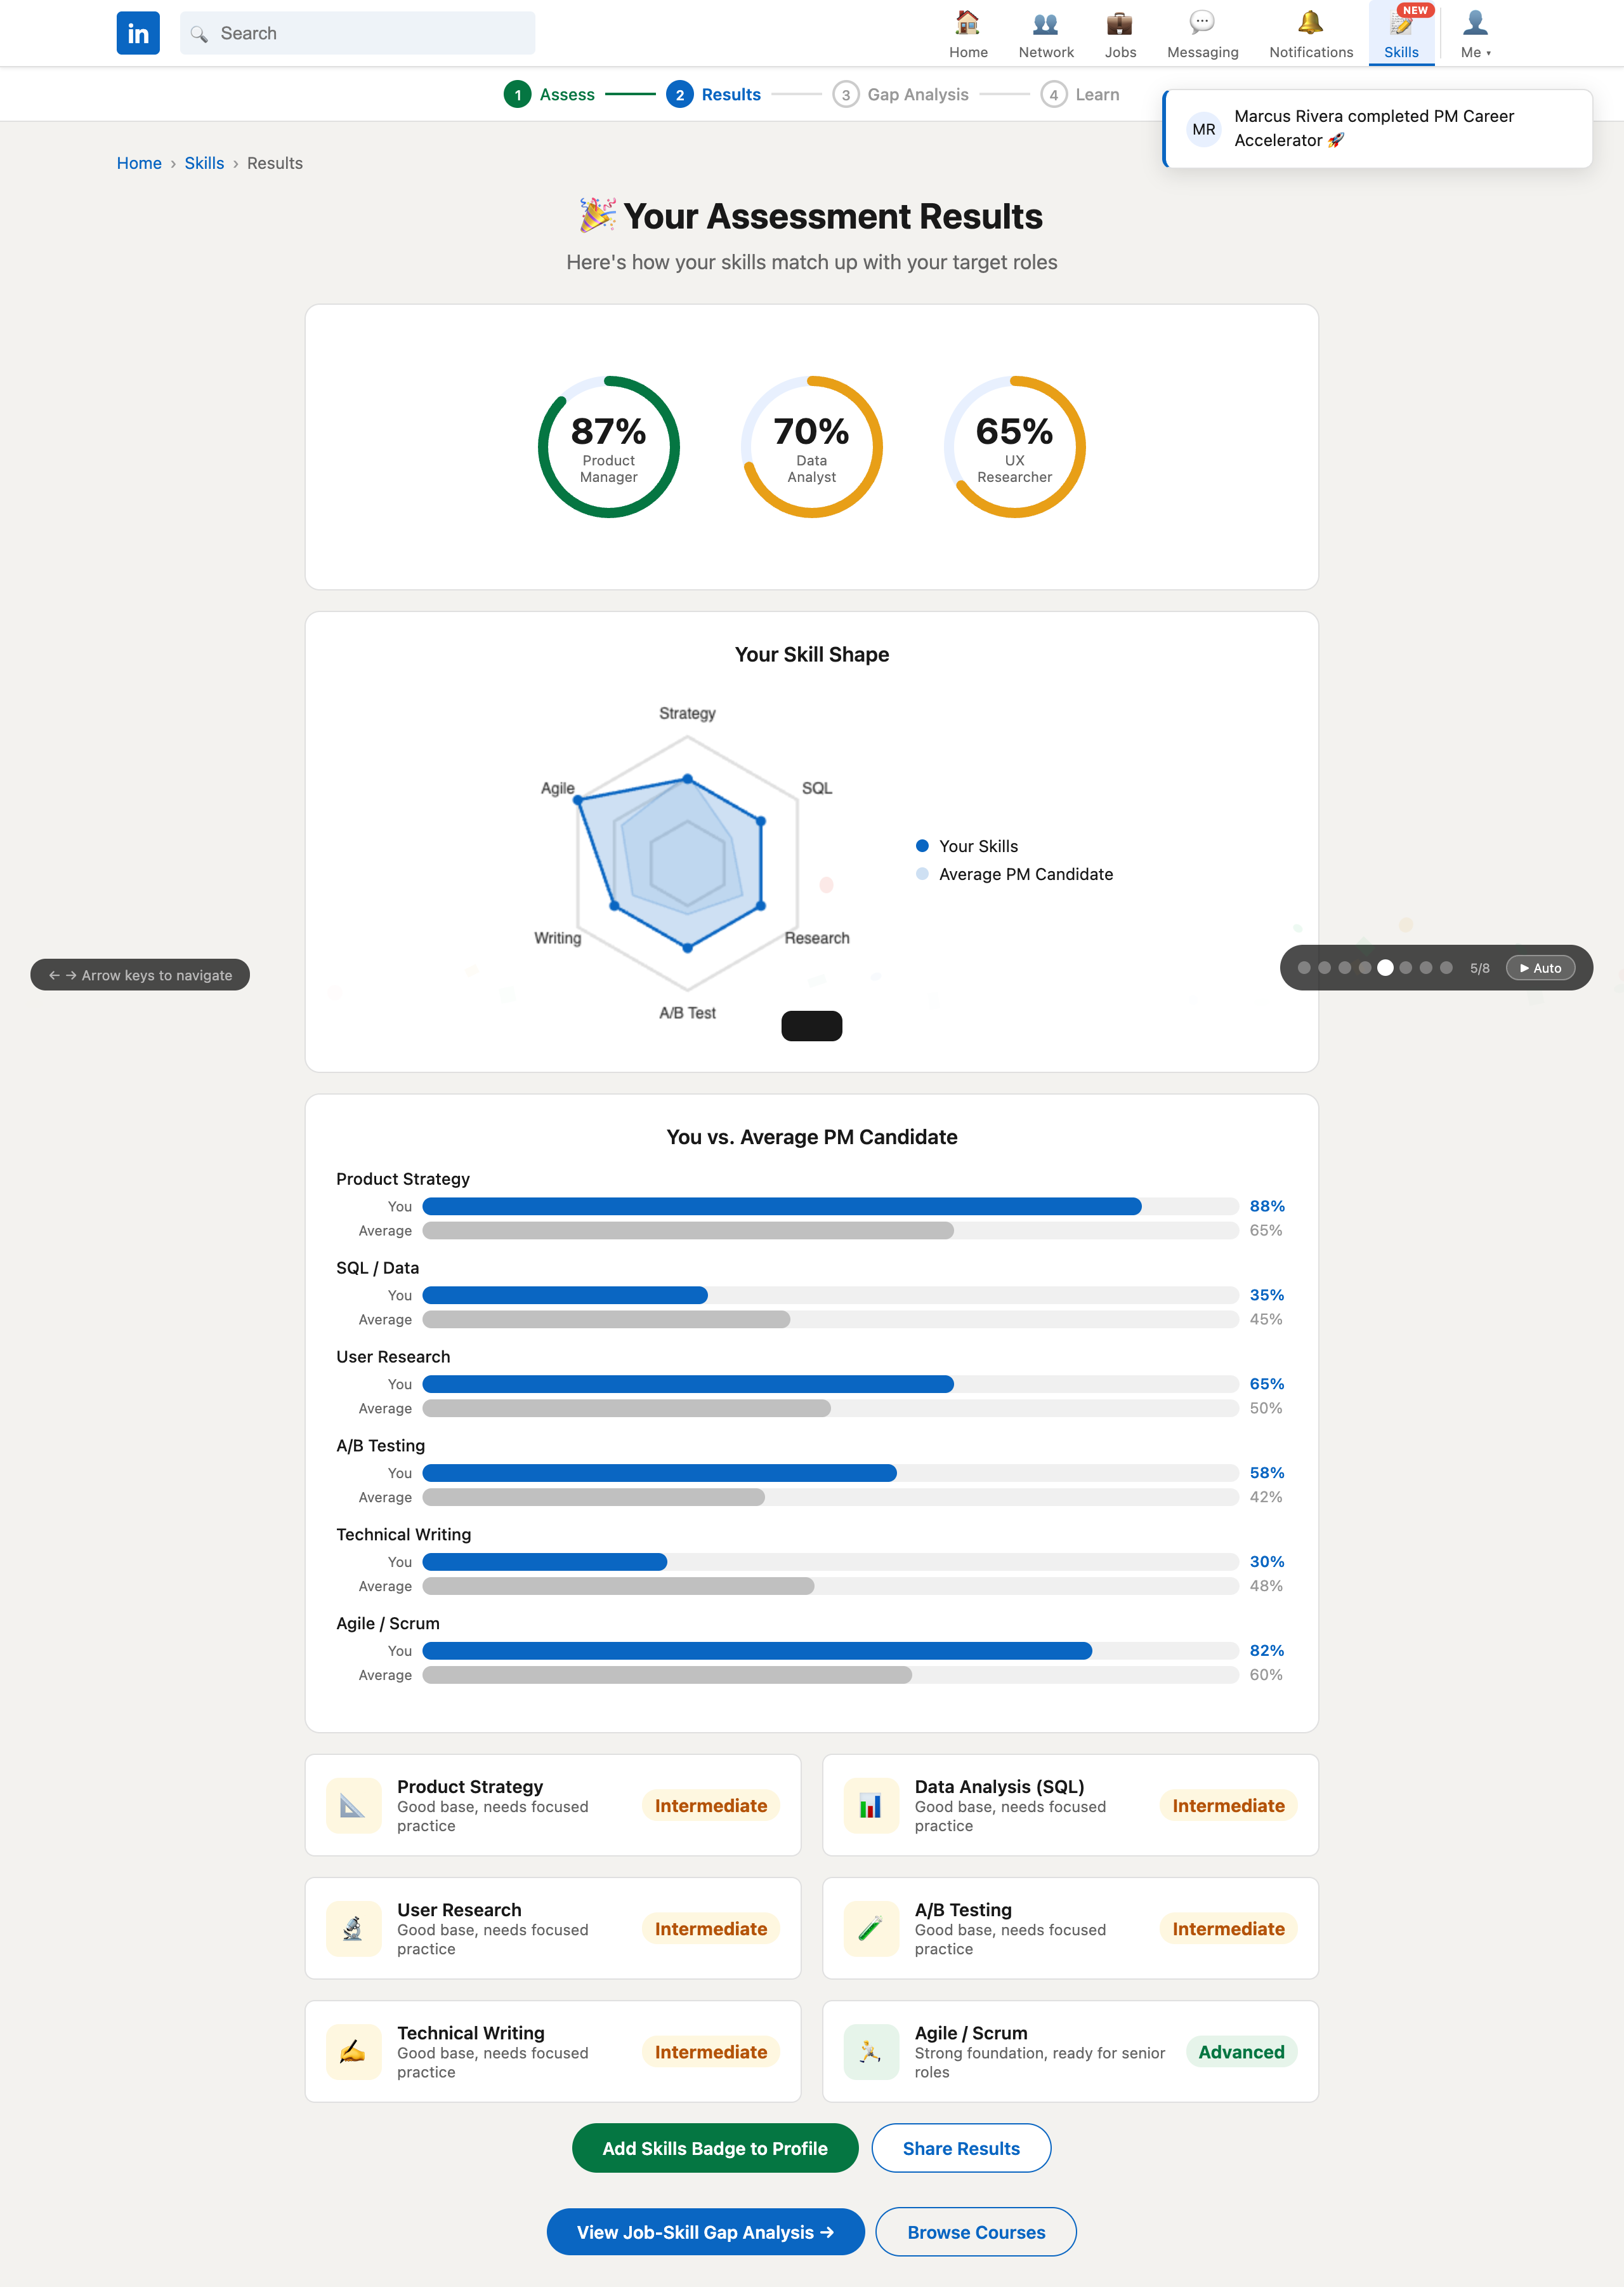
Figure 5. Assessment Results — live URL: parikshit7319.github.io/li-skills-prototype/

SCREEN 06
Job-Skill Gap Analysis
Green tags = skills you have; red tags = skills you need. A Before/After toggle shows projected job-match scores if the user completes the recommended courses.
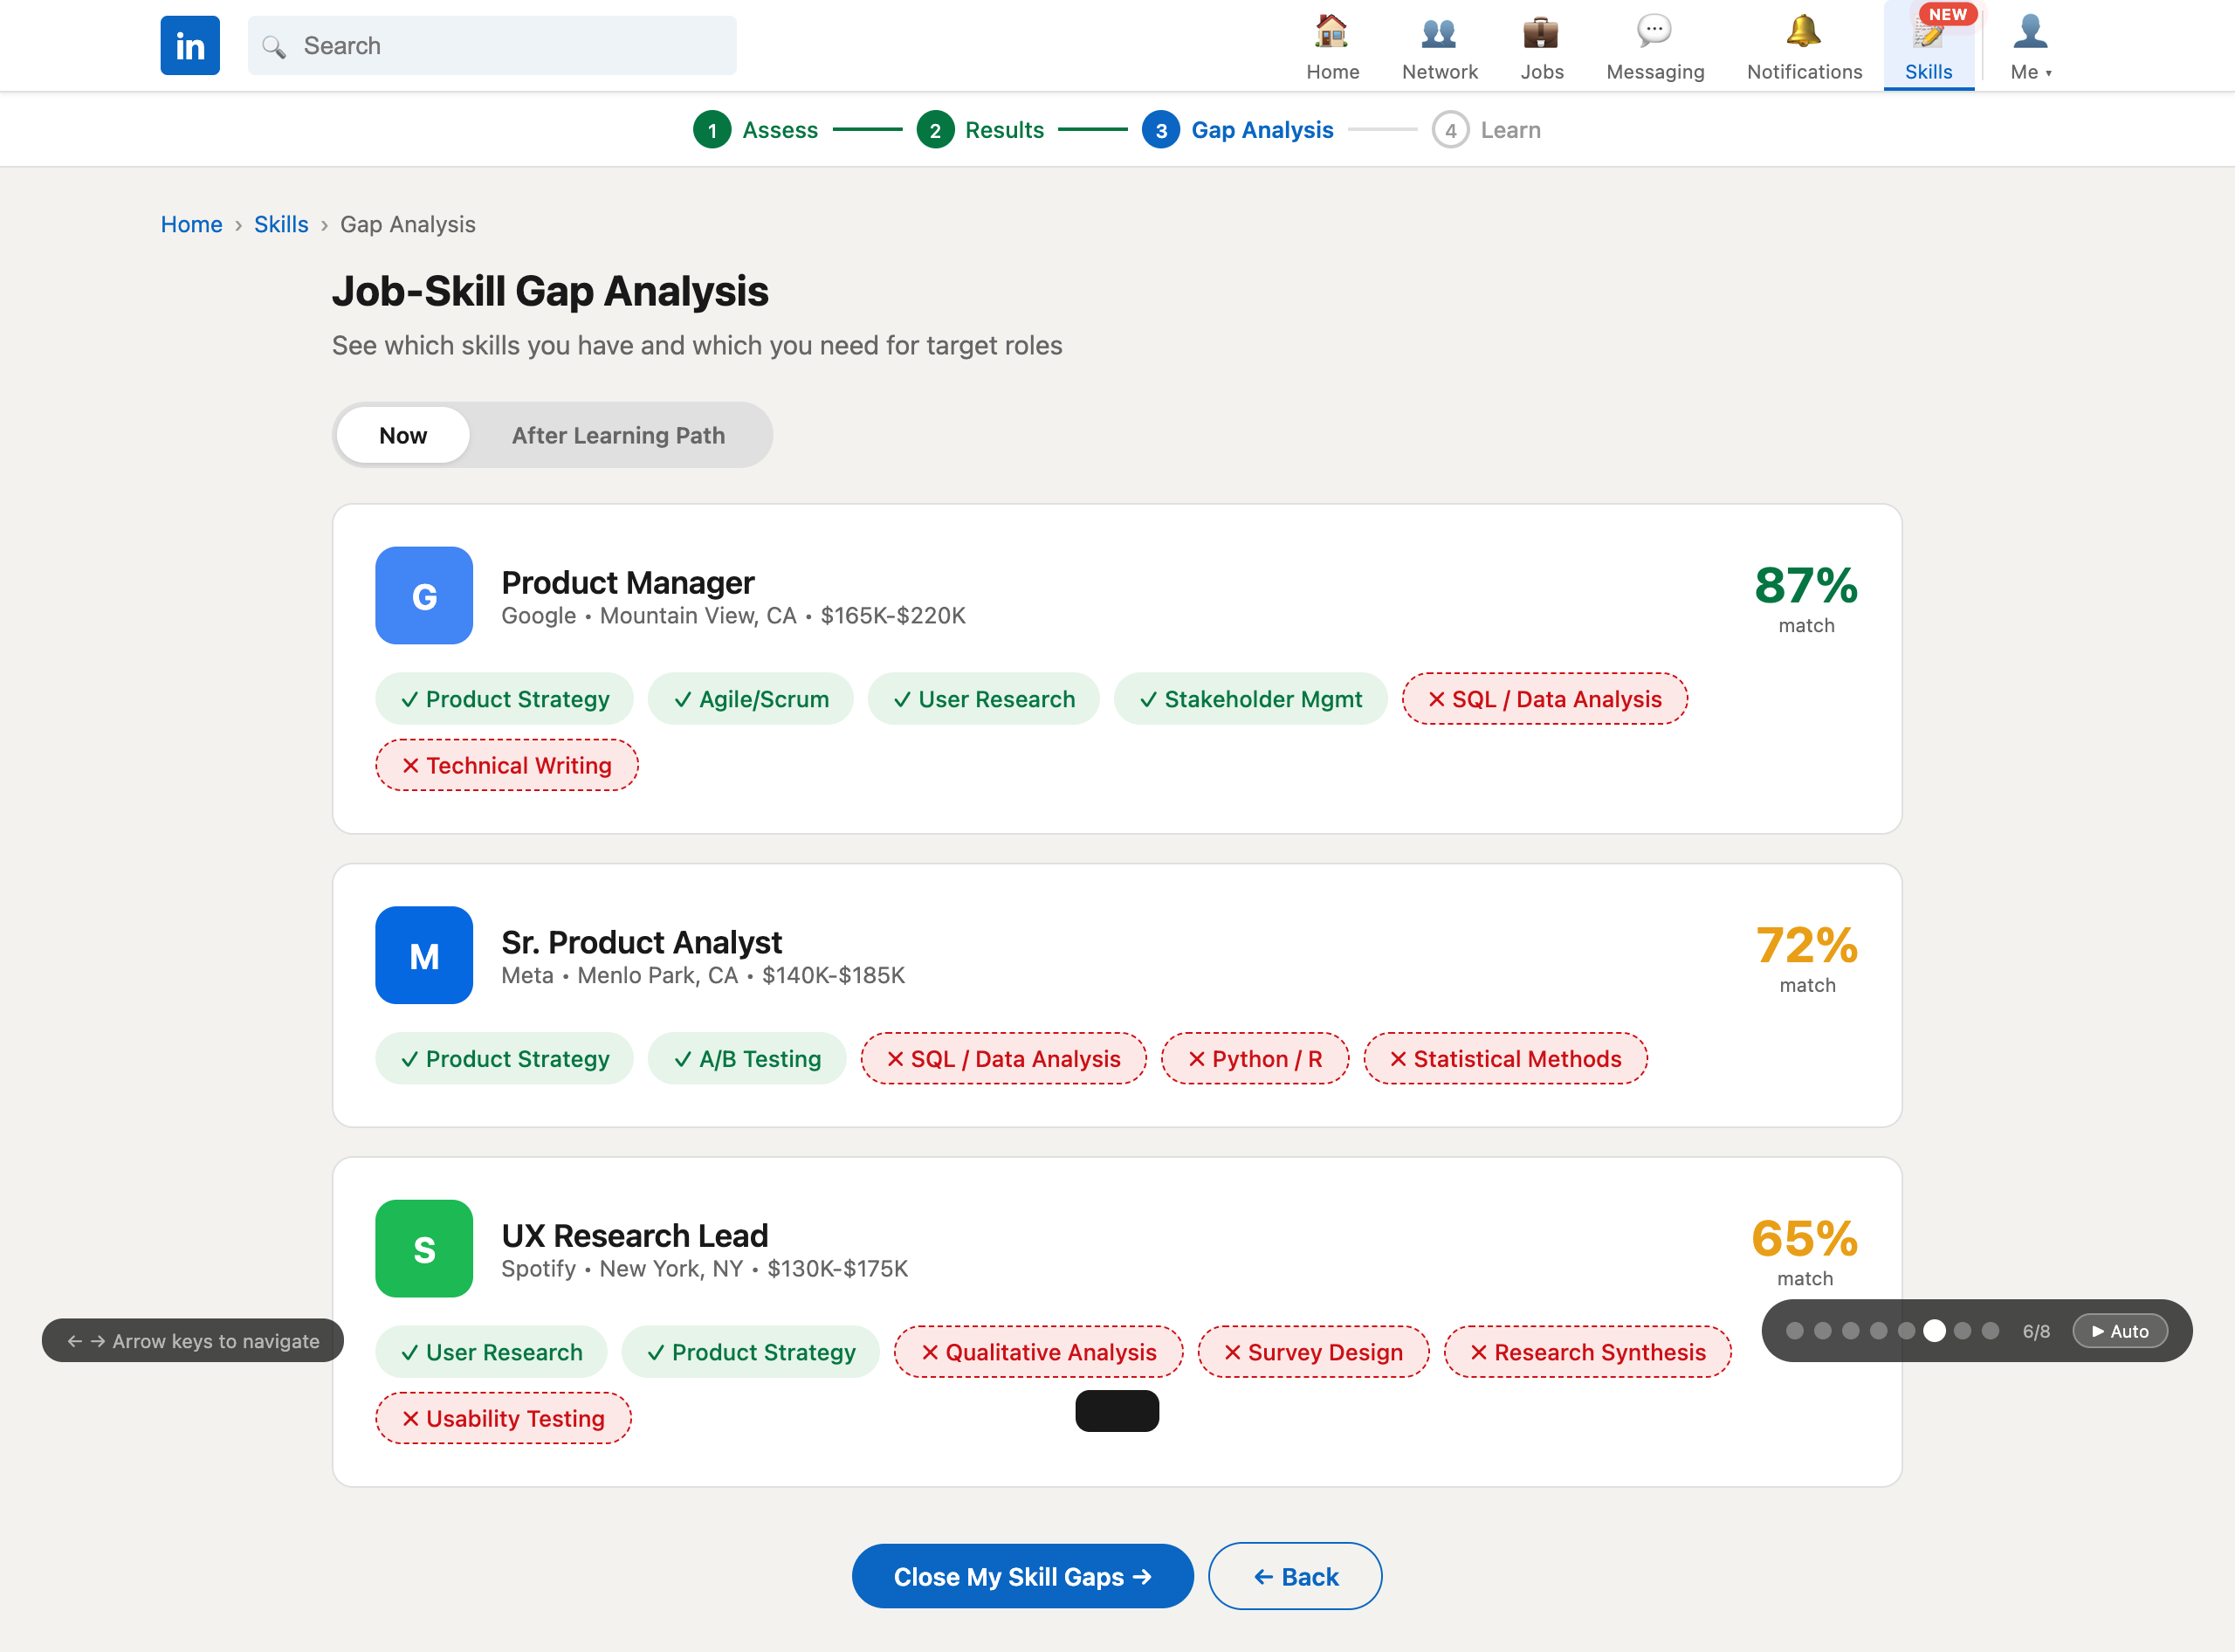
Figure 6. Job-Skill Gap Analysis — live URL: parikshit7319.github.io/li-skills-prototype/

SCREEN 07
Personalized Course Recommendations
Courses tailored to close specific skill gaps, with social proof ("Sarah M. and 11 others completed this") and explicit impact callouts ("+15% job match for PM").
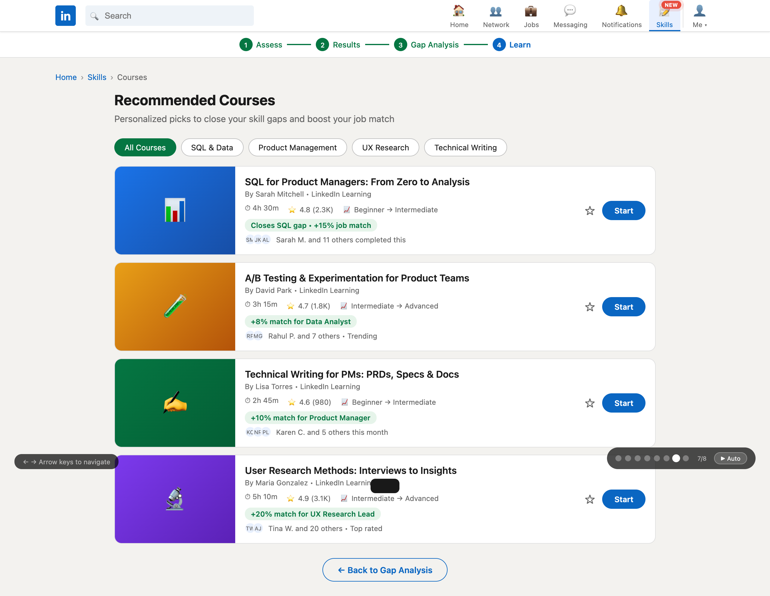
Figure 7. Personalized Course Recommendations — live URL: parikshit7319.github.io/li-skills-prototype/

SCREEN 08
Course Detail
Video preview, modules with progress tracking, learner reviews, skills-you-will-gain, and an "Impact on Your Profile" panel showing exactly how completion boosts match scores.
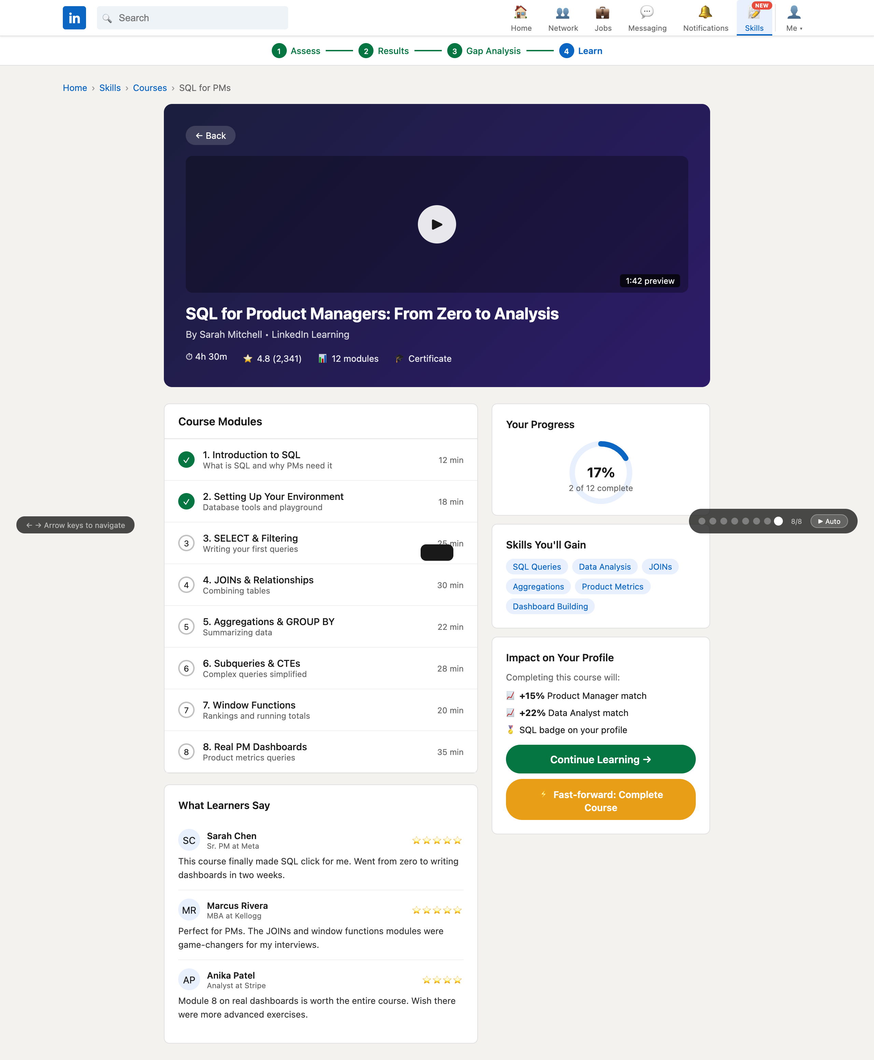
Figure 8. Course Detail — live URL: parikshit7319.github.io/li-skills-prototype/

GETTING STARTED
How to Use / Test the Prototype
Open the live prototype at parikshit7319.github.io/li-skills-prototype in any modern browser. No installation or sign-in required.
Navigation Controls
- Click to explore: Every button, card, widget, and link is interactive. Start on the LinkedIn home screen and click the blue "Skills" widget or nav item to enter the flow.
- Arrow keys (← →): Use left/right arrow keys to move through the 8 screens in order. Perfect for walkthroughs and class presentations.
- Presenter dots: A small dark pill at the bottom-right shows which screen you're on (e.g., 3/8). Click any dot to jump to that screen.
- ▶ Auto button: In the same bottom-right pill, click "▶ Auto" to auto-advance through all 8 screens every 9 seconds — ideal for passive demos or Q&A.
- Take the quiz: Answering the 5-question assessment produces dynamic match scores and a radar chart tailored to your responses.
- Before/After toggle: On the Gap Analysis screen, click "After Learning Path" to see red skill gaps flip to green and match scores jump. This sells the value proposition visually.
- Fast-forward course: On the Course Detail screen, click "Fast-forward: Complete Course" to see the projected match-score increase animate in real time.
Credits
Course: Tech Product Management • Spring 2026
Prototype built with HTML, CSS, and JavaScript. Hosted on GitHub Pages.

