1. <https://phoenix.craigslist.org/>  
   > Adaptive website

The website does not resize/re-align the UI components based on the screen dimensions, but mobile and desktop have different look and feel for the same website. (You may notice the body tag class name is different for desktop and mobile)

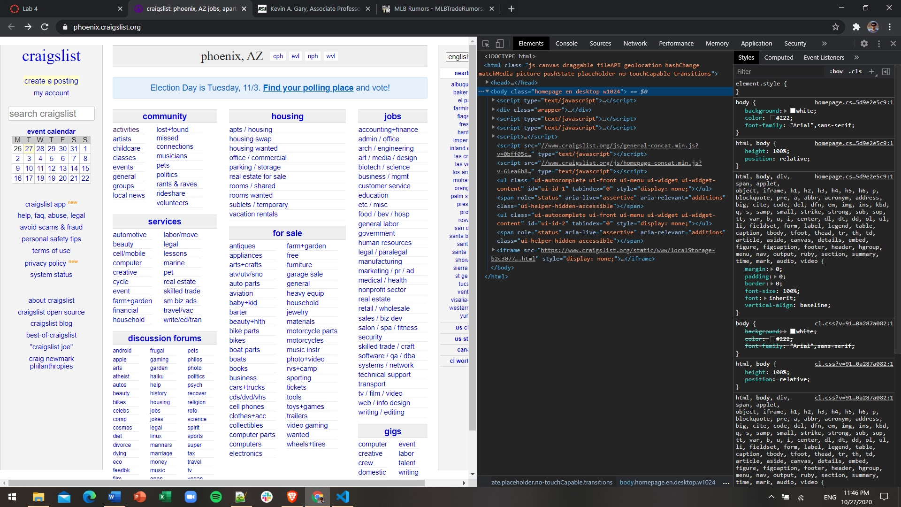

Figure : The website is not resizing the components upon reducing the screen size

Figure : The website has different look and feel when the rendering is viewed as from iPhone X

1. <https://www.public.asu.edu/~kgary/>  
   > Responsive website  
   The website resizes and re-aligns its components on reducing the screen size, but same website is rendered on mobile and desktop.

Figure : Website resizing/realigning its components upon reducing screen size

Figure : The website has same look and feel when rendering viewed from iPhone X

1. <https://www.mlbtraderumors.com/>  
   > Both responsive and adaptive  
   The website resizes and re-aligns its components on reducing the screen size, but mobile and desktop have different look and feel for the same website.

Figure : Website resizing/realigning its components upon reducing screen size



Figure : The website has different look and feel when the rendering is viewed as from iPhone X