**Problem Statement:** In this project, you should be able to develop a front-end web app using Angular and a Java backend using Spring Boot, configure the applications using Docker containers, deploy the project on AWS using CI CD Pipeline

**Real-World Scenario:** Medicare is a company that supplies medicines and a couple of other healthcare essentials at an affordable price. They found out that online ordering of medicines with companies, such as 100mg and mfine are gaining more profits by eliminating middlemen from the equation. As a result, the team decided to hire a full-stack developer to develop a healthcare web application with a rich and user-friendly interface.

**Roles:** Admin, User

**Technology stack :**

**Front End:**  Angular

**Back End:**  Spring boot + Mysql

**Testing :**

backend - Junit and postman

Frontend- selenium with cucumber

**DevOps:** Docker, Jenkins

**Cloud**: AWS-EC2

**Admin :**

Add the medicines

Edit the medicine details

Delete the medicine details

See the orders

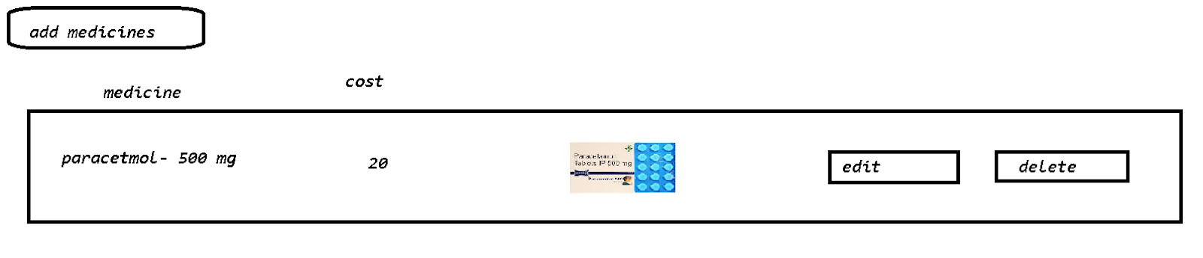

Orders :

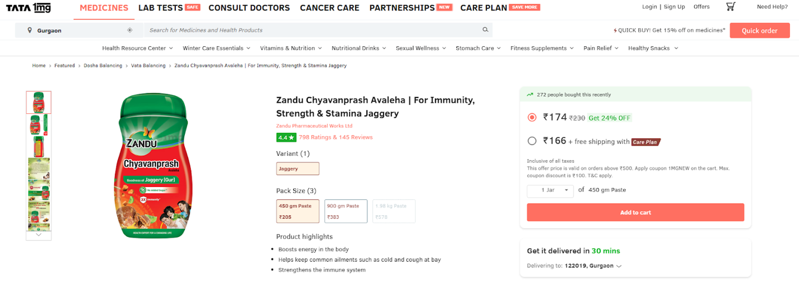

User : <registration,login>

1. Search the medicine
2. Give the number quantity of the medicine
3. Add to the cart-> Fill the address details
4. Make a dummy payment
5. Orderid
6. History

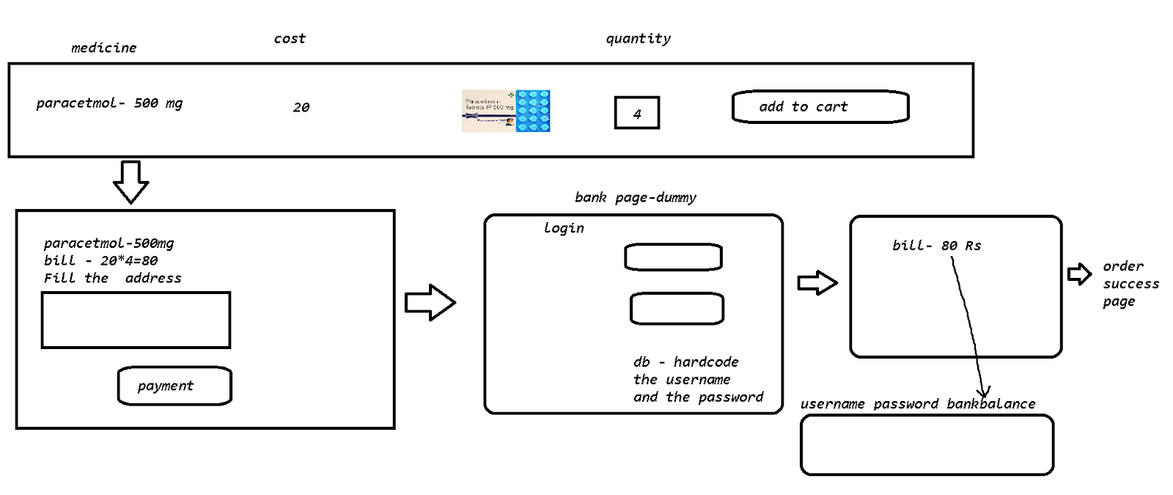

Development

Angular with spring boot :

<https://docs.google.com/document/d/1E-Nt4Se4dBFLcWLKbd2xvwMcUMIda6hadTXhMA9yNNw/edit?usp=sharing>

DevOps

Angular with spring boot application :

<https://docs.google.com/document/d/1BfxD_woyCnPVYUkp4Rf4WwMhTFWyu7V-03aFQciujn4/edit?usp=sharing>

Back End : <identify the modules>

1. Identify the POJO
2. Create a service - junit
3. Create a RestController - via Postman
4. @CrossOrigin(origins = "*")

Front End :

1. Identify the service for the back end opr
2. Identify the components

=> Check the integration of ang and spring boot -E2E

=>Test it with selenium and cucumber

===========================================================

DevOps :

Back end :

1. Push the code into the github
2. Create a Docker file
3. Create a ci/cd pipeline for making a war file -> push this onto the docker hub
4. Create the ec2 instance deploy the image and run it -[use for MySQL RDS ]

Copy the URL of the endpoints from the instance

Front End :

1. Update the service file with the necessary back end -url

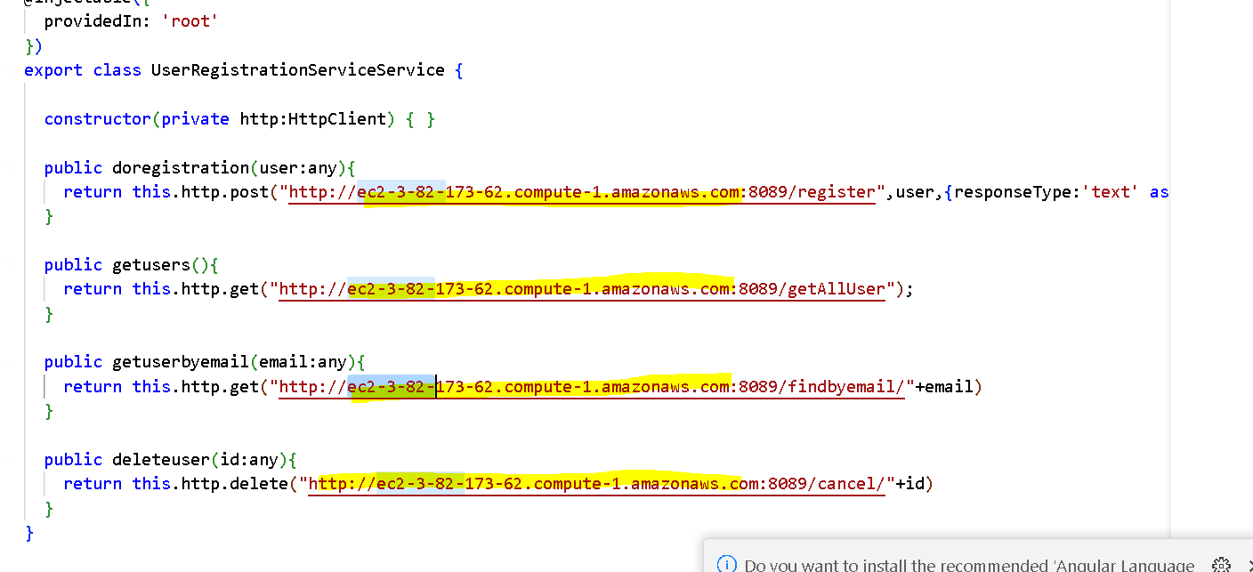

1. Make a build of the FE
2. Upload this build files in the S3 bucket

Use the static cloud URL as the main URL