

**SEMINAR**

**-:PROJECT TITLE:-**

**HOME INTERIOR DESIGN**

Made by:-

**Parimal Chaudhari**

**Roll No.-13**

**PRN-2010121245025**

**CONTENT**

|  |  |
| --- | --- |
| 1. | Abstract |
| 2. | Introduction |
| 3. | Theory |
| 4. | Codes |
| 5. | Output |
| 6. | Conclution |

**ABSTR ACT**

This project uses all of the knowledge that we have learned throughout the seminar.

I designed a website for Home Interior Design. I used HTML(Hyper Text Markup Language) and CSS(Cascading Style Sheets) Language . In This Website our client edit the design and send you, how your interior place look like after editing.

**INTRODUCTION**

Now a days peoples switch their life in very fast mode. Every person is always looks for saving time whenever it is possible. Now it is the habit of humans to do most of the things online or through online medium.

Functional beauty is another core concept of modern interior design. Designers will equip rooms with the latest technological advances so that convenience is king.

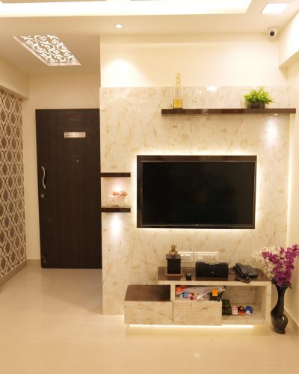

Interior designers make indoor spaces functional, safe, and beautiful by determining space requirements and selecting essential and decorative items, such as colors, lighting, and materials.

They must be able to draw, read, and edit blueprints.

Interior design is the art and science of enhancing the interior of a building to achieve a healthier and more aesthetically pleasing environment for the people using the space.

These websites or other apps saves time of travelling from home to Shop and Shop to home, also saves the expenses of traveling.

It is a better option to those people who don't have time to go to shop or who don't want to go there.

It saves time and energy as well.

***THEORY***

To run the website you can use any type of browser such

As Google Crome ,Microsoft Edge or any other browser. For codes we has used VS code(visual Studio code) .

The commonly used tags :-

1.div():-The <div> tag defines a division or a section in an HTML document. The <div> tag is used as a container for HTML elements - which is then styled with CSS or manipulated with JavaScript.

2.body():-The <body> tag defines the document's body. The <body> element contains all the contents of an HTML document, such as headings, paragraphs, images, hyperlinks, tables, lists, etc.

3.html():-HTML tags contain three main parts: opening tag, content and closing tag. But some HTML tags are unclosed tags.

**HTML Format:-**

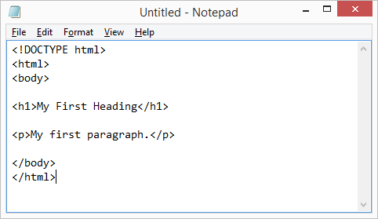

**Codes:-**

**For index page:**

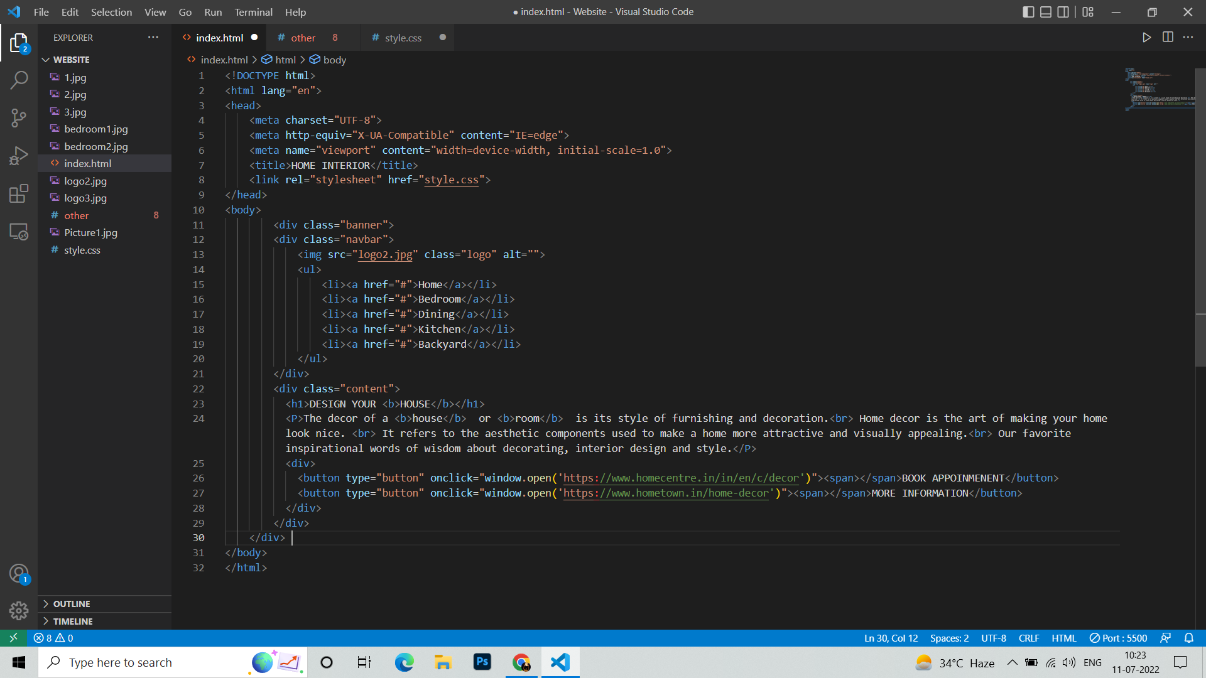

For CSS Page:--

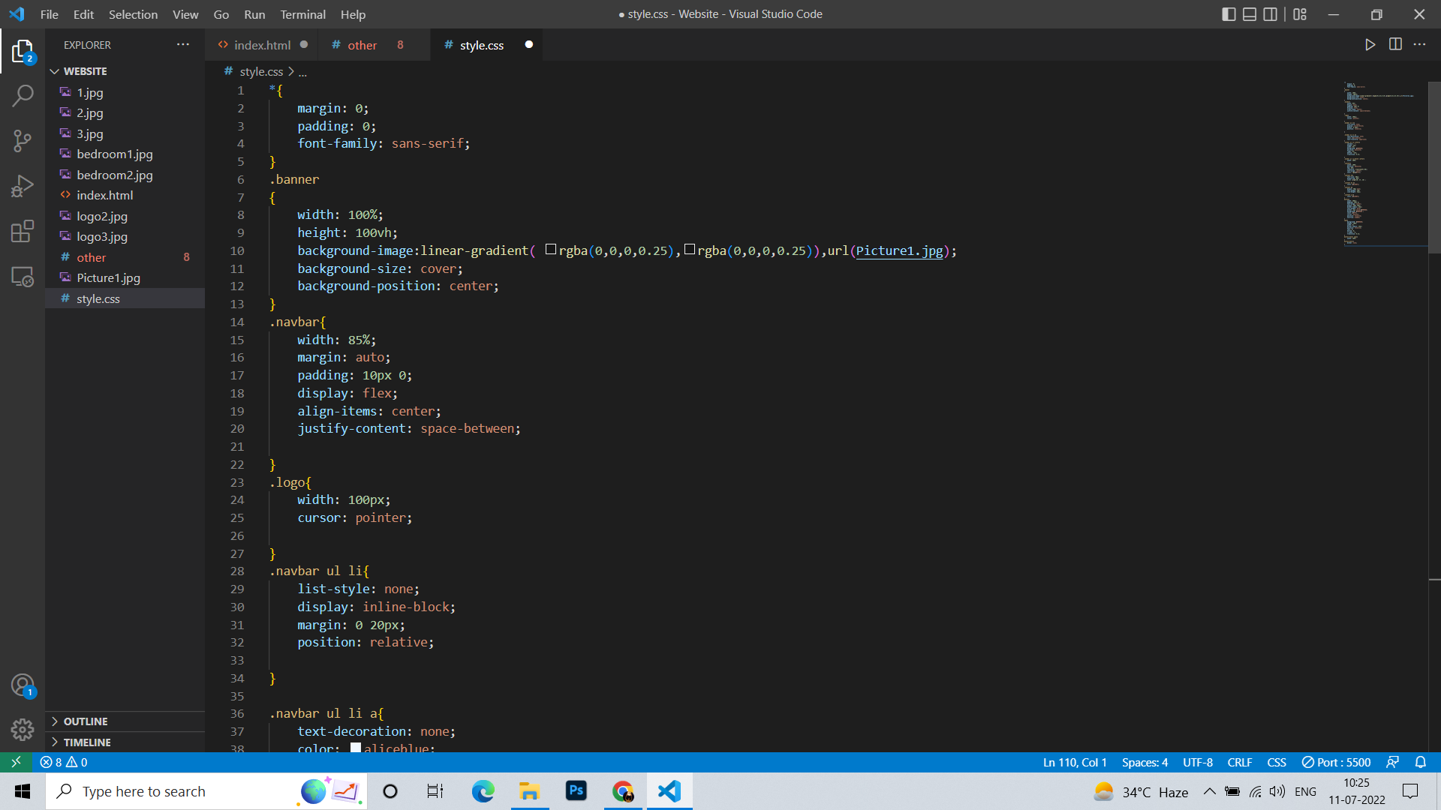

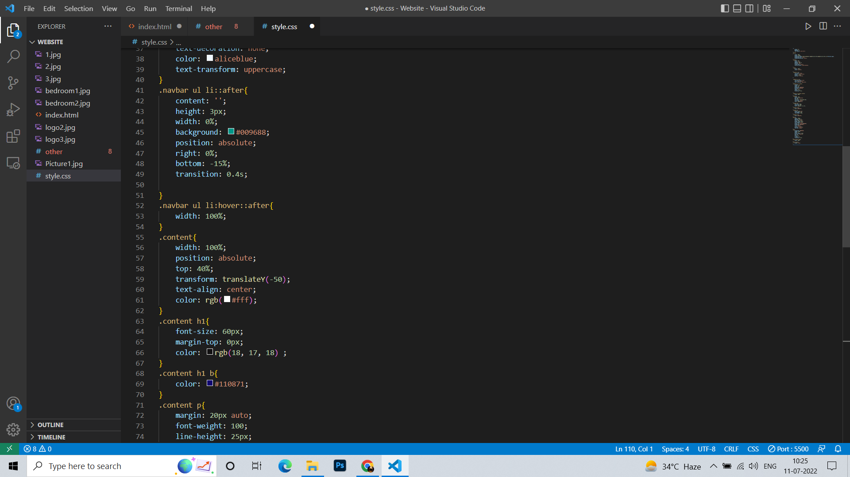

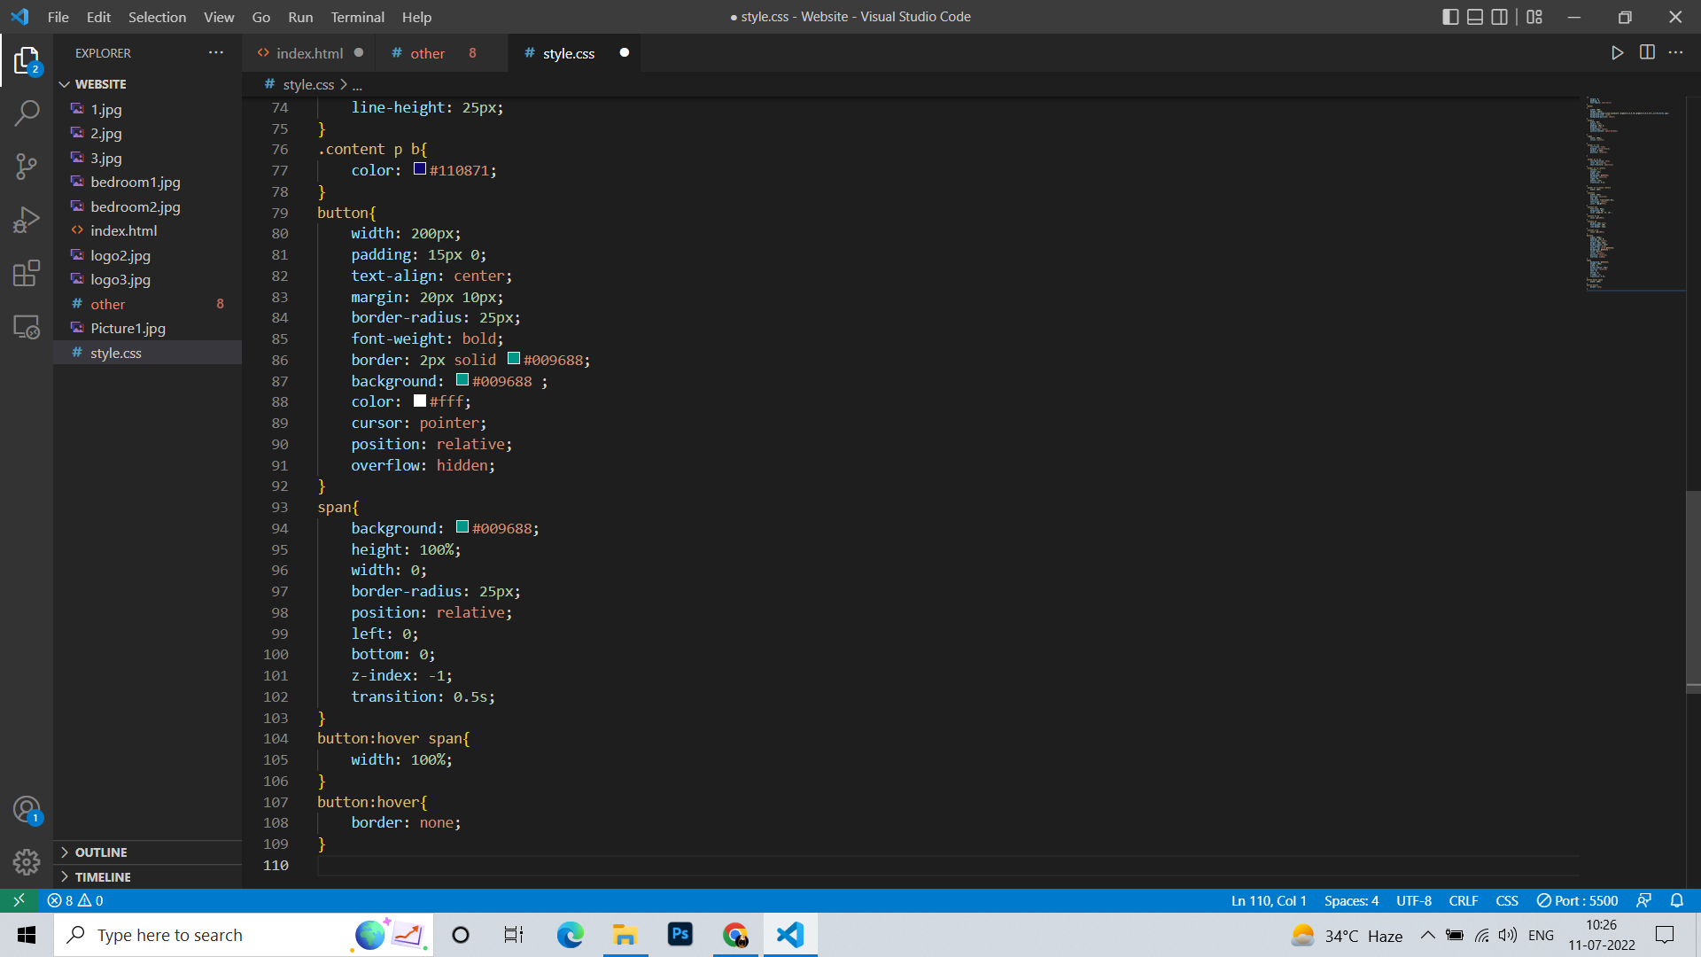

**For Registration Page:-**

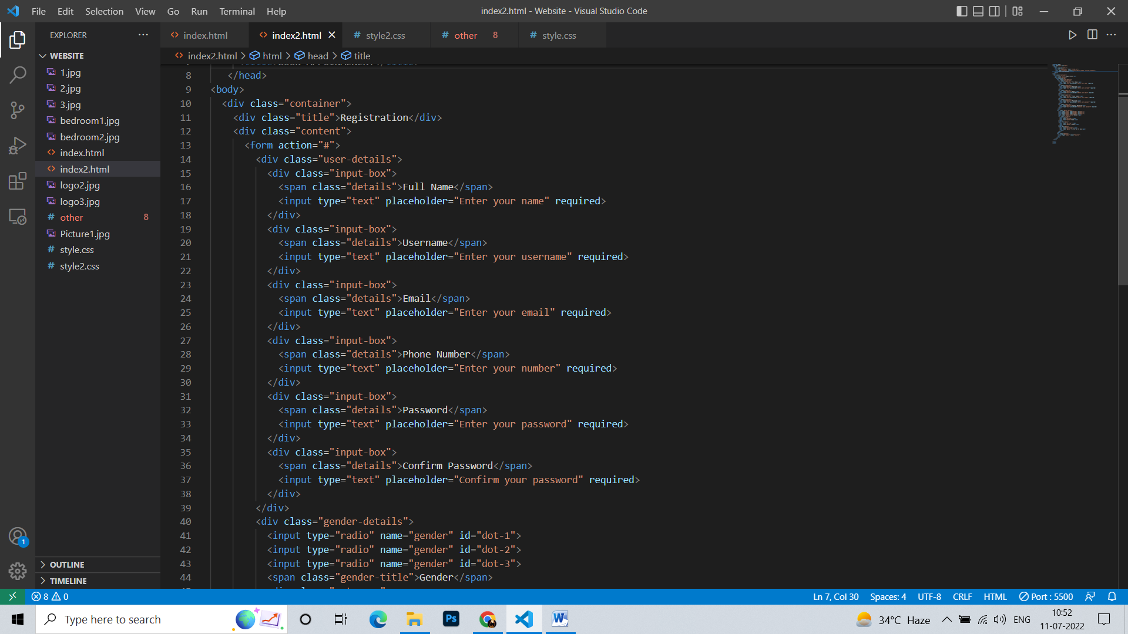

**For Registration CSS:-**

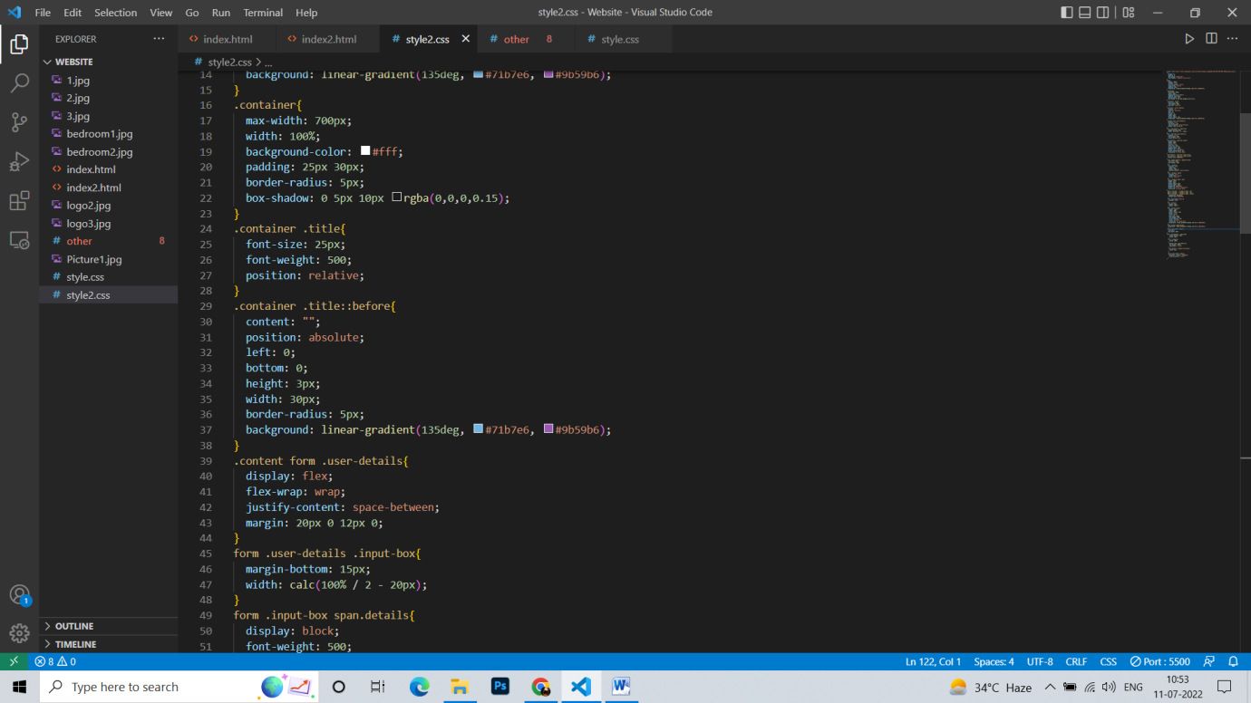

**OUTPUT**

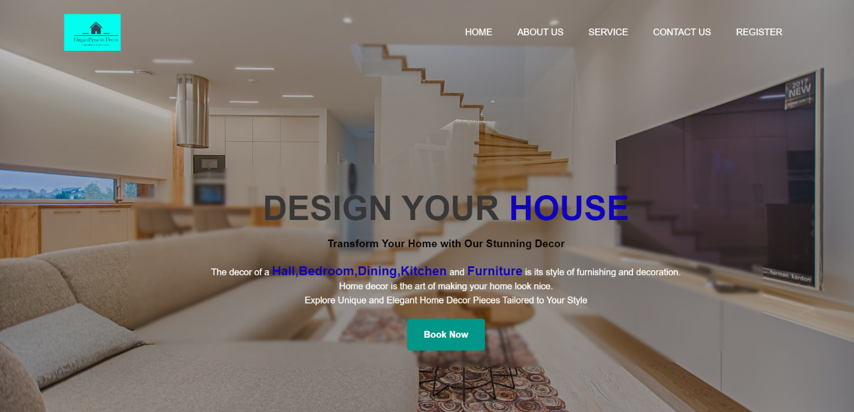

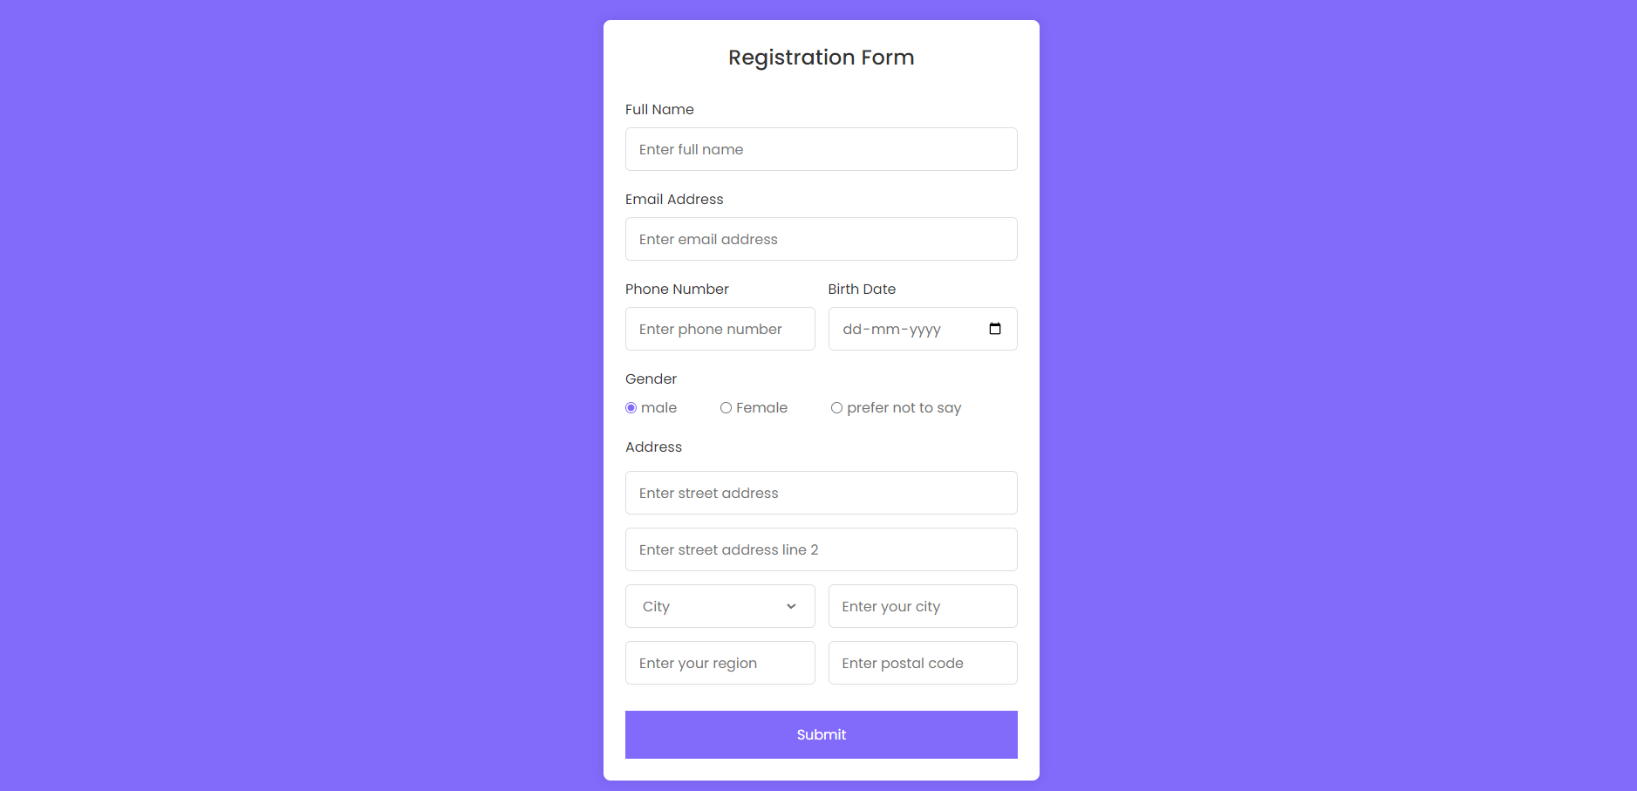

**\*CONCLUSION\***

#Advantages of online Elegant spaces Decors Website

> You can contact us any time and any where

> It is easy to use.

> It saves time.

> Provides a multiple offers.

# Future plan:-

* To increase labours[in this we can miss the client].
* Planing for giving 3d blueprint.
* To our services in various cities.