**solved by parimal A**

**TABLES**

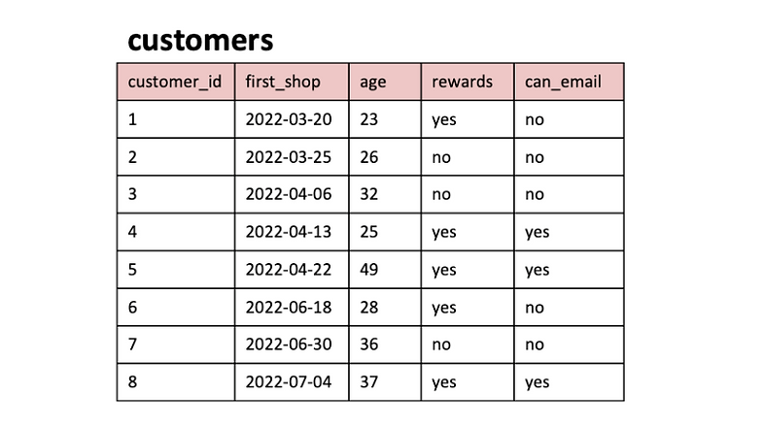

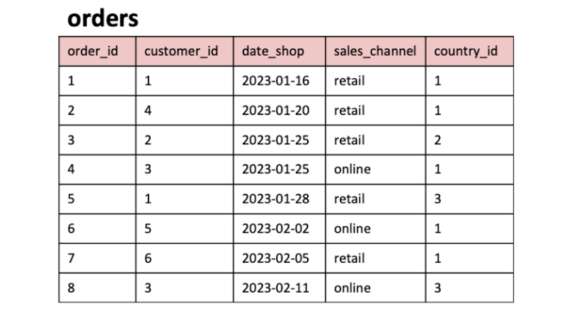C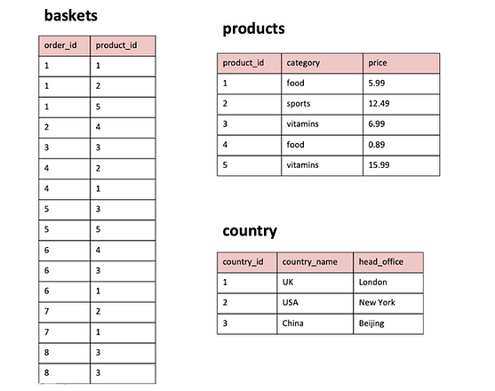

**SOLVE THESE QUESTIONS**:

1. What are the names of all the countries in the country table?  
2. What is the total number of customers in the customers table?  
3. What is the average age of customers who can receive marketing emails (can_email is set to 'yes')?  
4. How many orders were made by customers aged 30 or older?  
5. What is the total revenue generated by each product category?  
6. What is the average price of products in the 'food' category?  
7. How many orders were made in each sales channel (sales_channel column) in the orders table?  
8.What is the date of the latest order made by a customer who can receive marketing emails?  
9. What is the name of the country with the highest number of orders?  
10. What is the average age of customers who made orders in the 'vitamins' product category?

**TABLE QUERIES : 5 TABLES :**

|  |
| --- |
| ***-- Customer Insights Analyst for 'The General Store'***  ***create database store; #create database store***  ***use store;***  ***#Create table1***  ***CREATE TABLE country (***  ***country_id INT PRIMARY KEY,***  ***country_name VARCHAR(50),***  ***head_office VARCHAR(50)***  ***);***  ***#insert values in table 1***  ***INSERT INTO country (country_id, country_name, head_office)***  ***VALUES (1, 'UK', 'London'),***  ***(2, 'USA', 'New York'),***  ***(3, 'China', 'Beijing');***  ***select *from country;***  ***#Create table 2:***  ***CREATE TABLE customers (***  ***customer_id INT PRIMARY KEY,***  ***first_shop DATE,***  ***age INT,***  ***rewards VARCHAR(50),***  ***can_email VARCHAR(50)***  ***);***  ***INSERT INTO customers (customer_id, first_shop, age, rewards, can_email)***  ***VALUES (1, '2022-03-20', 23, 'yes', 'no'),***  ***(2, '2022-03-25', 26, 'no', 'no'),***  ***(3, '2022-04-06', 32, 'no', 'no'),***  ***(4, '2022-04-13', 25, 'yes', 'yes'),***  ***(5, '2022-04-22', 49, 'yes', 'yes'),***  ***(6, '2022-06-18', 28, 'yes', 'no'),***  ***(7, '2022-06-30', 36, 'no', 'no'),***  ***(8, '2022-07-04', 37, 'yes', 'yes');***  ***#CREATE TABLE3:***  ***CREATE TABLE orders (***  ***order_id INT PRIMARY KEY,***  ***customer_id INT,***  ***date_shop DATE,***  ***sales_channel VARCHAR(50),***  ***country_id INT,***  ***FOREIGN KEY (customer_id) REFERENCES customers(customer_id),***  ***FOREIGN KEY (country_id) REFERENCES country(country_id)***  ***);***  ***INSERT INTO orders (order_id, customer_id, date_shop, sales_channel, country_id)***  ***VALUES (1, 1, '2023-01-16', 'retail', 1),***  ***(2, 4, '2023-01-20', 'retail', 1),***  ***(3, 2, '2023-01-25', 'retail', 2),***  ***(4, 3, '2023-01-25', 'online', 1),***  ***(5, 1, '2023-01-28', 'retail', 3),***  ***(6, 5, '2023-02-02', 'online', 1),***  ***(7, 6, '2023-02-05', 'retail', 1),***  ***(8, 3, '2023-02-11', 'online', 3);***  ***SELECT *FROM orders;***  ***#create table no.4***  ***CREATE TABLE products (***  ***product_id INT PRIMARY KEY,***  ***category VARCHAR(50),***  ***price NUMERIC(5,2)***  ***);***  ***INSERT INTO products (product_id, category, price)***  ***VALUES (1, 'food', 5.99),***  ***(2, 'sports', 12.49),***  ***(3, 'vitamins', 6.99),***  ***(4, 'food', 0.89),***  ***(5, 'vitamins', 15.99);***  ***#createtable no.5 :***  ***CREATE TABLE baskets (***  ***order_id INT,***  ***product_id INT,***  ***FOREIGN KEY (order_id) REFERENCES orders(order_id),***  ***FOREIGN KEY (product_id) REFERENCES products(product_id)***  ***);***  ***INSERT INTO baskets (order_id, product_id)***  ***VALUES (1, 1),***  ***(1, 2),***  ***(1, 5),***  ***(2, 4),***  ***(3, 3),***  ***(4, 2),***  ***(4, 1),***  ***(5, 3),***  ***(5, 5),***  ***(6, 4),***  ***(6, 3),***  ***(6, 1),***  ***(7, 2),***  ***(7, 1),***  ***(8, 3),***  ***(8, 3);***  ***select *from baskets ;*** |

**SOLVED QUESTION QUERIES :**

|  |
| --- |
| **# QUESTIONS:**  **-- Q1. What are the names of all the countries in the country table?**  **select*from country ;**  **select country_name from country;**  **-- Q2.What is the total number of customers in the customers table?**  **SELECT *FROM customers;**  **select count(*)FROM customers; #8 customers**  **-- Q3. What is the average age of customers who can receive marketing emails (can_email is set to 'yes')?**  **SELECT AVG(age) AS average_age**  **FROM customers**  **WHERE can_email = 'yes'; # 37,000**  **-- Q4.How many orders were made by customers aged 30 or older?**  **select *from orders;**  **SELECT COUNT(*) AS order_count**  **FROM orders**  **WHERE customer_id IN (**  **SELECT customer_id**  **FROM customers**  **WHERE age >= 30 # 3 orders**  **);**  **-- Q5. What is the total revenue generated by each product category?**  **SELECT *FROM products;**  **SELECT category, SUM(price) AS total_revenue**  **FROM products**  **GROUP BY category;**  **-- Q6 .What is the average price of products in the 'food' category?**  **SELECT *FROM products;**  **SELECT AVG(price) AS average_price**  **FROM products**  **WHERE category = 'food'; #'3.440000'**  **-- Q7. How many orders were made in each sales channel (sales_channel column) in the orders table?**  **select *from orders;**  **SELECT sales_channel, COUNT(*) AS order_count**  **FROM orders**  **GROUP BY sales_channel; #retail : 5 and online:3**  **-- Q8. What is the date of the latest order made by a customer who can receive marketing emails?**  **SELECT *FROM customers;**  **#use subquery :**  **SELECT MAX(date_shop) AS latest_order_date**  **FROM orders**  **WHERE customer_id IN (**  **SELECT customer_id**  **FROM customers**  **WHERE can_email = 'yes'**  **);**  **-- Q9. What is the name of the country with the highest number of orders?**  **select *from country;**  **SELECT c.country_name**  **FROM country c**  **JOIN orders o ON c.country_id = o.country_id**  **GROUP BY c.country_name**  **ORDER BY COUNT(*) DESC**  **LIMIT 1; #uK**  **-- Q10. What is the average age of customers who made orders in the 'vitamins' product category?**  **SELECT AVG(c.age) AS average_age**  **FROM customers c, orders o, baskets b, products p #alias 3 tables fetch**  **WHERE c.customer_id = o.customer_id**  **AND o.order_id = b.order_id**  **AND b.product_id = p.product_id**  **AND p.category = 'vitamins'; # '29.7143'** |