Added a video header for dynamic content with two sections describing what we offer and challenges.

Overview Page:

On click of explore dashboard takes to home page

Data Download Tables Combined to Single Page.

Help and Guide Screen

Steps to use the Screen with a Demo Video

**Help & Guide Screen: Easily Reproducible**  
Future updates can be made with minimal effort by simply:

* Updating the text content
* Replacing the embedded video URL
* Adding or removing bullet points as needed

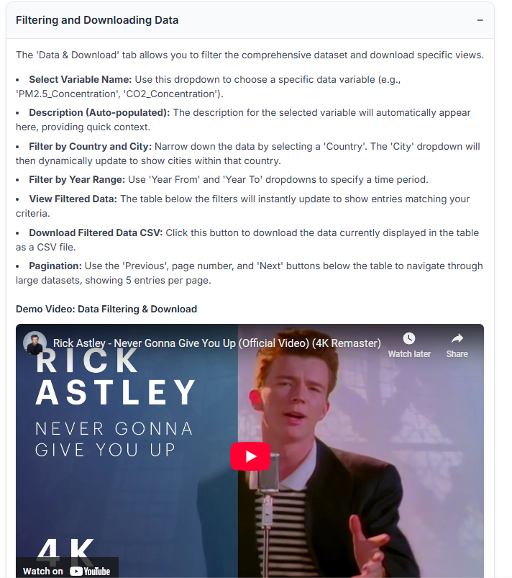

your_dash_app/

│

├── app.py

├── index.py

├── assets/

├── components/

│ ├── navbar.py

│ ├── sidebar.py

│ ├── filter_bar.py

│ ├── button.py

│ └── ...etc.

├── pages

│ ├── home.py

│ ├── data_download.py

│ └── ...

python app.py