Added a video header for dynamic content with two sections describing what we offer and challenges.
Overview Page:
On click of explore dashboard takes to home page

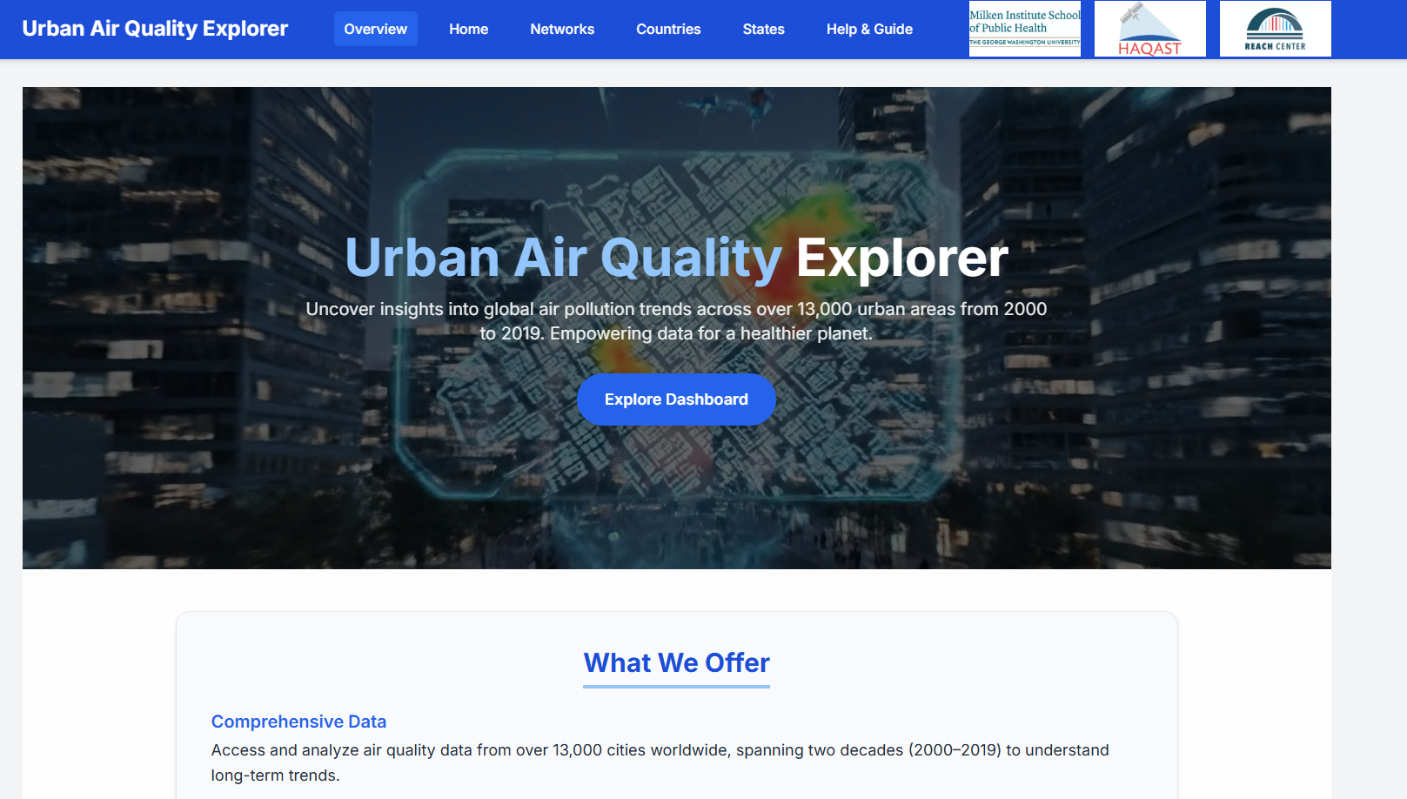
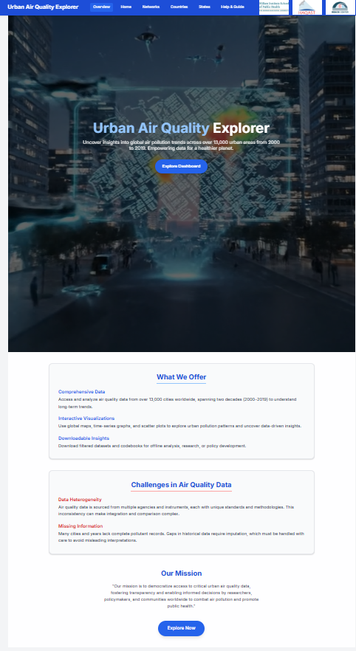
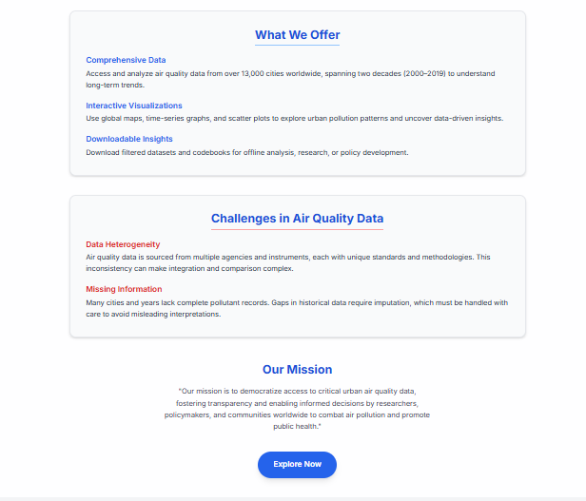

Data Download Tables Combined to Single Page.

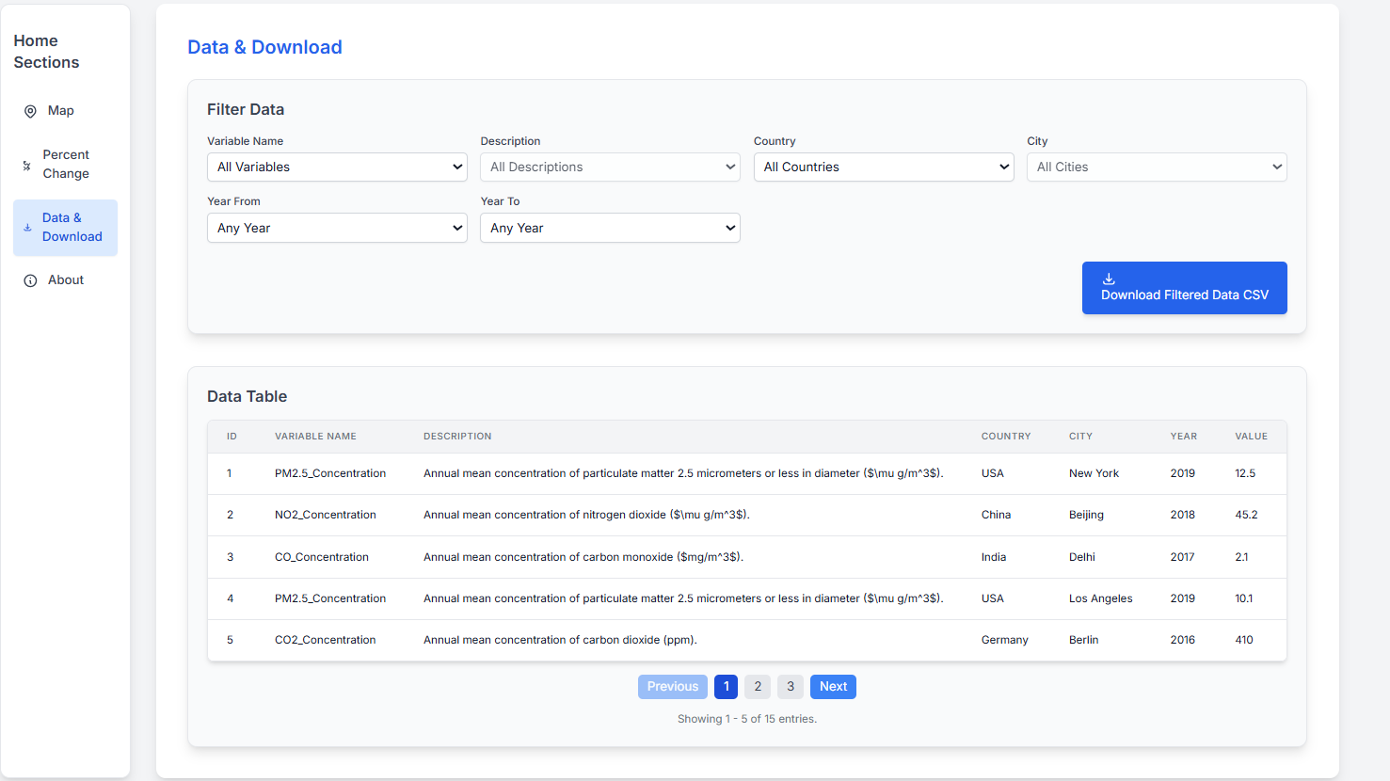
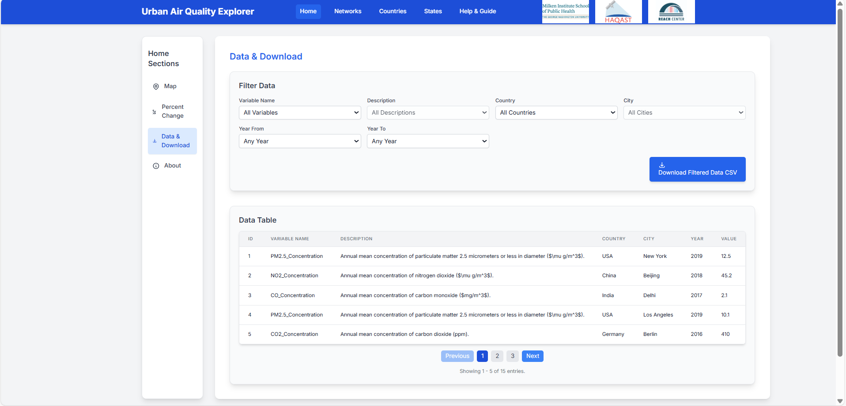
Help and Guide Screen
Steps to use the Screen with a Demo Video
Help & Guide Screen: Easily Reproducible
Future updates can be made with minimal effort by simply:
- Updating the text content
- Replacing the embedded video URL
- Adding or removing bullet points as needed
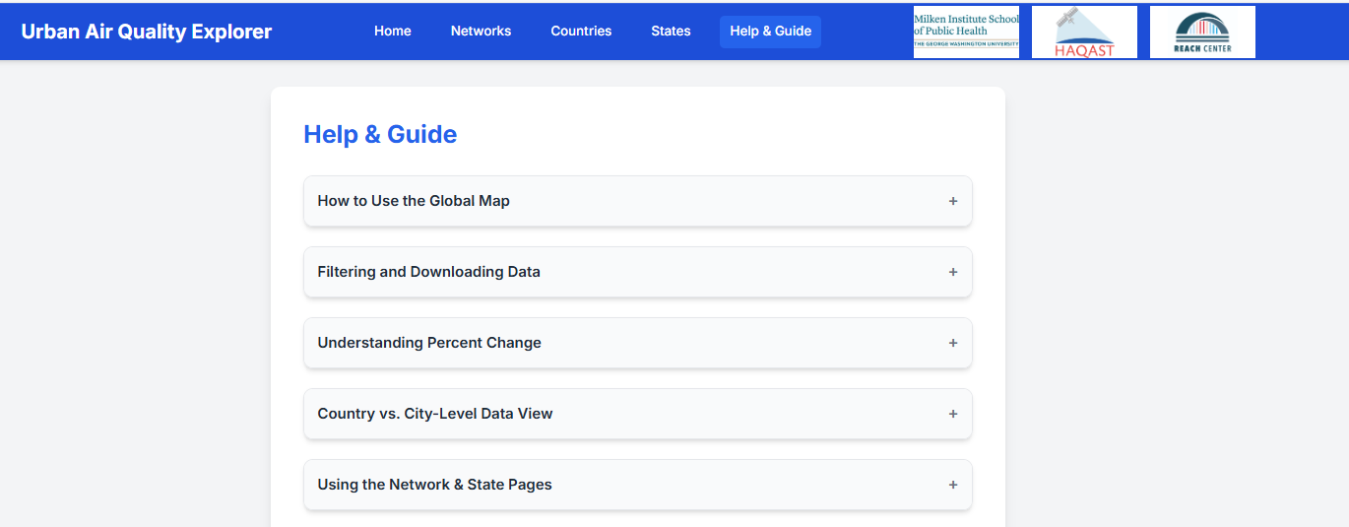

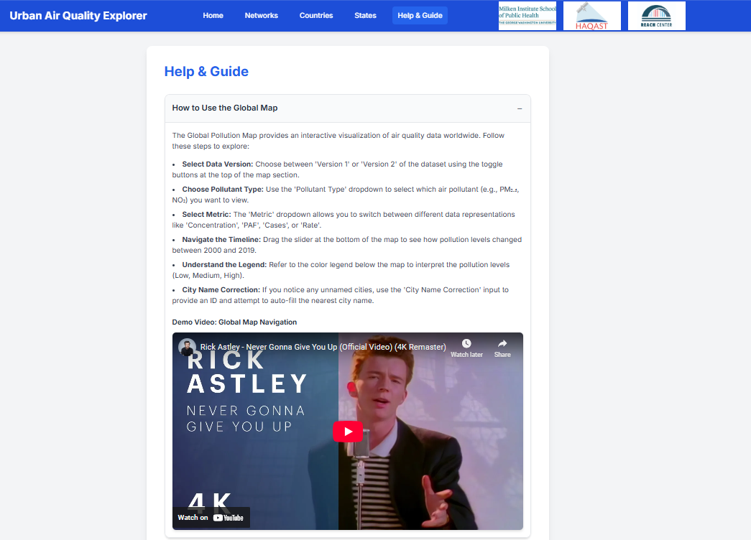

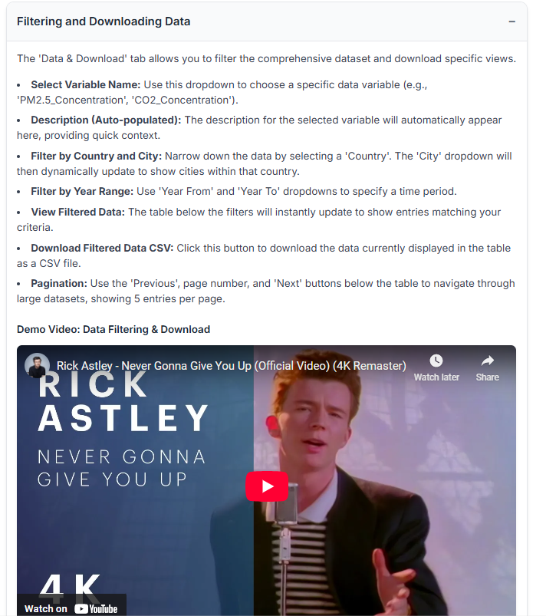

your_dash_app/
│
├── app.py
├── index.py
├── assets/
├── components/
│ ├── navbar.py
│ ├── sidebar.py
│ ├── filter_bar.py
│ ├── button.py
│ └── ...etc.
├── pages
│ ├── home.py
│ ├── data_download.py
│ └── ...

python app.py

