**Program 1**

**PART-A**

**A.1 Aim:**

Create a static web site using HTML that has

1. Home Page

2. Registration page

3. Contact Us page (optional)

**A.2 Prerequisite:**

There are no prerequisites as such to learn and implement HTML.

**A.3 Outcome:**

After successful completion of this experiment students will be able to

1. Understand the basic Technique in building a static web application using HTML

2. Implement basic tags of HTML

3. Understand usage of basic editor like Sublime Text 2 or 3

**A.4 Theory:**

A website is a collection of web pages. A web page holds some useful content along with images, videos, audio, animations, links to other pages and so on. These web pages are created with HTML. When executed, web pages open in browser and browser interprets HTML code and displays information.

HTML stands for Hyper Text Markup Language. It is a major language of the World Wide Web. It is simply a collection of **tags < >** that indicate the structure and format of a web document. Tags have **attributes**.

Every Web page when designed with HTML starts with <html> tag.

* This is a basic structure of simple web page. It prints My name is Yourname in browser when executed

<HTML>

<TITLE> This is the Title of my first page

</TITLE>

<BODY>

Hello Browser <BR>

<B> My Name is

<I> Yourname

</I>

</B>

</BODY>

</HTML>

* HTML has many tags like
  + <a href> - To create hyperlink
  + <img>- To embed images
  + <p> - To create paragraph
  + <table><tr><td><th>- To create table and put data in it
  + <form> - To create a form that has text fields, radio buttons, checkboxes…..
  + <Font><b><i>- To create specific font
  + **Many text formatting tags <heading tags><align tags>**
  + **<Border>- to specify border type, size….**

In this program, we will create a minimum of 3 web pages using HTML. Some **mandatory** tags to be implemented are

1. Anchor Tag

2. P

3. Img

4. Form

5. Table

6. Lists

**Note: It is left to discretion of students to decide the topic to make website on. Also students are given freedom to learn more tags and implement it much better to improve UI of the web page**

**PART B**

**(PART B: TO BE COMPLETED BY STUDENTS)**

**B.1 Software Code written by student:**

<!DOCTYPE html>

<html>

<head>

<title>Shopping Site</title>

<!-- Latest compiled and minified CSS -->

<link rel="stylesheet" href="https://maxcdn.bootstrapcdn.com/bootstrap/3.3.7/css/bootstrap.min.css">

<!-- jQuery library -->

<script src="https://ajax.googleapis.com/ajax/libs/jquery/3.3.1/jquery.min.js"></script>

<!-- Latest compiled JavaScript -->

<script src="https://maxcdn.bootstrapcdn.com/bootstrap/3.3.7/js/bootstrap.min.js"></script>

</head>

<body>

<ul id="navbar1">

<li id="navbar"><a class="active" href="#home" id="navbar2">Home</a></li>

<li id="navbar"><a href="#prod" id="navbar2">Products</a></li>

<li id="navbar"><a href="#size" id="navbar2">Size Chart</a></li>

<li id="navbar"><a href="#about" id="navbar2">About</a></li>

</ul>

<h1 align="center" style="padding-top:50px" id="home">Welcome to MPSTME Shopping</h1>

<!--

<div class="container">

<a href="#prod">Products</a>

<a href="#size">Size Chart</a>

</div>

-->

<p>

Lorem ipsum dolor sit amet, consectetur adipisicing elit, sed do eiusmod

tempor incididunt ut labore <b>et dolore magna aliqua.</b> Ut enim ad minim veniam,

quis nostrud exercitation ullamco laboris nisi ut aliquip ex ea commodo

consequat. Duis aute irure dolor in reprehenderit in voluptate velit esse

cillum dolore eu fugiat nulla pariatur. Excepteur sint occaecat cupidatat non

proident, sunt in culpa <i>qui officia deserunt mollit anim id est laborum.Lorem ipsum dolor sit amet, consectetur adipisicing elit</i>, sed do eiusmod

tempor incididunt ut labore et dolore magna aliqua. Ut enim ad minim veniam,

quis nostrud exercitation ullamco laboris nisi ut aliquip ex ea commodo

consequat. Duis aute irure dolor in reprehenderit in voluptate velit esse

cillum dolore eu fugiat nulla pariatur. <u>Excepteur sint occaecat cupidatat non

proident, sunt in culpa qui officia deserunt mollit</u> anim id est laborum.

</p>

<hr>

<h2 id="prod" align="center">Products</h2>

<ul>

<li align="center">

<h3>Hoodie</h3>

<img src="hoddie.jpg">

<h4>Price Rs 1299</h4>

<a href="registration.html">Buy Now</a>

<p>Lorem ipsum dolor sit amet, consectetur adipisicing elit, sed do eiusmod

tempor incididunt ut labore et dolore magna aliqua. Ut enim ad minim veniam,

quis nostrud exercitation ullamco laboris nisi ut aliquip ex ea commodo

consequat. Duis aute irure dolor in reprehenderit in voluptate velit esse

cillum dolore eu fugiat nulla pariatur. Excepteur sint occaecat cupidatat non

proident, sunt in culpa qui officia deserunt mollit anim id est laborum.</p>

</li>

<hr>

<li align="center">

<h3>TShirt</h3>

<img src="tshirt.jpg" height="200" width="200">

<h4>Price Rs 699</h4>

<a href="registration.html">Buy Now</a>

<p>Lorem ipsum dolor sit amet, consectetur adipisicing elit, sed do eiusmod

tempor incididunt ut labore et dolore magna aliqua. Ut enim ad minim veniam,

quis nostrud exercitation ullamco laboris nisi ut aliquip ex ea commodo

consequat. Duis aute irure dolor in reprehenderit in voluptate velit esse

cillum dolore eu fugiat nulla pariatur. Excepteur sint occaecat cupidatat non

proident, sunt in culpa qui officia deserunt mollit anim id est laborum.</p>

</li>

</ul>

<hr>

<h2 id="size" align="center">Size Chart</h2>

<table style="width:100%" border="1">

<tr>

<td>Size</td>

<td>Shirt Length</td>

<td>Chest Width</td>

<td>Sleeve Length</td>

</tr>

<tr>

<td>Small</td>

<td>72 cm</td>

<td>46 cm</td>

<td>37 cm</td>

</tr>

<tr>

<td>Medium</td>

<td>72 cm</td>

<td>46 cm</td>

<td>37 cm</td>

</tr>

<tr>

<td>Large</td>

<td>72 cm</td>

<td>46 cm</td>

<td>37 cm</td>

</tr>

</table>

</body>

</html>

(Registration page in expt 2)

**B.2 Input and Output**

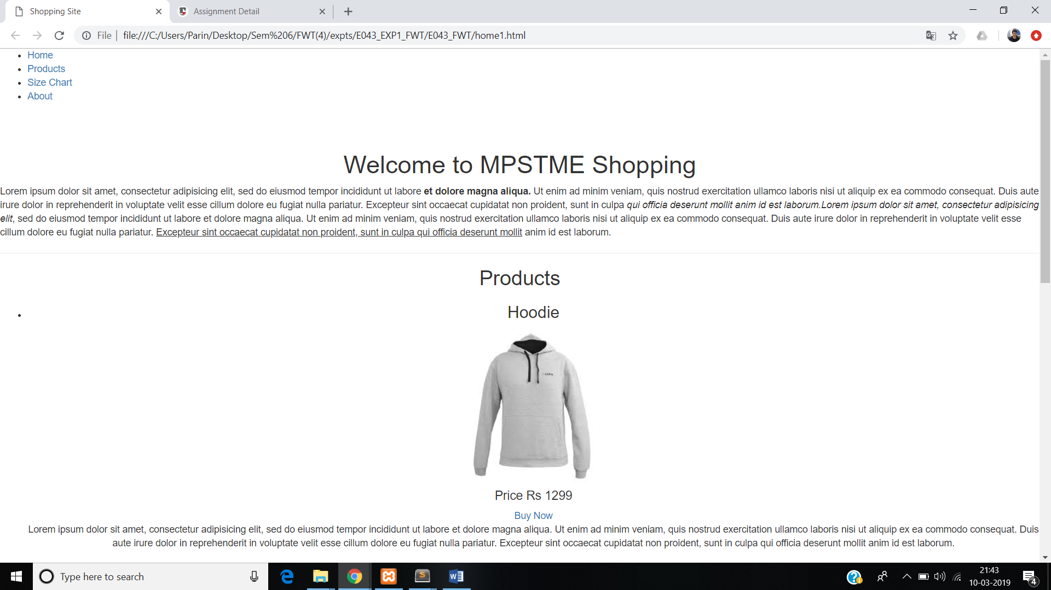

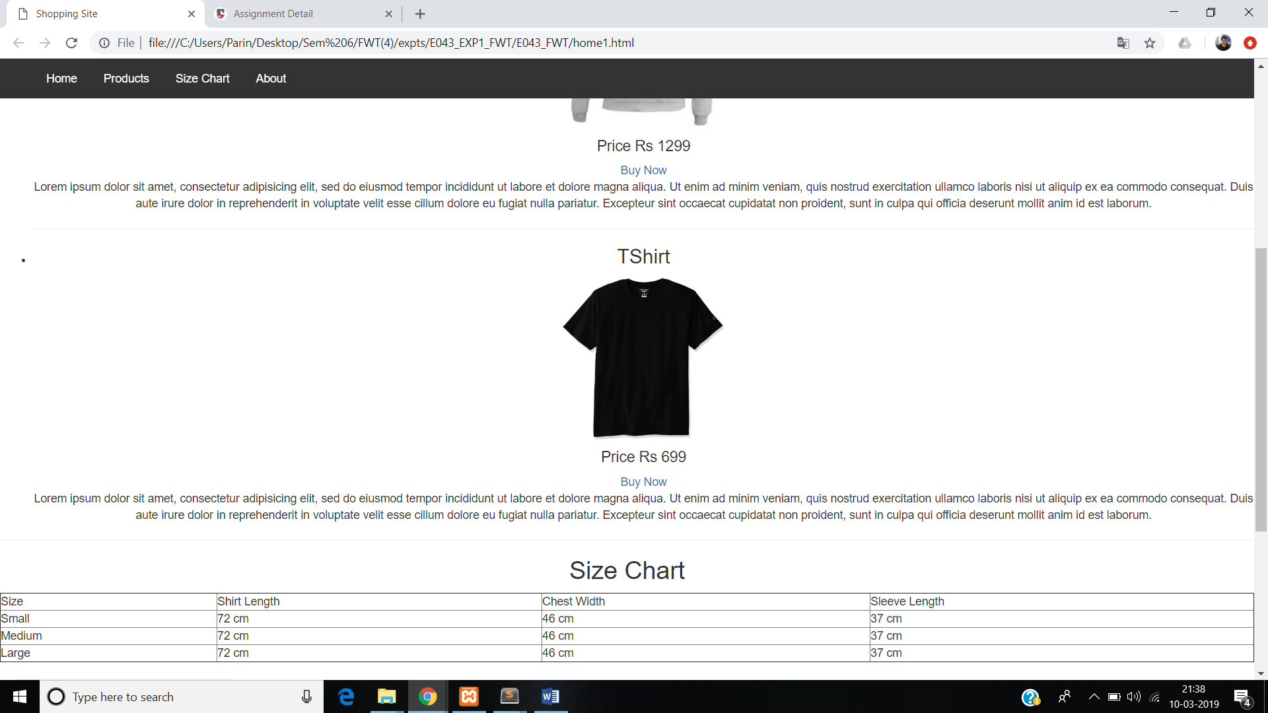

**B.3. Observations and Learning**

**Observed and learned how the various html tags are implemented in a simple webpage.**

**B.4. Conclusion**

**Successfully implemented all the basic html tags to create a static website without using css.**