DATA SCIENCE AND MACHINE LEARNING · END-SEMESTER PROJECT REPORT
ApexHunter
Finding Driver Mistakes and Pit-Stop Windows in Formula 1 Telemetry
Two seasons of real race data, two prediction problems, and every model tested honestly against a simple baseline
Submitted by
Parin Shah (23001091)
Malav Joshi (23001119)
Under the guidance of
Gauravkumarsingh Gaharwar
B Tech Computer Science
Navrachana University
November 2026

Abstract
This project asks two questions of Formula 1 telemetry, the data a car records several times a second: where did a driver make a mistake, and when should a driver change tyres? We built ApexHunter, a system that downloads every race and qualifying session of the 2023 and 2024 seasons (92 sessions, 57.9 million readings) with the FastF1 library, cleans the data, trains the models and shows the results on an interactive dashboard.
For mistake detection, every moment of a lap is compared with what the five fastest other drivers do at the same point of the track. Three detectors are compared: a Z-score rule as the baseline, an Isolation Forest and an LSTM autoencoder. Real mistakes are not labelled, so the detectors are scored in a controlled test with synthetic mistakes planted in laps they have not seen, and checked on real laps by the time each flagged moment cost. Both learned detectors beat the baseline (mean F1 0.34 and 0.40 against 0.28), and the Isolation Forest's real flags lose time more often than random places (18 % against 12 %).
For tyre strategy, the models predict how much slower the next lap will be: Ridge regression, a vanilla RNN and an LSTM, against a "no change" baseline that repeats the last lap. On five races held back for testing, the recurrent networks are the most accurate (0.328 s average error for the RNN against 0.357 s for the baseline). A pit-stop cost measured from each race turns these predictions into a five-lap pit window, which contains the driver's real stop more often than a random window (37 % against 29 % with Ridge). A ceiling test explains why better predictions do not give better windows: in modern Formula 1 the pit lap is set mainly by strategy and safety cars, not by tyre wear.

Contents
Abstract 2
Contents 3
1. Introduction 5
1.1 The problem 5
1.2 What we built 5
1.3 Main results 5
2. Key Terms 6
2.1 Why this is hard 6
3. Data Collection 7
4. Data Cleaning 7
4.1 Cleaning the telemetry 8
4.2 Preventing leaks from the future 8
5. Processing the Data: Feature Engineering 8
5.1 Mistake features: compare with the field 8
5.2 Tyre features: what the last five laps say 8
5.3 Measuring the cost of a pit stop 9
5.4 A finding: race data cannot rank the compounds 9
6. The Models We Trained 10
6.1 Z-score baseline 10
6.2 Isolation Forest 10
6.3 LSTM autoencoder 11
6.4 Ridge regression 11
6.5 Recurrent networks 11
6.6 From predictions to a pit window 11
6.7 What did not make it 11
7. How We Train and Test 12
7.1 A controlled test on synthetic mistakes 12
7.2 The real-lap check 12
7.3 Held-out races (tyre models) 12
7.4 Rules that keep us honest 13
8. The Development Journey 13
9. Results 14
9.1 Mistake detection 14
9.2 Predicting the next lap 15
9.3 Pit windows on the test races 15
9.4 The ceiling test 16
10. The Dashboard 17
11. Limitations and Future Work 20
12. Conclusion 20
References 21
Appendix A. Running the Project 21

1. Introduction

1.1 The problem
A Formula 1 car sends back speed, throttle, brake, gear, engine speed and position several times a second, and the FastF1 library makes this data public for every session since 2018. Teams employ engineers to read it; a fan or a junior engineer has no tool that points at the interesting moments. We framed two questions that can be answered from public data and, importantly, tested:
- Mistakes. In a driver's laps, where did he do something different from the fastest drivers at the same spot, in a way that cost time?
- Pit stops. From the laps driven so far, which laps form a good window for the next tyre change, and when a safety car comes out, should the driver stop now?
Both questions share the same difficulty: there is no answer key. No one labels mistakes, and the lap a team chose to stop is a strategic decision, not the "correct" answer. Most of the work in this project therefore went into building honest tests: synthetic mistakes at known places, races the models never saw, and simple baselines every model has to beat.

1.2 What we built
ApexHunter is a pipeline from raw telemetry to a dashboard (Figure 1). This semester's work replaced last semester's mistake detector, which mostly flagged ordinary braking, and its tyre model, which had several data errors, with the methods described in this report. Each step is a set of Python scripts with automated tests that run on real data.
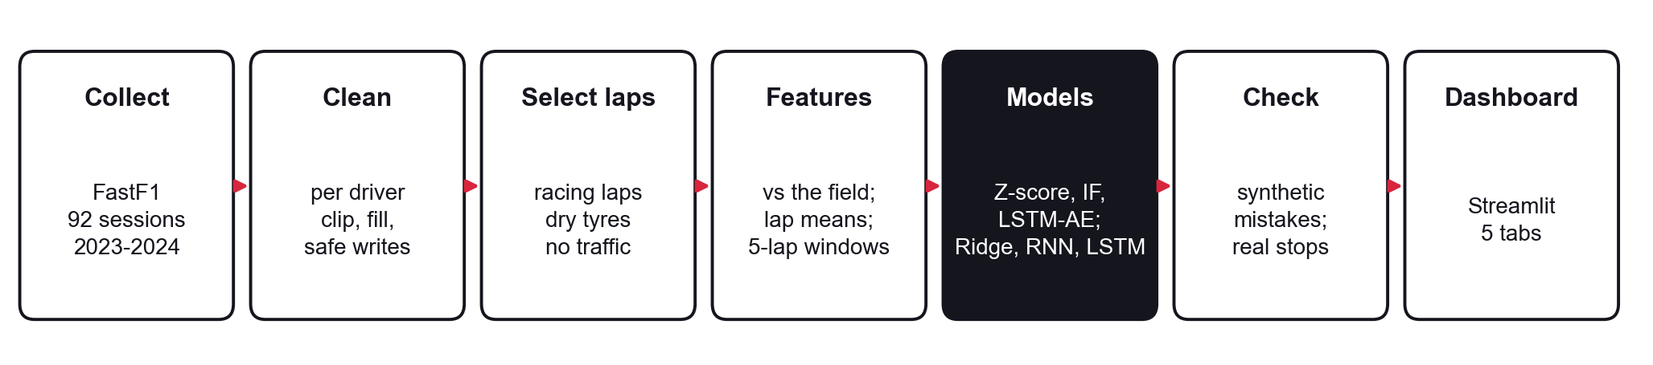
Figure 1. The ApexHunter pipeline. Each box is a group of Python scripts in the project repository.

1.3 Main results
Table 1. Headline results. Mistake results are the mean of four sessions; tyre results are on five races (2024 rounds 19–24) that no model saw during training.
Question | Result | What it means
Mistakes: Isolation Forest vs Z-score baseline | F1 0.34 vs 0.28 | In the controlled test on synthetic mistakes the Isolation Forest finds more (recall 0.27 vs 0.20) at similar precision; the LSTM autoencoder reaches F1 0.40.
Mistakes on real laps | 18 % vs 12 % | Share of Isolation Forest mistakes that really cost time, against random places on the same laps.
Next lap time: Ridge vs "no change" | 0.344 s vs 0.357 s average error | Ridge is slightly better than repeating the last lap (4 % lower error, R² 0.14). The RNN and LSTM reach 0.328 and 0.335 s.
Pit window vs a random window | 37 % vs 29 % of real stops | With Ridge's predictions the five-lap window contains the real stop more often than chance.
Ceiling test | Perfect tyre wear: 39 % vs 43 % | Even knowing the true tyre wear in advance does not find more real stops.

2. Key Terms
The report needs no background in motor racing. Table 2 defines the terms used throughout.
Table 2. Terms used in this report.
Term | Meaning in this report
Telemetry sample | One reading from the car: speed, throttle (0–100 %), brake (on/off), gear, engine speed (RPM) and position on track. About four per second.
Lap, stint | A lap is one trip round the track. A stint is the run of laps on one set of tyres, between two pit stops.
Pit stop, pit cost | A stop to change tyres. Its cost is the time lost against cars that did not stop: about 20–30 s depending on the track.
Safety car (SC), VSC | When the track is unsafe the field slows down behind a safety car, or to a set pace (virtual safety car). A stop then costs less, because everyone is slow.
Compound | The type of tyre: soft (fast, wears quickly), medium, hard (slow, lasts longer).
Representative lap | A lap at racing pace: not the first lap, not a pit or safety-car lap, not deleted by the stewards.
Anomaly | A data point that is unusual compared with the rest. A driving mistake is one kind.
Synthetic mistake | A mistake we insert on purpose at a known place in a real lap, so a detector can be scored on whether it finds it.
Precision, recall, F1 | Precision: of the moments flagged, how many are real mistakes. Recall: of the real mistakes, how many were flagged. F1 combines the two (1 is perfect).
MAE, RMSE, R², MAPE | Error measures for numbers: mean absolute error, root mean squared error, share of variation explained, and error as a percentage of the lap time.
"No change" baseline | The simplest forecast: the next lap will take exactly as long as the last one. Any model must beat it to be useful.
Test races | The five most recent races, kept aside and used only once, to score finished models.

2.1 Why this is hard
- There are no labels. Nobody marks mistakes in telemetry, and a team's real pit lap is a decision made with information we do not have (radio, rivals, weather forecasts).
- The signal is small. Tyres lose about 0.05 s per lap of age, while lap times vary by about 0.9 s from one lap to the next because of traffic, wind and small errors.
- Wear and fuel move together. As a stint goes on the tyres get older and the car gets lighter at the same time, so their effects are hard to separate.
The aim was therefore never to build a perfect strategist, but to find what the data really supports and prove it is not luck, a data leak or overfitting.

3. Data Collection
All data comes from the FastF1 Python library, which downloads Formula 1's official timing and car data. Table 3 lists what we collected.
Table 3. Data collected by the project.
Data | Source | Amount
Car telemetry: speed, RPM, gear, throttle, brake, X/Y/Z position, session time | FastF1 (download_season_data.py) | 92 sessions (46 races, 46 qualifying), 2023–2024; 57.9 million rows, 1.8 GB
Lap data: lap and sector times, stint, compound, tyre age, pit in/out times, track status | FastF1 laps, read from the local cache | about 50,000 race laps
Gap to the car ahead and DRS state (for the traffic filter) | FastF1 car data | every race sample
Corner positions for event locations | FastF1 circuit information | every track

Telemetry is stored as one Parquet file per session in a local data lake. Last semester's Big Data work (Spark, HDFS and MongoDB copies of the same data) is kept but is not needed for the models in this report; every model here reads the pandas output.

4. Data Cleaning
A model trained on wrong data gives wrong answers with complete confidence, so the first part of the semester was an audit of the whole code base. 55 problems were logged and each was fixed with a test that fails on the old code. Table 4 lists those that would have changed the results of this report.
Table 4. Data problems that affected the models, and how each was fixed.
Problem we found | What it would have caused | How we fixed it
Mistake detector used absolute values (speed, brake) | 95 % of "mistakes" were ordinary braking | Features measure the deviation from the fastest drivers at the same spot (Section 5.1)
Pit, safety-car and first laps mixed with racing laps | Slow laps flagged and learned as tyre wear | Only representative laps are used (a shared lap filter)
Intermediate and wet tyres mixed with dry tyres (2,460 laps) | Rain laps read as extreme wear | Dry tyres with a known tyre age only
Lap averages taken over irregularly spaced samples | About 1 km/h of noise in mean speed | Averages weighted by the time between samples
Slipstream and dirty air in race telemetry | Overtakes flagged as mistakes | Samples with DRS open or < 1 s behind another car are left out
Train/test split by random windows | Overlapping windows leaked into the test | Split by whole races, most recent races for testing
Scaler fitted on all data | Test statistics leaked into training | Scalers fitted on training races only
Mistake threshold tuned with a score that always picks the smallest value | Meaningless setting | Settings chosen with synthetic mistakes (Section 7)

4.1 Cleaning the telemetry
The cleaning script removes rows with no core values, fills short gaps within each driver, and clips physically impossible values (speed 0–380 km/h, RPM 0–15,000, throttle 0–100 %, brake 0–1). Files are written to a temporary name first and then renamed, so an interrupted run never leaves a half-written file. Telemetry samples arrive irregularly (0.014 to 0.76 s apart), which matters for every average taken later.

4.2 Preventing leaks from the future
- Decisions use only the past. A pit decision for lap k uses lap times up to lap k−1 and the track status of lap k; a prediction for lap k uses laps k−5 to k−1.
- Whole races are held out. Neighbouring five-lap windows share four laps, so a random split would put nearly identical windows on both sides.
- The test races are used once, to score finished models, never to choose settings.

5. Processing the Data: Feature Engineering

5.1 Mistake features: compare with the field
The key idea is to ask "is the driver doing something unusual compared with what the fastest other drivers do at this exact point on track?", not "is this sample unusual?". Braking hard before Turn 1 is normal; braking hard on a straight is not. Every sample is placed on the track by projecting its position onto the session's fastest lap (a median 0.3 m away), and the five fastest other drivers give a profile per 10 m of track: median speed, throttle, gear and acceleration, their spread, and the share of them braking. Five features follow (Table 5), smoothed over 0.5 s.
Table 5. Mistake-detection features.
Feature | Formula | Catches
speed_deficit | (field speed − speed) / field spread | slow corner, lock-up, off-track moment
throttle_diff | (throttle − field throttle) / field spread | early lift, late throttle
brake_mismatch | brake on/off − share of the field braking here | braking where the field doesn't
gear_diff | (gear − field gear) / field spread | wrong gear, missed downshift
accel_diff | (acceleration − field) / field spread; over 0.5 s | sudden deceleration

Dividing by the field's spread matters: braking points vary by 10–20 m, so a raw speed difference is always large there. Without it, 73 % of flags were braking samples; with it, 39 %.

5.2 Tyre features: what the last five laps say
Each racing lap is reduced to nine numbers: lap time; time-weighted mean throttle, brake and RPM; tyre age; the compound (soft, medium, hard); and the race lap number. A model sees five consecutive laps and predicts the next one. Lap time and the three telemetry means are given relative to the last lap of the window, so the model sees how pace is changing rather than which track it is (absolute lap times mostly identify the track: copying the last lap already explains 99 % of their variation).
The target is the change in lap time from the last lap of the window to the next lap, in seconds (Figure 2). On 28,745 windows from 45 races it averages +0.02 s with a spread of 0.90 s; 98 % of changes are within ±2 s. Predicting "no change" is off by 0.39 s on average.
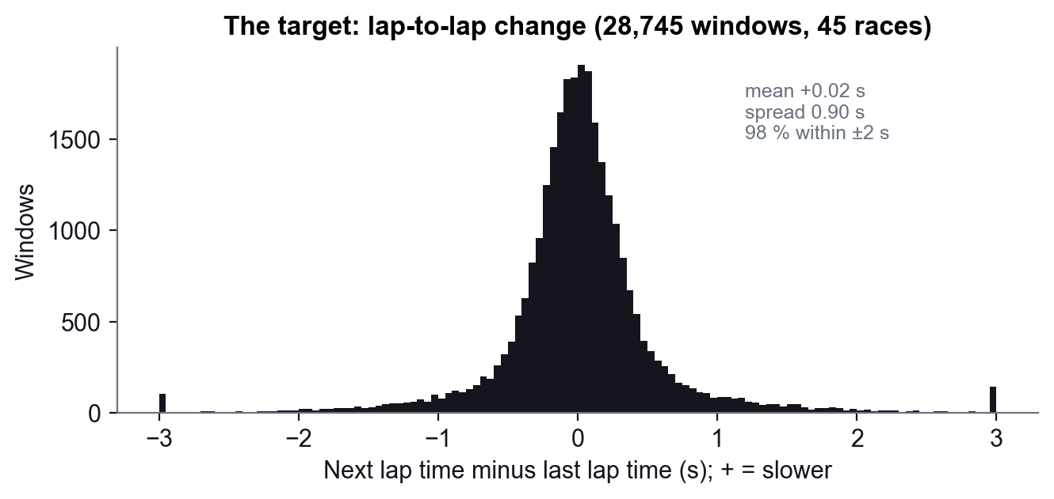
Figure 2. The tyre target: change in lap time from one lap to the next.

5.3 Measuring the cost of a pit stop
The cost of a stop is measured from each race's own laps: the driver's in-lap plus out-lap, minus the median of the same two laps for the cars that did not stop. Drive-through penalties (no tyre change) and first-lap damage stops are left out. Over 46 races the median normal stop costs 22.8 s (from 18.5 s at Spa to 30.0 s in Qatar), and a stop under a safety car or VSC costs about 0.7× as much (Figure 3). Each race uses the median of its own normal stops.
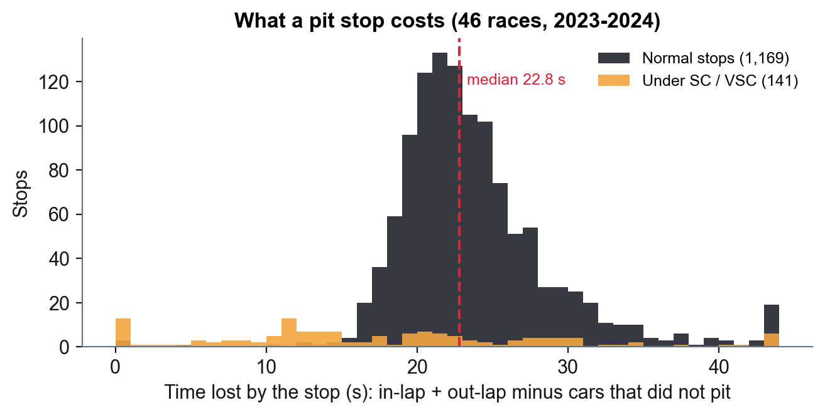
Figure 3. Time lost by a pit stop, normal and under a safety car or VSC.

5.4 A finding: race data cannot rank the compounds
We planned to let the strategy choose a tyre compound. A least-squares fit of lap time on a driver-race constant, compound, tyre age per compound and race lap showed that the compounds look almost the same in race data: the fresh-tyre gap between soft, medium and hard is 0–0.2 s, and its sign flips depending on which laps are included (Figure 4). Drivers save soft tyres, teams choose the compound that suits each stint, and "soft" means a different rubber (C1–C6) at every track. The strategy therefore uses the compound the driver actually fitted.
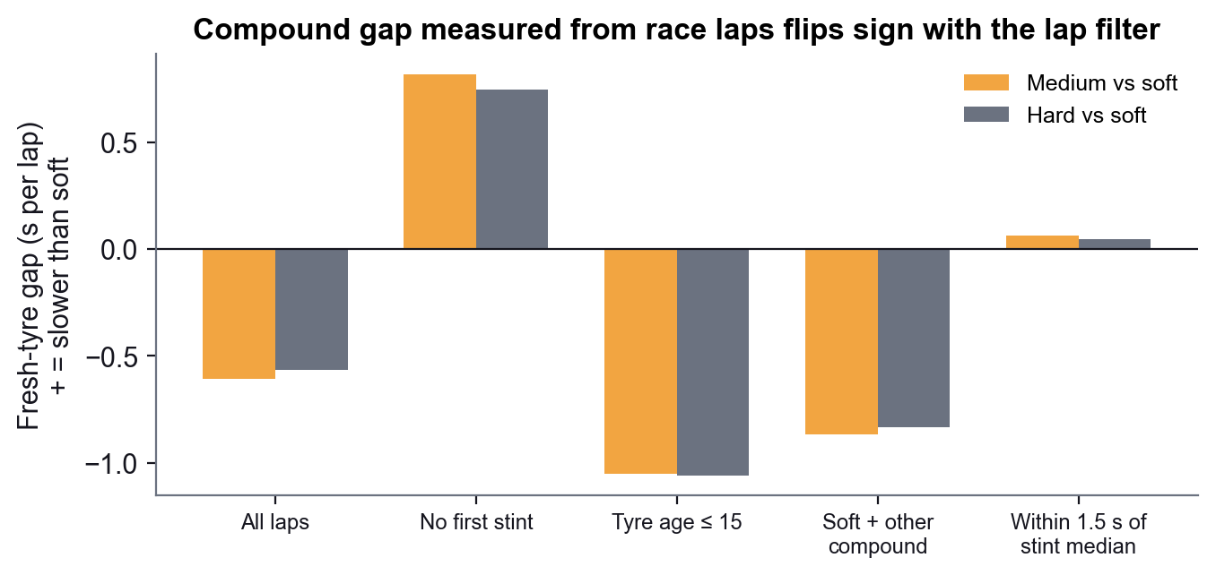
Figure 4. Fresh-tyre gap between compounds, fitted on 40 training races with different lap filters.

6. The Models We Trained
Table 6. Overview of the models.
Model | Type | Problem | Role
Z-score rule | Statistics, no training | Mistakes | Baseline: is a learned model needed?
Isolation Forest | Unsupervised ensemble of random trees | Mistakes | Main detector
LSTM autoencoder | Recurrent neural network | Mistakes | Reads driving as a sequence
"No change" | Rule, no training | Tyres | Baseline: next lap = last lap
Ridge regression | Regularised linear regression | Tyres | Main regression model
Vanilla RNN, LSTM | Recurrent neural networks | Tyres | Read the five laps as a sequence
Pit window | Calculation on the model's wear | Tyres | Turns predictions into advice

6.1 Z-score baseline
The Z-score rule learns each feature's mean and standard deviation on the training laps and scores a sample by its most extreme feature, |z| = |x − mean| / std. It needs no machine learning and shows how far a simple rule gets with the same features.

6.2 Isolation Forest
An Isolation Forest builds many random trees, each splitting on a random feature at a random threshold. Unusual points are separated from the rest after few splits, so the average path length to isolate a point is its anomaly score (Liu, Ting and Zhou, 2008). It needs no labels, which suits data with no answer key, and it can notice several moderate deviations at once.
- Settings: 200 trees, all rows per tree; max_features chosen from {1.0, 0.6} by F1 on synthetic mistakes.
- Training data: the driver's own racing laps (training on other drivers would make a slower driver look anomalous everywhere).
- Threshold: the 2 % most unusual samples are flagged (fixed for every session so counts compare across drivers).
- Events: flags less than 1 s apart are joined; runs of at least 0.5 s become events, each with a corner location, a reason in plain words and the time lost against the driver's own nearby laps.

6.3 LSTM autoencoder
The autoencoder reads 16 consecutive samples (about 2 s of driving) of the same five features, squeezes them through a small LSTM (16 hidden units) and rebuilds them. Trained only on the driver's normal laps, it learns what normal driving looks like over time; the samples it rebuilds worst are flagged, with the same 2 % threshold and event rule as the Isolation Forest.

6.4 Ridge regression
Ridge regression is linear regression with a penalty on large coefficients (Hoerl and Kennard, 1970):
minimise Σ (y − Xβ)² + α Σ β²
Each five-lap window is flattened into 45 inputs and standardised inside the pipeline, so the scaler only ever sees training races. The penalty α was chosen by validation error on the most recent 20 % of the training races. A first grid stopped at 10,000 and picked its edge; widened, the best is α = 30000. Such a strong penalty is a sign that the inputs carry little stable signal: the model is mostly pulled towards predicting the average.

6.5 Recurrent networks
A vanilla RNN and an LSTM (two layers, dropout 0.3, a linear output) read the same five-lap windows in order. They were trained with the same race split and metrics, three random starts each, so that the three models appear in one comparison (Section 9.2).

6.6 From predictions to a pit window
At every lap, every possible stop lap x of the stint is given a cost in seconds:
cost(x) = wear × (old-tyre ages on laps up to x + new-tyre ages after x) + pit cost(x)
The sum runs to the end of the following stint (the driver's next real stop or the finish), so the driver's real number of stops is kept. Fuel, track and car are the same on a given lap whichever option is chosen, so they cancel; only tyre age and the lap of the stop differ. Wear per lap of tyre age is the average of the lap-time changes known so far in the stint plus 0.053 s for the fuel burnt each lap (fitted on the training races). The best stop lap is the one with the lowest cost, and the window is the best lap ±2 (five laps). On a safety-car lap the stop is 30 % cheaper, which often makes "pit now" the best option.

6.7 What did not make it
- Choosing a compound. Race data cannot separate the compounds (Section 5.4).
- A window of all laps within 1 s of the best. Because wear is small the cost curve is flat, and the window spanned 9 or more laps, sometimes half a stint.
- Ten-lap windows for Ridge. Lap-time error about the same as with five laps (0.343 vs 0.352 s for "no change"), but worse pit windows, because predictions start only at lap 12.
- Wear from the last five laps only. It jumped with lap-to-lap noise; the stint average replaced it.

7. How We Train and Test

7.1 A controlled test on synthetic mistakes
Real mistakes are not labelled in Formula 1 data, so mistake detection is unsupervised and has no true accuracy. A standard way to test such detectors is to insert known anomalies and see how many are found. Laps are split into five folds by lap (GroupKFold). Each detector is fitted on the clean laps of four folds; in each held-out lap three fake mistakes of random types are planted (Table 8), with three random seeds. The detector's flags are turned into events with the same rule as the real output and scored per mistake.
Table 7. Fake mistakes used to score the detectors.
Fake mistake | Where | What is changed
Lock-up | inside a braking zone | an extra 15–30 km/h speed drop, then recovery
Early lift | just before the driver's own lift point | throttle off 0.5–1 s earlier, 3–8 km/h slower
Late throttle | after the driver re-applied throttle | throttle held at 0 for 0.5–1 s
Pedal overlap | in a braking zone | throttle 20–40 % while braking
Missed downshift | a corner below 150 km/h | one gear too high

Its limit: the test shows that a detector finds these patterns; it cannot show that every flagged real moment is a real mistake. That is why it is always reported next to the real-lap check.

7.2 The real-lap check
The second check uses no synthetic data at all: for each event, the time lost over a 300 m stretch is compared with the same stretch on the driver's nearby laps, and the share of events that really cost time is compared with 200 random spots on the same laps.

7.3 Held-out races (tyre models)
The tyre data is split by whole races in date order: the 5 most recent races (2024 rounds 19–24, 3,006 windows) are the test set and the other 40 races train the models; settings are chosen on the latest 20 % of the training races. The pit-window check then runs each model's predictions through the window calculation on the test races and scores every source on the same stints.
Table 8. How results are measured.
Measure | How it is computed | Good result
Precision, recall, F1 | Per synthetic mistake: is it inside an event; is an event on a mistake | Higher than the Z-score rule
Costly events | Share of events that lost time against the driver's own laps | Higher than random spots
MAE, RMSE | Error of the predicted lap time, in seconds | Lower than "no change"
R² | Share of the lap-time change explained (on absolute lap times any model scores 0.99) | Above 0
MAPE | Error as a percentage of the lap time | Lower than "no change"
Window hit rate | Share of real stops inside the five-lap window | Above a random window of the same size

7.4 Rules that keep us honest
- Every model faces a simple baseline (Z-score; "no change"), and is reported even when it loses.
- One test, used once. Settings were never tuned on the test races.
- Real-data tests. 197 automated tests, none of which fake project code or data; integration tests run on real races from the cache, and each fix comes with a test that fails on the old code.
- Random seeds. Neural networks are trained three times and reported as mean ± spread.

8. The Development Journey
The final design came out of several iterations. We keep the dead ends because each taught us something used later.
Table 9. Iterations of the project.
# | What we did | What we found | Outcome
1 | Audited last semester's code | 55 bugs, from leaks to a detector that flagged braking | Fixed, each with a test
2 | Mistakes: deviation from the field at the same spot | Braking share of flags 95 % → 37–54 % | Kept
3 | Synthetic mistakes to choose settings | A score with an answer key replaced one that always picked the smallest value | Kept
4 | Z-score baseline | Isolation Forest wins mainly on combined deviations (lock-ups) | Kept
4b | LSTM autoencoder | Best on synthetic mistakes (F1 0.40), but its real flags cost time only about as often as random places | Kept as comparison
5 | Tyres: predict absolute speed | Copying the last lap scored R² 0.994: it measured the track | Dead end
6 | Predict the change in lap time | A target with a meaningful baseline (0.39 s) | Kept
7 | Choose a compound | Race data cannot separate compounds | Dead end
8 | Pit window within 1 s of the best | Windows of 9+ laps; two logic flaws found on real data | Replaced by ±2 laps
9 | Ridge regression | Slightly better lap times, but no better pit windows than "no change" | Kept
10 | Ceiling test with perfect wear | Perfect wear does not find more real stops | Key finding
11 | Dashboard redesign | Five tabs; telemetry for every driver and session | Section 10

The turning point (iteration 6). Predicting a lap's absolute speed looked excellent (R² 0.99) only because every track has its own typical speed. Asking instead "how much slower will the next lap be?" removed the track and exposed how small the tyre signal really is, which is the honest starting point for everything after it.

9. Results

9.1 Mistake detection
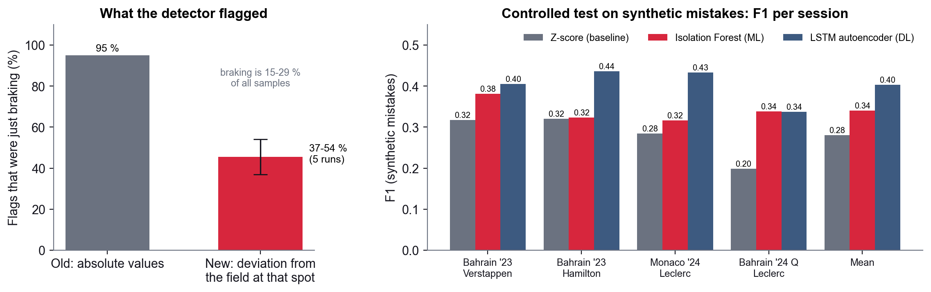
Figure 5. Left: share of flags that were just braking, before and after the rework. Right: F1 in the controlled test on synthetic mistakes, per session.
Table 10. Results per session (Z-score baseline / Isolation Forest / LSTM autoencoder). Precision, recall and F1 are from the controlled test on synthetic mistakes; the last column is the real-lap check (share of flagged moments that cost time, random places in brackets).
Session | Precision | Recall | F1 | Cost time (random)
2023 Bahrain race, Verstappen | 0.54 / 0.55 / 0.46 | 0.24 / 0.31 / 0.37 | 0.32 / 0.38 / 0.40 | 18 % / 15 % / 9 % (10 %)
2023 Bahrain race, Hamilton | 0.54 / 0.52 / 0.55 | 0.23 / 0.25 / 0.37 | 0.32 / 0.32 / 0.44 | 16 % / 19 % / 19 % (12 %)
2024 Monaco race, Leclerc | 0.76 / 0.55 / 0.64 | 0.18 / 0.23 / 0.33 | 0.28 / 0.32 / 0.43 | 0 % / 6 % / 2 % (10 %)
2024 Bahrain qualifying, Leclerc | 0.37 / 0.43 / 0.50 | 0.14 / 0.30 / 0.28 | 0.20 / 0.34 / 0.34 | 0 % / 33 % / 25 % (18 %)
Mean | 0.55 / 0.51 / 0.54 | 0.20 / 0.27 / 0.34 | 0.28 / 0.34 / 0.40 | 8 % / 18 % / 14 % (12 %)

The Isolation Forest finds more synthetic mistakes than the Z-score baseline in every session (mean F1 0.34 against 0.28). Its advantage comes from mistakes that combine several moderate deviations: it is better on lock-ups and missed downshifts, while the Z-score rule does well on early lifts, where throttle alone is extreme (Figure 6). The LSTM autoencoder, which reads about two seconds of driving as a sequence, finds the most (F1 0.40), especially mistakes that unfold over time.
The real-lap check tells a more careful story. The Isolation Forest's flagged moments cost time more often than random places on the same laps (18 % against 12 %); the autoencoder's only about as often (14 %), and the Z-score rule's less often (8 %). So the autoencoder is best at the synthetic patterns, and the Isolation Forest's real flags are the most useful. At Monaco none of the detectors beats random places: there many flagged moments differ from the field without costing Leclerc time.
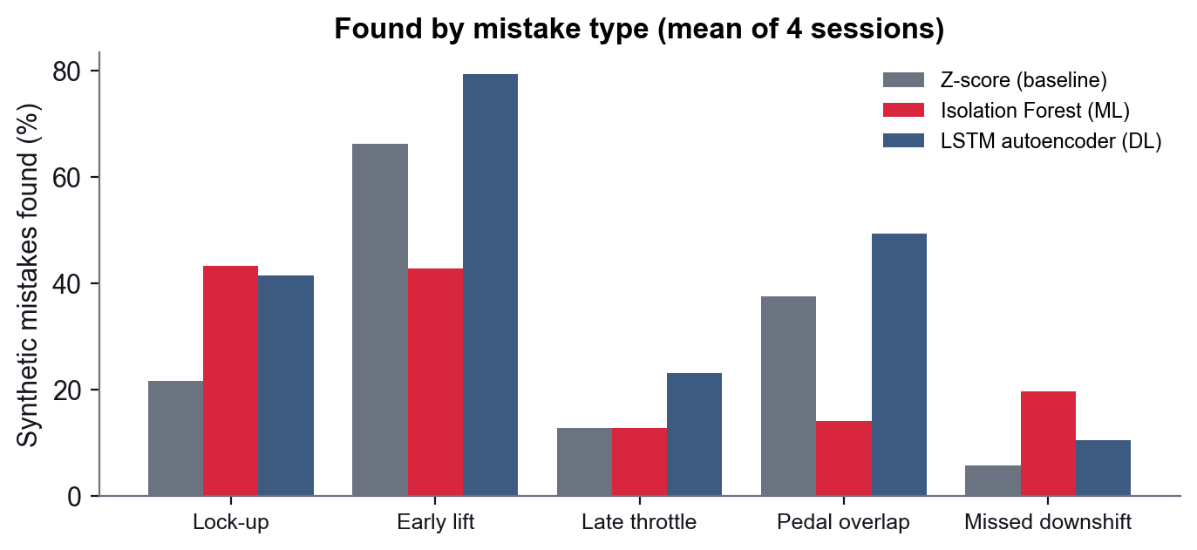
Figure 6. Share of synthetic mistakes found, by type (mean of four sessions).

9.2 Predicting the next lap
Table 11. Next-lap prediction on the 5 test races (3,006 windows). MAE and RMSE in seconds; R² of the lap-time change; MAPE of the lap time. The networks' MAE over three seeds: RNN 0.332 ± 0.007 s, LSTM 0.338 ± 0.004 s.
Model | MAE (s) | RMSE (s) | R² | MAPE (%) | Train MAE (s)
"No change" (next = last lap) | 0.357 | 0.593 | 0.00 | 0.392 | –
Ridge regression | 0.344 | 0.549 | 0.142 | 0.377 | 0.388
Vanilla RNN | 0.328 | 0.509 | 0.263 | 0.360 | 0.360
LSTM | 0.335 | 0.517 | 0.238 | 0.368 | 0.363

Ridge beats "no change" by about 4 % on MAE and 7 % on RMSE. Its largest coefficients show what it learned: an unusually fast or slow last lap is followed by a move back to normal. Tyre age adds only about 0.001 s per lap, so it learned no wear that speeds up as the tyre ages. Training error is higher than test error because the test races were calmer, not because of overfitting.
The two recurrent networks beat Ridge on every measure (MAE over three seeds: RNN 0.332 ± 0.007 s, LSTM 0.338 ± 0.004 s; R² about 0.25 against 0.14). The plain RNN is level with the LSTM: with only five laps per window the gradients do not vanish, so the LSTM's gates bring no advantage. Both networks start to memorise after 10–17 epochs (training error keeps falling while validation error rises), so the weights of the best validation epoch are kept.

9.3 Pit windows on the test races
Table 12. Real stops inside the five-lap window, on the same 163 stints of the test races.
Wear from | Real stop in window | Random 5-lap window | Margin (points) | Real SC/VSC stops called
"No change" baseline (fuel only) | 44.2 % | 29.5 % | +14.7 | 77 %
Ridge regression | 37.4 % | 28.7 % | +8.7 | 67 %
Vanilla RNN | 32.5 % | 27.0 % | +5.5 | 62 %
LSTM | 33.7 % | 27.7 % | +6.1 | 67 %

Every model finds the real stop above chance, but the trained models do not beat the simple baseline: their lap-to-lap predictions correct noise rather than measure wear, and averaged over a stint they often predict laps getting faster, which gives no window at all. Better lap-time accuracy (Section 9.2) therefore does not turn into better pit windows. Figure 7 shows one stint: Russell in Singapore 2023, who stopped under the lap-20 safety car inside a window centred on lap 22.
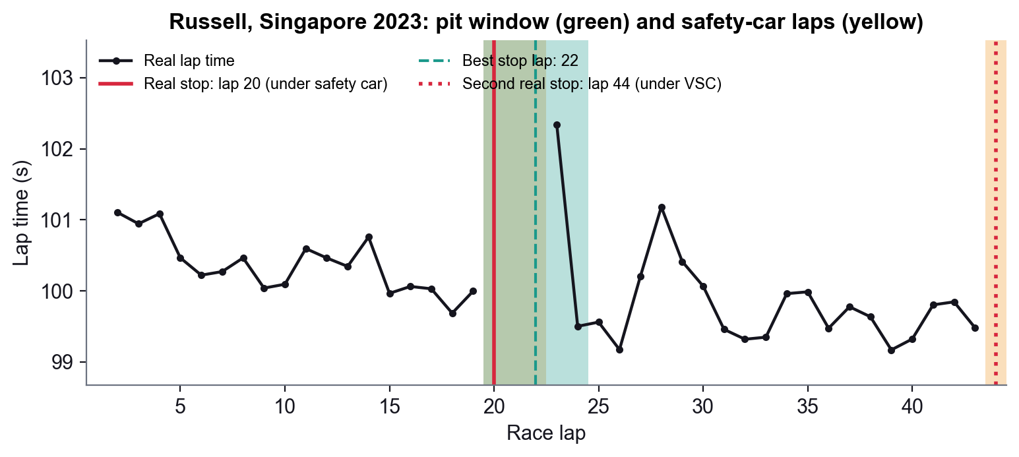
Figure 7. Pit window for Russell, Singapore 2023 ("no change" wear). Safety-car laps are yellow, the five-lap window green.

9.4 The ceiling test
To see how much a better tyre model could ever help, the window was given the true wear of every stint, measured from the whole stint including laps that had not happened yet. Over all 46 races (1,345 stints) it did no better than "no change" (Figure 8). Real stops are set by things outside a tyres-only model (undercuts, traffic, team plans and safety cars), and wear is so small that the best stop lap barely moves with it. Published work reaches a similar view: degradation rates are hard to separate in race data, and on F1 tyre data a tree model beat RNN, LSTM, GRU and transformer models (Todd et al., 2025).
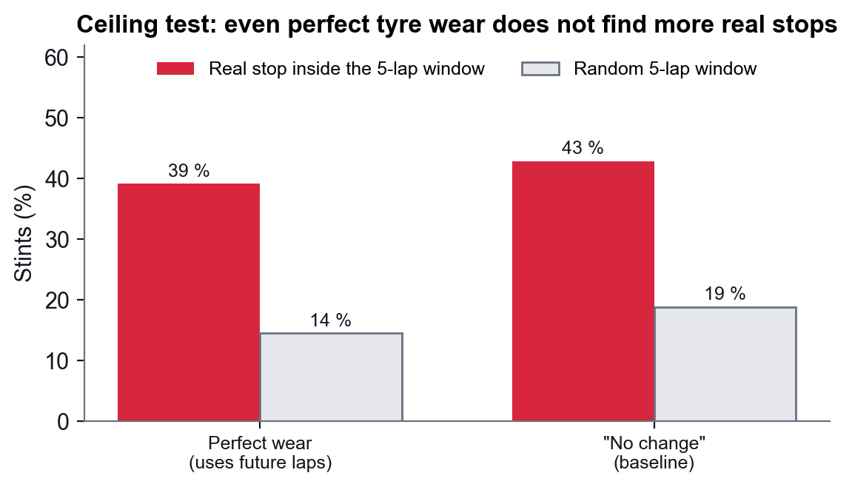
Figure 8. Ceiling test over 46 races: perfect wear against "no change" and the real lap times.

10. The Dashboard
All results are shown on a Streamlit dashboard, redesigned this semester around the two questions and their models. The sidebar picks the season, the Grand Prix, qualifying or race, and the driver; a slim header gives the finishing position, the fastest lap and the gap to the session's fastest lap. Five tabs follow, and only the open one is computed, so the app stays fast. Each chart was chosen for the question it answers (Table 12).
Table 13. Dashboard charts and why each was chosen.
Tab | Chart | Why this chart
Overview | Mistake summary, pit-window summary, model scoreboard | One screen that answers both questions for the chosen driver, with the overall model results
Telemetry | Lap picker: one dot per lap (pit, safety-car and fastest laps coloured) | Shows the whole session at a glance and lets the user open any lap with one click
Telemetry | Speed, throttle, gear against distance; brake as shaded bands; time delta | Distance puts the same corner at the same place for every lap, so two laps compare corner by corner; brake is only on or off, so bands fit better than a line; the delta shows where time is lost
Telemetry | Track map coloured by speed or gear, with a position slider named by corner | Links each point of the charts to a place on the track
Driver Mistakes | Track map with one marker per mistake (size = time lost) and a ranked list | Where the mistakes are and which cost the most, for each of the three detectors
Driver Mistakes | The chosen mistake: this lap against the field and the driver's usual laps | Explains why a moment was flagged, not just that it was
Driver Mistakes | Bars: F1 on synthetic mistakes; share of real flags that cost time | The two checks side by side, so the limit of the synthetic test is always visible
Tyres & Pit Window | Lap times of a stint with the window, safety-car laps, real and best stop | Shows in one picture whether the advice matched what the team did
Tyres & Pit Window | Bars: lap-time error per model; window against a random window | Compares the trained models on both measures, starting from zero
More | Apex detection video, racing-line search, Big Data pipeline | Last semester's work, kept in its own tab so it does not slow the main views

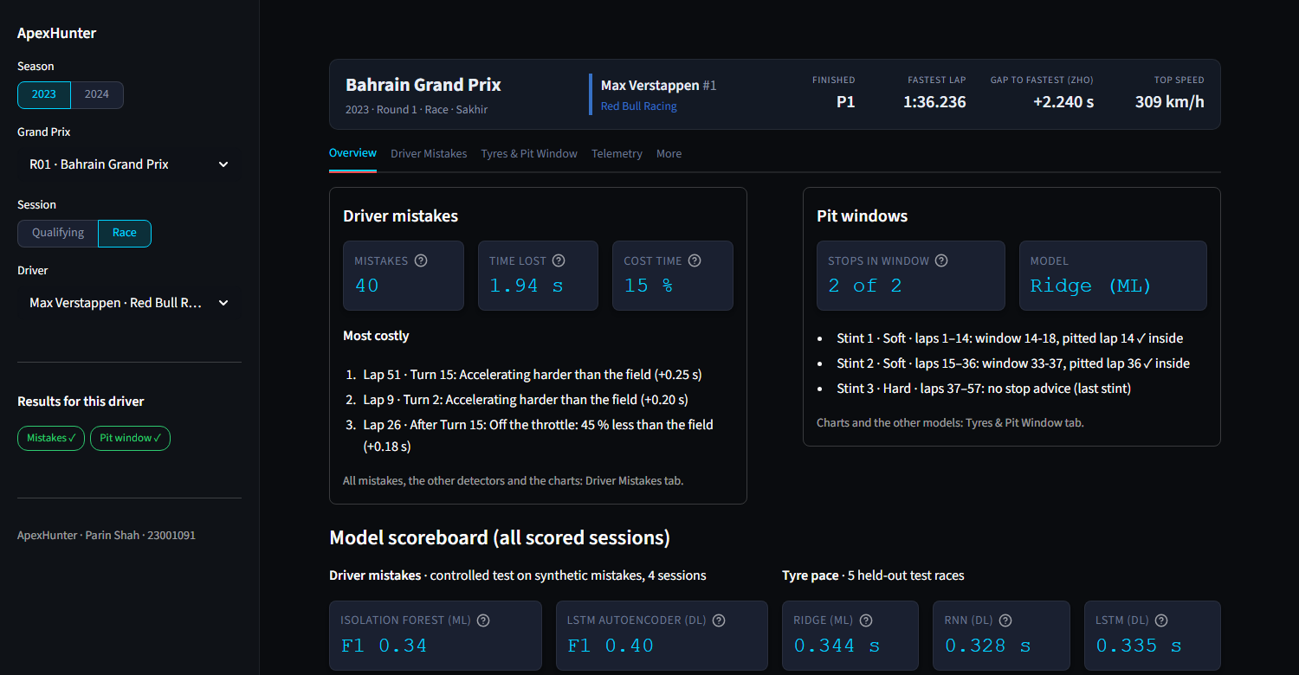
Figure 9. Overview tab: the driver's mistakes and pit windows in short, and the model scoreboard.
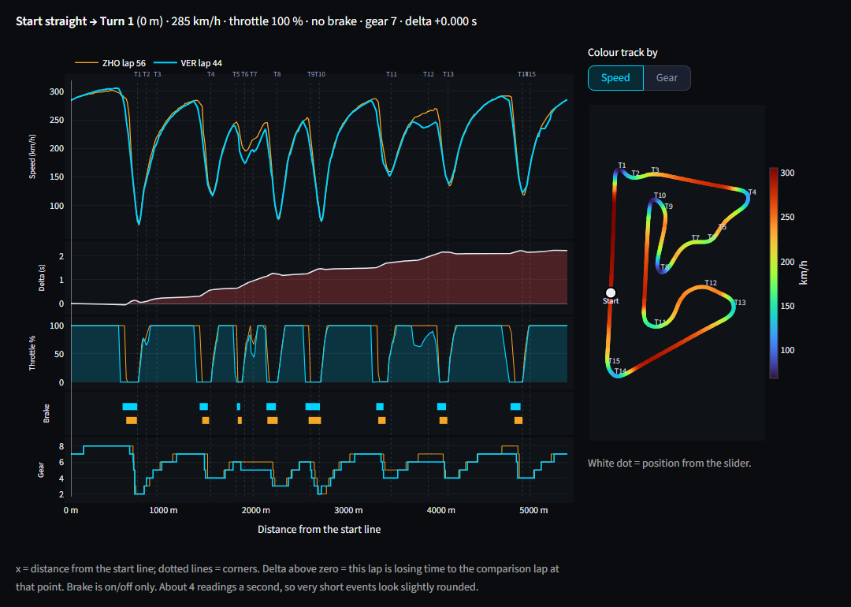
Figure 10. Telemetry tab: Verstappen's fastest race lap against Zhou's, plotted against distance, with the track map coloured by speed.
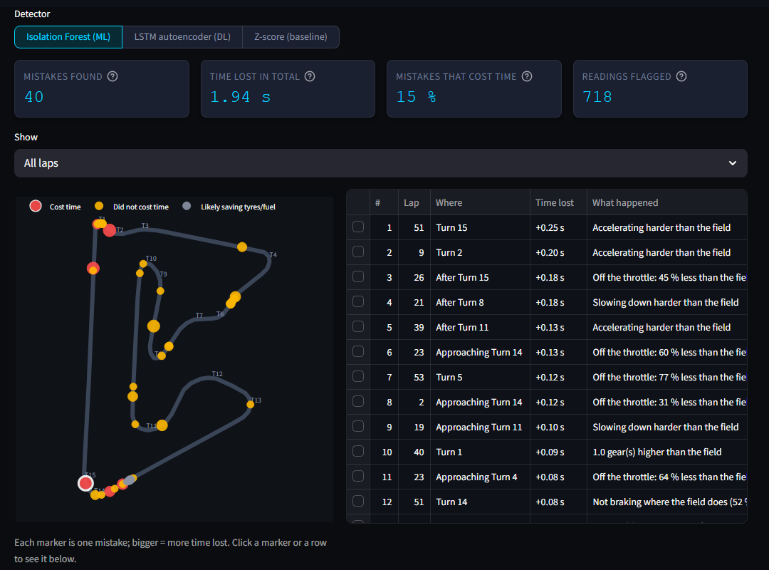
Figure 11. Driver Mistakes tab: detector switch, cards, mistakes on the track map and in a ranked list.
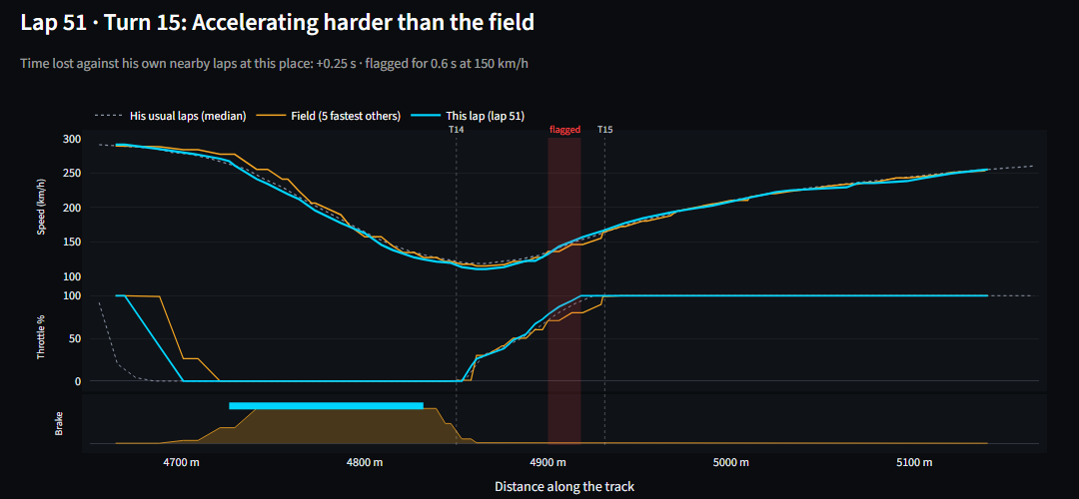
Figure 12. One mistake (lap 51, Turn 15): the lap against the field and the driver's usual laps.
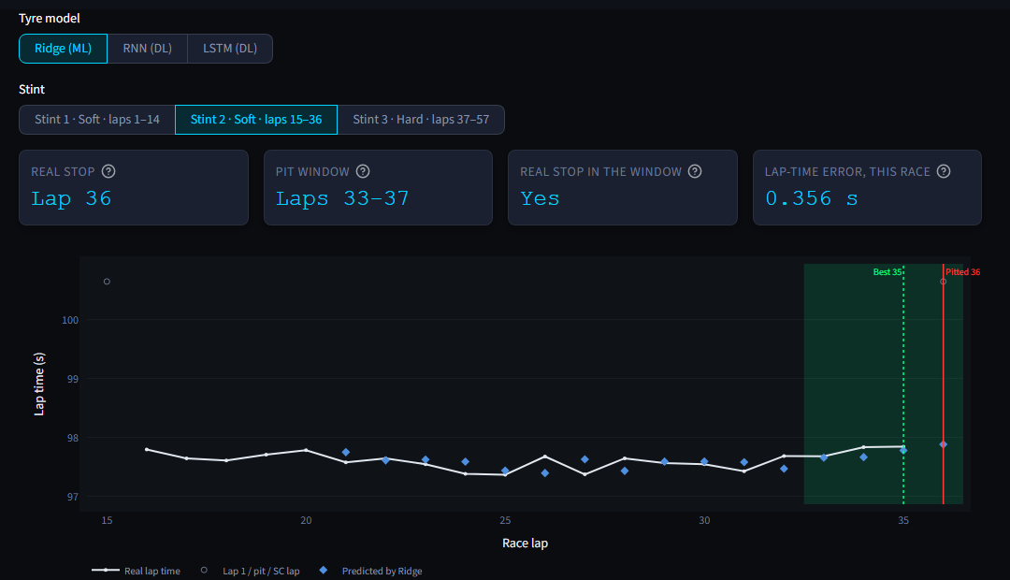
Figure 13. Tyres & Pit Window tab: stint 2 with Ridge's predicted lap times and the pit window.
The scripts behind the dashboard are listed in Appendix A.

11. Limitations and Future Work
- Synthetic mistakes. The controlled test measures "can it find these patterns"; it cannot prove that a flagged real moment was a mistake. The real-lap check covers part of that gap.
- Few sessions scored. Mistake detection was evaluated on four sessions, because each needs a full cross-validation run.
- A tyres-only strategy. Traffic, rivals and track position are ignored on purpose, which is why the ceiling is low: the models cannot see what really sets the pit lap.
- Five test races. Small differences between models (a few stints) are within noise.
- Next steps. Predicting the laps until a driver pits directly; adding traffic and rival cars to the strategy; and mistake and pit-window outputs for every driver of every race.

12. Conclusion
We built a complete system that downloads two seasons of Formula 1 telemetry, repairs it, turns it into features and tests every model against a simple baseline on data it has not seen. For mistake detection, comparing each driver with the fastest drivers at the same point of the track turned a detector that flagged ordinary braking into one that finds synthetic mistakes, and the Isolation Forest finds more of them than a Z-score rule, mainly where several small deviations combine; on real laps its flagged moments cost time more often than random places. For tyre strategy, Ridge regression predicts the next lap slightly better than repeating the last one, and a pit window built on a measured pit cost contains the real stop more often than chance. The most useful result is the honest one: even perfect knowledge of tyre wear would not find more real stops, because the pit lap is decided by strategy and safety cars. A redesigned dashboard shows all of this for any driver and session.
Just as valuable were the habits the project taught: clean the data first, compare with the right reference, use tests with an answer key when the data has none, keep a simple baseline in every comparison, and report what does not work.

References
[1] F. T. Liu, K. M. Ting and Z.-H. Zhou, "Isolation Forest," in Proc. 8th IEEE Int. Conf. on Data Mining, 2008, pp. 413–422.
[2] A. E. Hoerl and R. W. Kennard, "Ridge regression: Biased estimation for nonorthogonal problems," Technometrics, vol. 12, no. 1, pp. 55–67, 1970.
[3] S. Hochreiter and J. Schmidhuber, "Long short-term memory," Neural Computation, vol. 9, no. 8, pp. 1735–1780, 1997.
[4] J. L. Elman, "Finding structure in time," Cognitive Science, vol. 14, no. 2, pp. 179–211, 1990.
[5] F. Pedregosa et al., "Scikit-learn: Machine learning in Python," Journal of Machine Learning Research, vol. 12, pp. 2825–2830, 2011.
[6] A. Paszke et al., "PyTorch: An imperative style, high-performance deep learning library," in Advances in Neural Information Processing Systems 32, 2019.
[7] P. Schaefer et al., FastF1: a Python package for accessing and analyzing Formula 1 results, schedules, timing and telemetry, github.com/theOehrly/Fast-F1, 2023.
[8] J. Todd et al., "Explainable time series prediction of tyre energy in Formula One race strategy," arXiv:2501.04067, 2025.
[9] "A state-space approach to modeling tire degradation in Formula 1 racing," arXiv:2512.00640, 2025.
[10] M. Kuhn and K. Johnson, Applied Predictive Modeling. New York: Springer, 2013.

Appendix A. Running the Project
On Windows with Python 3.13, from the project folder:
python -m venv .venv && .venv\Scripts\pip install -r requirements.txt
python backend/scripts/etl/download_season_data.py
python backend/scripts/etl/clean_telemetry.py
python backend/scripts/detect_mistakes.py --session data_lake/clean_data/2023_1_R.parquet --driver 1 --compare
python backend/scripts/train_ridge.py
python backend/scripts/train_lstm.py --cell lstm --force (and --cell rnn)
python backend/scripts/check_strategy.py
python backend/scripts/predict_strategy.py --session data_lake/clean_data/2024_22_R.parquet --driver 1 --source all
python backend/scripts/tests/run_tests.py --all
streamlit run frontend/app.py

