A Fault-Tolerant Pipeline for Summarizing Long Books with LLMs
Parinaz Akef
Fall 2026

Part 1: Foundation and input processing
I set up a Node.js project (ES modules, tests with Vitest) and built the first pipeline stages. I tested them on The Picture of Dorian Gray from Project Gutenberg.
Text extraction. A cleaner removes the Gutenberg license header and footer and normalizes the text, so each paragraph is one line separated by a blank line.
Structure detection. A pattern-based detector finds chapter headings, ignores tables of contents (clusters of headings close together), and records each chapter as start/end character offsets in one shared text. This avoids copying text and makes loss or duplication verifiable. A coverage check confirms the pieces tile the text exactly.
LLM access layer. I wrote a provider-independent wrapper with four interchangeable clients: native Gemini (not tested against a live key), OpenRouter, a mock for free offline testing, and a usage logger that records tokens, latency and finish reason for every call in JSONL.
Results. 20 chapters detected (total 429,167 characters, about 107,000 estimated tokens), the coverage check passed, and 5 unit tests passed. A live call returned valid JSON with Gemini 3.8 Flash through OpenRouter, and with a small free model in prompt-based JSON mode.
Problems and decisions.
- API access from Iran: the official Gemini API isn’t available in my region, and my first OpenRouter requests got a 403 from a security layer. I made the provider swappable, used OpenRouter to reach Gemini models, and built a mock client so development doesn’t depend on network access. Then I used Tunnel for my VPN which finally allowed me to access OpenRouter models.
- 404 on a free model: the endpoint didn’t support strict structured output. I added three JSON modes (json_schema, json_object, prompt), so weaker models still work.
- 429 rate limit: the free model’s shared quota was exhausted. Handling this properly, with backoff and retries, is planned for Day 3.
- Thinking tokens: a trivial request used about 250 thinking tokens, so output limits and reasoning effort need tuning to control cost and avoid truncation.

Part 2: Summarization pipeline, validation, checkpoints, Persian support
Goal
Turn the chapters found on part 1 into structured summaries (chapter summary plus sections), keep continuity between chapters, and make the run resumable.
What I built
1. Structured per-chapter summarization. For each chapter, the paragraphs are numbered ([P1], [P2], ...) and sent to the model with a short “story so far” and a list of known characters. The model must return strict JSON: a chapter title, a chapter summary, sections given as paragraph ranges, an updated story-so-far, and an updated character list. The paragraph numbers make section boundaries checkable by code.
2. Schemas and validation. The response shape is defined once with Zod. A converter turns it into JSON Schema for the API, and removes keywords some providers reject. Every answer is checked in three layers: valid JSON, correct shape, and domain rules (the sections must tile paragraphs 1 to N with no gaps and no overlaps, and the title must be descriptive, not “Chapter 3”).
3. Retry with feedback. When validation fails, the model is asked again with the exact problems listed (up to 3 attempts). If the section ranges are still wrong, a deterministic repair forces them to tile the chapter, and the chapter is flagged repaired: true.
4. Rolling context. The “story so far” (about 250 words) and character list are carried from chapter to chapter, and rewritten by the model after each chapter. This is the incremental-updating approach from the BooookScore line of work. After all chapters, one extra call produces a whole-book overview, themes and main characters. A cut-off answer (MAX_TOKENS) is detected and retried. Splitting oversized chapters is planned for part 3.
5. Checkpoints and resume. Each finished step is written to .state/<book>/ by writing a temp file and renaming it, so a crash cannot leave a half-written file. Each checkpoint stores a fingerprint (SHA-256) of everything that influences the result: the chapter text, prompt version, provider and model, language, and the previous story state. Changing the prompt or model invalidates old results automatically. Because the previous state is part of the next chapter’s fingerprint, redoing chapter N also invalidates chapters N+1 onward. Progress is never lost when a run is interrupted.
6. Retry on transient errors. A retry wrapper handles rate limits (429), server errors (5xx), timeouts and network failures with exponential backoff and random jitter, honors the server’s Retry-After hint, and does not retry permanent errors such as a bad key. Each retry is printed.
7. Output. output/<book>.json (book info, optional overview, chapters with sections, per-chapter token usage, run totals, warnings) and output/<book>.md, with labels in the book’s language. Every provider call is logged (step, model, latency, finish reason, token counts) to .state/usage.jsonl.
8. Persian and multilingual support.
- The language is detected automatically, and the prompts require summaries in that language, with names kept exactly as written.
- Persian text is normalized (Arabic ي/ك converted to Persian forms, tatweel and diacritics removed, invisible direction marks removed, Arabic presentation forms folded with NFKC) while the half-space (ZWNJ) is kept.
- Chapter headings accept Persian words, digits and ordinals (فصل اول, فصل ۱, باب).
- Heading detection is line-based and runs before lines are joined into paragraphs. It strips Markdown noise (##, trailing \, **) and rejects false matches such as "فصل بهار بود" (“it was spring”).
- The cleaner handles both hard-wrapped (Gutenberg) text and web-style one-paragraph-per-line text.
9. Tooling. A CLI with inspect, summarize (with --title, --limit, --force) and show (prints chosen paragraphs so a human can verify a section). A mock LLM client returns schema-valid fake answers, so the whole pipeline can be developed and tested for free. 8 automated tests pass.
Results
- Dorian Gray (English): 20 chapters, full run completed, [X] chapters repaired, average attempts [X], tokens [in/out], estimated cost [X]. I read the chapters against my memory of the book, and found names, event order and relationships correct.
- Alice’s Adventures in Wonderland (Persian translation): 12 chapters detected, language fa, run completed with the JSON and Markdown outputs checked. The last run consumed 59,389 input and 17,881 output tokens (77,270 total) for chapters 3 to 12 and the overview. Chapters 1 and 2 were reused from checkpoints, which shows resume working on real calls. This is about $0.06 at the listed Flash-Lite prices.
- Resume test: I interrupted a real Persian run after chapter 2 had been saved. The next run reused chapters 1 and 2 and recomputed chapter 3 with no lost progress.
- Model: Gemini 3.5 Flash Lite via OpenRouter. A first two-chapter test used 17,699 tokens in total.
- Token estimate finding: the character-based estimate (4 chars per token) undercounts Persian. For the Persian run I roughly estimate 2.5 to 3 characters per token, so real counts are about 40% above the estimate.
Problems and decisions
- Package loss: npm install zod silently removed @google/genai, openai and vitest, because my hand-edited package.json lost its dependency list. Fixed by reinstalling and checking the file. Lesson: never hand-edit away the dependencies section.
- Free-model rate limits (429): free shared pools ran out repeatedly, which stopped real tests. I added backoff retries and moved real checks to a cheap paid model, keeping the free model only for plumbing.
- Structured-output support differs by model (404): one free endpoint refused strict JSON-schema output. I added three modes (json_schema, json_object, prompt) with JSON extraction and validation as a fallback.
- Titles echoed the heading: the cheap model returned “Chapter 2” instead of a descriptive title. I tightened the prompt, added a title validator that sends complaints back to the model, and bumped the prompt version so old checkpoints were invalidated.
- Persian headings not found: the real file mixed three styles (## فصل یازدهم, فصل دوم: عنوان glued to the next line, and unmarked text). I made heading detection line-based, stripped Markdown, and guarded against false matches. 12 of 12 chapters are now found, and English detection did not regress (still 20).
- Table-of-contents lines became visible: after the change, Dorian Gray’s contents list is detected line by line and correctly ignored as a table of contents. The result is only 20 more characters of text.
- Provider access: the Gemini API is unavailable from my region, so I used Gemini models through OpenRouter. The native Gemini client is written but untested against a live key.

  - The VS Code output for Alice in Wonderland:
PS C:\Users\Parinaz\Desktop\Abrotech_AI\book-summarizer> node scripts/stats.js output/Persian-Alices-Adventures-in-Wonderland.json
ماجراجویی های آلیس در سرزمین عجایب | google/gemini-3.5-flash-lite | 12 chapters
repaired chapters: 0
attempts: avg 1.00, max 1
chapter tokens: in 66000, out 17586, thinking 0
┌─────────┬────┬────────────┬──────────┬──────────┬──────────┬──────┬──────┐
│ (index) │ # │ paragraphs │ sections │ attempts │ repaired │ in │ out │
├─────────┼────┼────────────┼──────────┼──────────┼──────────┼──────┼──────┤
│ 0 │ 1 │ 96 │ 4 │ 1 │ false │ 5606 │ 872 │
│ 1 │ 2 │ 70 │ 4 │ 1 │ false │ 4664 │ 959 │
│ 2 │ 3 │ 80 │ 3 │ 1 │ false │ 4182 │ 980 │
│ 3 │ 4 │ 116 │ 4 │ 1 │ false │ 5823 │ 1385 │
│ 4 │ 5 │ 97 │ 4 │ 1 │ false │ 5205 │ 1430 │
│ 5 │ 6 │ 124 │ 4 │ 1 │ false │ 6004 │ 1577 │
│ 6 │ 7 │ 125 │ 4 │ 1 │ false │ 6264 │ 1784 │
│ 7 │ 8 │ 98 │ 4 │ 1 │ false │ 5990 │ 1808 │
│ 8 │ 9 │ 107 │ 4 │ 1 │ false │ 5975 │ 1813 │
│ 9 │ 10 │ 103 │ 3 │ 1 │ false │ 5672 │ 1784 │
│ 10 │ 11 │ 102 │ 3 │ 1 │ false │ 5143 │ 1803 │
│ 11 │ 12 │ 104 │ 3 │ 1 │ false │ 5472 │ 1391 │
└─────────┴────┴────────────┴──────────┴──────────┴──────────┴──────┴──────┘
PS C:\Users\Parinaz\Desktop\Abrotech_AI\book-summarizer>

  - For The Picture of Dorian Gray:
PS C:\Users\Parinaz\Desktop\Abrotech_AI\book-summarizer> node scripts/stats.js output/dorian-gray.json
The Picture of Dorian Gray | google/gemini-3.5-flash-lite | 20 chapters
repaired chapters: 0
attempts: avg 1.00, max 1
chapter tokens: in 127767, out 30506, thinking 0
┌─────────┬────┬────────────┬──────────┬──────────┬──────────┬───────┬──────┐
│ (index) │ # │ paragraphs │ sections │ attempts │ repaired │ in │ out │
├─────────┼────┼────────────┼──────────┼──────────┼──────────┼───────┼──────┤
│ 0 │ 1 │ 81 │ 3 │ 1 │ false │ 7011 │ 702 │
│ 1 │ 2 │ 136 │ 5 │ 1 │ false │ 8537 │ 986 │
│ 2 │ 3 │ 99 │ 4 │ 1 │ false │ 6920 │ 1257 │
│ 3 │ 4 │ 107 │ 4 │ 1 │ false │ 8463 │ 1339 │
│ 4 │ 5 │ 99 │ 3 │ 1 │ false │ 7097 │ 1437 │
│ 5 │ 6 │ 58 │ 3 │ 1 │ false │ 4954 │ 1404 │
│ 6 │ 7 │ 59 │ 3 │ 1 │ false │ 6887 │ 1379 │
│ 7 │ 8 │ 78 │ 4 │ 1 │ false │ 7970 │ 1609 │
│ 8 │ 9 │ 65 │ 3 │ 1 │ false │ 6336 │ 1531 │
│ 9 │ 10 │ 49 │ 3 │ 1 │ false │ 5399 │ 1696 │
│ 10 │ 11 │ 36 │ 3 │ 1 │ false │ 10456 │ 1707 │
│ 11 │ 12 │ 38 │ 3 │ 1 │ false │ 4786 │ 1581 │
│ 12 │ 13 │ 56 │ 3 │ 1 │ false │ 4597 │ 1533 │
│ 13 │ 14 │ 94 │ 4 │ 1 │ false │ 7309 │ 1648 │
│ 14 │ 15 │ 82 │ 3 │ 1 │ false │ 5690 │ 1603 │
│ 15 │ 16 │ 72 │ 4 │ 1 │ false │ 5492 │ 1764 │
│ 16 │ 17 │ 115 │ 4 │ 1 │ false │ 4270 │ 1843 │
│ 17 │ 18 │ 94 │ 4 │ 1 │ false │ 5937 │ 1856 │
│ 18 │ 19 │ 54 │ 3 │ 1 │ false │ 5969 │ 1899 │
│ 19 │ 20 │ 20 │ 3 │ 1 │ false │ 3687 │ 1732 │
└─────────┴────┴────────────┴──────────┴──────────┴──────────┴───────┴──────┘
PS C:\Users\Parinaz\Desktop\Abrotech_AI\book-summarizer>

  - Detecting the correct number of chapters:
PS C:\Users\Parinaz\Desktop\Abrotech_AI\book-summarizer> npm run inspect

> book-summarizer@1.0.0 inspect
> node src/cli.js inspect data/Persian-Alices-Adventures-in-Wonderland.txt

┌─────────┬────┬────────────────────────────────────────────┬───────┬─────────┐
│ (index) │ # │ heading │ chars │ ~tokens │
├─────────┼────┼────────────────────────────────────────────┼───────┼─────────┤
│ 0 │ 1 │ 'فصل اول: درون سوراخ خرگوش' │ 14169 │ 3543 │
│ 1 │ 2 │ 'فصل دوم: برکهٔ اشک‌ها' │ 10778 │ 2695 │
│ 2 │ 3 │ 'فصل سوم: مسابقهٔ بی‌قاعده و داستانی طولانی' │ 8748 │ 2187 │
│ 3 │ 4 │ 'فصل چهارم: خرگوش صورت‌حساب کوچکی می‌فرستد' │ 13065 │ 3267 │
│ 4 │ 5 │ 'فصل پنجم: پند و اندرز از کرم ابریشم' │ 10897 │ 2725 │
│ 5 │ 6 │ 'فصل ششم: خوک و فلفل' │ 12900 │ 3225 │
│ 6 │ 7 │ 'فصل هفتم: مهمانی چای دیوانه‌وار' │ 12571 │ 3143 │
│ 7 │ 8 │ 'فصل هشتم' │ 12543 │ 3136 │
│ 8 │ 9 │ 'فصل نهم' │ 11946 │ 2987 │
│ 9 │ 10 │ 'فصل دهم' │ 10992 │ 2748 │
│ 10 │ 11 │ 'فصل یازدهم' │ 9478 │ 2370 │
│ 11 │ 12 │ 'فصل دوازدهم' │ 10865 │ 2717 │
└─────────┴────┴────────────────────────────────────────────┴───────┴─────────┘
Language: fa
Total: 139360 chars, ~34840 tokens, 12 chapters
Coverage check passed.

  - Running the model on Persian text:

PS C:\Users\Parinaz\Desktop\Abrotech_AI\book-summarizer> npm run summarize

> book-summarizer@1.0.0 summarize
> node --env-file=.env src/cli.js summarize data/Persian-Alices-Adventures-in-Wonderland.txt --title "ماجراجویی های آلیس در سرزمین عجایب"

"ماجراجویی های آلیس در سرزمین عجایب": language=fa, 12 chapters, model=google/gemini-3.5-flash-lite
فصل اول: درون سوراخ خرگوش (96 paragraphs)
فصل دوم: برکهٔ اشک‌ها (70 paragraphs)
فصل سوم: مسابقهٔ بی‌قاعده و داستانی طولانی (80 paragraphs)
فصل چهارم: خرگوش صورت‌حساب کوچکی می‌فرستد (116 paragraphs)
فصل پنجم: پند و اندرز از کرم ابریشم (97 paragraphs)
فصل ششم: خوک و فلفل (124 paragraphs)
فصل هفتم: مهمانی چای دیوانه‌وار (125 paragraphs)
فصل هشتم (98 paragraphs)
فصل نهم (107 paragraphs)
فصل دهم (103 paragraphs)
فصل یازدهم (102 paragraphs)
فصل دوازدهم (104 paragraphs)
Book overview
Done. Tokens spent this run: {"promptTokens":69172,"outputTokens":18342,"thinkingTokens":0,"totalTokens":87514}
Wrote output/Persian-Alices-Adventures-in-Wonderland.json and output/Persian-Alices-Adventures-in-Wonderland.md
PS C:\Users\Parinaz\Desktop\Abrotech_AI\book-summarizer>

Part 3 (final): Robustness, observability, API and UI
Built
- Run tracking. Each run has lifecycle events (run_started, chapter_started, chapter_done, retry, warning, error, run_done), a status.json per book (running, done or failed), and an errors.jsonl with retries and failures. Every model call is logged with its book and run ID.
- Output validation. The whole book JSON is validated with Zod, and each chapter’s sections must tile its paragraphs, before any file is written.
- Oversized chapters. Chapters above a token limit are split at paragraph boundaries, summarized in order with the rolling story state, and merged. Paragraph numbers stay global, so nothing is lost or duplicated.
- Language-aware token estimates (English 4 characters per token, Persian about 2.75).
- Cost report. It filters usage by run, shows totals per step, and refuses to run without prices (LLM_INPUT_PRICE, LLM_OUTPUT_PRICE) so it can’t show a misleading $0.
- Fault-injection tests (no API calls). They cover 429 then success, 503 then success, network failure, permanent failure, invalid or truncated JSON, wrong section ranges, interrupted run and resume, corrupted checkpoint, oversized-chapter splitting, invalid final JSON, error logs and events, and the error status.
- Local HTTP API that lists books, estimates cost, starts jobs, reports progress, and serves JSON and Markdown.
- React front end for choosing a book, watching progress, reading summaries (with Persian right-to-left layout), and downloading results.
Results
- Real full run of Dorian Gray: 20 chapters and the overview in 21 model calls, 130,562 input and 28,448 output tokens. The report estimated $0.1103, and the OpenRouter balance fell from $0.28 to $0.39 (about $0.11), so they agree to within the dashboard’s rounding.
- Tests: 21 summarizer tests and 1 front-end test pass. The front-end build and TypeScript check pass.
Challenges
- Retry logs and checkpoints were written to the working directory, so tests could not be isolated. I added a workspace option.
- A cost report with no matching usage records printed $0. I added run IDs and made the report fail when there are no records or no prices.
- Retry logs ignored the per-call log path. A regression test exposed this and it was fixed.
- The front end’s non-demo client pointed at endpoints that did not exist. I added the local API and made demo mode opt-in.
- Opening the API’s root URL returned “Not found”, so I added a health route.
- Using AI assistants to patch files often failed to apply edits. I checked results by running tests and syntax checks.

How to Run
Install and run
1. Install Node.js from nodejs.org (the LTS version, or the 24.x you used). Check it with:
node -v
npm -v
2. Backend
cd src/book-summarizer
npm install
fill in .env file:
LLM_PROVIDER=openrouter # openrouter | gemini | mock
LLM_MODEL=<model id> # e.g. a google/gemini-... model from openrouter.ai/models
OPENROUTER_API_KEY=<your key> # or GEMINI_API_KEY with LLM_PROVIDER=gemini
STRUCTURED_MODE=json_schema
LLM_INPUT_PRICE=0.3 # USD per million tokens, used for cost reports
LLM_OUTPUT_PRICE=2.5
PORT=8787

Use LLM_PROVIDER=mock to try everything for free with fake summaries. Then start the API:
npm run server

3. Front end (second terminal, from the project root)
npm install
npm run dev
Open http://localhost:8080. The API at http://localhost:8787 shows a status page.

4. Command line (optional), from src/book-summarizer:
node src/cli.js inspect data/dorian-gray.txt
node --env-file=.env src/cli.js summarize data/dorian-gray.txt --title "The Picture of Dorian Gray" --limit 2
node --env-file=.env scripts/report.js output/dorian-gray.json
npm test

Add your own .txt books to src/book-summarizer/data. Interrupted runs resume automatically. Add --force to start over.

  - Structure overview
Frontend_Book_Summarize/ React app (routes: home, job progress, reader, summaries)
src/lib/api/ calls the backend; demo mode is opt-in (VITE_DEMO_MODE=true)
src/book-summarizer/ the summarizer (Node, no framework)
data/ input .txt books
output/ final <book>.json and .md
.state/<book>/ checkpoints, status.json, errors.jsonl; .state/usage.jsonl = every model call
src/cli.js command line (inspect, summarize, show)
src/server.js HTTP API used by the UI
src/pipeline.js orchestrates the whole run
src/extract/ read and clean text, detect language, Persian normalization
src/structure/ chapter detection, paragraph numbering
src/llm/ provider clients (Gemini, OpenRouter, mock), retry, usage log, validated generation, token estimates
src/summarize/ prompts, chapter and overview logic, oversized-chapter splitting
src/schema/ Zod schemas and final-output validation
src/state/ checkpoints, error log
src/pricing.js, scripts/report.js cost and usage report
test/ Vitest tests (all use fake providers)

Images
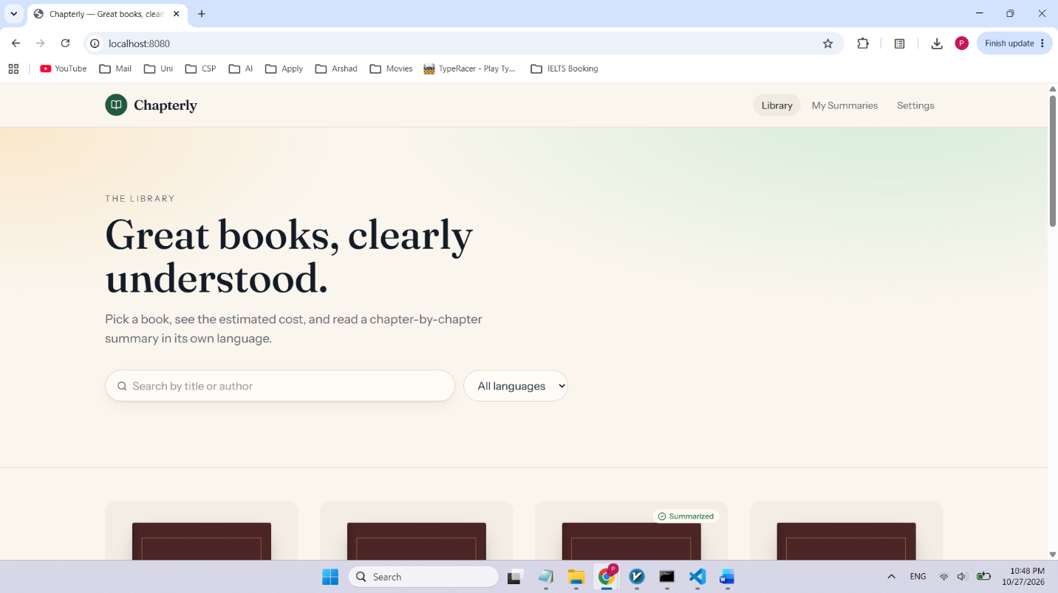

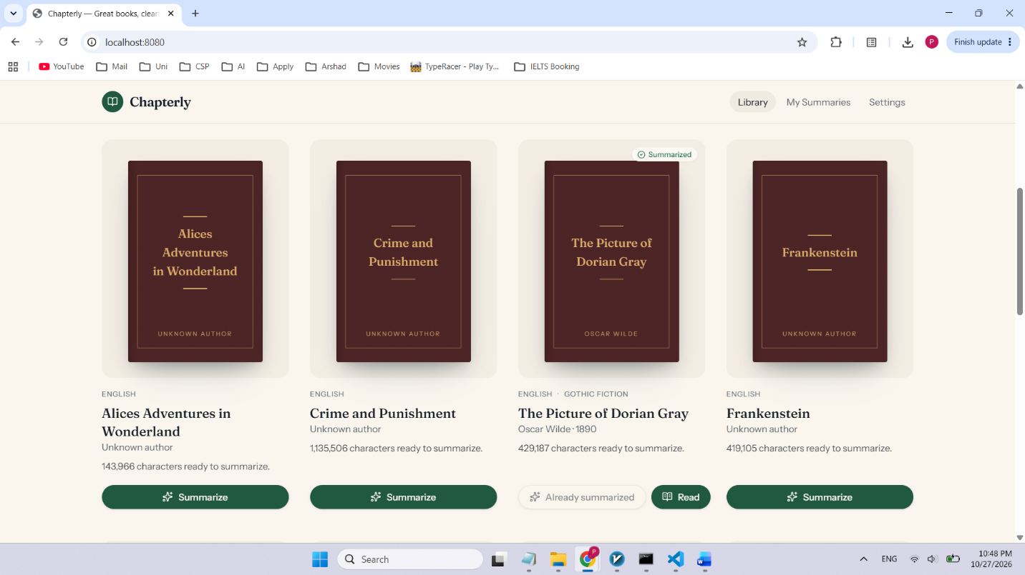

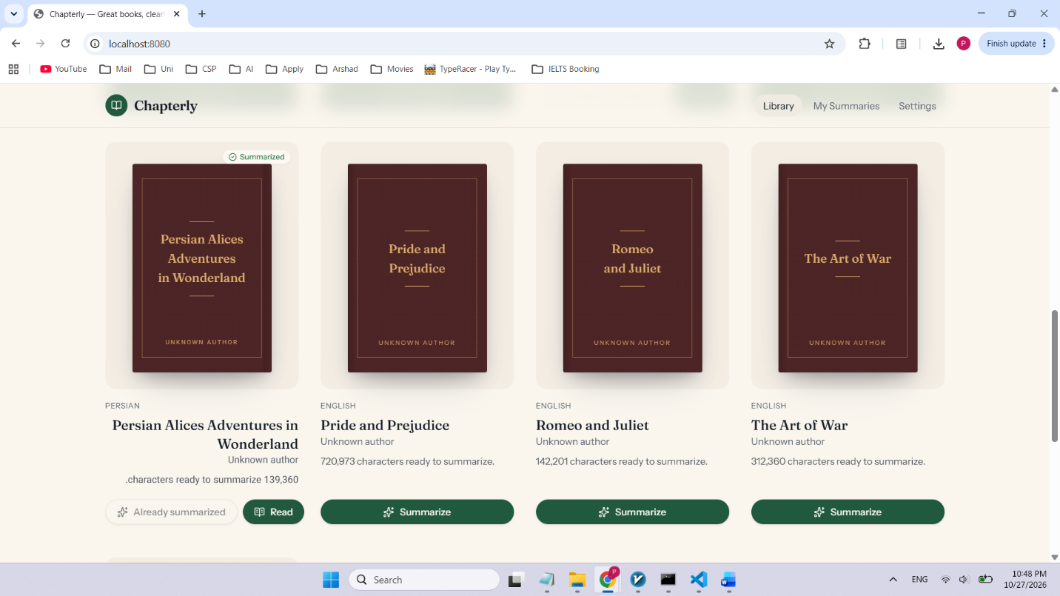

Selecting a book to summarize:
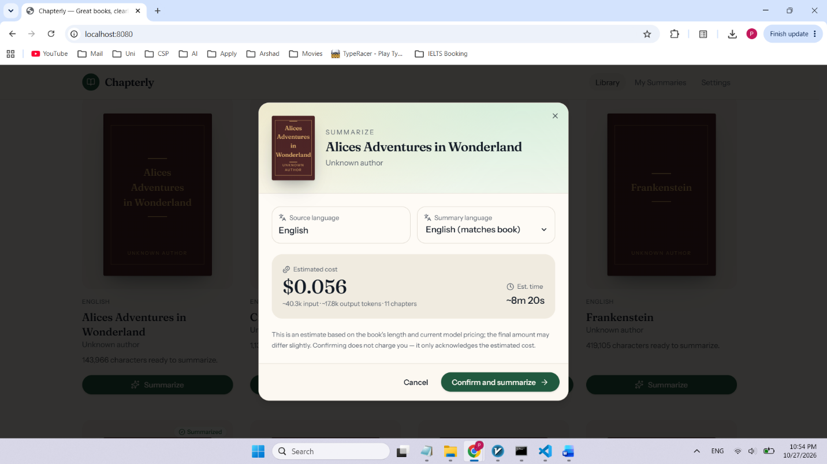

A failed sample (403 network error): VPN was not connected.
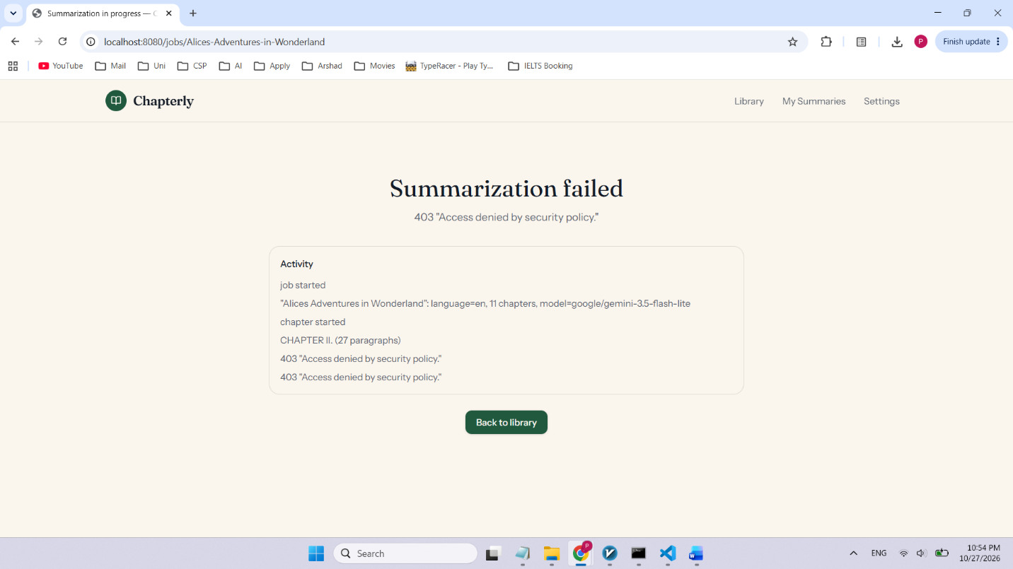
Logs identifying the error:
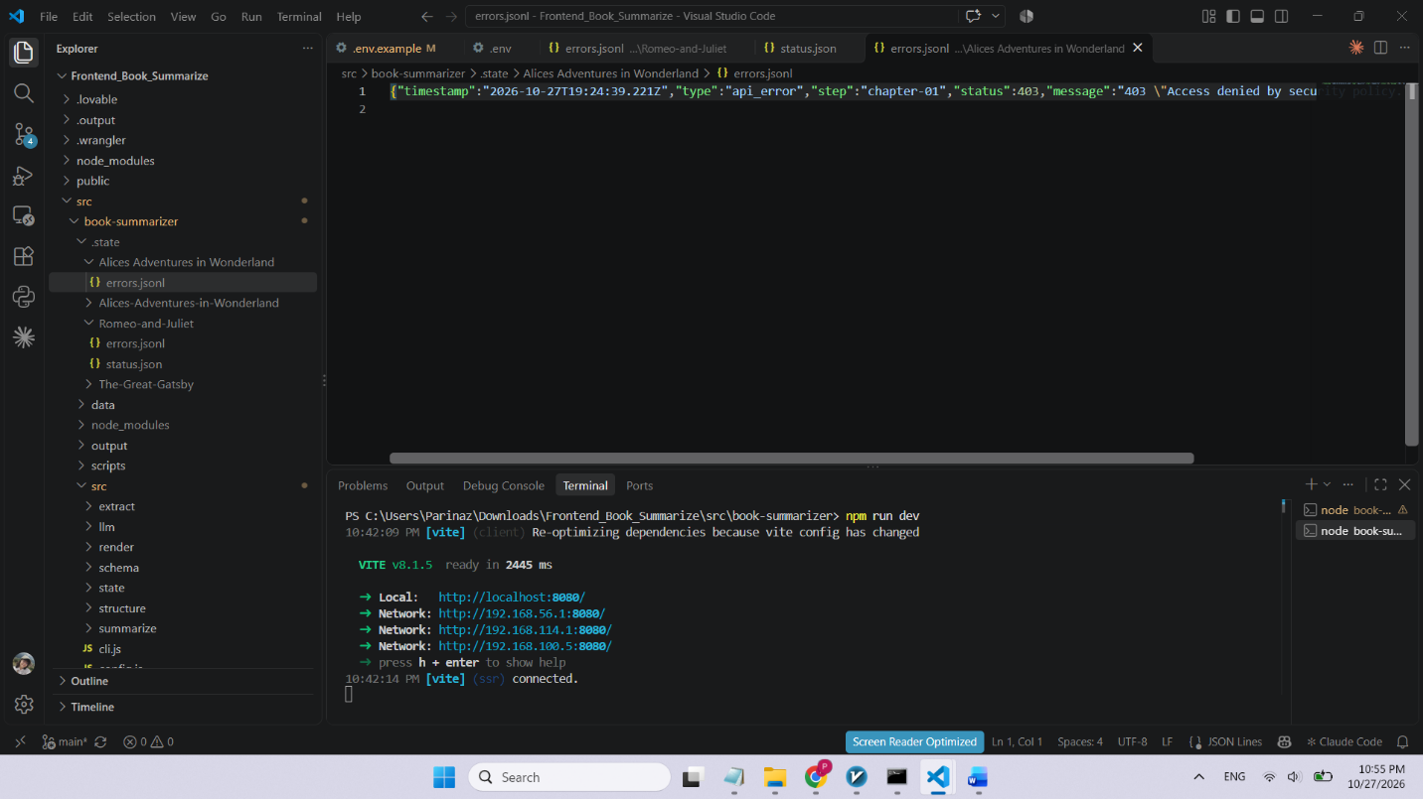

Openrouter API usage (Overall):
