30-Day Hospital Readmission Risk
Findings & Recommendations for Discharge Planning
Diabetes 130-US Hospitals Analysis, 1999–2008
Prepared for: Hospital Quality-Operations & Discharge-Planning Leadership
August 2026

Table of Contents
(In Word, right-click below and choose “Update Field” — or press Ctrl+A then F9 — to populate the page numbers.)

Executive Summary
This analysis examined more than 100,000 hospital encounters for diabetic patients across 130 hospitals (1999–2008) to answer one question: which factors are associated with a patient being readmitted within 30 days of discharge, and what should a discharge-planning team do differently as a result?
Overall, 11.4% of encounters resulted in a readmission within 30 days. That baseline is the yardstick every other figure in this report is measured against — a finding is only worth acting on if it pushes meaningfully above or below that number, and only if it's backed by enough patients to trust.
11.4%  Overall 30-day readmission rate | ~1 in 3  Highest-risk group identified | 61%  Risk model ranking accuracy
Three findings stand out:
1. A patient's history of hospital use — prior inpatient stays and ER visits — is the single strongest and clearest warning sign found, and the two compound each other.
2. Young adults (age 20–30) admitted primarily for diabetes are a distinct high-risk group, readmitted at nearly double the rate of diabetes patients at any other age.
3. A long hospital stay only becomes a red flag for readmission when it's paired with a heavy discharge medication load — either factor alone is a much weaker signal.
Together with a supporting predictive model, these findings point toward targeted, same-day discharge-planning actions rather than a one-size-fits-all policy. Recommendations are detailed in Recommendations (page reference in the Table of Contents).

Background
The dataset covers 101,766 inpatient hospital encounters for patients with a diabetes diagnosis, across 130 US hospitals and integrated delivery networks between 1999 and 2008. Each row represents one hospital stay — a patient with multiple admissions over the years appears more than once. After removing encounters that ended in the patient's death or a transfer to hospice care (where a 30-day readmission isn't a meaningful measure), 99,343 encounters remained as the working analysis set.
This project was scoped as an operations and quality-improvement question — what a hospital's own discharge-planning team can see and act on — rather than a billing or insurance-cost analysis.
A note on how the findings were checked: every pattern in this report is backed by a large enough group of patients to be trustworthy, not a handful of cases that happened to show an extreme result. Where a group was too small to draw a reliable conclusion from, it was either excluded or flagged rather than reported as a finding. The technical detail behind this check is in the Appendix.

Finding 1 — Prior Hospital Use Is the Clearest Warning Sign
Patients with a history of frequent hospital use before this admission — 3 or more prior inpatient stays combined with 2 or more prior emergency room visits in the year before — were readmitted within 30 days close to 1 in 3 times (34.5%), roughly three times the overall 11.4% baseline.
Critically, this is not just “sicker patients being sicker” twice over. The two histories compound each other: among patients with no prior inpatient stays, ER visit history barely moves the readmission rate. But among patients who already have 3 or more prior inpatient stays, additional ER visit history adds substantially more risk on top of that — the combined group's rate (34.5%) is higher than what either factor alone would predict (26.4% for inpatient history alone, 25.3% for ER history alone).
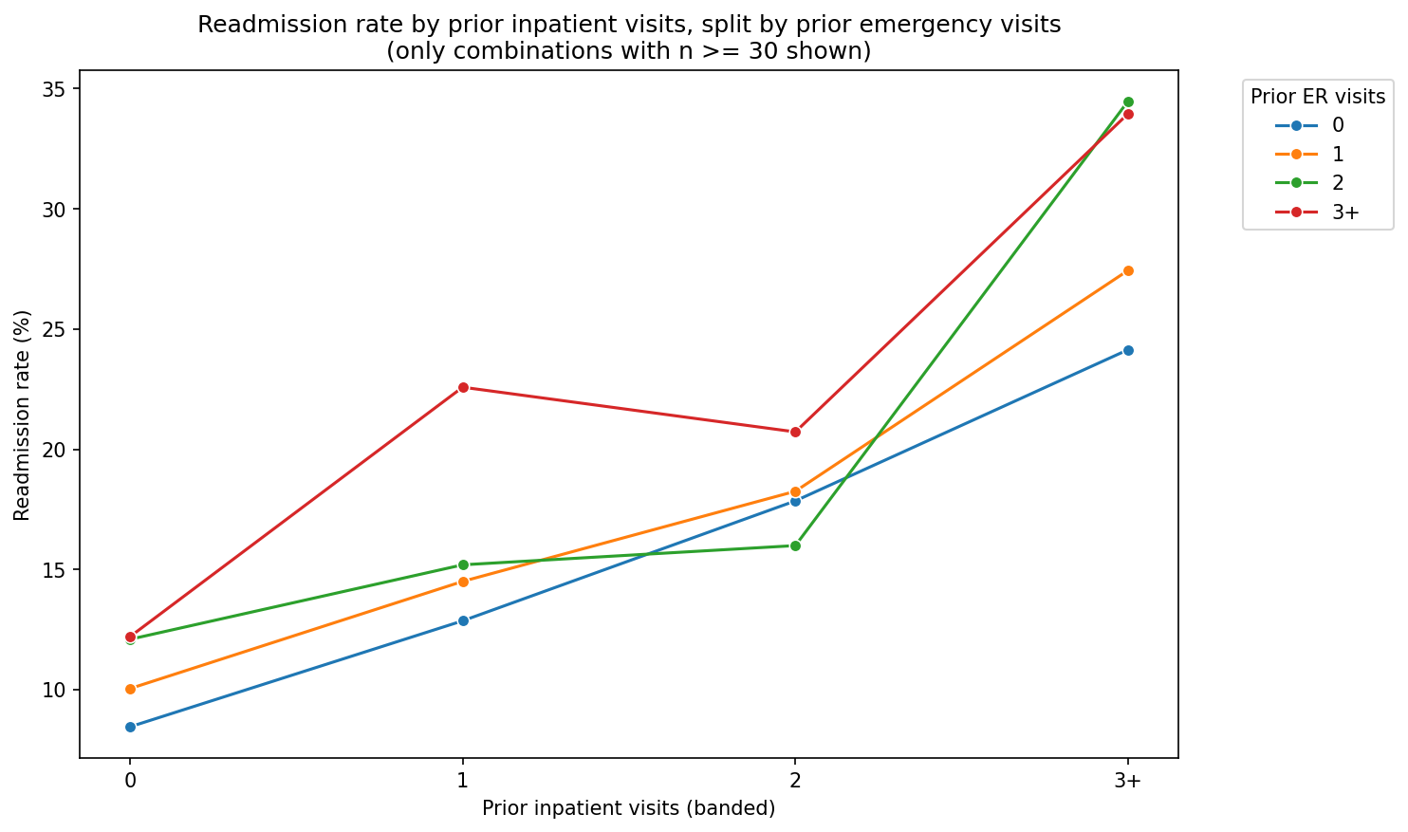
Readmission rate by prior inpatient visits, split by prior emergency visits. The gap between the lines widens sharply once a patient has 3+ prior inpatient stays — direct evidence the two risk factors compound rather than simply overlap.
This finding also lines up with LACE, a discharge-risk tool already used in many hospitals, which weighs emergency-visit history heavily. That's a useful credibility check: this isn't a new or unproven idea, it's confirmation of an established one, in this hospital system's own patients — and unlike a diagnosis or lab result, it's already known the moment a patient is admitted.

Finding 2 — Young Adults With Diabetes Are a Distinct High-Risk Group
Diabetes patients overall don't stand out much by age — except for one clear exception. Patients aged 20–30 admitted primarily for diabetes were readmitted at over 20%, compared to roughly 12–15% for diabetes patients at every other adult age. The gap is large and consistent enough not to be explained by chance, and it isn't explained by medication load or any other factor checked — it's specific to this age group and this diagnosis together.
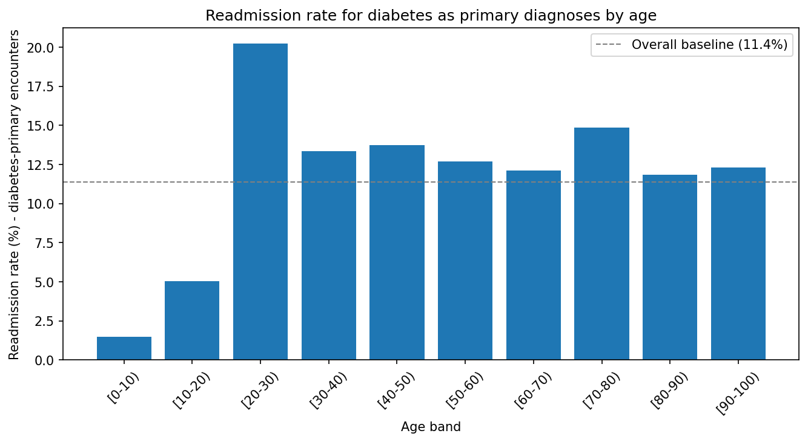
Readmission rate for diabetes-primary encounters by age band. The 20–30 age band sits far above the overall 11.4% baseline (dashed line) and every neighboring age group.
This age range is a recognized gap in diabetes care nationally: young adults are often transitioning from pediatric to adult-managed care, a period associated with higher rates of missed follow-up and treatment non-adherence. This data confirms that's a real, measurable pattern in this hospital system's own patients, not just a general concern from the medical literature.

Finding 3 — Long Stays Are Only Risky When Paired With a Heavy Medication Load
On their own, a longer hospital stay and a high number of discharge medications are each only mildly associated with higher readmission risk. But together, they create the single highest-risk combination found anywhere in this analysis: patients staying 10 or more days who leave on 26 or more medications were readmitted at over 15% — the highest rate observed in the entire dataset, and well above patients with either factor alone.
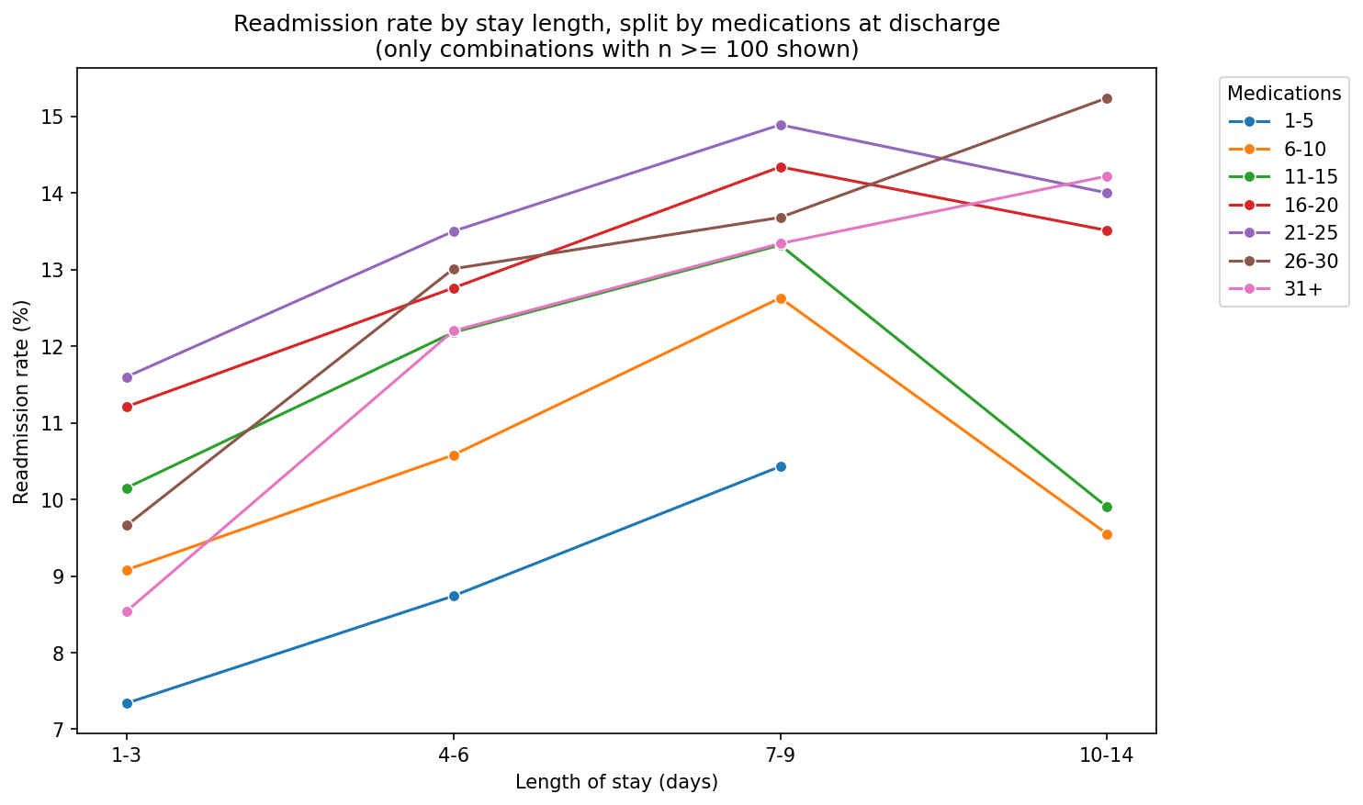
Readmission rate by length of stay, split by number of discharge medications. Through the first week, every medication band moves together — but past 7–9 days, only the heaviest medication bands (26+) keep climbing.
Shorter stays with many medications, or long stays with few medications, don't show this same effect — it's specifically the combination that matters. This points to a genuinely more medically complex group of patients, not simply a longer recovery from a routine procedure.

Supporting Patterns
A few additional patterns came out of the same analysis. They didn't make the top three — either the effect size was smaller, or they're operational context rather than a direct readmission-risk driver — but they're worth having on record.

Elderly patients on many medications are a second, distinct high-risk group
Separately from Finding 3's stay-length interaction, medication count on its own becomes a much stronger risk factor as patients get older. Among patients under 60, more medications makes little difference to readmission risk. But among patients aged 80–90, those on 26–30 medications were readmitted more than twice as often as those on only 1–5 medications (16.5% vs. 7.7%).
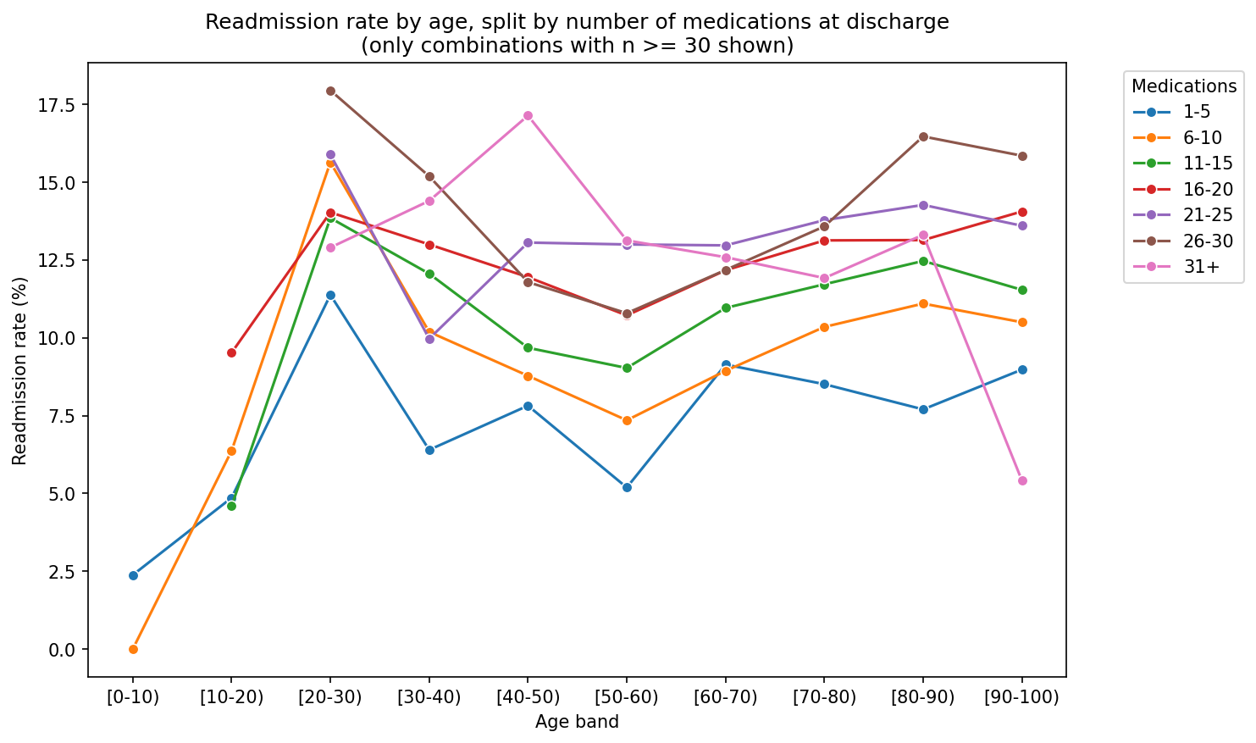
Readmission rate by age band, split by number of discharge medications. The lines sit close together through middle age, then fan out sharply from about age 60 onward.

Diagnosis type has a modest, real effect — both on risk and on length of stay
Looking at readmission rate by primary diagnosis category alone, diabetes-primary encounters carry the highest rate, followed by injury and circulatory conditions; musculoskeletal diagnoses carry the lowest. The spread here is real but much smaller than the findings above — diagnosis type alone is a comparatively weak signal next to a patient's utilization history. Diagnosis type also affects how long patients stay on average, which matters more for bed-capacity planning than for discharge-risk flagging.
Diagnosis category | 30-day readmission rate | Avg. length of stay (days)
Diabetes | 13.1% | 4.33
Injury | 12.4% | 4.62
Circulatory | 11.7% | 4.21
Other | 11.7% | 4.77
Neoplasms (cancer) | 10.9% | 5.28
Respiratory | 10.1% | 4.19
Musculoskeletal | 9.5% | 3.91

Where a patient was admitted from — a modest, partly data-quality-driven pattern
Readmission rate varies somewhat by admission source (roughly 9.5% to 15.7% across sources with enough patients to measure reliably). However, about 7% of encounters have an admission source that isn't a real category — it's simply unrecorded in the source data. This pattern is included for completeness but shouldn't be treated as a strong standalone finding without cleaner source data.

Comparing the Risk Factors Side by Side
Each finding above was also measured on a common scale — an odds ratio — so the relative strength of each factor can be compared directly. An odds ratio of 2, for example, means the higher-risk group's odds of readmission are twice the reference group's; a dashed line at 1 marks “no difference from baseline.”
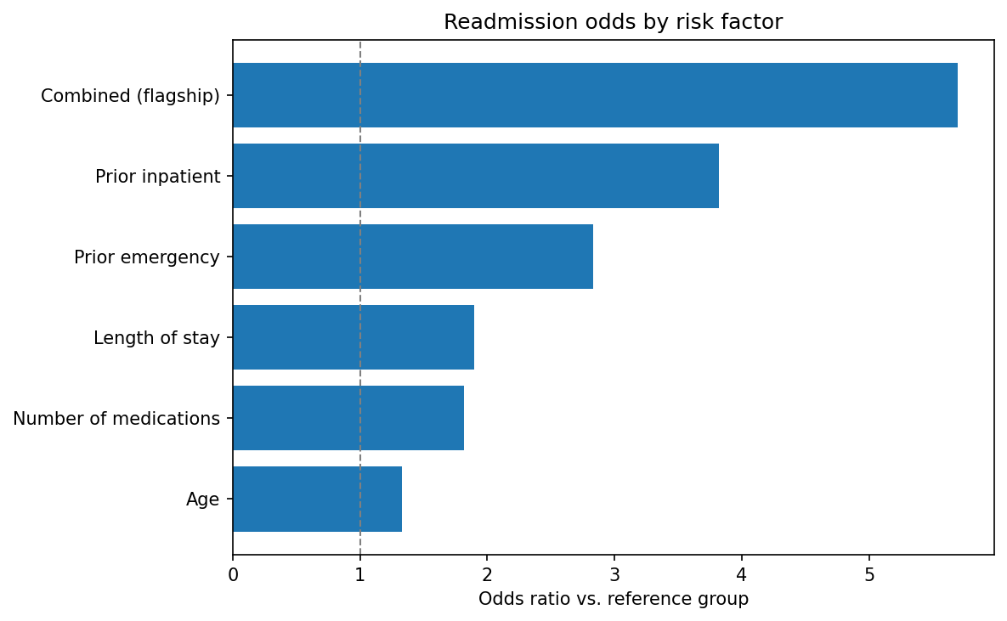
Readmission odds by risk factor. The combined utilization-history finding (Finding 1) sits well clear of every individual factor on its own.
The combined prior-utilization finding is, by a clear margin, the strongest signal in the dataset — over five and a half times the reference group's odds. Prior inpatient history and prior ER history are each strong on their own; length of stay, medication count, and age are real but comparatively modest individual factors, which is consistent with why Findings 1–3 focus on combinations rather than single variables.

The Risk-Scoring Tool
Beyond the rate-based findings above, a statistical model was built to score each individual patient's own readmission risk, rather than only their group's average rate. It's important to be clear about what this tool is and isn't: it ranks patients from higher to lower risk using the same factors described above — it does not predict any individual outcome with certainty.
The model correctly ranks a higher-risk patient above a lower-risk one about 61% of the time — meaningfully better than chance (50%), but a modest, honest signal rather than a highly precise one. This is consistent with how much of readmission risk this data alone can realistically explain.
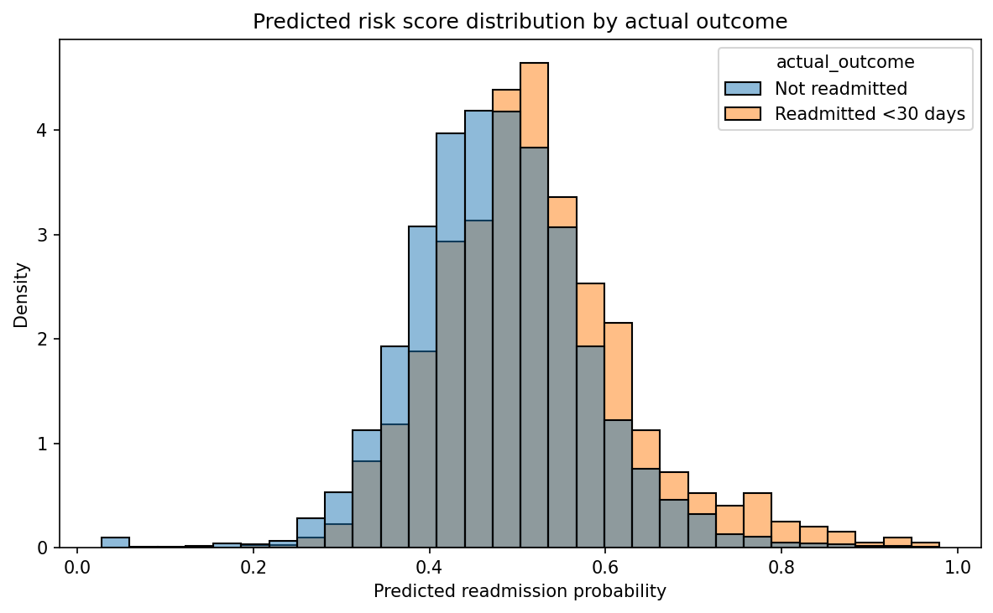
Predicted risk scores for patients who were and weren't actually readmitted. The two groups overlap substantially, but patients who were readmitted skew visibly toward higher scores — a genuine but imperfect signal, not a clean split.
The model's own top individual risk factors match the findings above almost exactly — prior inpatient visits, then prior ER visits, then length of stay, then medication count, in that order — an independent confirmation that the same patterns hold whether you look at group averages or an individual-level model.
This model powers a daily risk watchlist in the accompanying Power BI dashboard, giving the discharge-planning team a ranked list of current patients to prioritize rather than waiting to notice risk only after a readmission has already happened.

Recommendations
Four concrete actions follow directly from the findings above:
- Use hospital-utilization history as a same-day discharge-planning flag. Prior inpatient stays and ER visits are already known at admission, so at-risk patients (Finding 1) can be identified before discharge planning starts, rather than being noticed only after a readmission. The dashboard's risk watchlist already surfaces this daily.
- Build a dedicated young-adult diabetes transition protocol. For patients aged 20–30 admitted primarily for diabetes (Finding 2), add a diabetes educator consult and a structured follow-up appointment within 7 days of discharge, rather than relying on the same general diabetes discharge instructions used across all ages.
- Add a pharmacist-led medication reconciliation review for the 10+ day stay / 26+ medication overlap. This targets the actual highest-risk group found (Finding 3), instead of a blanket review policy spread evenly across all long-stay patients.
- Extend medication reconciliation review to elderly patients on a heavy medication load, even when their stay wasn't long — a distinct risk pattern from Action 3 above, supported by the elderly/medication finding in Supporting Patterns.

Limitations & What This Analysis Does Not Tell Us
This report is intended to be read alongside a few honest caveats:
The data covers 1999–2008. Clinical practice and discharge processes have changed since then, so findings should be validated against more recent data before being treated as current operating fact, even though the underlying patterns (utilization history, age-related risk, medication complexity) are the kind that tend to persist.
Every finding in this report was only reported after checking it was backed by a large enough group of patients — patterns from very small groups were excluded rather than reported, even where they looked dramatic.
The risk-scoring tool ranks patients relative to each other; its scores should not be read as exact probabilities of readmission for an individual patient.
About 7% of encounters have an unrecorded admission source, and a small fraction of encounters have an unrecorded primary diagnosis — these gaps are shown transparently in the supporting dashboard rather than hidden or estimated.

Appendix — Technical Detail
This section is for readers who want the statistical and modeling detail behind the findings above. It is not required reading to understand or act on the recommendations.

A. How reliability was checked
For every group examined in this analysis (an age band, a medication-count band, or a combination of factors), three values were computed: the readmission rate, the group size (n), and a margin of error — the standard 95% confidence interval for a sample proportion (the Wald interval):
margin of error = 1.96 × √( rate × (1 − rate) / n )
A readmission rate computed from a handful of patients is not equally trustworthy as the same-looking rate computed from thousands. Attaching a margin of error to every rate made this explicit and checkable. As a working standard, groups with fewer than 30 encounters were excluded from findings throughout this analysis, in Python, SQL, and the predictive model alike.

B. Predictive model performance detail
A logistic regression model was trained on each patient's first hospital encounter (69,990 encounters, to satisfy the model's independence assumption), using the seven factors validated in the findings above: prior inpatient visits, prior ER visits, length of stay, number of medications, age, medical specialty, and diagnosis category. The model used balanced class weighting to account for the fact that only 11.4% of encounters are readmissions.
Overall performance: AUC = 0.607, recall = 0.55, precision = 0.12 for the readmitted class.
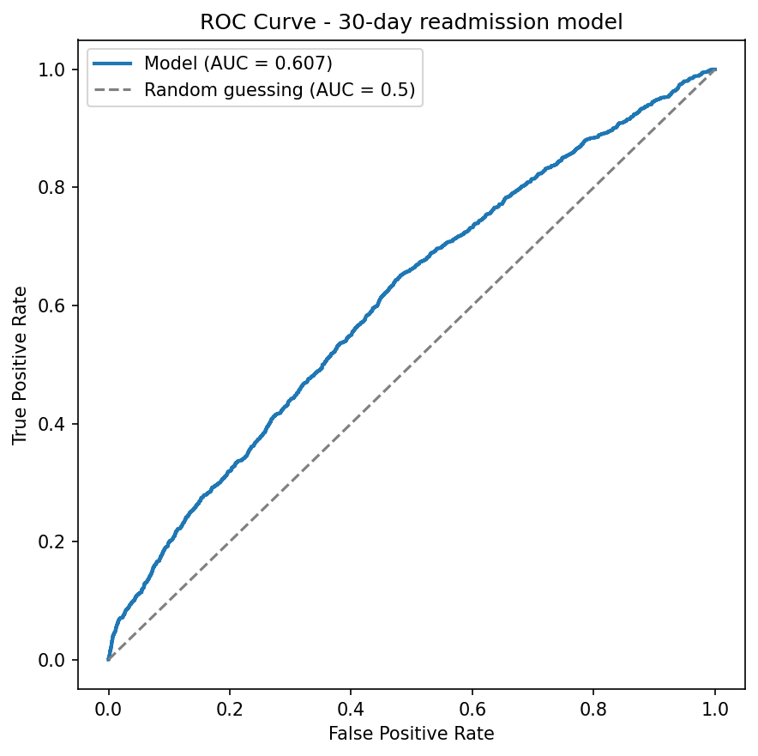
ROC curve. Bows modestly above the diagonal (random chance), consistent with an AUC of 0.607 — a real but modest ability to separate higher- and lower-risk patients.
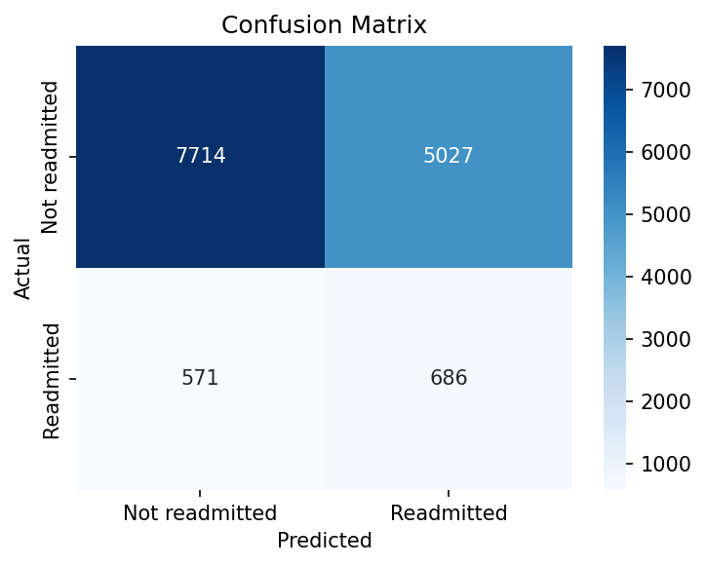
Confusion matrix on the held-out test set. The precision trade-off is visible here: a large share of patients flagged as high-risk were not, in fact, readmitted within 30 days — an expected consequence of prioritizing catching true readmissions (recall) over avoiding false alarms.
An explicit interaction term between prior inpatient and prior ER visits (recreating Finding 1 directly as a model feature) was tested and made no meaningful difference to overall accuracy — because that interaction only strongly affects a small high-utilization subgroup (~1,200 of 69,990 patients), which has limited leverage on a whole-population ranking metric. This is why Finding 1 is presented as a rule-based discharge-planning flag rather than folded into the model itself.
Model coefficients were cross-checked against the rate-based findings above and matched in both direction and relative ranking: number_inpatient > number_emergency > time_in_hospital > num_medications — the same order found independently through simple rate comparisons, which is a meaningful confirmation that the two approaches agree.

C. External validation against the published source study
This dataset was originally published alongside a peer-reviewed study (Strack et al., 2014). As a further check on this analysis, several of that paper's own published figures were independently recreated from this data.
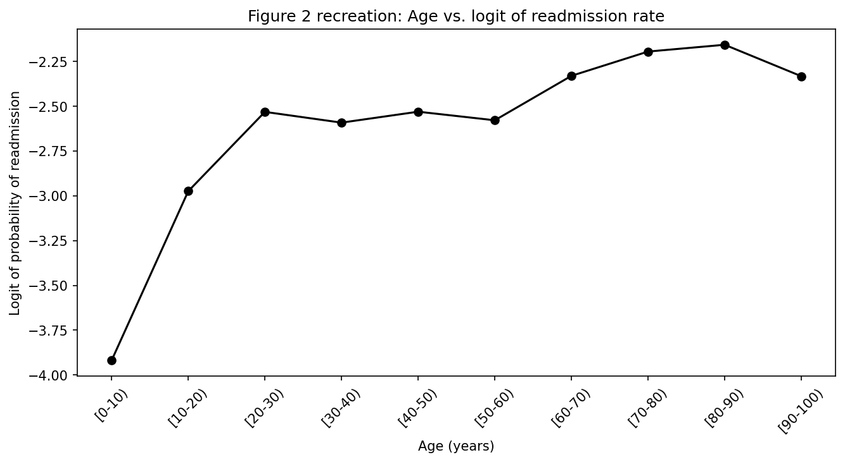
Recreation of the source paper's age-vs-readmission relationship. The three-segment shape — a steep rise through early adulthood, a flat plateau through middle age, and a second rise from around age 60 — matches the published paper's description exactly.
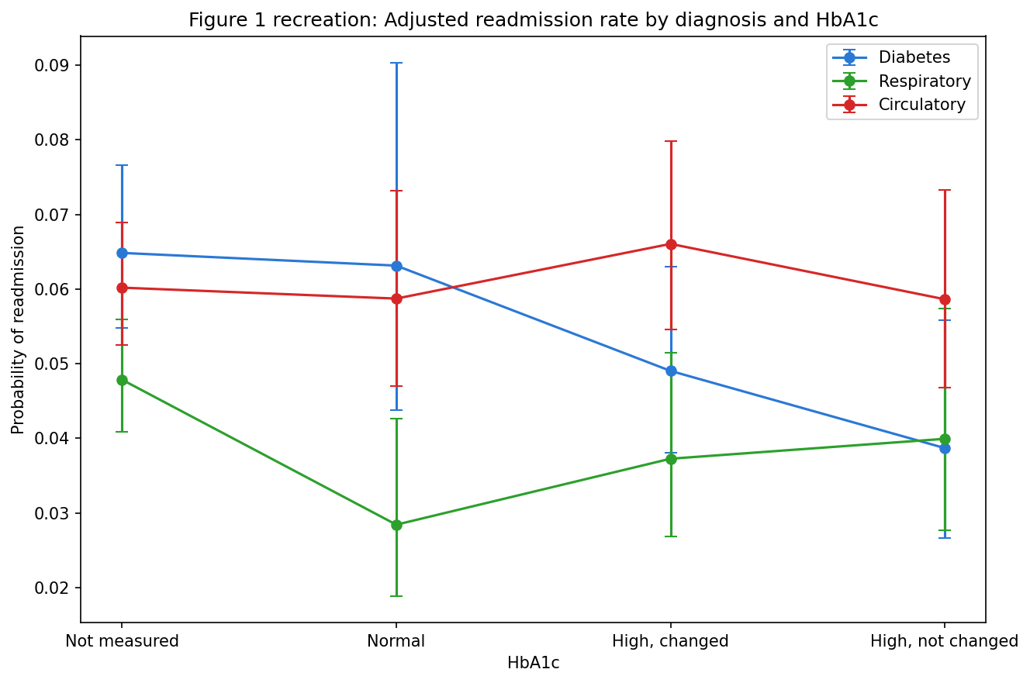
Recreation of the source paper's diagnosis × HbA1c-testing relationship for three diagnosis categories. Diabetes patients show a clear decline in predicted readmission risk as HbA1c testing increases — the paper's central finding, replicated here.
These recreations matched the published paper's reported patterns closely, including its central claim that HbA1c testing is associated with materially lower readmission risk specifically for diabetes patients (and not for circulatory patients) — an independent, external check that the patterns in this dataset are genuine and previously peer-reviewed, not artifacts of this particular analysis.
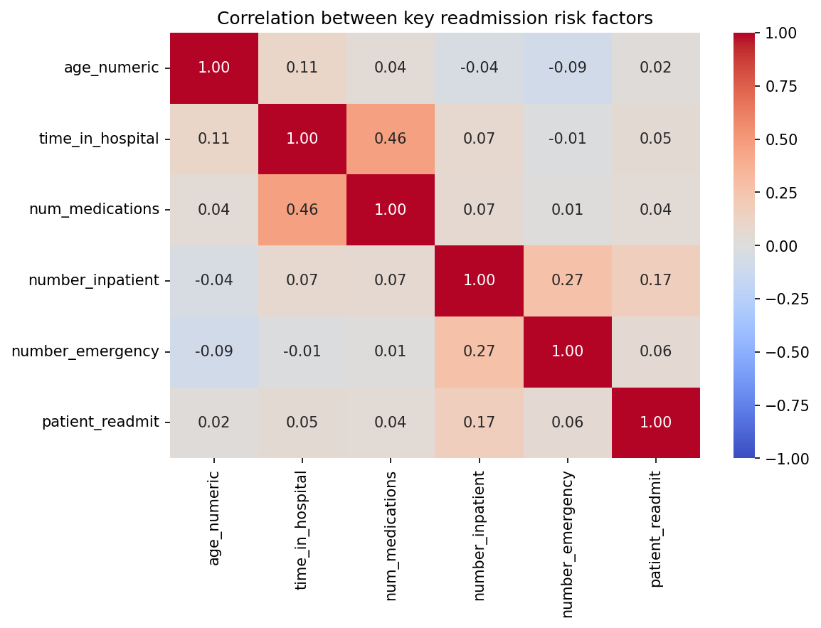
Correlation between the core numeric risk factors and the readmission outcome. No two predictors are highly correlated with each other (all below 0.5), supporting the conclusion that Findings 1 and 3 reflect genuine compounding effects rather than one variable simply standing in for another.

D. Full effect-size reference
Percentage-point swing from lowest to highest reliable band, for each factor examined individually:
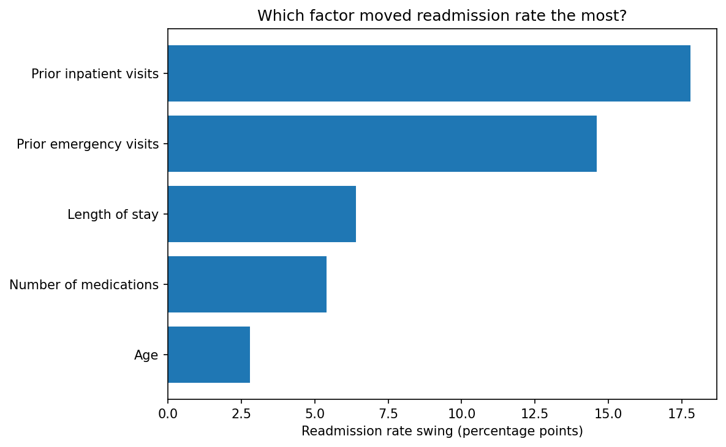
Effect size (percentage-point swing, lowest to highest reliable band) for each individual risk factor.
Finding | Reference group | Comparison group | Odds ratio
Prior inpatient visits | 0 visits (8.6%) | 3+ visits (26.4%) | 3.82x
Prior emergency visits | 0 visits (10.7%) | 3+ visits (25.3%) | 2.83x
Combined (flagship) | both 0 (8.45%) | 3+ inpatient & 2+ ER (34.5%) | 5.70x
Length of stay | day 1 (8.4%) | day 10 (14.8%) | 1.90x
Number of medications | 1–5 meds (~7.6%) | 21+ meds (~13%) | 1.82x
Age | 50–60 (9.8%) | 80–90 (12.6%) | 1.33x

