📘 1. Unraveling the World of Data and Its Insights
Data is raw information.
Analytics + Statistics convert that raw information into meaningful insights, enabling decisions in:
- Business
- Healthcare
- Social media
- Finance
- Education
- Machine Learning

✔ Types of Data
Type of Data | Examples
Numerical | Age, weight, income, marks
Categorical | Gender, city, department
Ordinal | Rating scale (1 to 5), satisfaction level
Time Series | Stock prices, daily sales

✔ Why do we analyze data?
- To understand what is happening
- To explain why it is happening
- To predict what may happen
- To recommend what to do next

Population vs Sample

1. What is a Population?
A population includes all members of a defined group that you want to study or draw conclusions about.

Population Parameters
- Population Mean = μ
- Population Standard Deviation = σ
- Population Proportion = P

2. What is a Sample?
A sample is a small subset of the population selected for analysis.

Sample Statistics
- Sample Mean = x̄
- Sample Standard Deviation = s
- Sample Proportion = p

📘 2. The Basics of Statistics: Descriptive Insights
Descriptive statistics summarize large datasets into simple numbers.

📌 Measures of Central Tendency

5, 7, 7, 9, 10, 12, 13, 15, 15, 18, 20, 40

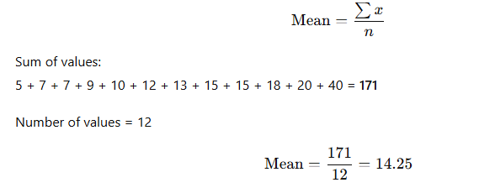

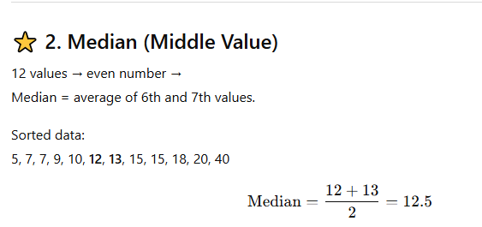

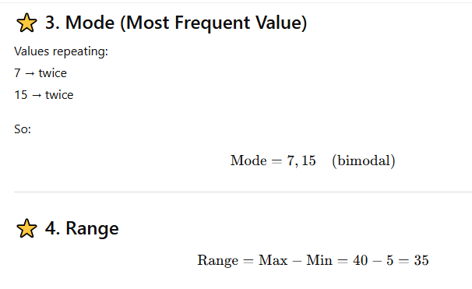

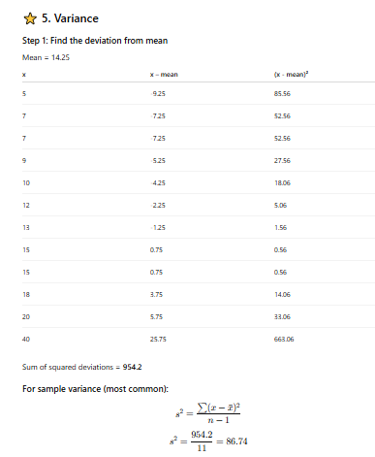

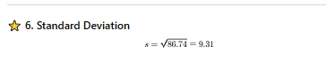

1️⃣ Mean (Average)
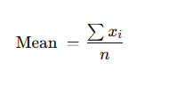Example:
Marks = 10, 20, 30
Mean = (10+20+30)/3 = 20

2️⃣ Median
Middle value when data is sorted.
- Odd n → middle value
- Even n → average of two middle values

3️⃣ Mode
Most frequent value
Examples:
- Shoe size most sold = 7
- Website most visited browser = Chrome ✔

📘 3. Measuring Data Spread: Dispersion Insights
Dispersion tells us how spread out the data is.

📌 1️⃣ Range
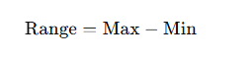

📌 2️⃣ Variance
Shows average squared deviation from mean.
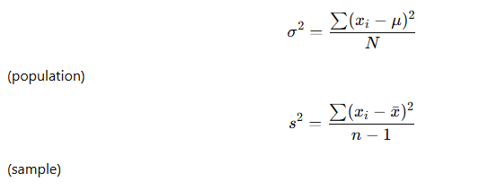

📌 3️⃣ Standard Deviation
Square root of variance.
Shows how far values are from the mean.
σ=σ2\sigma = \sqrt{\sigma^2}σ=σ2​
More SD = more spread
Low SD = stable data

📌 4️⃣ Interquartile Range (IQR)
Middle 50% of data.
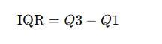

📘 4. Unlocking Relationships: The Power of Association

Association checks how variables move together.

📌 1️⃣ Covariance

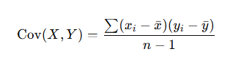
- Positive → move in same direction
- Negative → move in opposite direction
- 0 → no pattern

📌 2️⃣ Correlation (Pearson)
Standardized covariance, ranges from −1 to +1.
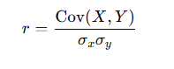
r value | Meaning
+1 | Perfect positive
-1 | Perfect negative
0 | No relationship
0.3–0.5 | Moderate
> 0.7 | Strong
Example:
- Study time vs marks = positive correlation
- Price vs demand = negative correlation
covariance, Pearson correlation coefficient, and skewness for a worked example so you can see the full math + interpretation.
Note: covariance & correlation need a pair of variables. I used the test scores you gave:
Y (Scores) = [5, 7, 7, 9, 10, 12, 13, 15, 15, 18, 20, 40]
and for demonstration I created a plausible paired variable:
X (StudyHours) = [1, 2, 2, 3, 4, 5, 5, 6, 6, 7, 8, 12]
If you already have a real paired variable (e.g., StudyHours, Attendance), tell me and I’ll re-run with that.

1) Quick summary of results (rounded)
- Mean(Score) = 14.25
- Mean(StudyHours) = 5.0833
- Sample covariance (Cov(X,Y)) = 27.4318
- Pearson correlation r = 0.9629 (strong positive correlation)
- Skewness (Fisher–Pearson adjusted g₁) = 2.0967 (strong positive skew)
  - Unadjusted skew (simple third moment / s³) = 1.6016

4) Practical takeaways / interpretation
- Covariance > 0 and r ≈ 0.963 → X and Y move together strongly (in our example: more study hours → higher scores).
- High skewness (≈ 2.10) shows the distribution of scores is right-skewed (long tail to the right). The value 40 is an outlier and inflates mean & variance.
- Because of skew and outlier, the median (12.5) is a more robust “center” than the mean (14.25) for describing typical score.
- If you plan to run regressions or parametric tests, consider:
  - transforming data (log) or
  - using robust methods or
  - removing/inspecting outliers before modeling.

Population vs Sample

1. What is a Population?
A population includes all members of a defined group that you want to study or draw conclusions about.

Examples
- All customers of Zomato in India
- All 8th-grade students in a school
- Every product sold in 2024
- Every employee in a company

Key Points
- Represents the entire group
- Usually large (sometimes infinite)
- Hard to measure completely
- True parameters come from population (like μ, σ)

Population Parameters
- Population Mean = μ
- Population Standard Deviation = σ
- Population Proportion = P

2. What is a Sample?
A sample is a small subset of the population selected for analysis.

Examples
- 500 Zomato customers selected from all users
- 100 students selected randomly from all 8th graders
- 1000 product records out of 10 lakh sales
- Surveying 200 employees instead of all 5000

Key Points
- Represents a part of the population
- Used when studying entire population is impossible
- Should be random to reduce bias
- Sample statistics are used to estimate population parameters

Sample Statistics
- Sample Mean = x̄
- Sample Standard Deviation = s
- Sample Proportion = p

3. Why Do We Use Samples?
Studying the whole population can be:
✔ Expensive
✔ Time-consuming
✔ Impossible (infinite population like website visitors)
Sampling allows:
✔ Faster results
✔ Lower cost
✔ Statistical inference using probability

4. Population vs Sample — Comparison Table
Feature | Population | Sample
Definition | Whole group | Subset of population
Size | Very large (N) | Small (n)
Values | Parameters | Statistics
Mean | μ | x̄
Standard deviation | σ | s
Analysis | Difficult | Easier
Accuracy | High | Estimate of population
Cost & Time | High | Low

📘 5. Decoding Skewness: Understanding Data Distribution
Skewness measures symmetry.

📌 Formula for Skewness (Fisher’s)

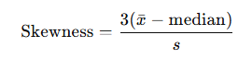

Types:
- Positive skew (Right-skewed): Mean > Median
- Negative skew (Left-skewed): Mean < Median
- Symmetric: Mean = Median

📘 6. Unlocking the World of Probability
Probability measures the likelihood of an event.

📌 Formula

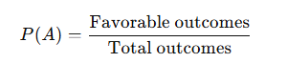

⭐ Properties:
- 0 ≤ P(A) ≤ 1
- P(Not A) = 1 – P(A)
- P(A and B independent) = P(A) × P(B)
- P(A or B) = P(A) + P(B) – P(A and B)

📘 7. Understanding Uniform Distribution
A uniform distribution has equal probability for all outcomes.

✔ Example: Rolling a fair dice

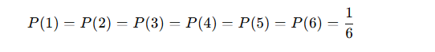
Used in simulations, gaming, randomization.

📘 8. The Binary World of Binomial Distribution
Used when data has two outcomes → Success or Failure.

📌 Conditions:
✔ Fixed number of trials (n)
✔ Two outcomes (success/failure)
✔ Probability remains constant (p)
✔ Independent trials

📌 Formula
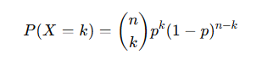

📌 Example
Probability of 7 heads in 10 coin tosses.

Normal Distribution (Gaussian Distribution)
The Normal Distribution is one of the most important probability distributions in statistics.
It is a bell-shaped, symmetrical, continuous distribution where:
- The mean = median = mode
- Most data lies close to the center
- Data gradually decreases toward both extremes

📌 Properties of Normal Distribution
- Bell-shaped & symmetrical
Left and right sides mirror each other.
- Mean = Median = Mode
All three located at the center.
- Total area under the curve = 1 (100%)
- 68–95–99.7 Rule (Empirical Rule)
  - 68% of data lies within ±1 standard deviation
  - 95% within ±2 standard deviations
  - 99.7% within ±3 standard deviations

The Z-score standardizes any normally distributed data
If a dataset follows (or approximately follows) a normal distribution, you can convert every value into a Z-score using:
After this transformation, the entire dataset becomes a Standard Normal Distribution with:
- Mean = 0
- Standard deviation = 1
- 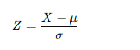
This new distribution is called the Z-distribution.

📘 9. The Z-Score Journey (Standard Score)
Z-score tells how many standard deviations a value is from the mean.

📌 Formula-

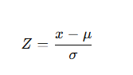

📌 Interpretation
Z-Score | Meaning
0 | exactly on mean
+1 | 1 SD above mean
-1 | 1 SD below mean
> ±3 | outlier
Used in:
- Outlier detection
- Standard normal distribution
- Hypothesis testing

📘 10. The T-Score (Student’s t-statistic)
Used when:
✔ Sample is small (n < 30)
✔ Population SD is unknown

📌 Formula

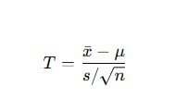

Uses
- Confidence intervals
- Hypothesis testing
- A/B testing
- Small sample research

