Consider iris dataset. Let’s break this down step by step — focusing on how the Z-score helps when working with the Iris dataset (the classic dataset with features like sepal length, sepal width, petal length, petal width).

Dataset Overview
The Iris dataset has 4 numerical features:
- Sepal Length (cm)
- Sepal Width (cm)
- Petal Length (cm)
- Petal Width (cm)

Feature Ranges (from the original dataset)
Feature | Minimum | Maximum | Range (Max - Min)
Sepal Length | 4.3 | 7.9 | 3.6
Sepal Width | 2.0 | 4.4 | 2.4
Petal Length | 1.0 | 6.9 | 5.9
Petal Width | 0.1 | 2.5 | 2.4
Observations
- Petal length varies widely (1.0 to 6.9) — biggest range.
- Sepal width has the smallest range (2.0 to 4.4).
- Because of these unequal ranges, if you directly train models without scaling:
  - Features with larger numeric ranges (like petal length) will dominate model training.
  - Distance-based algorithms (like KNN, clustering) and gradient-based ones (like logistic regression) will perform unevenly.

Hence we use Z-score standardization or Min-Max scaling to bring all features to a comparable range — typically centered around 0 (Z-score) or within [0, 1] (Min-Max).

Step 2: What is a Z-score?
Z-score = (x - mean) / standard deviation
It measures how far a value is from the mean, in units of standard deviation.
Example:
If sepal length = 6.5,
mean(sepal length) = 5.8,
std(sepal length) = 0.8,
then
Z = (6.5 - 5.8) / 0.8 = 0.875
This means this flower’s sepal length is 0.875 standard deviations above the mean.
Step 3: Why use Z-score?

1. Feature Scaling for Algorithms
Machine learning models (like Logistic Regression, KNN, SVM, Neural Networks) are sensitive to feature scale.
- Sepal length values ≈ 4–7
- Petal length values ≈ 1–6
If we don’t scale:
Features with larger numeric ranges (like sepal length) will dominate the learning process.
By using Z-score standardization, we bring all features to a similar scale:
- Mean = 0
- Standard deviation = 1
Ensures fair contribution of all features.

2. Detecting Outliers

What is a Z-score?
The Z-score (standard score) tells us how many standard deviations a value is from the mean.
Z= (x−μ)​ / σ
where:
- x = the value
- μ = mean of the feature
- σ = standard deviation of the feature
Example: Using Petal Length from Iris dataset
Let’s assume:
- Mean petal length (μ) = 3.76 cm
- Standard deviation (σ) = 1.76 cm
Now let’s calculate for a few flowers:
Petal Length (x) | Z = (x−μ)/σ | Interpretation
3.8 | (3.8 − 3.76) / 1.76 = 0.02 | Very close to mean
1.2 | (1.2 − 3.76) / 1.76 = −1.46 | Smaller than average
6.9 | (6.9 − 3.76) / 1.76 = +1.78 | Larger than average
0.5 | (0.5 − 3.76) / 1.76 = −1.86 | Quite small
9.0 | (9.0 − 3.76) / 1.76 = +2.98 | Very large — close to outlier zone
10.5 | (10.5 − 3.76) / 1.76 = +3.83 | Possible outlier
Rule of Thumb
- If Z > +3 or Z < −3,
the observation is unusual or a potential outlier.
Why this helps
When you apply Z-score standardization:
- All features are centered at mean = 0 and SD = 1.
- Outliers become easy to detect because they stand far away from the 0 line (mean).

So,
Z-score helps spot unusual values.
- If Z > 3 or Z < -3 → possible outlier.
Example:
A flower with petal width = 4.5 (which is far beyond normal range)
will have a high positive Z-score, flagging it as an anomaly.
This helps in data cleaning before training.

3. Improving Model Performance
Algorithms like:
- Logistic Regression
- KNN
- SVM
- Neural Networks
perform better when features are standardized — convergence is faster, and model accuracy improves.
4. Better Visualization and Interpretation
When all features are on the same scale (thanks to Z-score),
you can easily:
- Plot them on the same axis.
- Compare distributions.
- Visualize clusters more clearly (like in PCA plots).

Step 4: Example using Python (Simple Demo)
from sklearn.datasets import load_iris
from sklearn.preprocessing import StandardScaler
import pandas as pd

# Load the data
iris = load_iris()
df = pd.DataFrame(iris.data, columns=iris.feature_names)

# Apply Z-score standardization
scaler = StandardScaler()
df_scaled = scaler.fit_transform(df)

# Convert back to dataframe
df_scaled = pd.DataFrame(df_scaled, columns=iris.feature_names)
print(df_scaled.head())
Output: All columns will now have values roughly between -3 and +3,
and mean ≈ 0 for each feature.
Step 5: In Summary
Purpose | Benefit
Scaling | Puts all features on same scale
Outlier detection | Z > 3 or Z < -3 shows extreme values
Improved learning | Helps models converge faster
Visualization | Enables fair comparison between features

Z-score and Z-test are closely related, but they are not the same thing.
Think of it like this:

✅ Z-Score = Standardization Formula
A z-score tells you how far a single data point is from the mean in terms of standard deviations.

Formula
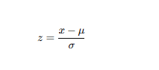
Where:
- x = individual value
- μ = mean
- σ = standard deviation

Purpose of Z-Score
- Standardize values
- Compare data across different scales
- Detect outliers
- Convert distribution into standard normal (mean = 0, std = 1)

✅ Z-Test = Hypothesis Test Using Z-Score
A z-test uses sample data to check if a population mean is different from a hypothesized value.

Formula for Z-Test
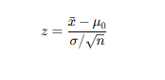

Where:
- xˉ = sample mean
- μ0​ = population value being tested
- σ = population standard deviation (known)
- n = sample size

Purpose of Z-Test
- Decide accept or reject the null hypothesis
- Compare populations
- Compare sample mean vs population mean

🔗 How Are They Related?
Z-Score | Z-Test
Standardizes a single value | Standardizes a sample mean
Used in descriptive statistics | Used in inferential statistics
Formula does not use sample size | Formula uses n\sqrt{n}n​
Answers: “How unusual is this value?” | Answers: “Is this difference statistically significant?”
Used for outliers | Used for hypothesis testing

⭐ Key Relationship
👉 The Z-test basically calculates a z-score of the sample mean.
- Z-score = for one value
- Z-test = z-score applied to sample mean to make statistical decisions
Thus,
Z-score → building block
Z-test → statistical test that uses z-score as its engine

📌 Example Showing the Relationship

🎯 Example:
Population mean = 100
Population std dev = 15
Sample mean = 108
Sample size = 36

Z-Test Calculation
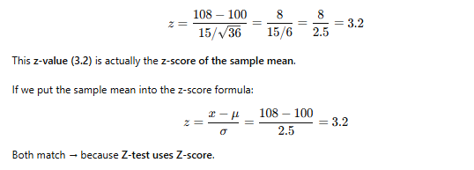

🎉 Final Answer
✔ Z-score tells how far a value is from mean.
✔ Z-test uses that idea to compare sample mean vs population mean.
✔ Z-test is basically: z-score + sample size + hypothesis testing.

#-------------------------------------------

What is a p-value in this context?

p-value = Probability of seeing such data if the null hypothesis is true or The p-value tells us the probability of seeing a value this extreme or more if the data follow a normal distribution.

When to Use Each
Concept | Use Case | Example
Z-score | To standardize or detect outliers in continuous numeric data | Scaling features before ML, identifying unusual petal lengths
p-value | To test hypotheses or measure statistical significance | Testing if mean petal length differs from a hypothesized value

A hypothesis is a statement or assumption we want to test using data.
For example:
“The average petal length of Iris flowers is 3.76 cm.”
We test it using two hypotheses:
Type | Symbol | Meaning
Null Hypothesis | H0​ | There is no significant difference from the claimed or overall mean.
Alternative Hypothesis | H1​ | There is a significant difference (value is unusually large/small).
So here:
- H0​: Average Petal length = 3.76
- H1​: Average Petal length ≠ 3.76
Decide using p-value
The p-value tells us the probability of seeing a value this extreme or more if the data follow a normal distribution. It comes from the Z-score — you can convert one to the other using the cumulative normal distribution.
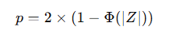
where Φ(Z) = probability up to Z (from Z-table or normal CDF).
The factor 2 is for a two-tailed test (checking both sides).
After computing the p-value from your Z-score:
Rule | Decision
p ≤ 0.05 | Reject H0 → Data shows a significant difference.
p > 0.05 | Fail to reject H0​ → No significant difference; it’s likely random.
0.05 (5%) is a conventional significance level, meaning we allow a 5% chance of being wrong if we claim a significant effect.

Interpret with Example

“If the true mean is really 3.76 cm (H₀ true),
how likely is it that I would randomly see a flower with petal = 9.0 cm?”
That likelihood is your p-value.
For x = 9.0,
- Z=2.98
- p≈0.003
Since p = 0.003 < 0.05, we reject H₀ → This petal length is significantly different (very unlikely to occur by random chance).
Hence, it’s possibly an outlier.

If p-value is small (e.g., 0.003)
It means:
“If H₀ were true, it’s extremely rare (0.3% chance) to see such a big difference.
So you think:
“Hmm, this looks too unlikely to be just random —
maybe H₀ is not true after all!”
Therefore, you reject H₀.

For x = 3.8,
- Z=0.02
- (p ≈ 0.98 > 0.05, we fail to reject H₀, meaning it’s perfectly normal.

If p-value is large (e.g., 0.98)
It means:
“If H₀ were true, it’s quite common (98% chance) to see data like this.”
So you think:
“Nothing strange here — data is consistent with H₀.”
Therefore, you fail to reject H₀ (accept that everything’s normal).

In summary:
p-value size | Meaning | Decision
Small (≤ 0.05) | Data is very unlikely if H₀ is true → something unusual → probably H₀ is wrong | Reject H₀
Large (> 0.05) | Data is quite likely even if H₀ is true → nothing unusual | Fail to reject H₀

Visualizing the p-value and z-score :
Imagine a bell-shaped curve that represents all possible values of petal length if our null hypothesis (H₀) were true.
Mean (μ) = 3.76, Standard Deviation (σ) = 1.76.
Most data (≈68%) lies within ±1σ,
and almost all (≈99.7%) lies within ±3σ.

Your flower with petal length = 9.0 cm
We calculated its Z-score:
Z=9.0−3.761.76=+2.98Z = {9.0 - 3.76}/{1.76} = +2.98Z=1.769.0−3.76​=+2.98
So, it lies almost 3 SDs to the right of the mean, way out in the tail.

The p-value area under the tail
The p-value is the shaded tail area under the curve beyond |Z| = 2.98.
tiny shaded area = p = 0.003 (0.3%).
This means:
If the true mean really were 3.76, there’s only a 0.3% chance we’d randomly observe a petal length as extreme as 9.0 cm.

Decision rule
Criterion | Interpretation | Decision
p ≤ 0.05 | Too unlikely under H₀ | Reject H₀
p > 0.05 | Reasonably likely under H₀ | Fail to reject H₀
Here:
p = 0.003 < 0.05 → Reject H₀ → 9.0 cm petal is an outlier or unusual case.

Relation between Z-score and p-value
Z-score | p-value (approx.) | Meaning
0 | 1.00 | Exactly mean
±1 | 0.32 | Common
±2 | 0.05 | Borderline unusual
±3 | 0.003 | Very rare → outlier zone

Intuition
Term | Layman analogy
Z-score | “How many standard steps away from normal?”
p-value | “How shocking is this observation if everything were normal?”
Threshold (0.05) | “Only 5% of cases this extreme happen by chance — so maybe something’s really different.”

Why both are used together
- Z-score gives how far the data point is from the mean (in SD units).
- p-value tells how rare such a Z-score would be, if H₀ is true.
- You use p-value to make statistical decisions, while Z-score helps to detect and visualize outliers.

The chart is a normal distribution curve — the bell-shaped curve that shows how data is spread around the mean (μ).
On this curve:
- The center (μ) is the average or expected value if the null hypothesis is true.
- The vertical line at 9.0 represents the observed data point (your sample result).
- The Z-score = 2.98 shows how many standard deviations the observed data is away from the mean.
- The green shaded region to the right of the line is the p-value region — it shows how likely it is to get data this extreme if the null hypothesis were true.

Now, Z = 2.98 Interpretation
A Z-score of 2.98 is quite large — it means the data point is almost 3 standard deviations away from the mean.
For a Z = 2.98,
the p-value ≈ 0.0014 (0.14%).

Compare both approaches
Approach | Purpose | Decision for Z = 2.98
Descriptive (Outlier rule) | Checks if a value looks unusual (not a formal test) | Not an outlier yet, since < +3
Inferential (Hypothesis testing) | Tests if data significantly disagrees with null | p = 0.0014 < 0.05 → Reject H₀
So, even though Z = 2.98 is just inside the 3-SD rule,
its p-value is still small enough (0.0014) that — statistically — it’s considered significant at the 5% or 1% level.

Decision Rule
Significance Level (α) | Decision Rule
α = 0.05 (5%) | If p ≤ 0.05 → Reject H₀
α = 0.01 (1%) | If p ≤ 0.01 → Reject H₀
α = 0.001 (0.1%) | If p ≤ 0.001 → Reject H₀
In this case:
p = 0.0014 < 0.05
So, we reject the null hypothesis.

Conclusion
The data point (Z = 2.98) lies far in the tail of the curve.
The shaded area (p-value) is very small.
Conclusion:
The observed data is too extreme to occur by random chance under the null hypothesis. We reject the null hypothesis.
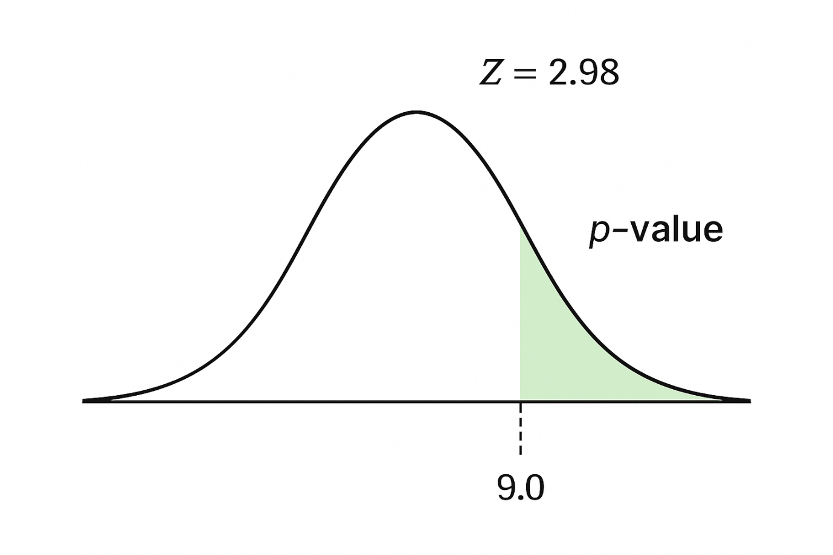

Summary:
- Z-score of ±3 roughly ↔ p-value ≈ 0.003 → potential outlier.
- Use Z-score when working with feature values or outlier detection.
- Use p-value in hypothesis testing (e.g., “Is Iris setosa’s petal length significantly different from overall mean?”).

When to use each
Method | Use for | Example
Z-score | Standardization, Outlier detection, Feature scaling | Preprocessing Iris features before ML
p-value (with hypothesis test) | Statistical inference, comparing means, evaluating models | Testing if one Iris species’ petal length differs from another

Population
Definition:
The entire group you’re interested in studying.
It includes all possible individuals or observations.
Example (Iris dataset context):
All Iris flowers in the world (of all three species).
Characteristics:
- Described using parameters (like population mean μ, population standard deviation σ).
- Usually too large to measure completely.
- So we estimate it using samples.
Sample
Definition:
A subset (small portion) of the population — that you actually collect data from.
Example:
The 150 flowers in the Iris dataset (50 from each species).
Characteristics:
- Described using statistics (like sample mean x̄, sample standard deviation s).
- Used to make inferences about the population (using hypothesis tests, confidence intervals, etc.).
Comparison Table:
Concept | Population | Sample
Definition | Entire group | Small part of population
Symbol for mean | μ (mu) | x̄ (x-bar)
Symbol for std. deviation | σ (sigma) | s
Data availability | Usually unknown | Collected and available
Purpose | True but unknown parameters | Used to estimate population parameters
Example (Iris) | All Iris flowers | The 150 flowers measured in the dataset

Why Sampling Matters
We collect a sample because:
- Measuring every individual in a population is impossible.
- With random sampling, we can make valid conclusions about the population using probability theory.

Connection to Hypothesis Testing
When we do a test like:
“Is the mean petal length significantly greater than 3.7 cm?”
We’re using:
- Sample data (x̄, s, n)
to make conclusions about
- Population parameters (μ).
So we assume:
- Null hypothesis H₀: μ = 3.7 (population mean)
- Test using sample mean and sample size → compute p-value or Z-score.

Using Hypothesis Testing, we try to interpret or draw conclusions about the population using sample data. A Hypothesis Test evaluates two mutually exclusive statements about a population to determine which statement is best supported by the sample data. Whenever we want to make claims about the distribution of data or whether one set of results are different from another set of results in applied machine learning, we must rely on statistical hypothesis tests.
Ex: Mean (μ), Variance (σ²), Standard Deviation (σ), Proportion (π)
Population: Population is a collection of objects that we want to study/test.
The Sample Statistic is used as an estimate of the population parameter.
Ex: Sample Mean (x̄), Sample Variance (S²), Sample Standard Deviation (S), Sample Proportion (p)
Central Limit Theorem (CLT) States that :
Even if your original data is not normally distributed (for example, skewed, uniform, etc.),
if you take large enough samples (usually n ≥ 30) and calculate their means:
- The distribution of those means will become approximately normal.
- The mean of the sample means will be close to the population mean (μ).

Example using the Iris Dataset
- Suppose we take multiple random samples of Petal Length (each with 30 flowers).
- We calculate the mean petal length for each sample.
- If we plot those means, the resulting graph will be bell-shaped, even if individual petal lengths were not.
Why CLT is Important
- It allows us to use Z-scores and p-values (which assume normality) for hypothesis testing.
- It connects sample data to population insights — a foundation for inferential statistics.
Term | Meaning
Population | The entire group you’re studying (e.g., all flowers in the world).
Sample | A small subset of the population (e.g., 50 flowers chosen randomly).
Sampling Distribution | The distribution of all possible sample means.
CLT says | The sampling distribution of the means becomes normal as ( n ) increases.
- Population (the big group):
Imagine we have a large population — for example, all flowers in a garden, all students in a school, or all measurements of petal lengths in the Iris dataset.
This population might have any shape of distribution — it could be normal, skewed, or irregular.

- Samples (smaller groups):
Now, instead of measuring everyone, we take small random samples (say 30 flowers each time) and calculate their average petal length.
We repeat this many times — each time taking a new random sample and calculating a new average.

- Sampling Distribution of the Mean:
If we now collect all those sample averages and plot them on a graph —
something amazing happens:
  - The shape of this graph (of sample means) starts to look like a bell curve (normal distribution),
even if the original population was not normal.

- As the sample size increases (n ≥ 30):
  - The distribution of sample means becomes more and more normal.
  - The mean of these sample means tends to equal the population mean (μ).
  - The spread (standard deviation) of the sample means becomes smaller, following:

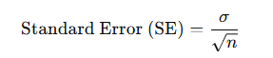
Why CLT matters:
- It allows us to use Z-scores, t-tests, and p-values for making conclusions about populations — even when the population’s original shape is not normal.
- It’s the reason why inferential statistics (like hypothesis testing and confidence intervals) work reliably.

Formula-

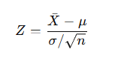
Where:

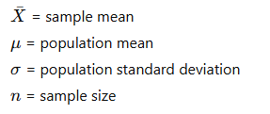
The Central Limit Theorem (CLT) is the foundation of why hypothesis testing works.
It allows us to take a sample, calculate statistics like the mean, and then make probabilistic conclusions about the population — even when we don’t have access to the whole population.

Confidence Interval (CI)

Definition
A confidence interval gives a range of values within which the true population parameter (like the mean) is likely to lie, based on your sample data.
It shows both the estimate (like sample mean) and the uncertainty around it.
Intuitive Explanation
Imagine you take many samples from a population and calculate their means.
Each sample will have a slightly different mean — but most will cluster near the true population mean.
A confidence interval tells us:
“We are X% confident that the true population mean lies between [lower limit, upper limit].”
For example:
“We are 95% confident that the average petal length of all Iris flowers lies between 3.4 cm and 4.1 cm.”
Formula (based on CLT)
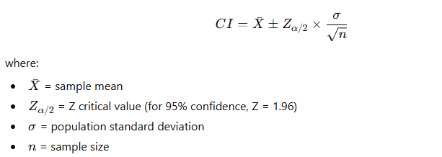
Example (Iris Dataset)
Let’s use Petal Length data again:
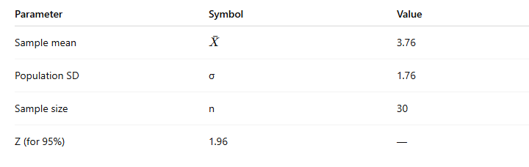
Then,
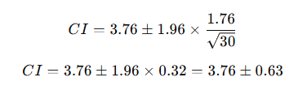
Confidence Interval = [3.13, 4.39]
So we can say:
“We are 95% confident that the true average petal length of all Iris flowers lies between 3.13 and 4.39 cm.”

Interpretation
- 95% confidence does not mean there’s a 95% probability the true mean is inside this range.
- It means that if we repeated the sampling many times, 95% of such intervals would contain the true mean.
Relation to CLT and Hypothesis Testing
Step | Concept | Purpose
CLT | Sampling means follow normal distribution | Justifies using Z-scores
Confidence Interval | Gives range estimate for population mean | Measures uncertainty
Hypothesis Testing | Checks if a sample mean significantly differs | Makes a yes/no decision
Connection:
If your hypothesized population mean (e.g., μ = 4.5) lies outside your 95% CI → you’d likely reject the null hypothesis in hypothesis testing.

So, next we do Hypothesis Testing.

Setting up the hypothesis test
When we do hypothesis testing, we set up two competing ideas:
- Null hypothesis (H₀): There is no significant difference between sample and population mean.
Example: “The average petal length in the Iris dataset is 3.76 cm.”
- Alternative hypothesis (H₁): There is a significant difference.
Example: “The average petal length in the sample is not equal to 3.76 cm.”
Compute Z-score (using CLT formula). Because CLT ensures the sampling distribution of Xˉ is normal, this Z-score tells us how far our sample mean is from the population mean — in standard deviations.

Find the p-value
The p-value is the probability of observing such an extreme Z-score if the null hypothesis is true.
- If p ≤ 0.05, the data is unlikely under the null hypothesis → Reject H₀.
- If p > 0.05, the data is consistent with the null hypothesis → Fail to reject H₀ (accept H₀).
Tool | Purpose | Based on
Z-score | Measures how far sample mean is from population mean (in SD units) | CLT (Normal sampling distribution)
p-value | Measures how rare that difference is under H₀ | Probability from Z-distribution
CLT | Justifies using Z/p-value even with limited sample data | Sampling theory

Example (Iris Petal Length)
Let’s say:
- Population mean (μ) = 3.76
- Sample mean (x̄) = 6.9
- Standard deviation (σ) = 1.76
- Sample size (n) = 30
Then,
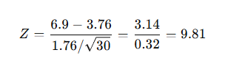
Such a huge Z (≈ 9.81) gives an extremely small p-value (< 0.00001).
So, Reject the null hypothesis.
The sample mean (6.9) is statistically much larger than the population mean (3.76).
#-----------------------------------------

Null Hypothesis (H₀):
A statement in which no difference or effect is expected. If the null hypothesis is not rejected, no changes will be made.

Alternate Hypothesis (H₁):
A statement that some difference or effect is expected. Accepting the alternative hypothesis will lead to changes in opinions or actions. It is the opposite of the null hypothesis.

One-Tailed Test:
A one-tailed test is a statistical hypothesis test in which the critical area of a distribution is one-sided so that it is either greater than or less than a certain value, but not both. If the sample being tested falls into the one-sided critical area, the alternative hypothesis will be accepted instead of the null hypothesis.

Two-Tailed Test:
A two-tailed test is a method in which the critical area of a distribution is two-sided and tests whether a sample is greater than or less than a certain range of values. If the sample being tested falls into either of the critical areas, the alternative hypothesis is accepted instead of the null hypothesis.

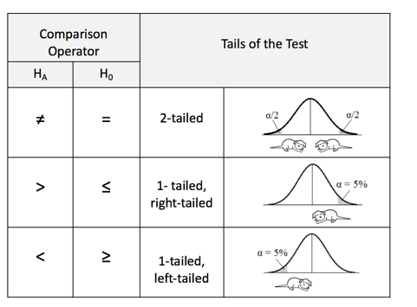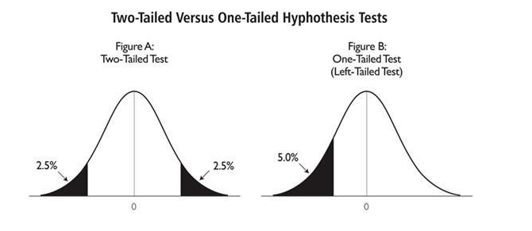

Test Statistic:
The test statistic measures how close the sample has come to the null hypothesis. Its observed value changes randomly from one random sample to a different sample. A test statistic contains information about the data that is relevant for deciding whether to reject the null hypothesis or not.
Different hypothesis tests use different test statistics based on the probability model assumed in the null hypothesis. Common tests and their test statistics include:
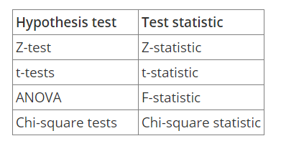
In general, the sample data must provide sufficient evidence to reject the null hypothesis and conclude that the effect exists in the population. Ideally, a hypothesis test fails to reject the null hypothesis when the effect is not present in the population, and it rejects the null hypothesis when the effect exists.

Type-I Error:
Type-I error occurs when the sample results, lead to the rejection of the null hypothesis when it is in fact true. Type-I errors are equivalent to false positives.

Type-II Error:
Type-II error occurs when based on the sample results, the null hypothesis is not rejected when it is in fact false. Type-II errors are equivalent to false negatives.
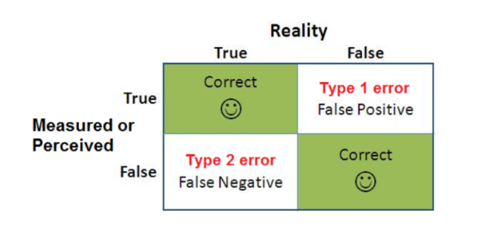
Type-I errors can be controlled. The value of alpha, which is related to the level of Significance that we selected has a direct bearing on Type-I errors.

Level of Significance (α):
The probability of making a Type-I error and it is denoted by alpha (α). Alpha is the maximum probability that we have a Type-I error. For a 95% confidence level, the value of alpha is 0.05. This means that there is a 5% probability that we will reject a true null hypothesis.

P-Value:
The p-value is used all over statistics, from t-tests to simple regression analysis to tree-based models almost in all the machine learning models. We all use P-values to determine statistical significance in a hypothesis test.
P-values evaluate how well the sample data support the argument that the null hypothesis is true. It measures how compatible your data are with the null hypothesis. How likely the effect observed in your sample data if the null hypothesis is true?
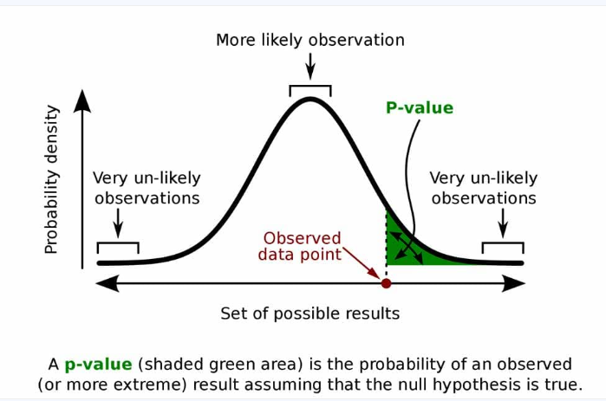
High P-Values: Your data are likely with a true null
Low P-Values: Your data are unlikely with a true null
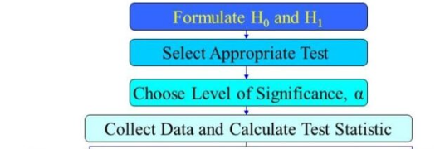
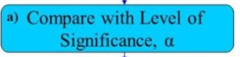
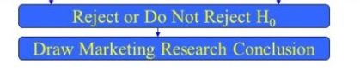

Deep Learning Concept (Dropout Layer)

Dropout Layer – Simple Explanation
When training a neural network, it can sometimes memorize the data instead of learning patterns — this is called overfitting.
Dropout layer helps prevent overfitting.
It randomly turns off (drops out) some neurons during training so the model doesn’t rely on specific neurons only — it learns more general patterns.
Layman Analogy:
Imagine a classroom where, every day, a few students are randomly asked to sit out.
This forces the remaining students to learn the full syllabus — making everyone smarter overall!
Key points:
- Used only during training (not during testing).
- Helps the network become more robust.
- Common dropout rate: 0.2 – 0.5 (i.e., 20%–50% neurons temporarily off).
In Keras:
from tensorflow.keras.layers import Dropout

model.add(Dropout(0.3))
Part 4 – Python Coding PracticeDry Run Code for Odd-Even Numbers
Problem: Find if a number is odd or even.
Code:
num = 7

if num % 2 == 0:
print("Even number")
else:
print("Odd number")
Dry Run (for num = 7 ):
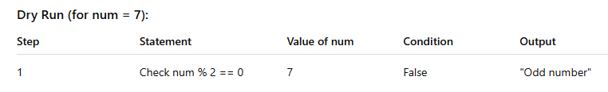
Output → Odd number
Dry Run Code for Prime Numbers
Problem: Check if a number is prime.
Code:
num = 7
if num > 1:
for i in range(2, num):
if num % i == 0:
print("Not Prime")
break
else:
print("Prime Number")
else:
print("Not Prime")
Dry Run (for num = 7):
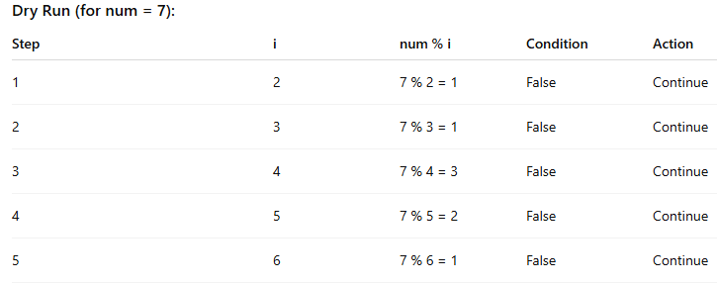
Loop completes → Else executes → “Prime Number”
Output → Prime Number

