SOFTWARE DEVELOPMENT / DOMAIN 01
DATACHECK
Browser-local CSV Preflight Validator
A focused engineering proof of concept for safer data hand-offs
ASSESSMENT FORMAT | 10 focused hours (compressed from 3 days)
PROJECT TYPE | Browser-based developer / operations utility
CORE WORKFLOW | Upload → validate → review → export
REPORT DATE | 4 November 2026
SUBMISSION STATUS
Working proof of concept
Automated unit tests pass. Browser end-to-end verification and public deployment were not completed in the creation environment; these boundaries are recorded in this report.

Executive Summary
DataCheck is a browser-local CSV pre-import validator. It reads a CSV file in the browser, identifies common quality and structure problems, presents row-level findings, and exports two separate outputs: records with no detected row-level issues and an issue report. The core checks cover blank cells, duplicate complete rows, duplicate values in a selected key column, syntactically invalid email addresses, invalid dates, inconsistent row widths, empty headers, and repeated headers.
The central engineering decision is to keep the application static and local. The selected CSV is processed through browser APIs; no upload endpoint, application backend, account system, database, or third-party runtime library is required. Python’s built-in HTTP server is used only to serve the files during a local demonstration.
Outcome A focused proof of concept with a parser/validator separated from the interface, 12 passing automated tests, and reproducible local run instructions.

1. Opportunity & Problem
The project addresses a practical workflow hypothesis: people who receive CSV exports before importing them into another system need a quick way to catch common errors. A blank required value, repeated identifier, malformed email, impossible date, or inconsistent row width can cause rejected imports or downstream cleanup work.
This hypothesis has not been validated through customer interviews or production workflow observation. The project therefore demonstrates a plausible problem and a testable solution, not proven market demand or measured productivity gains.
Target workflow: an operations, analyst, or developer user receives one CSV file, performs a first-pass quality check, reviews the flagged records, and exports a clean subset plus an issue log for follow-up.

2. Exploration & Competitive Landscape
The official documentation of three established approaches was reviewed on 4 November 2026. The review is directional; it is not a hands-on benchmark or a claim that the products were tested side by side.
Approach | Documented capability | Design implication
OpenRefine | Facets, filters, clustering, and transformations for exploring and cleaning data. | A full exploration and correction environment. DataCheck stays narrower: first-pass validation rather than transformation.
CSVLint | CSV upload or URL input, optional schema, dialect controls, and validation feedback. | Closest direct comparison. DataCheck uses a small set of inferred checks and browser-local processing, but offers less schema-driven coverage.
Great Expectations | Declarative Expectations, suites, and validation runs for repeatable data quality assertions. | A programmable validation framework. DataCheck is an interactive single-file utility, not a replacement for pipeline-level validation.

Competitive position: DataCheck prioritises immediate, local preflight for one file. Its differentiator is simplicity of setup and the absence of server-side CSV upload in this implementation. It does not claim broader rule coverage, enterprise controls, collaborative workflows, or automated repair.

3. Alternatives Considered
Direction | Reason considered | Decision
CSV pre-import validator | Clear input/output workflow, useful validation rules, feasible in a short time window, and straightforward to test. | Selected: strongest balance of value, scope, and evidence.
API response / contract inspector | Relevant developer utility with observable status, latency, and response-shape checks. | Not selected: authentication, network variability, and schema configuration would increase setup and test risk.
Web asset / performance audit tool | Could help developers inspect page assets and loading behaviour. | Not selected: browser-specific measurements and benchmark interpretation make a defensible result harder within the compressed window.

4. Project Thesis & Scope
Thesis: build a single-file, browser-local CSV preflight tool for users who need to identify common structural and value issues before importing a dataset into another workflow.
In scope: CSV file selection and drag/drop; parser support for quoted fields, escaped quotes, commas, CRLF, embedded newlines, and UTF-8 BOM; issue summaries; selectable unique-key detection; filters; clean CSV export; issue CSV export; size and row limits.
Out of scope: account management, server storage, schema authoring, automatic correction, historical audit workspace, team collaboration, background monitoring, and production integration.

5. Engineering Strategy
The implementation uses static HTML, CSS, and native JavaScript ES modules. The browser File API reads the selected file; the parser creates a two-dimensional row array; the validation engine returns a structured issue model; the interface renders summaries and filters; Blob and object URLs produce downloads.
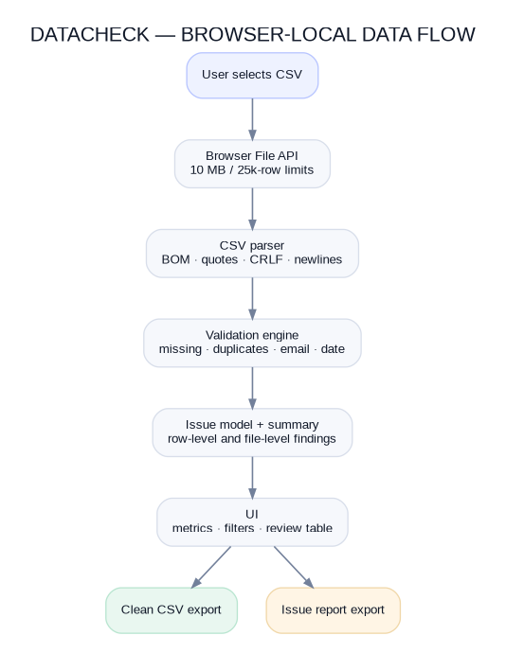
Figure 1. DataCheck browser-local data flow. The local static server does not receive file contents.

Major engineering decisions
- No framework or runtime dependency: reduces setup and supply-chain surface for a small static tool.
- Parser and validation logic are separate: business rules can be tested with Node’s built-in test runner without mounting a browser DOM.
- The unique-key column is user-selectable: the tool does not assume every dataset uses an `id` header, although it suggests one when present.
- Duplicate groups mark every occurrence: the first record is not silently treated as valid when a later row repeats its key or full contents.
- Date formats are deliberately constrained: day-first slash/dash values are used; ambiguous US-style values are rejected rather than guessed.
- Rows with any row-level issue are excluded from clean export: the issue report preserves the reason and source row number.

6. Implementation
Module | Responsibility | Status
index.html / styles.css | Semantic interface, responsive layout, upload area, metrics, settings, review table, exports. | Implemented
src/csv.js | Quote-aware CSV parser and CSV-safe serializer. | Implemented and unit tested
src/validator.js | Missing values, duplicate rows/keys, email/date checks, header and row-shape checks, filtering. | Implemented and unit tested
src/app.js | File limits, browser state, rendering, key selection, filters, and downloadable exports. | Implemented; browser E2E not verified here
tests/ | Node built-in unit tests for parser and validator. | 12 tests pass

Input constraints: CSV files up to 10 MB and 25,000 data rows. The parser supports UTF-8 BOM, quoted commas, escaped quotes, CRLF, and embedded newlines. It rejects unterminated quoted fields and unexpected trailing characters after a closing quote.

7. Validation & Evidence
Automated test result 12 passed · 0 failed · 0 skipped

Validation area | Evidence / result
CSV parsing | Basic rows, trailing newline, quoted commas, escaped quotes, embedded newlines, BOM, and CRLF covered.
Malformed input | Unterminated quoted fields and invalid characters after a closing quote are rejected.
Data rules | Missing values, invalid email, invalid date, duplicate complete rows, and duplicate keys covered.
Structure | Inconsistent row width and duplicate header behaviour covered.
Date boundaries | Impossible calendar dates, valid ISO time/timezone, and invalid clock values covered.
Static checks | `node --check` passed for all three JavaScript modules; static server returned HTTP 200 for `index.html`.

The complete command output is preserved at `03_EVIDENCE/testing/npm-test-output.txt`. The unit tests verify the parser and validation engine; they do not prove that every UI interaction or browser download works end to end.
Browser automation and screenshot capture were blocked by the creation environment’s browser policy. Therefore, no screenshot is claimed as captured evidence and no full browser interaction test is reported. The candidate should run the local demo in a normal browser and capture genuine screenshots before external submission if required.

8. Iteration
Two concrete improvements were made during implementation review:
- File-level findings were initially easy to miss because they do not belong to a particular data row. A dedicated file-level banner was added to the results view for empty or repeated header names.
- A remote font import was removed. The application now uses local system-font fallbacks and has no third-party runtime dependency or application network request.
The test fixture was also adjusted after the first run exposed an expectation mismatch: duplicate-key logic intentionally flags all occurrences, including the first. A clean record was added to the fixture so the test also verifies the clean-row count. This was a test expectation correction, not a claim that the product logic was defective.

9. Limitations & Risks
- No automatic repair: DataCheck detects and reports issues but deliberately preserves original source values.
- Email validation is syntactic; it does not check mailbox existence or deliverability.
- Date checks are inferred from column names. A date-like field with an unrelated header may be missed, and a non-date field with a matching name may be checked incorrectly.
- Ambiguous US-style `MM/DD/YYYY` values are not accepted; duplicate comparisons trim outer whitespace but remain case-sensitive.
- The application operates in memory and enforces size/row limits. Large files must be split before processing.
- There is no schema editor, persistent history, authentication, team access, or production integration.
- No browser end-to-end test, cross-browser matrix, accessibility audit, large-file benchmark, or penetration test was completed here.

10. Next Development Stage
With another week, the priority should be user validation and correctness before adding features:
- Observe 3–5 real CSV hand-off workflows and turn repeated requirements into explicit acceptance criteria.
- Add a simple optional schema/rules panel for required columns and configurable date formats, while keeping defaults conservative.
- Add browser end-to-end tests for upload, key selection, filters, downloads, and reset using a supported test environment.
- Benchmark representative 1 MB, 5 MB, and near-limit files; profile rendering and consider virtualized rows if needed.
- Complete accessibility and cross-browser testing, then package a static deployment with clear privacy messaging.

11. Tool & Assistance Declaration
Substantial AI assistance was used to scope the project, synthesize official competitor documentation, generate and revise application code and tests, and prepare the report and package. The code must not be represented as wholly unaided or fully self-authored. The candidate is responsible for inspecting, running, understanding, modifying, and defending the project before submission.
No third-party application framework or runtime JavaScript package is required. The Node built-in test runner is used for unit tests; Python `http.server` serves static files locally. Official product documentation for OpenRefine, CSVLint, and Great Expectations informed the competitive comparison. Source links are listed below.

References
1. OpenRefine, “Exploring facets,” https://openrefine.org/docs/manual/facets
2. OpenRefine, “Transforming data,” https://openrefine.org/docs/manual/transforming
3. CSVLint, homepage, https://csvlint.io/
4. CSVLint, “About this service,” https://csvlint.io/about
5. Great Expectations, “Create an Expectation,” https://docs.greatexpectations.io/docs/core/define_expectations/create_an_expectation/
6. Great Expectations, “Run Validations,” https://docs.greatexpectations.io/docs/core/run_validations/
The complete hour-by-hour challenge adaptation is supplied separately in `00_HOUR_BASED_ASSESSMENT_PLAN.md`.

