# Ancient Greek of Myceneans

Started during the **Bronze Age**:

* 3000 BC --> 1000 BC

Minoans also started around this time

TIMELINE Comparison:

* 2000 BC --> 1900 BC ~ First Greek Settlers
* 1600 BC --> 1000 BC ~ Mycenaean
* 1200 BC --> 1050 BC ~ Civilization Collapse

# Culture

**Mycenaean culture ---> Pottery and Grave Sites** 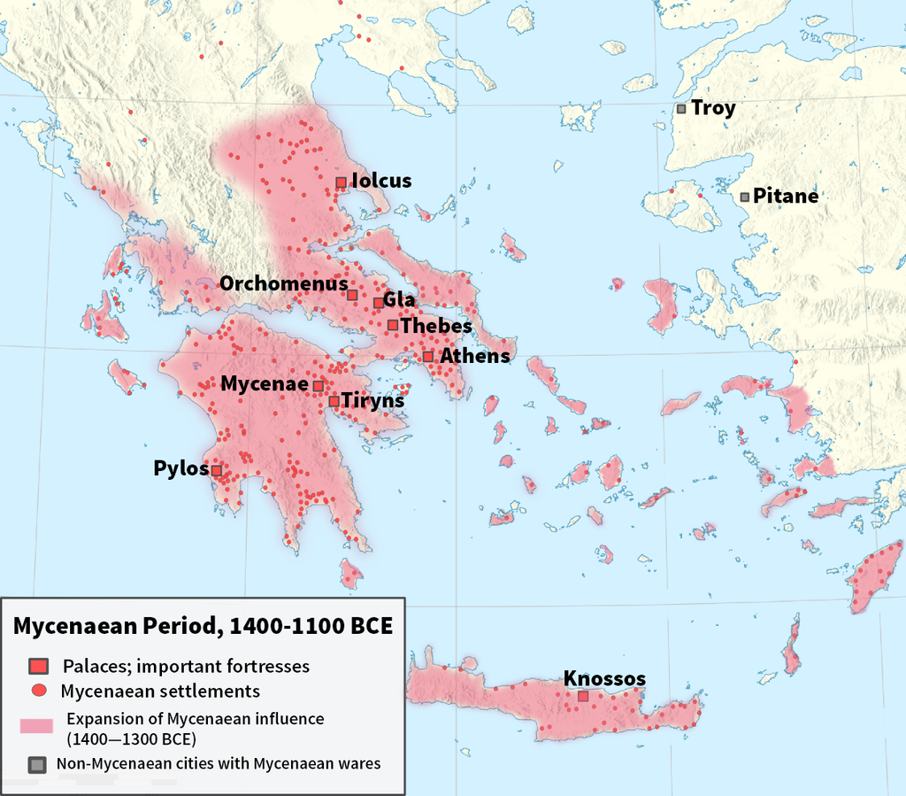

**They had:**

* Capital: **Mycenae**
* A single ruling king
* Large stone structures
* Spoke early form of **Greek**

## Mycenaean Language

* Linear A **Script**
  + **Minoan** (Undecipherable)
  + **Fire Baked**
  + **Earlier**
* Linear B **Script**
  + **Mycenaean**
  + **Fire baked**
  + **Later**

Both actually do contain similarities, however B was **different enough.**