**Quality Assurance**As a group we would have meetings on a regular basis to fit the needs of a agile development plan and during these meetings we would have code reviews, where either our code wasn’t working as it should or not at all and we’d review each other's work and come up with solutions.

**Code Reviews**

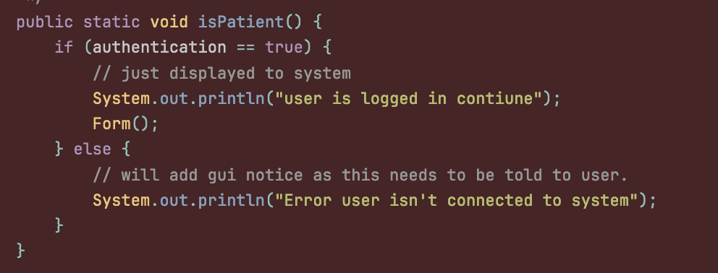

After a small code review we found the left code wasn’t working correctly, we adjusted it and made it so the java file requires an email, where you have to be logged in to have inputted.

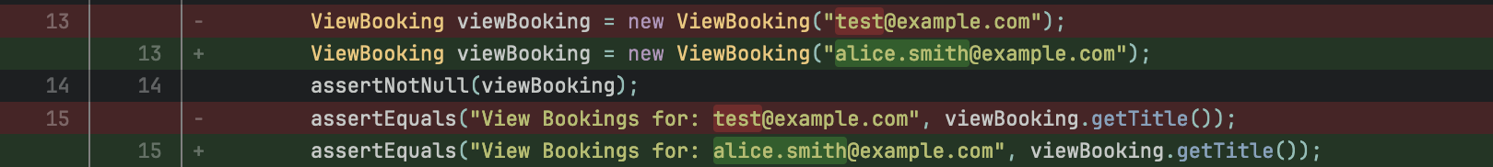We found that naming certain database elements was confusing, however after our sprint 2 meeting we were able to correct these errors throughout the rest of the code.

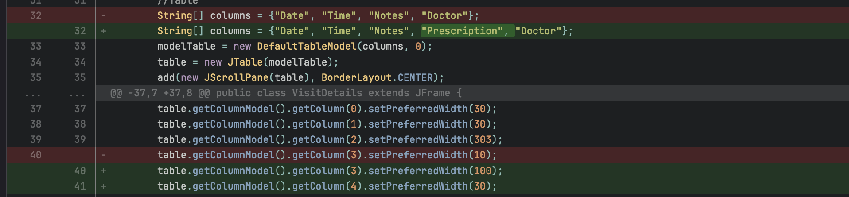

During one of our last meetings during sprint 3 we realized we didn’t have a prescription column in visitDetails.java (a simple error) but this is why our meetings are so important.

**Refactoring**

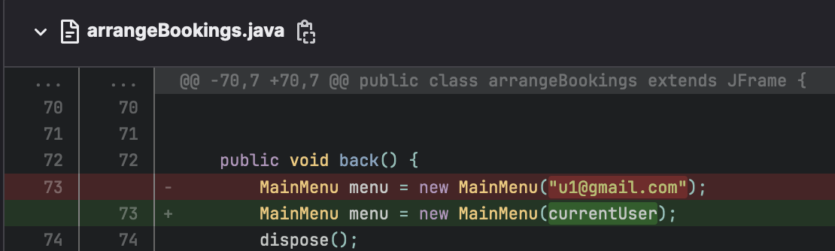

In this screenshot we have implemented a dynamic approach to the email entering in our overall programme.

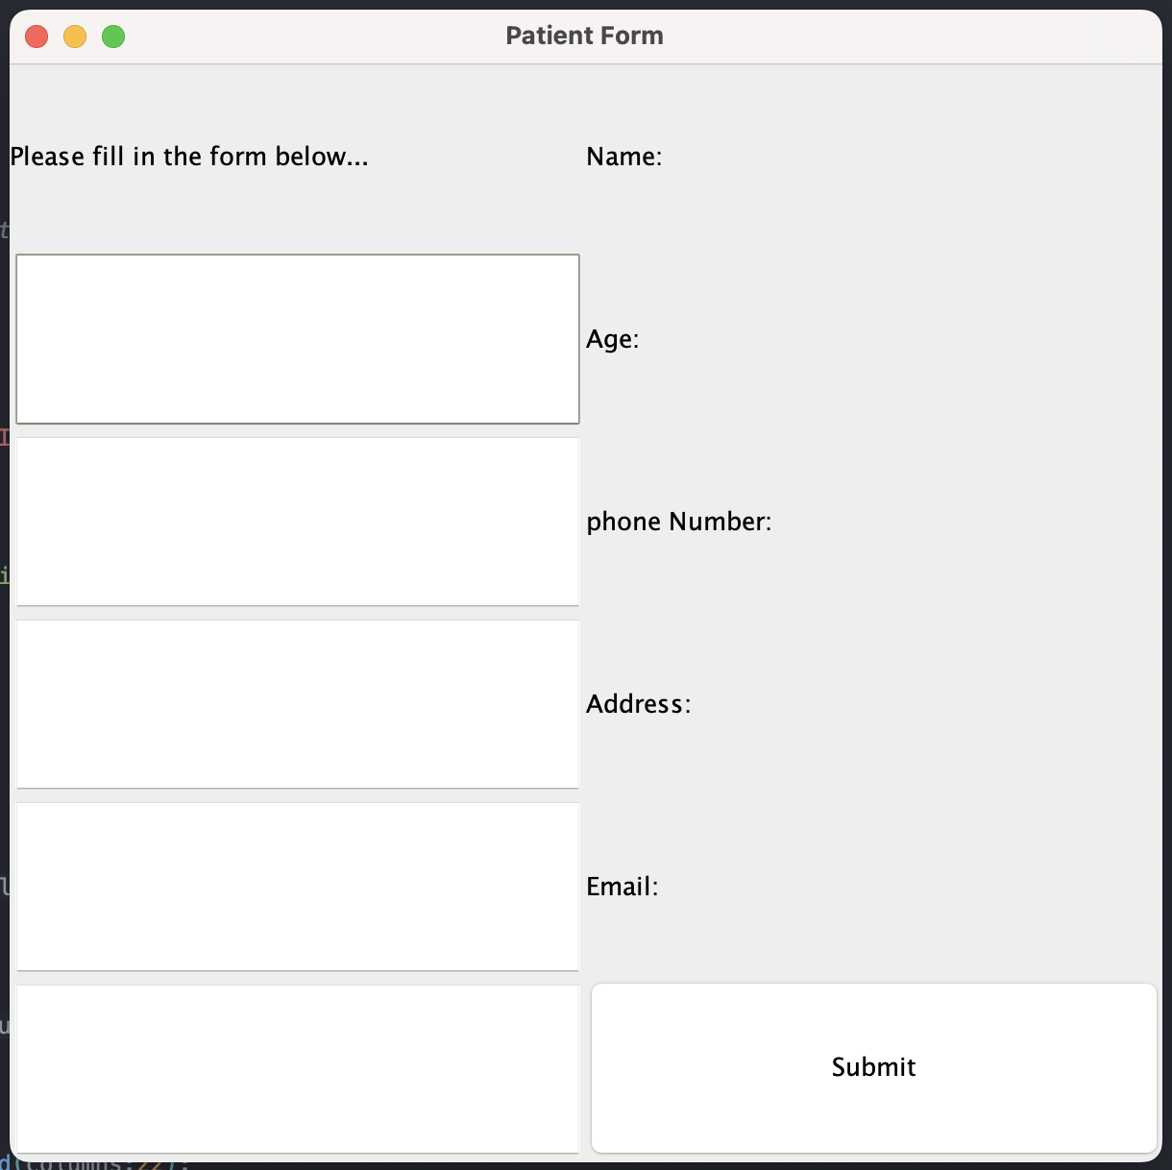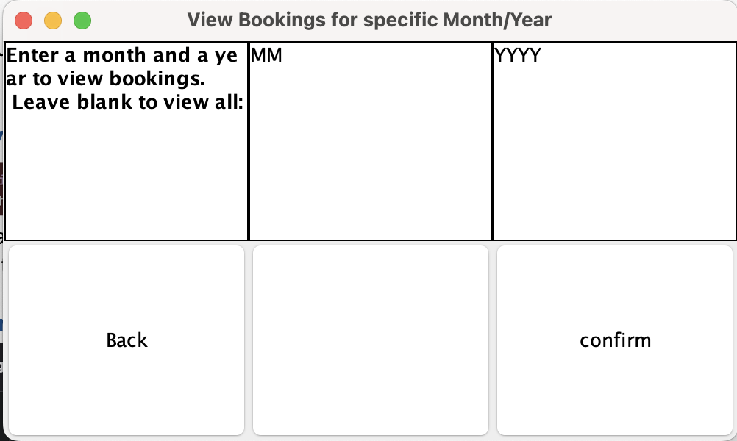

We made both GUIs and found the one on the right had more functionality and decided to use that instead. Update includes Back button and formatting.  
**Tracking Issues**

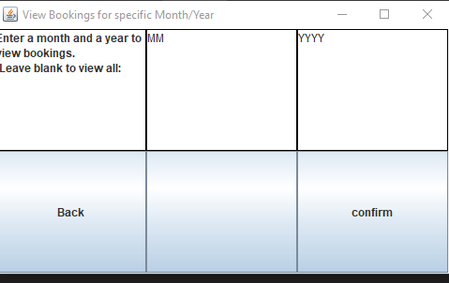

After looking at the requirements it was noticed that we were missing ‘the system show allow a patient to view their bookings by entering a month and year’ so above is the adjustment fixed to ensure we didn’t miss anything from the assessment ‘client’.

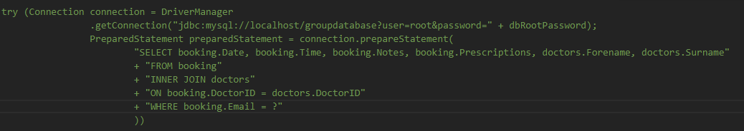

When the above is our query first runs, it also created a new and empty booking which has now been patched. Now when the query is run the returned items are correct and it does not add any additional empty bookings.