*Exercise 2: Dynamic Range and Precision(disparate.cc)* ***Explained***

* Initial int_32 behavior works as expected. 100mil + 1 displayed 100,000,001
* Things got tricky when attempting to do the same with float data types. 100mil + 1.0 only displayed 100,000,000.0. Where’s the 1!??!

* Tried resetting the “setprecision” in the “cout” statement to 9 (and later 10) to no avail…

* Realized I was doing all these changes on my “main” branch, so I created a new branch “precision”, merged the changes, switched back to main and did a git restore to put everything back to normal…
* …but of course, I didn’t add or stage any changes so had to start from scratch… ☹

***FINALLY TADA!***

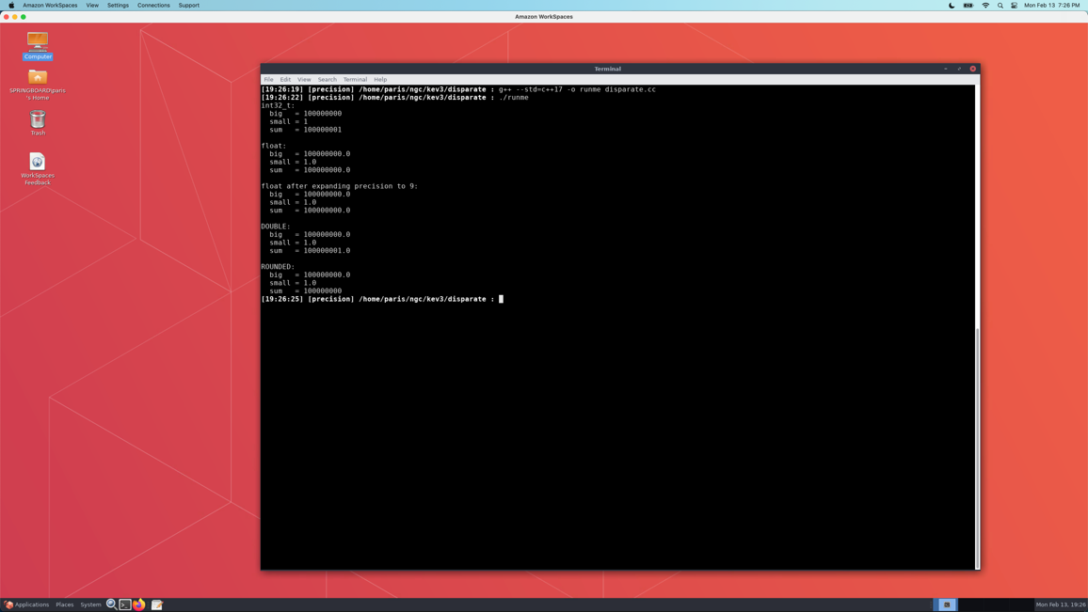

* Rectified the precision issue by changing the data type to one that holds more precision. Apparently floats can only hold a max of 7 decimal places in C++. Float >> int << double << long double
* Also, tried rounding the value. Not great, but much more accurate than simply allowing it to be truncated.