*Exercise 4: Float Division(division.cc)*

***Explained***

* This is very similar to the previous Integer division exercise. The only difference in the code here is that we are using floats as opposed to integers. In addition, the result is to be displayed using scientific notation using the “scientific” keyword.
* At first glance everything seems to be output as expected, but upon further inspection the numbers don’t quite seem to be right. For instance: ½ should equal 0.5000000e00 | instead we get 5. 0000000e00.
* In C++, dividing a float by a float will always equal a float. Sometimes though it could be inaccurate depending on the precision.
* In this case though, I’m admittedly not quite sure what is going on. Why would the decimal place move one place to the right?
* After removing the “scientific” keyword the values do display properly (obviously no longer in scientific notation). Maybe because, displaying the e00 necessary for scientific notation messes with the precision in a way that causes inaccuracies? In fact, the error seems to occur only in cases where there is a remainder… I guess that makes sense if this is a precision issue. Still, I’m not completely clear on what’s going on…

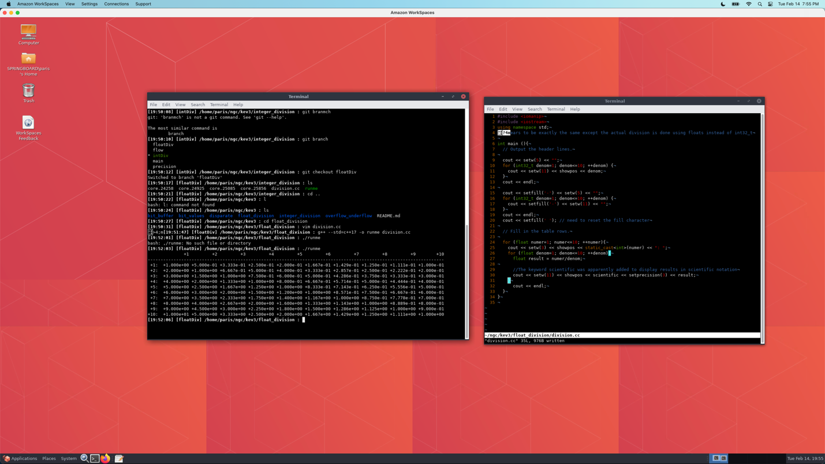

* Results after increasing the decreasing the numerator to start at -10 (and playing with the formatting a bit).

