*Exercise 3: Integer Division(division.cc)*

***Explained***

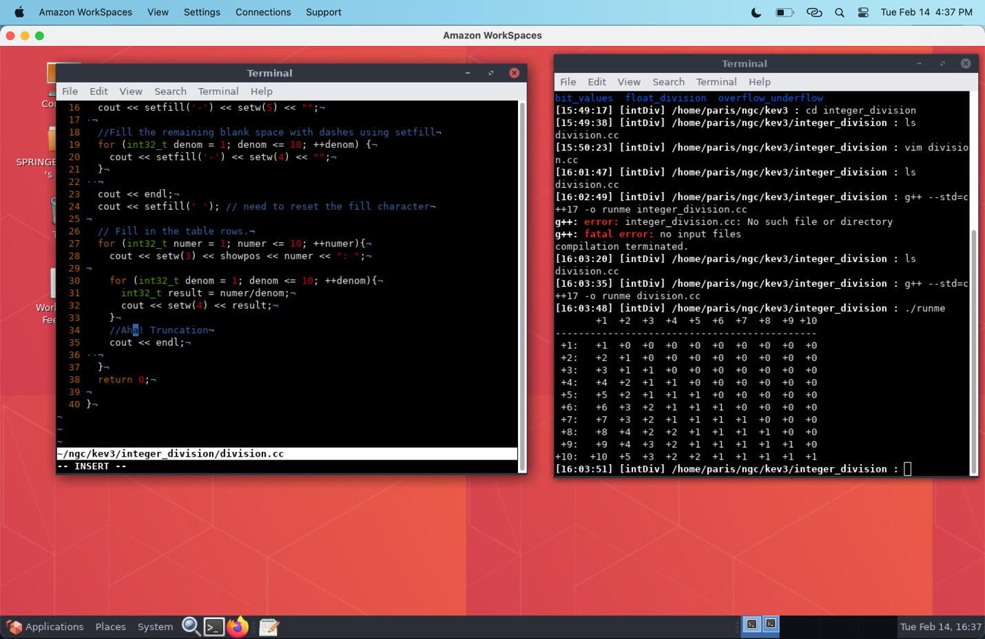

* The output works as expected (if you are cognizant of how integer division works in C++). For the rest of us, lol, why isn’t it showing a decimal or rounding like in other languages?
* Turns out that, in C++, integer division neither rounds up nor down. Integer division in C++ actually truncates the remainder!
* So how can we fix this?

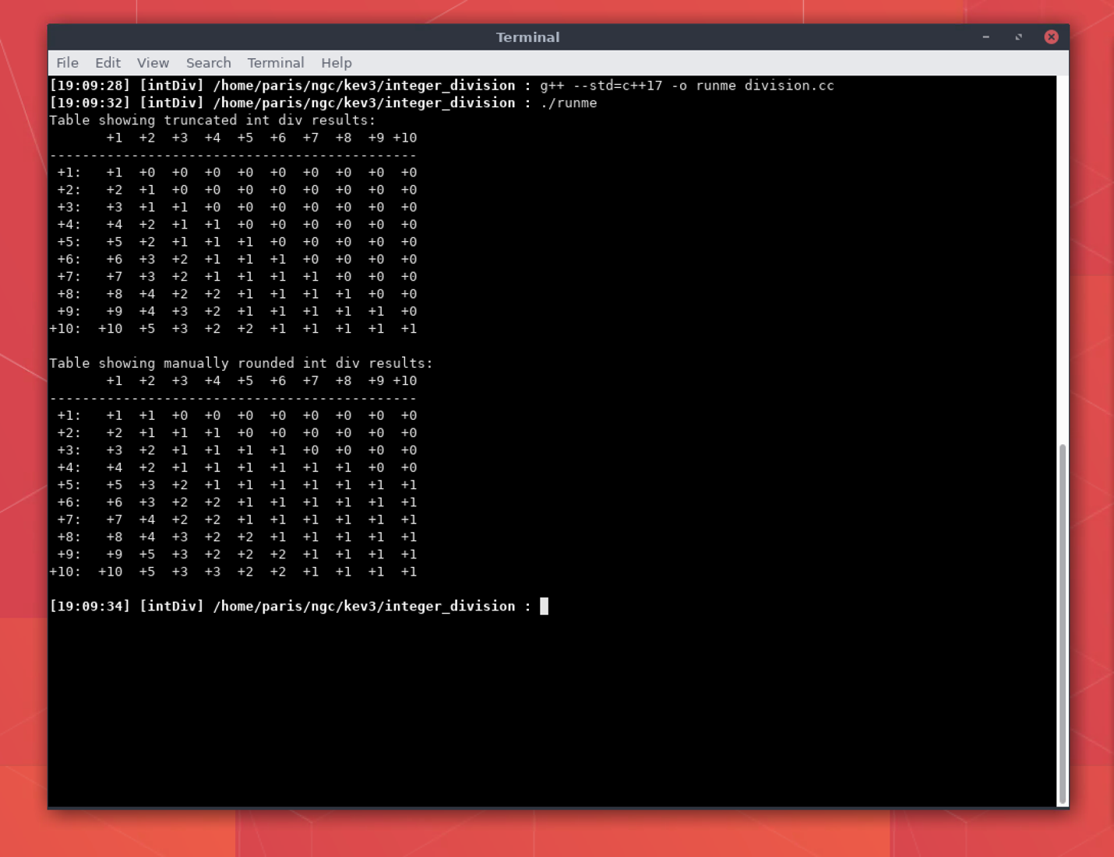

* Here we essentially divide the denominator in half, add it to the numerator, and then divide that new total by the original denominator.
* Essentially this adds the part that will eventually be truncated to the numerator before the division is performed, effectively rounding to the nearest integer before the truncation can occur.