

**SI430: Lab 02 --- Using Sockets**

Names: Chris Paris, Meris Larkins

Alphas: 264845, 253486

External source(s)   
Referred to webpages provided by lab instructions (python documentation pages, mdn web docs)

Honor

We wrote the code on my own except the help from the external source(s) listed above. Moreover, we didn’t copy any part of the code from other midshipmen.

Initials: CPP and MEL

Challenges

Formatting http messages was confusing, especially GET requests and 404.

What we learned and what was interesting to us

UDP is connectionless.

HTTP requires specific formatting for sending and receiving.

# **Part 1**

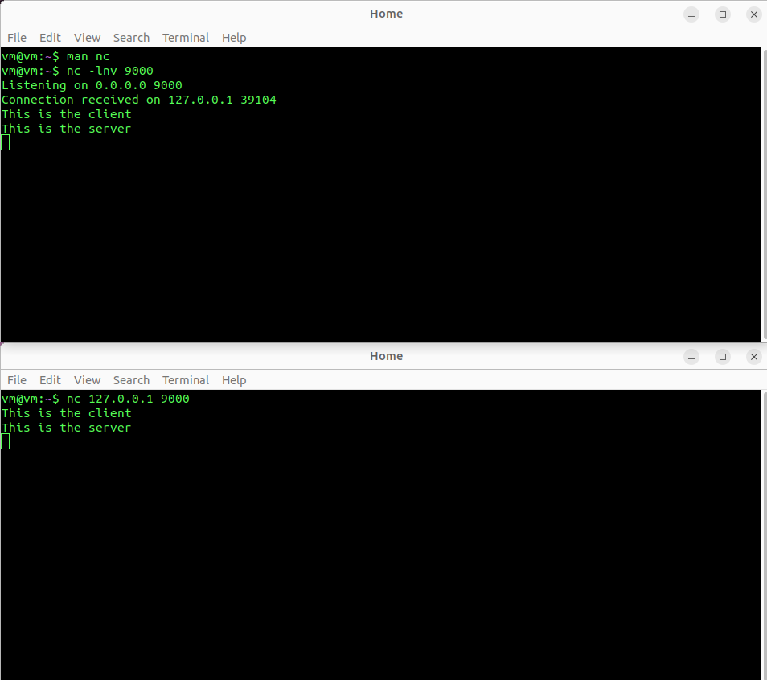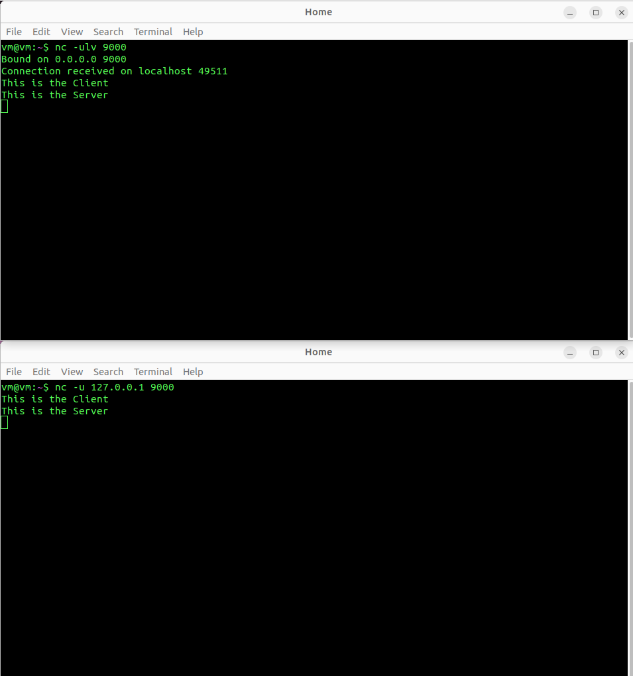

# **Part 2**

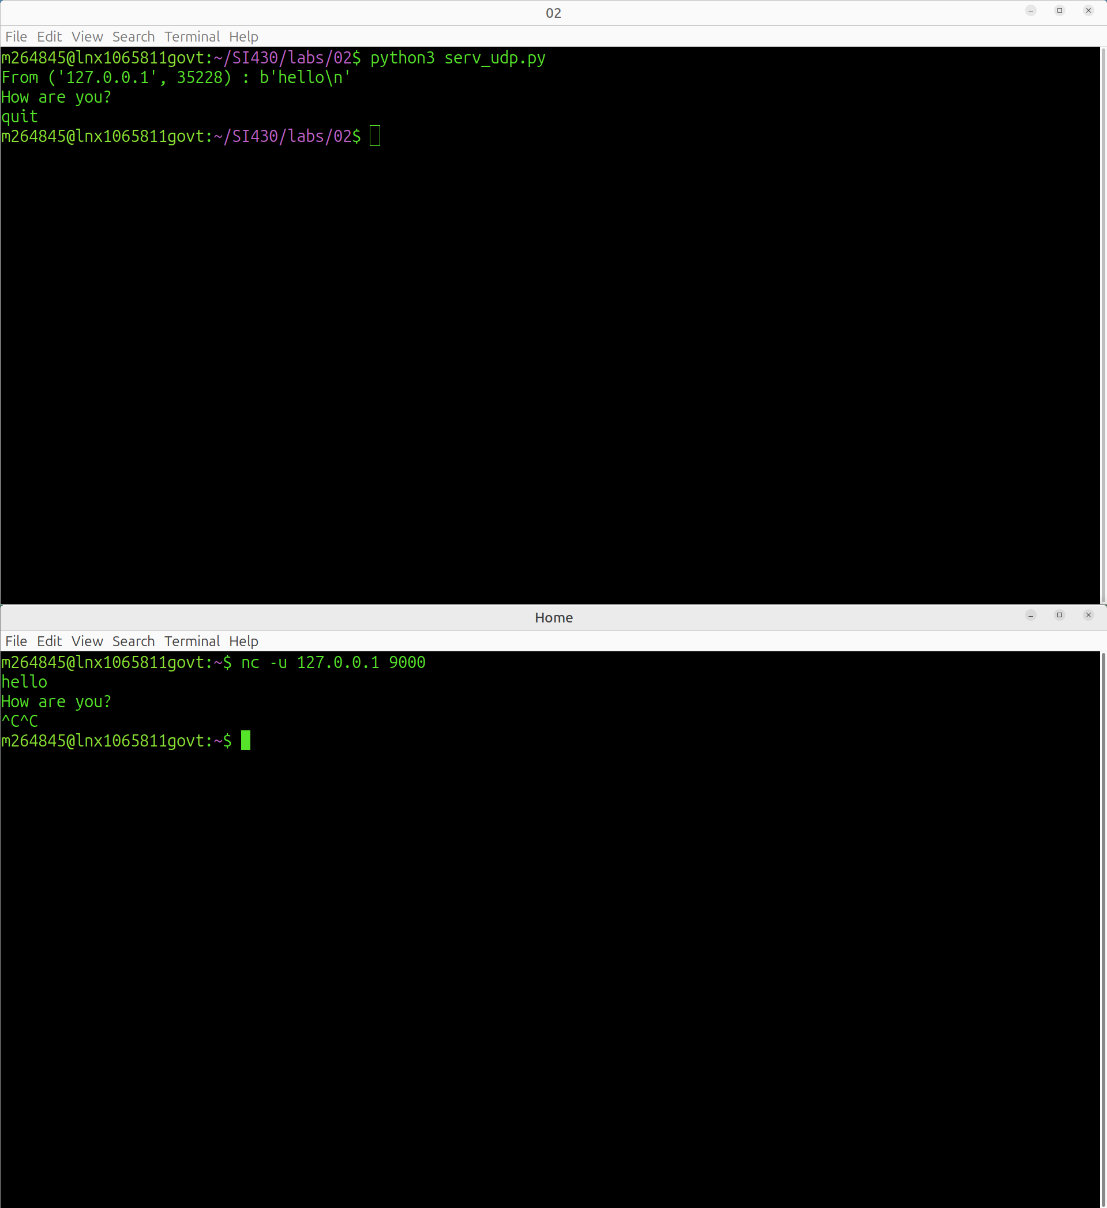

# **Part 3**

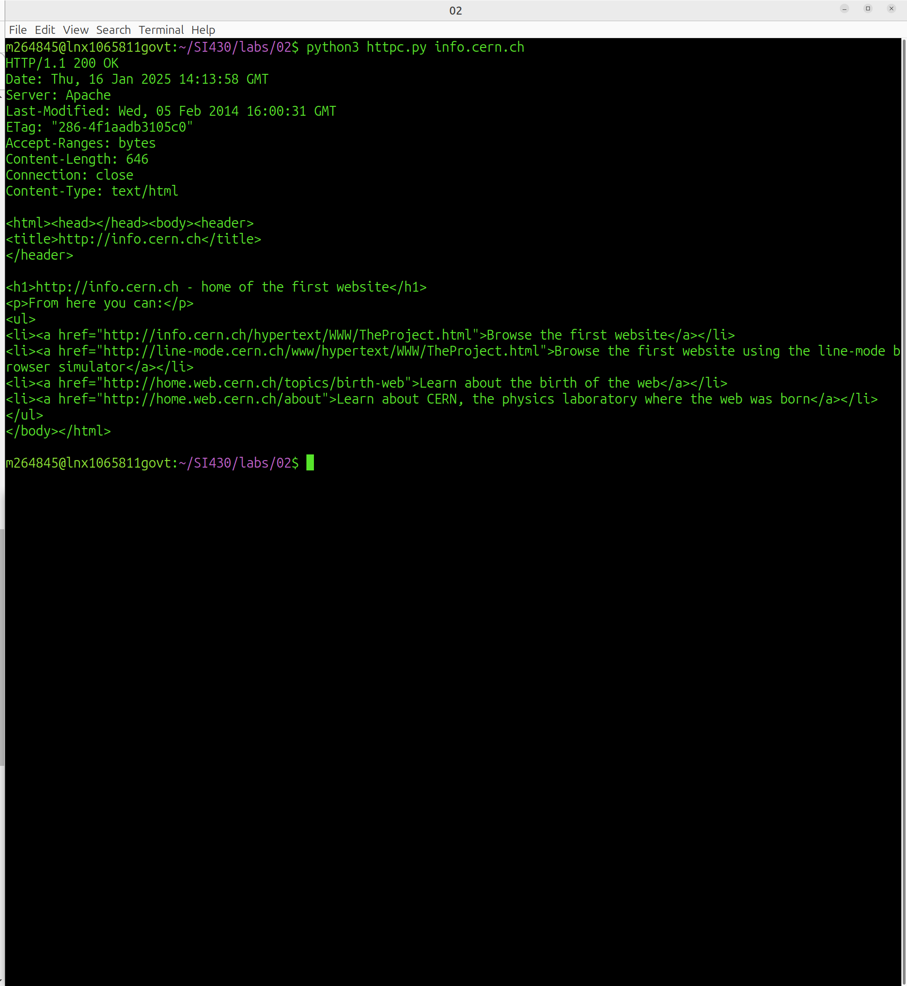

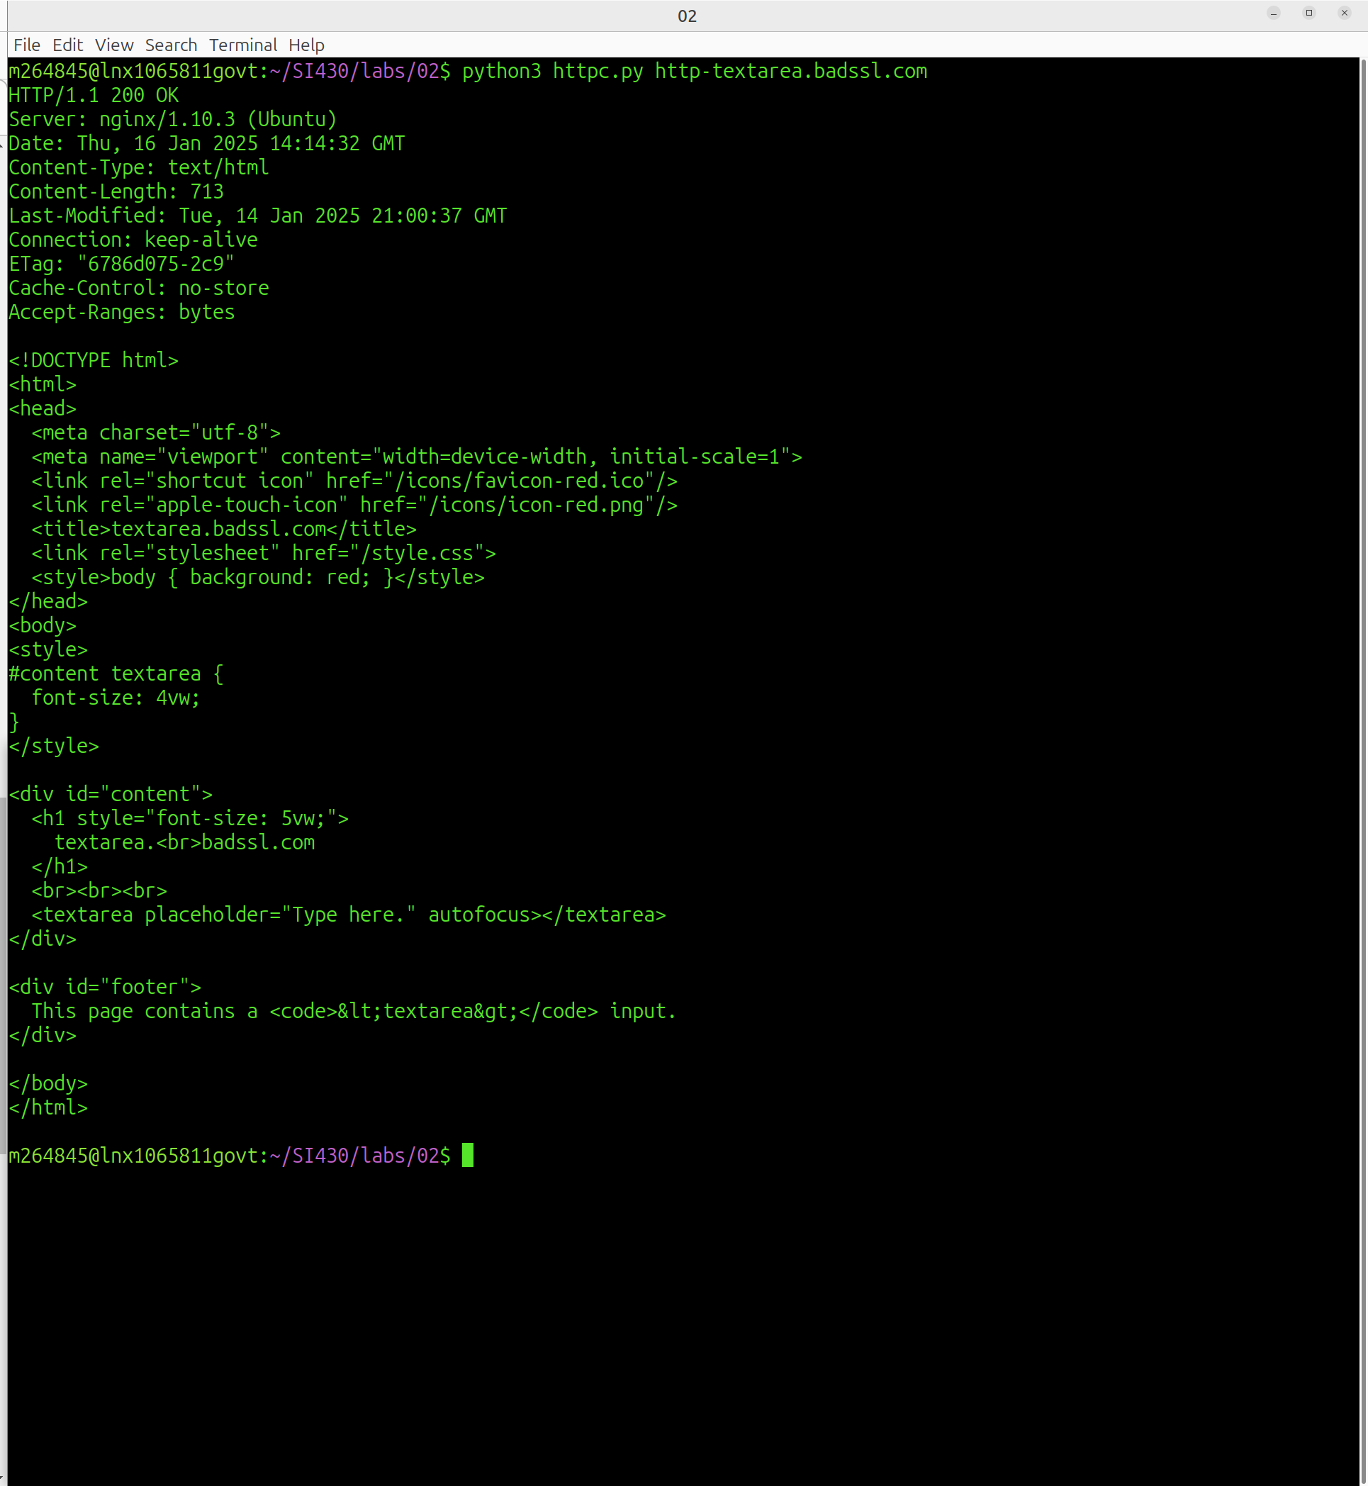

# **Part 4**