

**SI430: Lab xx --- Lab Title**

Names: Chris Paris and Meris Larkins

Alphas: 264845, 253486

External source(s)   
(“I referred to this site for x,” etc.)

Honor

We wrote the code on our own except the help from the external source(s) listed above. Moreover, we didn’t copy any part of the code from other midshipmen.

Initials: CPP and MEL

Challenges

(e.g., it was difficult to figure out how to x)

What we learned and what was interesting to us

(Specify what you learned and what was interesting to you)

# **Part 1**

Commands in submitted file 08.sh

1.

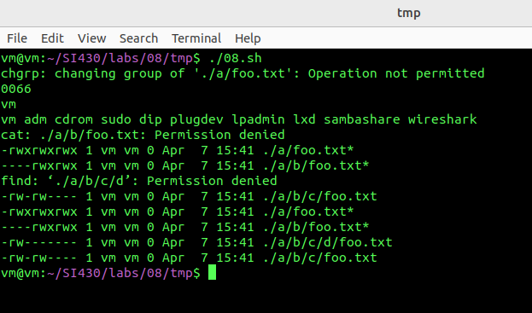2.

Umask returns the permissions mask. 0066 means that there are no special permissions, the user has no permissions, the group has execute only, and others have execute only. This is a negative permission, so when the file is created, the umask removes permissions from the default a+rwx.

3.

In step 8 we removed all permissions from the user/owner.

# **Part 2**

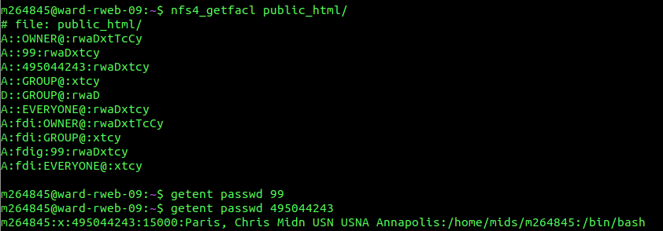

**2.**

Ace Types: A:Allow (allows user to do perms), D:Deny (prevents user to do perms), U:audit(log any use of perms), L:alarm(generate an alarm when user tries to use perms)

Ace Flags: g:group(principal is a group not a user), d:directory-inherit(newly created subdirectories inherit the ACE), f:file-inherit(new files inherit the ACE, minus inheritance flags), n:no-propagate-inherit(new subdirectories inherit ace, minus inheritance flags), i:inherit-only(the ACE is not considered in perms checks, is inherited, but inherited ACES don’t have the flag), S:successful-access(alarm when principal is allowed to use permissions), F:failed-access(alarm when principal is blocked from using perms)

Perms: r:read-data, w:write-data, a:append-data, x:execute, d:delete, D:delete-child, t:read-attributes, T:write-attributes, n:read-named-attributes, N:write-named-attributes, c:read-ACL, C:write-ACL, o:write-owner, y:synchronize

4.

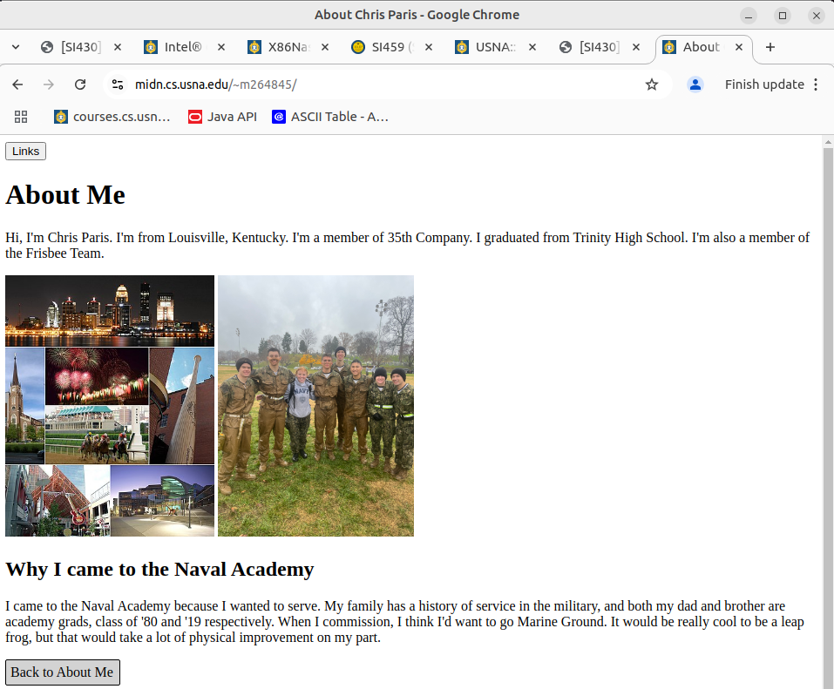

5.

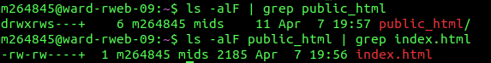

7. After adding access, homepage accessible.

# **Part 3**

We have read and understand the powershell articles.