

**SI430: Lab xx --- Lab Title**

Names: Paris, Larkins

Alphas: 264845, 253486

External source(s)   
(“I referred to this site for x,” etc.)

Honor

We wrote the code on our own except the help from the external source(s) listed above. Moreover, we didn’t copy any part of the code from other midshipmen.

Initials: CPP and MEL

Challenges

(e.g., it was difficult to figure out how to x)

Generally pretty linear and easy.

Had to refer ahead to course notes from following lecture.

What we learned and what was interesting to us

(Specify what you learned and what was interesting to you)

# **Part 1**

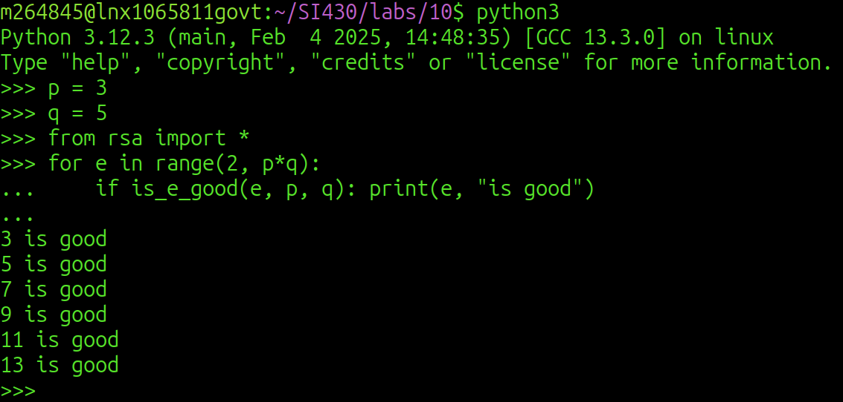

# **Part 2**

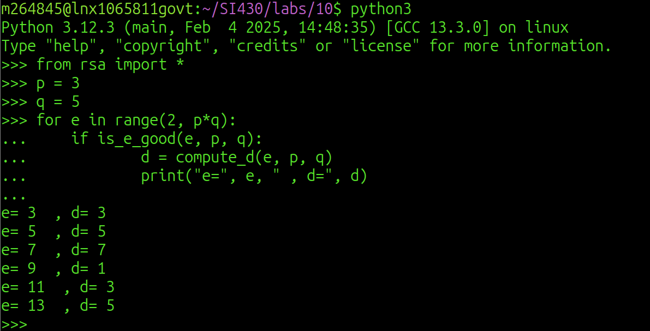

# **Part 3**

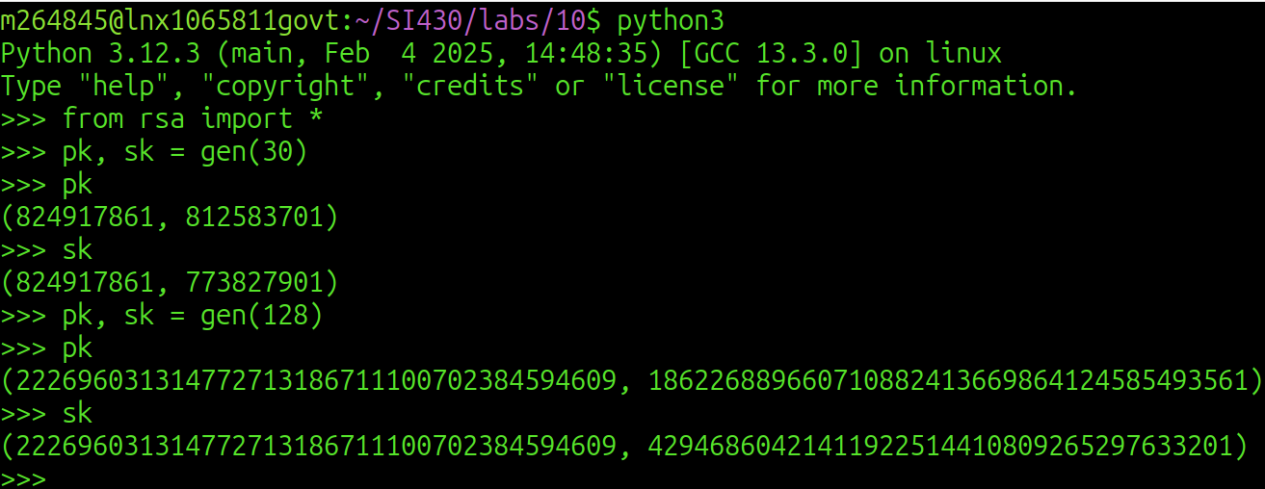

# **Part 4**

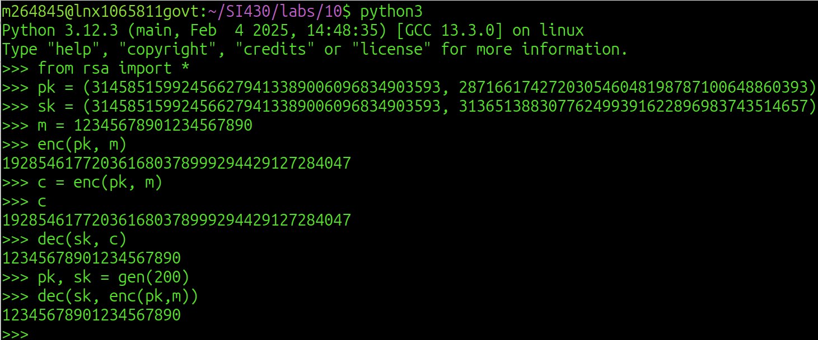

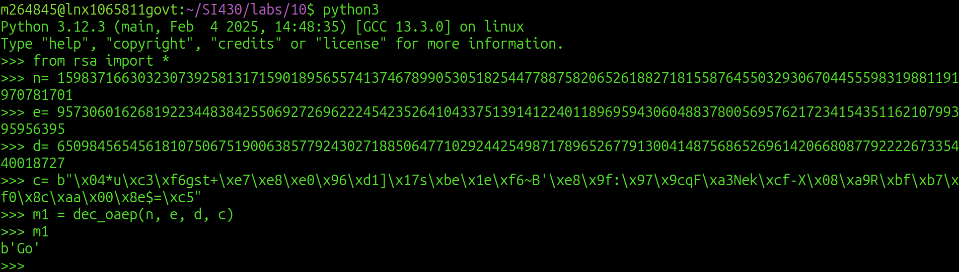

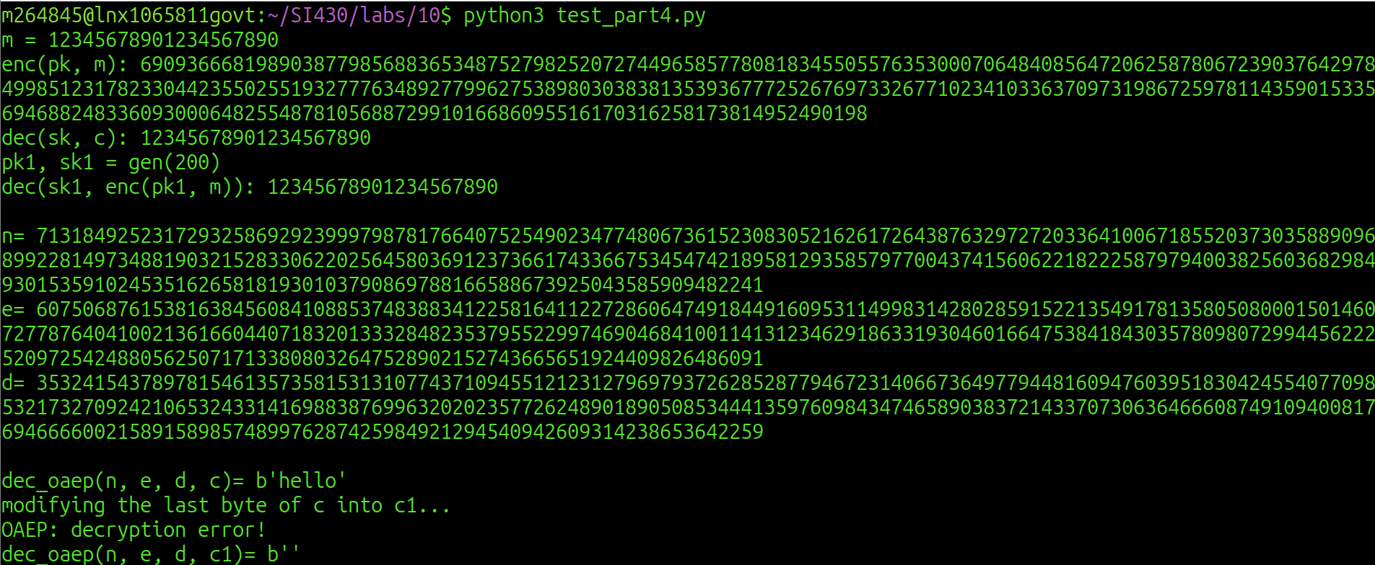

# **Part 5**

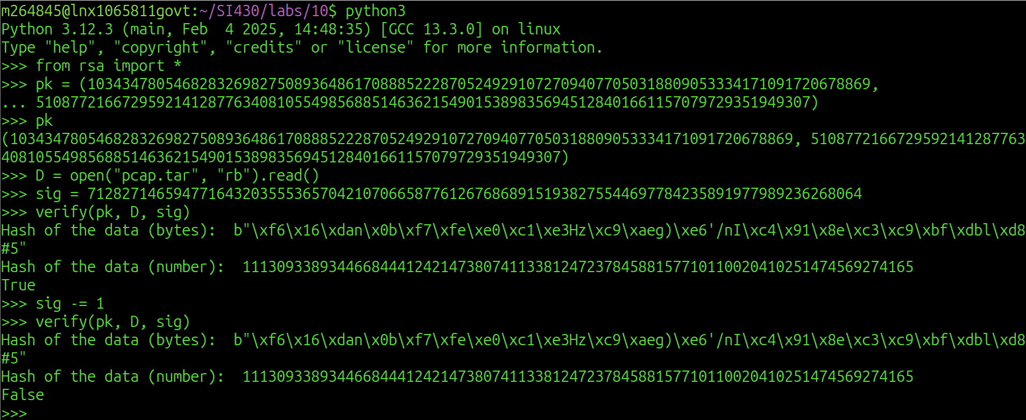

# **Part 6**

