Parisa Rezapour (2543171)

EE568

Final Project:

Design of a Salient-Pole Synchronous Hydro-Generator

Prof. Ozan Keysan

Spring 2022

**Content**

Introduction – Literature Review ……………………………………………………………. 3

Analytical Calculation & Sizing …………………………………………………………….. 4

FEA Modelling ……………………………………………………………………………… 20

Comparison & Discussion …………………………………………………………………… 25

References …………………………………………………………………………………… 28

**Introduction**

A recent urge towards the use of renewable energy as a source for electricity production has formed due to a growing concern for fossil fuel consumption and depletion which in turn eventuates to release of greenhouse gases to the atmosphere and destruction of natural resources [1-2].

Hydropower being one of the major sources amongst the various sources of renewable energy, holds about 17 percent of the global power generation [2-4]. Hydroelectric systems consist of various components such as generator, turbine, control system, etc. [5]. Considering the generator component of the system, although AC machines have shown a proper performance in tackling the renewable energy sources, there is continuing research on utilizing other machines for this purpose. Due to their mature technology and high power ratings, synchronous generators have been the most common type of the machines used in large hydropower stations. Synchronous generators have the disadvantage of large amounts of field loss and requiring refurbishment of slip rings and brushes. On the other hand, induction generators and permanent magnet synchronous generators are more desirable for small hydropower systems because of the high fluctuations in water flow [6].

Renovation of hydroelectric generators is of high concern [6]. Partial discharge (PD) is one of the factors giving rise to this issue. PD is an electrical discharge, which does not link the electrodes between an insulation system completely under high electric field stress [7]. This phenomenon results in the aging of the insulation system. Partial discharge shows itself where the semi-conductive and stress-grading coatings of high voltage bars overlap. Reapplying the coatings can be useful for the repairment. However, the effect of this method will vanish after a short while, and it calls for regular repairs [8].

Another important topic regarding the hydro generators is copper loss reduction. For this matter, acquiring an acceptable coil design can lead to better thermal characteristics and enhanced heat dissipation [9]. Moreover, design of loads connected to hydro generators requires to be employed with sinusoidal EMF. Geometrical improvements can be applied to the rotor pole shape of the salient pole synchronous generator to achieve a better sinusoidal approximation for the rotor MMF. In addition, relative positioning of the damper winding and the slots in the stator side has a significant role in diminishing the slot ripple and producing a smoother MMF waveform [10].

In this study, a salient pole synchronous hydroelectric generator will be designed to meet some pre-defined specifications. In the first step, an analytical calculation and sizing will be carried out. Next, an FEA analysis using ANSYS MAXWELL software will be performed by implementing the same dimensions resulting from the first step and defining suitable boundaries and well-defined meshing. Finally, there will be a comparison between the analytical and FEA results to discuss the possible inconsistencies.

**Analytical Calculation & Sizing**

Design will be carried out with the help of the values given in Table 1.

Table . Input Data



The larger the value of machine constant, the smaller is the volume (D2L) of the machine, and this will be effective in reducing the cost. Machine constant is larger if machine is designed for higher specific magnetic and electrical loadings. Due to the limitations in the ranges that these two values can be chosen from, there should be a compromise.

Designing with higher magnetic loading, will give a rise to the possibility of saturation, hence core losses will increase, and as a result the efficiency will decrease, and the temperature will rise more which will demand better insulation and cooling. In addition, with higher magnetic loading, more magneto-motive force is required to pass the flux through the airgap, which increases the magnetizing current resulting in lower power factor. But in the case of a synchronous alternator, magnetizing current is not much of an issue since it is provided with dc excitation.

If designed with high electrical loading, there will be large amount of copper loss in the windings. This will cause issues related to heat dissipation in the slots and thermal expansion. High value of electrical loading should also be taken into consideration when selecting the insulation material and thickness.

In the recent years, the insulation production has gotten more advanced. Therefore, in this design a rather high electrical loading has been chosen to compensate for the low magnetic loading.

Magnetic loading (avg): 0.75 T

Electrical loading (rms): 55000 A/m

For the calculation of the machine constant, is required and it depends on the winding design. Here, machine constant can be calculated for , and after the winding diagram is decided, it can be recalculated with the actual value of .

Apparent power:

Calculating number of poles:

Notice that, this value is for , and it should be reevaluated later.

Aspect ratio (X):

Typical aspect ratio for synchronous machines is derived using the following equation:

**Winding design:**

Selecting number of slots considering the tooth thickness limitations:

If :

If :

If :

If :

All these values could be possible to design, but since there is no need for a very large tooth thickness, the rest of the design will be carried out choosing .

An analysis has been done to choose the proper value for coil throw of the winding design, and the results are as follows:

Table . Fundamental winding factor for different slot/pitch combinations



Table . 3rd harmonic winding factor for different slot/pitch combinations



Table . 5th harmonic winding factor for different slot/pitch combinations



There should be a compromise between going for the best fundamental winding factor and going for the lower winding factor of the harmonics. Here, it has been preferred to have a better fundamental winding factor and this is feasible by choosing .

Since the pole pitch in terms of slot number is , the chosen winding design is over-pitched .

Now actual winding factor can be calculated:

Slot/pole/phase (q):

q is not an integer, so this results in a fractional slot winding design.

Distribution Factor:

Pitch Factor:

Winding Factor:

Calculating fundamental winding factor :

According to MOTORCAD, this design has a winding factor lower than what we calculated analytically. This discrepancy is due to the unusual winding design which makes it incorrect to use the pitch factor equation in this case. Therefore, will be used for the next derivations.

Figure 1. Winding design in MotorCAD for coil throw=8 and Q=252

Now, the actual machine constant, inner stator diameter and axial length can be recalculated:

**Airgap length calculation:**

According to the Design of Rotating Electrical Machines book by Juha Pyrhonen, the following equation can be an acceptable approximation for determining the airgap of a salient pole synchronous machine:

For salient-pole synchronous machine coefficient is .

Since this machine is a huge generator, there can be significant vibrations and movements. Hence, we will consider a coefficient with the value of 1.5 for dealing with a heavy-duty machine:

**Rotor outer diameter :**

**Stator outer diameter :**

Taking the ratio to be 0.9 for 32 number of poles,

**Number of turns per phase :**

Assuming , can be derived from the equation below:

: flux per pole

and are the magnetic loading and pole area respectively.

Since number of turns per phase should be an integer, is chosen for this design.

To keep the terminal voltage in the rated value, decreasing the number of turns will lead to higher flux per pole, which can be reevaluated as follows:

**New magnetic loading** will be:

Total number of turns:

Total number of conductors:

**Conductor per slot:**

To find the area of the conductors, a current density should be assigned for the armature winding.

Due to the relatively high value of electrical loading, to stay in the safe zone, the current density in the stator windings is set to be .

**Phase current (rms):**

Total area of conductors in a slot:

Before getting slot/tooth dimensions, proper flux densities should be assigned to different parts of the stator and rotor core.

The following values are taken from Table 6.1 in chapter 6 of Design of Rotating Electrical Machines book by Juha Pyrhonen, and are as follows:

Table . Chosen flux densities for different parts of the machine



**Tooth width:**

If the flux only goes through the teeth:

**Slot pitch :**

**Slot width :**

**Stator back core thickness :**

**Slot height :**

**Slot area :**

**Rotor back core thickness :**

**Pole width :**

Checking the fill factor in the stator slots:

Since, this machine has a high voltage value, there should be enough insulation to avoid the risks faults. Hence, the value of fill factor is acceptable.

Since the full-load field MMF per pole gives the , the following steps will be taken to find this value:

Phasor diagram for the lagging case has been presented in the figure below:

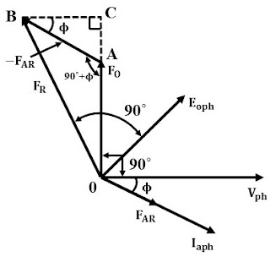

Figure . Phasor diagram for MMF vectorial summation

where, is the no-load field MMF per pole, is the armature MMF per pole and is the power factor (PF).

For a 3-phase system, is calculated using the following equation:

Next, will be determined with the knowledge that:

is the defined as the Short Circuit Ratio.

According to A Course in Electrical Machine Design by A.K.Sawney, Typical values of SCR for Hydro alternators may be in the range of 1 to 1.5.

Assuming for this design, it is established that:

Now, the value for the full-load field MMF per pole , can be found as follows:

This is also the value of :

Assuming the following values for the field winding:

Total area for field winding in the space between two poles can be calculated as follows:

Area of empty space between poles is equal to:

Now, determining the pole height can be proceeded by assuming a value for shaft diameter and finding the width of empty part next to a pole:

**Shaft Diameter:**

Width of empty part next to a pole :

**Total pole height :**

**Pole body height :**

**Pole shoe height :**

Assuming cross-section of field winding to be:

Total **number of turns for field winding** will be:

Now, using the value of and which has been calculated before, **field current** is determined as:

**Material selection:**

According to [11], segmented laminations made from silicone steel with 0.35- or 0.50-mm thickness are the common material used in hydro generator cores due to their low loss.

This design has been carried out with the material choice of **Cogent Power M270-50A**, and it has been selected from the library of ANSYS MAXWELL.

And for the windings, aluminum and copper are two popular choices which both have their merits and drawbacks. Although aluminum outrivals copper when it comes to weight and cost, in this huge generator, thermal issues and cooling are of greater concern. Therefore, **copper** is a better choice here due to its high thermal conductivity.

**Electrical circuit parameter estimation:**

**Flux per pole:**

**Induced voltage :**

**Armature phase resistance :**

**Field resistance :**

**FEA Modelling**

FEA results have been carried out using ANSYS MAXWELL and are presented in this section. Consistencies and any discrepancies will be discussed in the next section.

Figure . 2D Model in ANSYS MAXWELL

**Resulting waveforms:**

Figure . Torque vs. Time

Figure . Current vs. Time

Figure . Induced Voltage vs. Time

Figure . Flux Linkage vs. Time

Figure . Input Voltage vs. Time

Figure 9. DQ Inductance vs. Time

The significant difference between direct-axis and quadrature-axis inductances in Figure 9, stems from the saliency in the machine which adds a reluctance element to the torque.

Figure . DQ Flux vs. Time

Figure 11. DQ Current vs. Time

Figure . Airgap Flux Density vs. Time (No-Load)

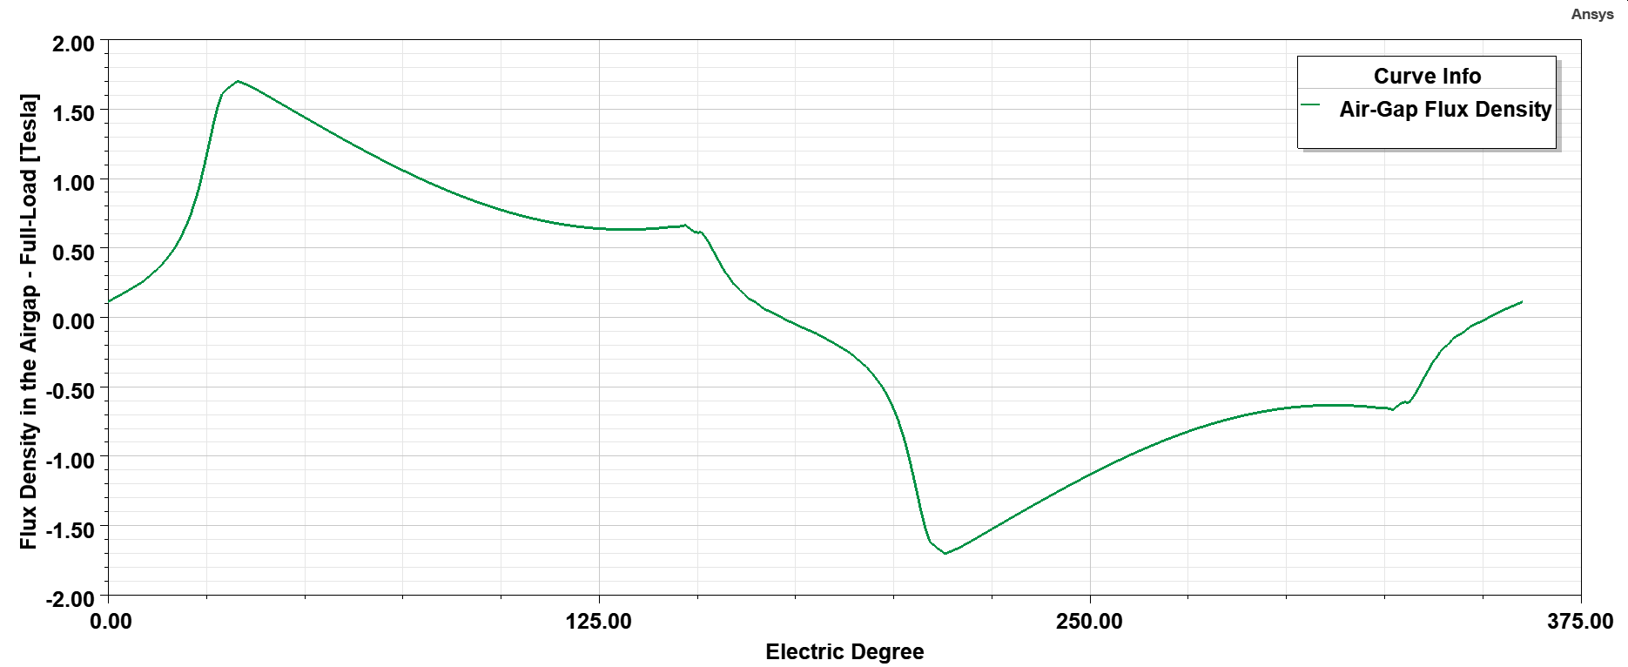

Figure . Airgap Flux Density vs. Time (Full-Load)

Figure . Cogging Torque vs. Time

As can be seen from Figure 13., this design shows a promising performance when it comes to cogging torque. This low value keeps the machine vibrations to in an acceptable level.

**Comparison and Discussion**

Several iterations and reevaluation of some parameters have been carried out in the analytical part of the design. The reasonings have been explained thoroughly in the same part.

The followings are the results taken from the RMxprt module of the ANSYS MAXWELL software:

Table . RMxprt results for rated values



Table . RMxprt results for Losses



Table . RMxprt and analytical results for armature resistance



Table . RMxprt and analytical results for field resistance



Table . RMxprt results for flux densities



According to Table 8 and Table 9, FEA results show an acceptable consistency with the analytical results. Moreover, flux densities are in a satisfactory range for each part of the machine as seen in Table 10.

Finally, some of the important parameters of the machine are presented in the tables below:

Table . RMxprt results for mass of different parts of the machine



Table . Torque & power densities



Table . Main dimension of the machine



**References**

[1] Singh, R. R., Chelliah, T. R., & Agarwal, P. (2014). Power electronics in hydro electric energy systems–A review. *Renewable and Sustainable Energy Reviews*, *32*, 944-959.

[2] Ciric, R. M. (2019). Review of techno-economic and environmental aspects of building small hydro electric plants–A case study in Serbia. *Renewable Energy*, *140*, 715-721.

[3] International Energy Agency (IEA), 2001, Guidelines for Hydroelectric Generator Upgrading, Technical Report, The Hydro Power Upgrading Task Force.

[4] Znidarich, M. M. (2008). Hydro generator high voltage stator windings: Part 1–essential characteristics and degradation mechanisms. *Australian Journal of Electrical and Electronics Engineering*, *5*(1), 1-17.

[5] Fortaleza, B. N., Juan, R. S., & Tolentino, L. K. S. (2018). IoT-based pico-hydro power generation system using pelton turbine. *J. Telecommun. Electron. Comput. Eng*, *10*(1-4), 189-192.

[6] Chau, K. T., Li, W., & Lee, C. H. (2012). Challenges and opportunities of electric machines for renewable energy. *Progress In Electromagnetics Research B*, *42*, 45-74.

[7] Illias, H., Yuan, T. S., Mokhlis, H., Chen, G., & Lewin, P. L. (2012, December). Partial discharge patterns in high voltage insulation. In *2012 IEEE international conference on power and energy (PECon)* (pp. 750-755). IEEE.

[8] Soltani, R., Gaillardetz, P., Chichkin, I., & Ledger, B. (2019, June). Investigation of Partial Discharge Activity and Insulation Life of a Large Hydro Generator. In *2019 IEEE Electrical Insulation Conference (EIC)* (pp. 172-175). IEEE.

[9] Znidarich, M. M. (2009). Hydro Generator High Voltage Stator Windings: Part 2-Design for Reduced Copper Losses and Elimination Of Harmonics. *Australian Journal of Electrical and Electronics Engineering*, *5*(2), 119-135.

[10] Walker, J. H. (1981). *Large synchronous machines: design, manufacture, and operation* (Vol. 14). Oxford University Press.

[11] Znidarich, M. M. (2008, December). Hydro generator stator cores part 1-constructional features and core losses. In *2008 Australasian Universities Power Engineering Conference* (pp. 1-8). IEEE.

[12] Pyrhonen, J., Jokinen, T., & Hrabovcova, V. (2008). Design of rotating electrical machines. Chichester, West Sussex, United Kingdom: Wiley.