SCHOOL OF COMPUTING · WICHITA STATE UNIVERSITY
Writing Your Senior Project Report
with LaTeX and Overleaf
A Complete Student Guide to the APA 7 LaTeX Template
Senior Project I & II
Instructor: Prof. Cody Farlow
Guide and template created by
Parisa Rostami
Graduate Teaching Assistant

Download the template:
github.com/ParisaRostaami/APA7-LaTeX-Template
Version 1.0 · Fall 2026
© 2026 Parisa Rostami. Licensed under CC BY-NC 4.0.

Contents
About This Guide 5
What You Will Be Able to Do 5
How This Guide Is Organized 5
Conventions Used in This Guide 5
1. What Is LaTeX? 7
1.1 The Idea in One Sentence 7
1.2 LaTeX Compared With a Word Processor 7
1.3 Why We Use LaTeX for the Senior Project 8
1.4 How LaTeX Turns Your Text Into a PDF 8
1.5 Key Vocabulary 9
2. What Is Overleaf? 11
2.1 Overview 11
2.2 Creating Your Account 11
2.3 What the Free Plan Includes 11
2.4 A Tour of the Overleaf Editor 12
2.5 Features That Save Time 13
3. LaTeX Basics You Need 15
3.1 The Anatomy of a LaTeX Document 15
3.2 Commands 15
3.3 Environments 16
3.4 Paragraphs and Spacing 16
3.5 Special Characters 16
3.6 Formatting Text 17
3.7 Lists 18
3.8 Math 18
3.9 Comments 19
3.10 Reading Errors: The First Look 19
4. APA 7 Student Paper Essentials 20
4.1 What APA Style Is 20
4.2 The Rules, and Who Takes Care of Each One 20
4.3 Title Case and Sentence Case 21
5. Getting the Template into Overleaf 22
5.1 Download the Template From GitHub 22
5.2 Upload the Template to Overleaf 23
5.3 The First Compile 23
5.4 What Is Inside the Project 24
6. A Guided Tour of main.tex 25
6.1 The Big Picture 25
6.2 The Document Class Line 25
6.3 The Packages 26
6.4 Filling In the Title Page 26
6.5 The Abstract and Keywords 28
6.6 Writing the Body 28
6.7 Optional: One File per Section 29
7. Headings and Structure 31
7.1 The Five APA Heading Levels 31
7.2 Heading Rules 31
8. Citations and References 33
8.1 How It Works 33
8.2 Anatomy of a .bib Entry 34
8.3 Entry Types for a Computing Project 34
8.4 Getting BibTeX Entries Quickly 36
8.5 Citation Commands 37
8.6 APA Citation Rules You Should Know 37
8.7 Citing Generative AI Tools 38
8.8 The Reference List 38
9. Tables 40
9.1 APA Table Rules 40
9.2 The Template Table, Line by Line 40
9.3 Column Types 41
9.4 Example: A Requirements Table 41
10. Figures 43
10.1 Uploading an Image 43
10.2 The Figure Code 43
10.3 Referring to Tables, Figures, and Other Elements 44
10.4 Why Did My Figure Move? 44
10.5 Figures You Did Not Create 44
10.6 Diagrams for Software Projects 45
11. Equations, Code, Appendices, and More 46
11.1 Equations 46
11.2 Code in Your Report 46
11.3 Appendices 47
11.4 Links, Footnotes, and Other Small Elements 47
12. Writing Your Senior Project Report 48
12.1 Senior Project I and Senior Project II 48
12.2 A Suggested Report Outline 48
12.3 The Outline in LaTeX 49
12.4 What to Cite in a Software Project 50
12.5 APA Writing-Style Essentials 51
12.6 Writing as a Team 51
12.7 Submission Checklist 52
13. Troubleshooting and FAQ 54
13.1 A Debugging Routine 54
13.2 Common Errors and How to Fix Them 54
13.3 Problems With References 55
13.4 Frequently Asked Questions 55
Appendix A. Quick Reference Cheat Sheet 57
Appendix B. Working on Your Own Computer (Optional) 59
B.1 Install a LaTeX Distribution 59
B.2 Choose an Editor 59
B.3 Compile From the Command Line 59
B.4 Get the Template With Git 60
B.5 A Simple Team Workflow With Git 60
Appendix C. Hands-On Exercises at a Glance 61
Appendix D. Further Resources 62
The Template 62
APA Style 62
LaTeX and Overleaf 62
Tools for Your Project 62

BEFORE YOU BEGIN

About This Guide
This guide teaches you everything you need to write your Senior Project report in APA 7 style using LaTeX and Overleaf. You do not need any previous experience with LaTeX. We start with what LaTeX is and why it is worth learning, move through the basics of Overleaf, and then walk through every part of the APA 7 student template that you will use for your report.

What You Will Be Able to Do
By the end of this guide, you will be able to:
- explain what LaTeX and Overleaf are and how a LaTeX document becomes a PDF;
- create, edit, compile, and download a LaTeX project in Overleaf;
- upload the APA 7 template and fill in a correct APA student title page;
- organize your report with APA heading levels;
- manage sources in a .bib file and cite them correctly in APA style;
- add APA-formatted tables, figures, equations, code excerpts, and appendices;
- structure a complete Senior Project report and check it before submission; and
- find and fix the most common LaTeX errors on your own.

How This Guide Is Organized
Part | Chapters | What it covers
I. Foundations | 1–3 | What LaTeX and Overleaf are, and the LaTeX basics you need
II. The APA 7 Template | 4–11 | APA rules, getting the template, and every element of the template in detail
III. Your Report | 12–13 | Structuring your Senior Project report, teamwork, the submission checklist, and troubleshooting
Appendices | A–D | Cheat sheet, working on your own computer with Git, exercise summary, and resources

Conventions Used in This Guide
You see | It means
\textbf{text} | Something you type exactly as shown, in Overleaf or in a file.
File → Word Count | A menu, button, or option to click in Overleaf.
Try It box (green) | A hands-on exercise. We will do these together in class.
Tip box (blue) | A shortcut or good habit that saves time.
Watch Out box (orange) | A common mistake and how to avoid it.
Key Idea box (navy) | A concept you should remember.

Key Idea: In a hurry? The five-step quick start
- Download APA7_Student_Template.zip from the GitHub repository (Chapter 5).
- In Overleaf, click New Project → Upload project and select the zip file. Do not unzip it first.
- Open main.tex and fill in the title page block (Chapter 6).
- Write your report, cite sources with \parencite{key}, and add entries to references.bib (Chapter 8).
- Click Recompile, check the PDF against the checklist in Chapter 12, and download it.

PART I · FOUNDATIONS

1. What Is LaTeX?

1.1 The Idea in One Sentence
LaTeX (usually pronounced “LAY-tek” or “LAH-tek”) is a system for preparing documents: you write plain text mixed with short formatting instructions, and a program turns that text into a polished PDF.
In Microsoft Word or Google Docs, you format by clicking buttons and you see the final look as you type. This is called WYSIWYG, “what you see is what you get.” LaTeX works differently. You describe the structure of your document (“this is a section heading,” “this is a citation,” “this word is emphasized”), and LaTeX decides how it should look by following a set of rules. This approach is sometimes called WYSIWYM, “what you see is what you mean.”
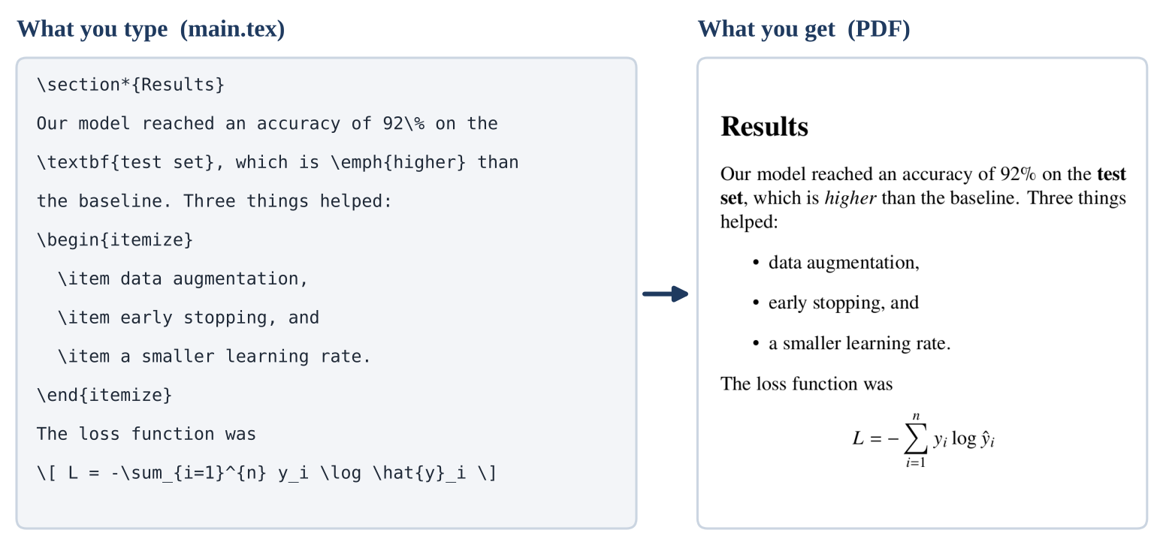
Figure 1. On the left is what you type in LaTeX. On the right is the PDF that LaTeX produces from it.
Look closely at Figure 1. You never told LaTeX which font size to use for “Results,” how far to indent the bullet points, or how to draw the summation sign. You only said what each piece is, and LaTeX handled the how. That is the core idea. For your report, the APA 7 template contains all of the “how” rules, so you only need to write the “what.”

1.2 LaTeX Compared With a Word Processor
 | Word or Google Docs | LaTeX
How you format | Click buttons; the result appears immediately | Type short commands; compile to see the result
Consistency | Manual; easy for headings and spacing to drift | Automatic; every heading follows the same rule
Citations and references | Typed by hand or with a plug-in | Generated automatically from your list of sources
Equations | Equation editor | Excellent, the standard in science and engineering
Long documents | Can become slow and unstable | Handles hundreds of pages without trouble
Teamwork and version control | Binary files that are hard to compare | Plain text that works well with Git
Learning curve | Low | Moderate for the first few hours, then easy

1.3 Why We Use LaTeX for the Senior Project
- The template does the APA formatting for you. Margins, spacing, fonts, headings, the title page, and the reference list are all handled automatically. You focus on content.
- Citations cannot drift out of sync. If you cite a source, it appears in the reference list. If you remove the citation, the entry disappears. No more missing or extra references.
- It handles technical content well. Equations, algorithms, code excerpts, and tables of results look professional with very little effort.
- It is a career skill. Most computer science research papers, theses, and many technical reports are written in LaTeX. If you plan to go to graduate school or work in research, you will use it again.
- It is plain text. Your report can live in a Git repository next to your code, and teammates can see exactly what changed.

1.4 How LaTeX Turns Your Text Into a PDF
Writing a LaTeX document is a lot like writing a program. You write source code (a file ending in .tex), and a compiler builds the output (a PDF). When you click Recompile in Overleaf, a short sequence of programs runs behind the scenes, as shown in Figure 2.
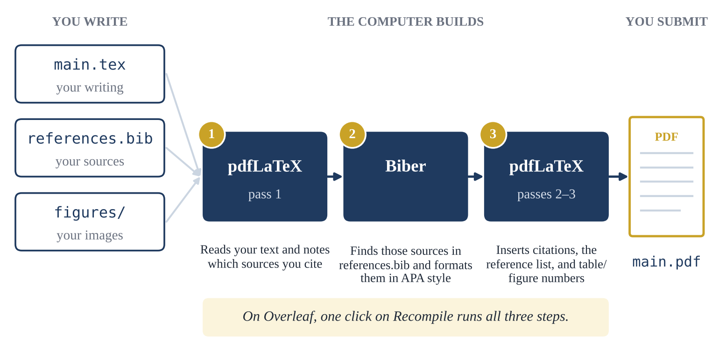
Figure 2. What happens when you click Recompile. Overleaf runs all of these steps for you.
Just like code, a LaTeX document can contain errors. If there is an error, LaTeX tells you which line it is on, and it may not produce a PDF until you fix it. Chapter 13 shows you how to read these messages. Do not worry: most errors are simple typos, such as a missing brace.

1.5 Key Vocabulary
You will see these terms throughout the guide. You do not need to memorize them now; come back to this table whenever you need it.
Term | Meaning
Source file (.tex) | The plain-text file you write. Your report lives in main.tex.
Compile | Turning the source file into a PDF. In Overleaf you click Recompile.
Command | An instruction that starts with a backslash, such as \section{Method}.
Argument | The input a command needs, written inside braces: the Method in \section{Method}.
Option | An optional setting written in square brackets, such as [width=0.5\linewidth].
Environment | A block that starts with \begin{name} and ends with \end{name}, such as a list or table.
Package | An add-on that gives LaTeX new features, loaded with \usepackage{name}.
Document class | The overall layout rules of a document. Our template uses the apa7 class.
Preamble | Everything before \begin{document}: settings, packages, and title-page information.
Body | Everything between \begin{document} and \end{document}: the content of your paper.
Comment | Text after a % sign. LaTeX ignores it, so it never appears in the PDF.
Bibliography file (.bib) | The file that stores your sources. Ours is references.bib.
Citation key | The short, unique name you give a source, such as lecun2015deep.
Biber | The program that reads your .bib file and formats references in APA style.
Float | A table or figure that LaTeX is allowed to move to the best position on the page.
Log | The report LaTeX writes while compiling. It contains errors and warnings.

CHAPTER 2

2. What Is Overleaf?

2.1 Overview
Overleaf is a website for writing LaTeX documents. It gives you an editor, a compiler, and a PDF viewer in your web browser, so there is nothing to install. Your projects are saved automatically in the cloud, you can open them from any computer, and you can share them with teammates and your instructor.
For this course, Overleaf is the recommended way to work. If you prefer to work on your own computer, Appendix B explains how, but you do not need to.

2.2 Creating Your Account
- Go to overleaf.com and click Register (or Sign up).
- Sign up with your university email address. Using your school address keeps your coursework in one place and makes it easy for your instructor to recognize you when you share a project.
- Open the confirmation email from Overleaf and click the link to verify your address.
- Log in. You will land on your Projects dashboard, which lists all of your projects.

2.3 What the Free Plan Includes
The free Overleaf plan is enough for this course. A few limits are worth knowing, especially for team projects:
Feature | Free plan
Number of projects | Unlimited
Collaborators | One invited collaborator per project (see Section 12.6 for team strategies)
Compile timeout | 10 seconds per compile. The template compiles in a few seconds.
Track changes and full project history | Paid plans only. The free plan keeps only recent history.
Git and GitHub integration | Paid plans only (you can still use Git on your own computer; see Appendix B)

These limits come from Overleaf’s documentation at the time of writing (October 2026) and may change. Check the current plans at overleaf.com/user/subscription/plans.

2.4 A Tour of the Overleaf Editor
When you open a project, you see the editor. Figure 3 is a simplified drawing of it. The numbers match the table below.
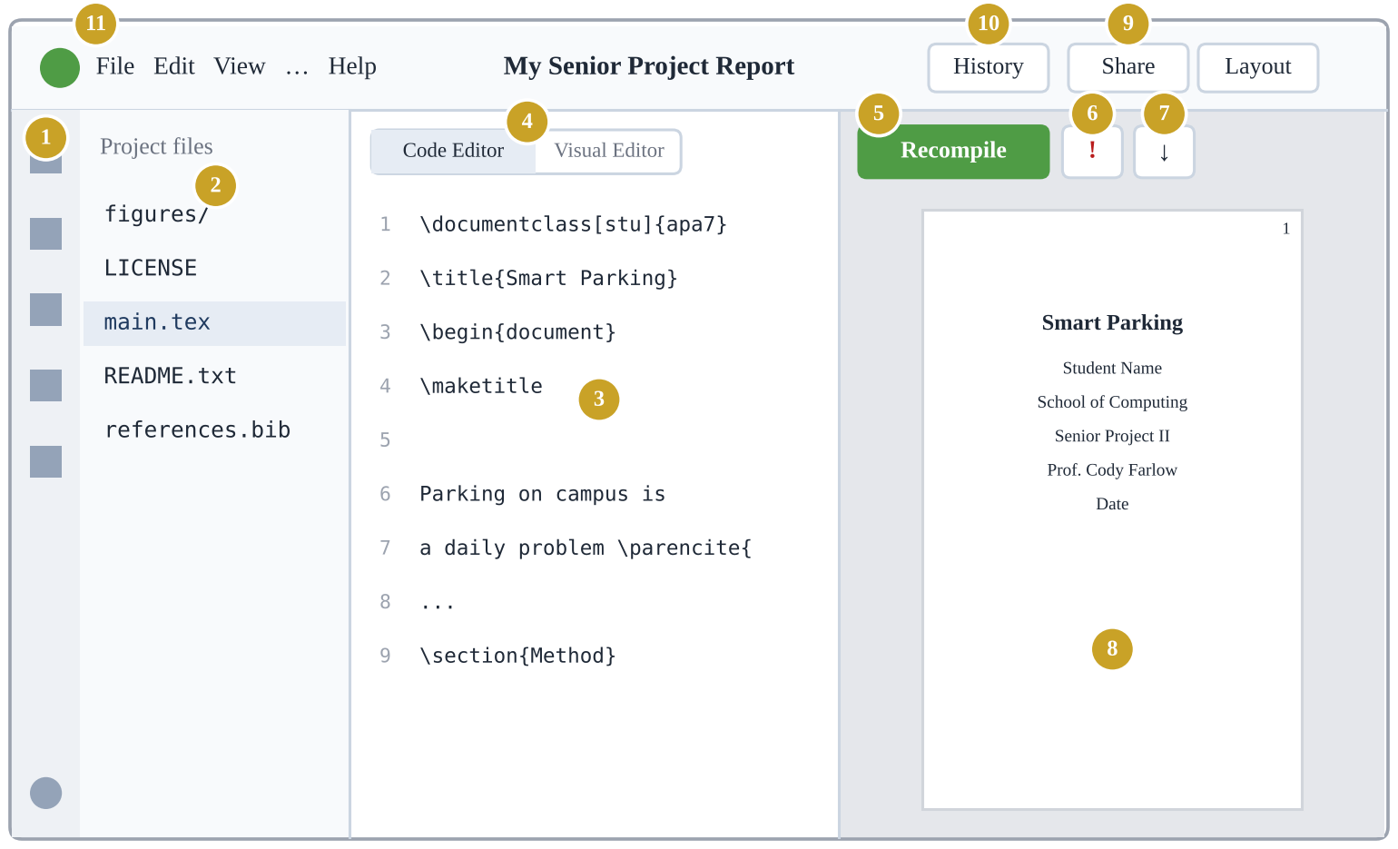
Figure 3. The main parts of the Overleaf editor (simplified drawing; your screen may look slightly different as Overleaf updates its design).
# | Part | What it does
1 | Left rail | Icons for the file tree, search, integrations, review, and chat. Settings and Help are at the bottom.
2 | File tree | All files in your project. Click a file to open it. Buttons at the top create files and folders and upload files.
3 | Editor | Where you type. Line numbers help you find errors.
4 | Code Editor / Visual Editor | Switches between raw LaTeX (Code Editor) and a word-processor-like view (Visual Editor). This guide uses the Code Editor.
5 | Recompile | Builds the PDF from your source. The small arrow next to it has options such as auto-compile.
6 | Logs and output files | Shows errors (red), warnings (yellow), and the raw log. A number appears here when something is wrong.
7 | Download PDF | Saves the compiled PDF to your computer.
8 | PDF preview | The compiled document. Double-click any spot to jump to the matching line in the editor.
9 | Share | Invite collaborators or create a link to your project.
10 | History | See and restore earlier versions (limited on the free plan).
11 | Menu bar | File, Edit, View, and Help menus. For example, File → Word Count and File → Download.

2.5 Features That Save Time
Action | Windows | Mac
Recompile | Ctrl + Enter or Ctrl + S | Cmd + Enter or Cmd + S
Comment or uncomment selected lines | Ctrl + / | Cmd + /
Find and replace | Ctrl + F | Cmd + F
Make selected text bold or italic | Ctrl + B / Ctrl + I | Cmd + B / Cmd + I
Undo | Ctrl + Z | Cmd + Z

- Jump between PDF and code. Double-click text in the PDF preview to jump to its source line. This is the fastest way to find where something is written.
- Auto-compile. In the menu next to Recompile you can turn on auto-compile so the PDF updates as you type. Many people prefer to recompile manually.
- Spell check. Overleaf underlines misspelled words. You can set the language in Settings.
Try It: 1 — Your first LaTeX document (10 minutes)
- In your Overleaf dashboard, click New Project → Blank project and name it LaTeX Practice.
- Overleaf opens a short example document. Select everything in main.tex (Ctrl + A or Cmd + A) and delete it.
- Type the code below exactly as shown (Figure 4 shows the code and the result).
- Click Recompile.
\documentclass{article}
\title{My First \LaTeX{} Document}
\author{Your Name}
\date{\today}

\begin{document}
\maketitle

\section*{Introduction}
Hello, world! This is my first document
written in \LaTeX. I can make text
\textbf{bold} and \textit{italic}.
\end{document}
Checkpoint: The PDF preview shows a centered title, your name, today’s date, an “Introduction” heading, and one paragraph with a bold word and an italic word.

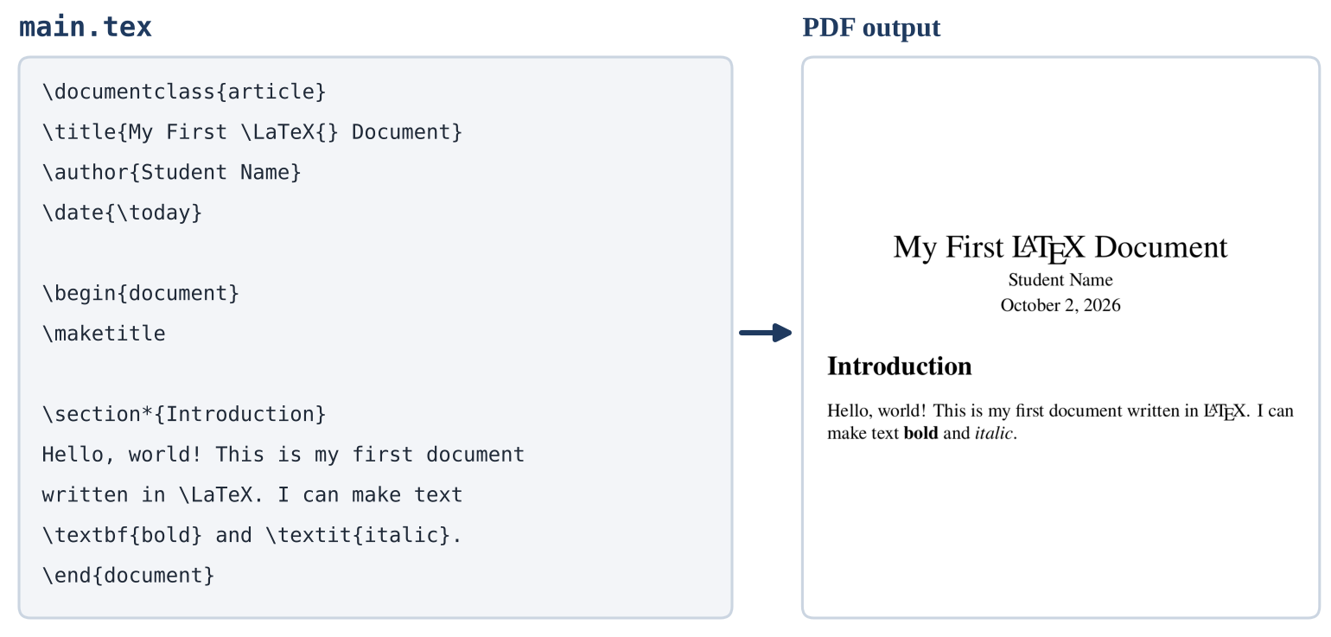
Figure 4. The code for Try It 1 and the PDF it produces.
CHAPTER 3

3. LaTeX Basics You Need
This chapter covers the small set of LaTeX ideas you need for your report. You do not need to learn all of LaTeX: the template takes care of most of it.

3.1 The Anatomy of a LaTeX Document
Every LaTeX document has the same three parts:
\documentclass{article} % 1. The document class: what kind of document

\usepackage{graphicx} % 2. The preamble: packages and settings

\begin{document} % 3. The body: everything that appears in the PDF
Your text goes here.
\end{document}
- The document class comes first and sets the overall design. Our template uses \documentclass[...]{apa7}.
- The preamble is everything between the document class and \begin{document}. It loads packages and stores settings.
- The body is everything between \begin{document} and \end{document}. Anything after \end{document} is ignored.

3.2 Commands
A command starts with a backslash (\) followed by letters. Many commands take an argument in braces { }, and some accept options in square brackets [ ].
Example | What it does
\textbf{important} | Prints “important” in bold. The argument is the text to format.
\section{Method} | Starts a section with the heading “Method.”
\includegraphics[width=0.5\linewidth]{figures/ui.png} | Inserts an image. The option sets its width; the argument is the file name.
\maketitle | A command with no argument. It prints the title page.

Watch Out: Commands are case-sensitive
\Section{Method} and \textBF{word} will cause errors. Always type commands in lowercase unless this guide shows otherwise.

3.3 Environments
An environment applies a format to a block of content. It always has a matching pair of \begin{...} and \end{...} with the same name:
\begin{itemize}
\item First point
\item Second point
\end{itemize}
If you forget the \end{...} line, or misspell the name in one of the two lines, you will get an error. Indenting the lines inside an environment is optional, but it makes your code easier to read.

3.4 Paragraphs and Spacing
- A blank line starts a new paragraph. This is the only way you should create paragraphs.
- A single line break does nothing. LaTeX joins the lines into the same paragraph. You can put each sentence on its own line, which makes editing and teamwork easier.
- Several spaces count as one space. You cannot add extra space by pressing the space bar many times.
- Do not fix spacing by hand. Avoid \\ to end paragraphs and avoid \vspace to add gaps. The APA template already sets double spacing and indentation correctly.
This is the first paragraph. It continues
on this line because there is no blank line.

This is a second paragraph, because a blank line came before it.

3.5 Special Characters
Ten characters have a special meaning in LaTeX. To print them as ordinary characters, type the version in the second column. The first five are the ones students run into most often.
Character | Type this | Why it matters
% | \% | % starts a comment. Without the backslash, the rest of the line disappears silently! Write 85\%.
& | \& | & separates table columns. Write R\&D or Johnson \& Johnson.
_ | \_ | _ is for subscripts in math. Write my\_variable or file\_name.py.
# | \# | Used internally by commands. Write C\# or issue \#12.
$ | \$ | $ starts and ends math. Write \$500.
{ } | \{ \} | Braces group arguments.
~ | \textasciitilde{} | ~ is a non-breaking space (see Section 3.6).
^ | \textasciicircum{} | ^ is for superscripts in math.
\ | \textbackslash{} | Starts every command. Note: \\ means “new line,” not a backslash.

Tip: URLs and file paths
Inside \url{...}, special characters such as _, %, and # are handled for you: \url{https://github.com/team/my_repo} works as is.

3.6 Formatting Text
You type | You get | Notes
\textbf{bold} | bold | For strong emphasis; use sparingly in APA papers.
\textit{italic} | italic | For titles of books, key terms on first use, and statistics.
\emph{emphasis} | emphasis | Preferred for emphasis; LaTeX chooses the right style.
\texttt{print()} | print() | Monospaced text for code, file names, or commands.
``quoted'' | “quoted” | Two backticks, then two apostrophes. Or use \enquote{quoted}.
pages 10--20 | pages 10–20 | Two hyphens make an en dash, used for ranges.
a pause---like this | a pause—like this | Three hyphens make an em dash.
Table~1, p.~5 | Table 1, p. 5 | ~ is a space that never breaks across lines.
and so on\ldots | and so on… | Correctly spaced ellipsis.

Watch Out: Straight quotation marks
Typing the " key produces wrong-looking quotation marks in LaTeX. Use `` and '' (or \enquote{...}) so the PDF shows proper curly quotation marks.

3.7 Lists
Use itemize for bullet points and enumerate for numbered lists. Lists can be nested.
\begin{enumerate}
\item Collect the parking sensor data.
\item Clean the data:
\begin{itemize}
\item remove duplicate readings, and
\item fill in missing timestamps.
\end{itemize}
\item Train the prediction model.
\end{enumerate}
APA allows bulleted lists and numbered lists. Use a numbered list when the order matters (for example, the steps of a procedure).

3.8 Math
Math goes between dollar signs for inline math, which sits in the sentence, or inside an equation environment for a displayed, numbered equation.
The model has $n$ layers and a learning rate of $\alpha = 0.001$.

\begin{equation}
\text{Accuracy} = \frac{TP + TN}{TP + TN + FP + FN}
\label{eq:accuracy}
\end{equation}
You type (inside math) | Meaning | You type (inside math) | Meaning
x^2 | superscript | \leq \geq \neq | ≤ ≥ ≠
x_i | subscript | \times \cdot | × ·
\frac{a}{b} | fraction | \in \rightarrow | ∈ →
\sqrt{x} | square root | \alpha \beta \theta | α β θ
\sum_{i=1}^{n} | summation | \log \max | log max
\text{word} | normal text in math | O(n \log n) | O(n log n)

Tip: Finding a symbol
If you do not know the command for a symbol, draw it at detexify.kirelabs.org, and it will suggest the command.

3.9 Comments
Anything after % on a line is a comment. Comments are useful for notes to yourself or your team, and for temporarily hiding text without deleting it. Select lines and press Ctrl + / (Cmd + / on a Mac) to comment or uncomment them.
% TODO (Jordan): add the latency results here
We tested the system with 50 users. % this sentence will appear
% This whole sentence is hidden from the PDF.

3.10 Reading Errors: The First Look
When something is wrong, a red number appears next to the Logs and output files icon. Click it to see the messages. Each error says what went wrong and on which line. Three habits will solve most problems:
- Fix the first error first. One mistake can cause a chain of later errors that disappear once the first is fixed.
- Look at the reported line and the line just before it. Missing braces are often on the previous line.
- Recompile after each fix. Small steps make it easy to see what helped.
Chapter 13 lists the most common error messages and how to fix each one.
Try It: 2 — Practice the basics (15 minutes)
In your LaTeX Practice project, add the following below your Introduction paragraph:
- a new section with \section*{Practice};
- a sentence that uses the characters %, &, and _ correctly (for example, “Our R&D budget grew by 15% in file_v2.”);
- a numbered list with three items, one of which contains a nested bullet list; and
- one inline equation and one numbered equation.
Now break something on purpose: delete one closing brace } and click Recompile. Open the logs, read the error message, find the line it points to, and fix it.
Checkpoint: Your PDF shows the special characters correctly, both lists, and an equation numbered (1) on the right. You found and fixed the error you created.

PART II · THE APA 7 TEMPLATE

4. APA 7 Student Paper Essentials

4.1 What APA Style Is
APA style is a set of rules for formatting and writing papers, published by the American Psychological Association in the Publication Manual of the American Psychological Association (7th ed., 2020). It covers how a paper looks (margins, fonts, headings), how you credit sources (in-text citations and the reference list), and how you write (clear, concise, bias-free language).
APA 7 has two versions of the paper format: the professional paper (for journal submissions) and the student paper (for coursework). Your report is a student paper. The template is set up for the student format.
Two trustworthy references for APA rules are the Purdue OWL APA General Format page and the official APA Style website.

4.2 The Rules, and Who Takes Care of Each One
The table below lists the main APA 7 student paper rules. The last column tells you whether the template handles the rule for you or whether it is your job.
Requirement | APA 7 rule (student paper) | Who handles it
Page and margins | US Letter (8.5 × 11 in.), 1-in. margins on all sides | Template
Font | A readable font used consistently, such as Times New Roman 12 pt (Calibri 11, Arial 11, Lucida Sans Unicode 10, Georgia 11, and Computer Modern 10 are also accepted) | Template (Times New Roman style)
Line spacing | Double-spaced throughout, including the title page and references | Template
Alignment | Flush left with a ragged right edge (not justified) | Template
Paragraph indent | First line of each paragraph indented 0.5 in. | Template
Page numbers | Top right corner of every page, starting with the title page | Template
Running head | Not required for student papers | Template (omitted)
Title page | Title, author name(s), affiliation, course number and name, instructor, due date | You fill in the fields; the template lays them out
Abstract | Only if your instructor asks for one | You decide (keep or remove)
Headings | Five levels with specific formats | You choose the level; the template formats it
Tables and figures | Bold number, italic title, notes below | You write the title; the template formats it
In-text citations | Author–date format, such as (LeCun et al., 2015) | You pick the command; the template formats it
Reference list | New page, “References” centered in bold, alphabetical, hanging indent | Automatic, from references.bib
Capitalization | Title case for the paper title and headings; sentence case for titles in the reference list | You (title case); Biber helps with references
Writing style | Clear, precise, bias-free; consistent tense; numbers and abbreviations used correctly | You (see Section 12.5)

Key Idea: The template formats; you write
The template guarantees the look of an APA paper. Following APA is also about content: an accurate and complete .bib entry for every source, headings that match the structure of your report, and honest attribution of everything you did not create yourself.

4.3 Title Case and Sentence Case
Two capitalization styles appear throughout APA papers:
Style | Rule | Example | Used for
Title case | Capitalize major words and any word of four or more letters. Lowercase short articles, conjunctions, and prepositions (a, an, the, and, but, for, of, to, in, on, at, by) unless they start the title or subtitle. | A Real-Time Parking Availability System for Urban Campuses | Paper title, headings, table and figure titles
Sentence case | Capitalize only the first word, the first word after a colon, and proper nouns. | A real-time parking availability system for urban campuses | Titles of works in the reference list (Biber applies this for you)

CHAPTER 5

5. Getting the Template into Overleaf

5.1 Download the Template From GitHub
The template is published in a public GitHub repository. You do not need a GitHub account to download it.
What | Where
Repository page | github.com/ParisaRostaami/APA7-LaTeX-Template
Direct download of the template | APA7_Student_Template.zip
QR code | On the cover of this guide

To download it from the repository page:
- Open the repository page.
- In the list of files, click APA7_Student_Template.zip.
- Click the Download raw file button (the downward-arrow icon on the right side of the file view).
- The file APA7_Student_Template.zip is saved to your Downloads folder.
Watch Out: Use the template zip, not “Download ZIP”
The green Code → Download ZIP button on the repository page downloads everything in the repository, including this guide. For Overleaf, download only APA7_Student_Template.zip as described above.

Watch Out: Mac users: Safari may unzip the file automatically
If you find a folder named APA7_Student_Template instead of a .zip file, Safari unzipped it for you. Either right-click the folder and choose Compress, or in Safari open Settings → General and uncheck Open “safe” files after downloading, then download again.

5.2 Upload the Template to Overleaf
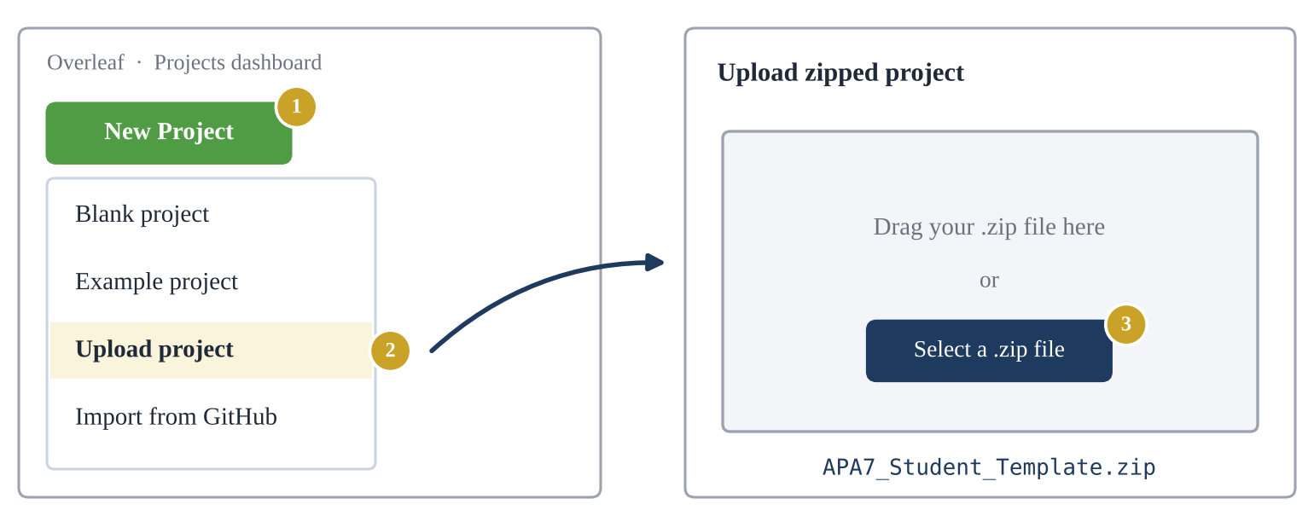
Figure 5. Creating a new Overleaf project from the template zip file. The numbers match the steps below.
- Go to your Overleaf Projects dashboard and click New Project.
- Choose Upload project.
- Click Select a .zip file (or drag the file into the box) and choose APA7_Student_Template.zip. Do not unzip it first.
- Overleaf creates the project and opens it in the editor. The project name comes from the zip file name.
- Rename the project to something meaningful, for example Team Phoenix – Senior Project I Report. Click the project name at the top of the editor (or use Rename on the dashboard).

5.3 The First Compile
Overleaf usually compiles the project as soon as it opens. If the PDF preview is empty, click Recompile. After a few seconds, you should see a six-page sample paper: a title page, an abstract page, the main text with sample headings, a table and a figure, the reference list, and an appendix.
If something looks wrong, check two settings. Click Settings at the bottom of the left rail and open the Compiler tab:
Setting | Should be
Compiler | pdfLaTeX
Main document | main.tex
TeX Live version | Leave the default

Tip: You never run Biber yourself on Overleaf
Overleaf detects that the template uses Biber and runs it automatically every time you recompile (Figure 2). If references ever look stale, see “Clear cached files” in Section 13.1.

5.4 What Is Inside the Project
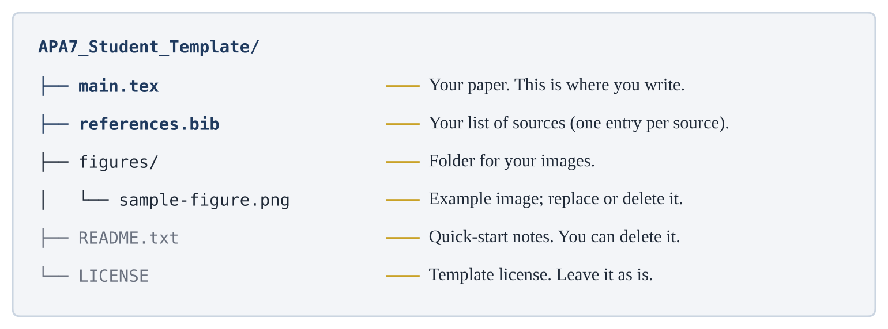
Figure 6. The files in the template project and what each one is for.
You will spend almost all of your time in main.tex and references.bib. Images go in the figures folder. The README.txt file is a short version of this guide, and LICENSE explains the terms of use of the template. Neither affects your PDF.
Try It: 3 — Set up your report project (10 minutes)
- Download APA7_Student_Template.zip from the repository.
- In Overleaf, create a new project with New Project → Upload project.
- Compile it and rename the project to [Your Team Name] – Senior Project Report.
- In the file tree, click each file once to see what is inside.
- In the PDF preview, double-click the heading “Tables and Figures” and notice that the editor jumps to the matching line in main.tex.
Checkpoint: You have your own copy of the template, it compiles into a six-page PDF, and you can move between the PDF and the source.

CHAPTER 6

6. A Guided Tour of main.tex

6.1 The Big Picture
Open main.tex. It follows the same structure as every LaTeX document (Section 3.1), with extra parts for the title page and references. Figure 7 shows the parts in order. Only the two highlighted parts need your attention: the title-page information and the body.
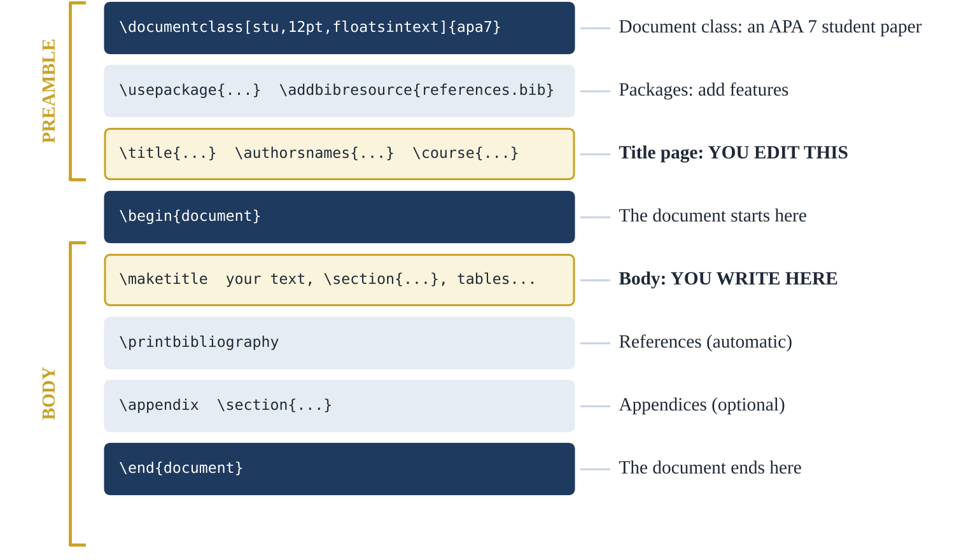
Figure 7. The structure of main.tex. You edit the highlighted parts.
The comments at the top of the file, starting with %%, describe the template and its license. Leave them in place. They do not appear in your PDF.

6.2 The Document Class Line
\documentclass[stu,12pt,floatsintext]{apa7}
Option | What it does
stu | Student paper mode: creates the APA student title page (with course, instructor, and due date) and no running head.
12pt | Sets the font size to 12 points, the APA size for Times New Roman.
floatsintext | Places tables and figures in the text near where you mention them, instead of collecting them at the end of the paper.

Watch Out: Do not change “stu” to another mode
The apa7 class also has man, jou, and doc modes for journal manuscripts. They add a running head and other features that student papers should not have.

6.3 The Packages
The next block loads the packages the template needs. You do not need to change anything here.
Line | Purpose
\usepackage[american]{babel} | American English rules for hyphenation and for words such as “and” in citations.
\usepackage[T1]{fontenc} | Correct handling of accented letters and special characters.
\usepackage{newtxtext,newtxmath} | Times New Roman–style text and matching math font.
\usepackage{csquotes} | Correct quotation marks; required by the APA citation style.
\usepackage[style=apa,...]{biblatex} | APA 7 citations and reference list, processed by Biber.
\addbibresource{references.bib} | Tells LaTeX where your sources are stored.
\usepackage{graphicx} | Lets you insert images with \includegraphics.
\usepackage{booktabs} | Clean horizontal table lines (\toprule, \midrule, \bottomrule).
\usepackage{amsmath} | Better equations.
\hypersetup{hidelinks} | Makes links and cross-references clickable without colored boxes.

Tip: Adding a package later
If you need a new feature, such as code listings (Section 11.2), add its \usepackage line in this block, before the title-page section.

6.4 Filling In the Title Page
Find the block marked TITLE PAGE. Replace each placeholder with your own information. Here is an example for a team of three:
\title{SmartPark: A Real-Time Parking Availability System for Campus Drivers}

\authorsnames{Alex Kim, Jordan Lee, Sam Rivera}

\authorsaffiliations{{School of Computing, Wichita State University}}

\course{CS 000: Senior Project I}
\professor{Prof. Cody Farlow}
\duedate{December 4, 2026}
Field | What to write | Rules and tips
\title | The full title of your report | Title case (Section 4.3). Be specific and descriptive. No period at the end. Avoid abbreviations the reader may not know. It is printed in bold automatically.
\authorsnames | Every team member’s name | Separate names with commas. LaTeX adds “and” before the last name for you. Write names as first name, middle initial (optional), last name. Do not add titles or degrees.
\authorsaffiliations | Your department and university | Keep the double braces {{...}}. All team members share one affiliation.
\course | Course number and name | Use the course number and name exactly as they appear in the syllabus, for example CS 000: Senior Project I (replace CS 000 with the real course number).
\professor | Your instructor | Prof. Cody Farlow
\duedate | The assignment due date | Write the month in full: December 4, 2026.

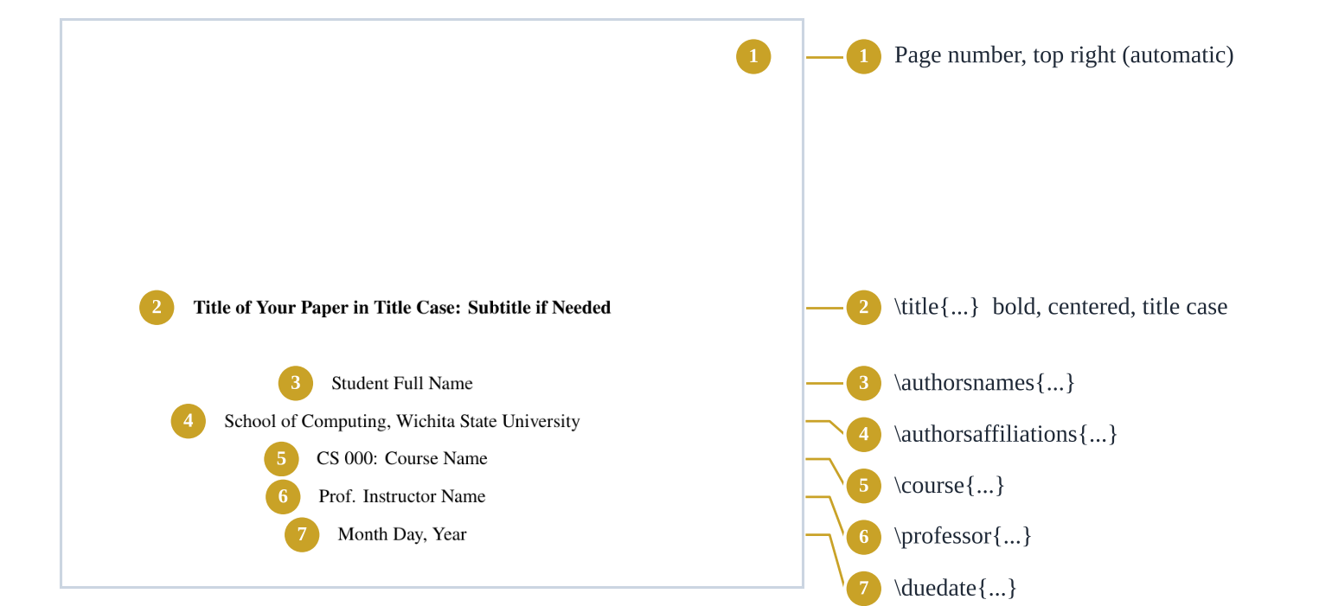
Figure 8. The title page of the template and the command that produces each line.
Watch Out: Keep the double braces
\authorsaffiliations{{School of Computing, Wichita State University}} must have two opening and two closing braces. With only one pair, the comma is treated as a separator and the affiliation is split incorrectly.

6.5 The Abstract and Keywords
APA does not require an abstract for student papers unless your instructor asks for one. Follow your assignment instructions.
- To keep the abstract: replace the placeholder text inside \abstract{...} with one paragraph, usually 150–250 words, that summarizes the problem, your approach, the main results, and why they matter. Replace the keywords with three to five terms that describe your project.
- To remove the abstract: put % at the start of the \abstract and \keywords lines (select them and press Ctrl + / or Cmd + /). The abstract page disappears from the PDF.
% \abstract{...}
% \keywords{...}

6.6 Writing the Body
Your paper starts right after \maketitle. The template repeats your title in bold at the top of the first page of text, as APA requires. Start writing your introduction directly below «\maketitle», without an “Introduction” heading; in APA style, the first paragraphs after the title are understood to be the introduction.
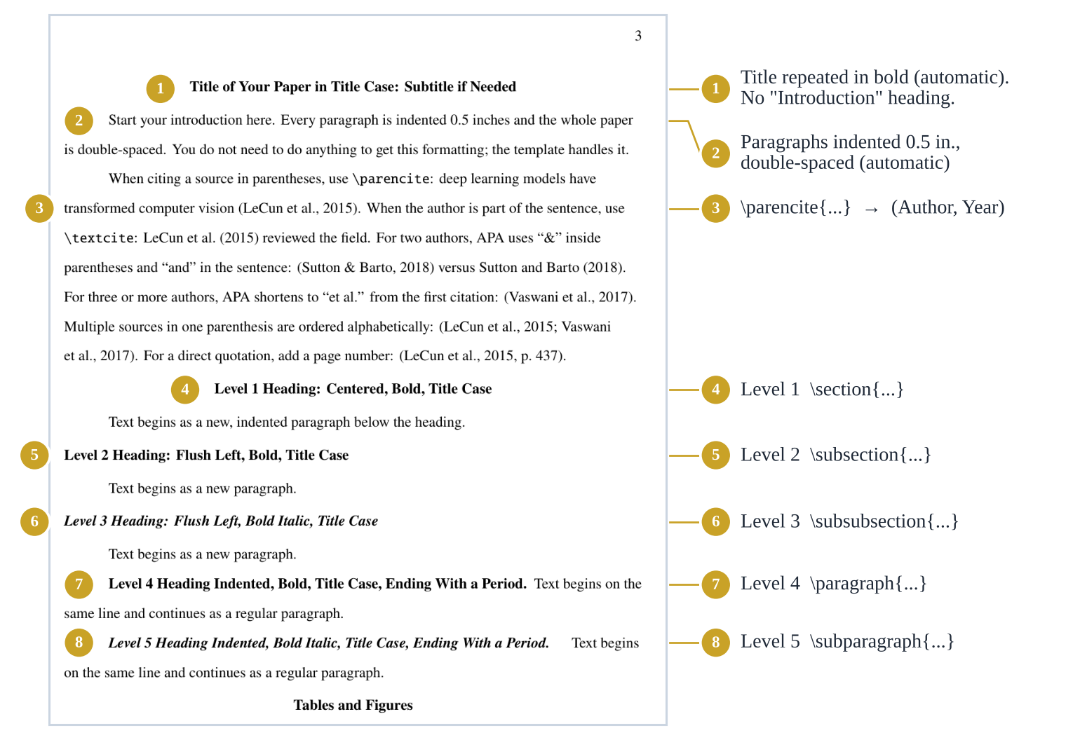
Figure 9. The first page of text. Everything marked “automatic” is handled by the template.
Delete the sample text and headings as you replace them with your own, but keep these lines:
\begin{document}
\maketitle
... your report ...
\printbibliography
... appendices (optional) ...
\end{document}

6.7 Optional: One File per Section
For a long report or a team, it is helpful to put each major section in its own file. Create a folder named sections in Overleaf (New folder button in the file tree), add a file for each section, and include them in main.tex with \input:
\maketitle
\input{sections/introduction}
\input{sections/requirements}
\input{sections/design}
\input{sections/testing}
\printbibliography
The section files contain only text and LaTeX commands, with no \documentclass and no \begin{document}. Each teammate can own one file, which reduces the chance of two people editing the same lines.
Try It: 4 — Make the title page yours (10 minutes)
- Fill in \title, \authorsnames, \authorsaffiliations, \course, \professor, and \duedate for your team.
- Decide with your team whether your assignment needs an abstract. Keep it, or comment it out.
- Recompile and compare your title page with Figure 8.
Checkpoint: Your title page shows your real title in bold title case, all team members joined with “and,” your affiliation, the course, Prof. Cody Farlow, and the due date. The page number 1 appears at the top right.

CHAPTER 7

7. Headings and Structure

7.1 The Five APA Heading Levels
APA 7 has five levels of headings. Each level has its own format, and each one maps to a LaTeX command. You only choose the level; the template applies the format.
Level | APA format | LaTeX command
1 | Centered, Bold, Title Case | \section{...}
2 | Flush Left, Bold, Title Case | \subsection{...}
3 | Flush Left, Bold Italic, Title Case | \subsubsection{...}
4 | Indented, Bold, Title Case, Ending With a Period. Text continues on the same line. | \paragraph{...}
5 | Indented, Bold Italic, Title Case, Ending With a Period. Text continues on the same line. | \subparagraph{...}

In most reports, you will use Levels 1 to 3. Here is how they look in source code:
\section{System Design}
The system has three components ...

\subsection{Architecture}
We chose a client–server architecture because ...

\subsubsection{Database Layer}
The database stores ...

\paragraph{Indexing Strategy}
Write the text right after the heading command; it continues on the same line.

7.2 Heading Rules
- No “Introduction” heading. The introduction begins right after the title (Section 6.6).
- No numbers. APA headings are not numbered, and the template does not number them. Do not type numbers into the heading text.
- Do not skip levels. A Level 3 heading must sit under a Level 2 heading.
- Use at least two subsections, or none. If a section has a Level 2 heading, it should have at least two of them.
- Use title case for every heading (Section 4.3).
- Level 4 and 5 headings end with a period, which the template adds automatically. Do not type one yourself.
Tip: Page breaks
The reference list and each appendix start on a new page automatically. You rarely need to force a page break; if you must, use \clearpage.

CHAPTER 8

8. Citations and References
This is the most important chapter. Correct citations are part of academic integrity, and they are where LaTeX saves you the most time.

8.1 How It Works
Citations in the template follow a simple three-part system:
- Store each source once as an entry in references.bib. Each entry has a unique citation key.
- Cite the source in main.tex by its key, for example \parencite{lecun2015deep}.
- Recompile. Biber looks up the key, formats the in-text citation, and adds the source to the reference list in APA style.
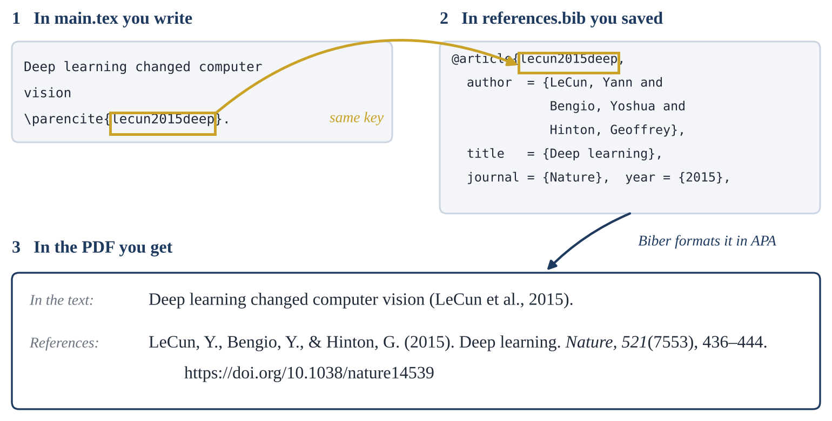
Figure 10. From citation key to formatted citation and reference list entry.
Key Idea: Only cited sources appear in the reference list
An entry in references.bib that you never cite will not appear in your references. This is exactly what APA requires: every cited source is in the reference list, and every source in the list is cited. You can keep extra entries in the file without worrying.

8.2 Anatomy of a .bib Entry
@article{lecun2015deep, <- entry type and citation key
author = {LeCun, Yann and Bengio, Yoshua and
Hinton, Geoffrey},
title = {Deep learning},
journal = {Nature},
year = {2015},
volume = {521},
number = {7553}, <- the issue number
pages = {436--444},
doi = {10.1038/nature14539} <- last field: comma optional
}
(The arrows are explanations for this guide only; do not type them.)
Rule | Example
The citation key must be unique and contain no spaces. A good pattern is author + year + first word of the title. | lecun2015deep, nist2020security
Every field except the last one ends with a comma. | year = {2015},
Separate authors with the word and, never with commas. | {LeCun, Yann and Bengio, Yoshua}
Write each name as Last, First. | Barto, Andrew G.
An organization as author needs double braces so it is not read as a person’s name. | author = {{OpenAI}}
Protect capital letters that must stay capitalized (acronyms, proper nouns) with braces. | title = {Fine-tuning {BERT} for {Python} code}
Use two hyphens for page ranges. | pages = {436--444}
Write the DOI without the https://doi.org/ prefix; the style adds it. | doi = {10.1038/nature14539}

8.3 Entry Types for a Computing Project
Choose the entry type that matches the kind of source. These are the types you are most likely to need:
Source | Entry type | Key fields
Journal article | @article | author, title, journal, year, volume, number, pages, doi
Book | @book | author, title, edition, publisher, year
Chapter in an edited book | @incollection | author, title, editor, booktitle, publisher, year, pages
Conference paper | @inproceedings | author, title, booktitle, publisher, year, pages, doi
Web page or online documentation | @online | author, title, year (and month, day), url
Software, library, or code repository | @software | author, title, version, year, url
Dataset | @dataset | author, title, titleaddon, publisher, year, url or doi
Technical report or standard | @report | author, title, number, institution, year, doi or url
Generative AI tool | @software | author, title, version, titleaddon, year, url

Here are complete examples you can copy and adapt:
@online{python_tutorial,
author = {{Python Software Foundation}},
title = {The {Python} tutorial},
year = {2024},
url = {https://docs.python.org/3/tutorial/}
}

@software{numpy_2024,
author = {{NumPy Developers}},
title = {{NumPy}},
version = {2.1.0},
year = {2024},
url = {https://numpy.org}
}

@dataset{lecun1998mnist,
author = {LeCun, Yann and Cortes, Corinna and
Burges, Christopher J. C.},
title = {The {MNIST} database of handwritten digits},
titleaddon = {Data set},
publisher = {Courant Institute, New York University},
year = {1998},
url = {http://yann.lecun.com/exdb/mnist/}
}

@report{nist2020security,
author = {{National Institute of Standards and Technology}},
title = {Security and privacy controls for information systems
and organizations},
number = {SP 800-53 Rev. 5},
institution = {U.S. Department of Commerce},
year = {2020},
doi = {10.6028/NIST.SP.800-53r5}
}
These entries produce the following APA references:
Reference list output
Python Software Foundation. (2024). The Python tutorial. https://docs.python.org/3/tutorial/
NumPy Developers. (2024). NumPy (Version 2.1.0). https://numpy.org
LeCun, Y., Cortes, C., & Burges, C. J. C. (1998). The MNIST database of handwritten digits [Data set]. Courant Institute, New York University. http://yann.lecun.com/exdb/mnist/
National Institute of Standards and Technology. (2020). Security and privacy controls for information systems and organizations (SP 800-53 Rev. 5). U.S. Department of Commerce. https://doi.org/10.6028/NIST.SP.800-53r5

Tip: Retrieval dates
Add urldate = {2026-10-01} to an @online entry only when the page is designed to change over time (for example, a live dashboard or a frequently updated wiki page). APA then prints “Retrieved October 1, 2026, from …”. For stable pages, leave it out.

8.4 Getting BibTeX Entries Quickly
You rarely need to type entries from scratch. Use one of these sources, then check and clean the result:
Source | How
Google Scholar | Search for the paper, click the quotation-mark icon (Cite) under the result, then click BibTeX. Copy the text into references.bib.
Publisher or library page | Look for Cite, Export citation, or Download citation and choose BibTeX.
A DOI | Paste the DOI into doi2bib.org to get a BibTeX entry.
Zotero (free reference manager) | Collect sources with the browser connector, then export the collection as BibTeX (the Better BibTeX add-on keeps keys stable).

Watch Out: Always check imported entries
Automatically generated entries are often incomplete or wrong. Before you cite one, check that:
- the DOI is present if the source has one (Google Scholar often leaves it out);
- acronyms and proper nouns in the title are protected with braces, for example {BERT};
- the entry type is right (Scholar sometimes labels conference papers as articles); and
- you cite the published version of a paper rather than a preprint when one exists.

8.5 Citation Commands
You type | You get | Use it when
\parencite{lecun2015deep} | (LeCun et al., 2015) | The citation is in parentheses (most common).
\textcite{lecun2015deep} | LeCun et al. (2015) | The authors are part of your sentence.
\parencite[p.~437]{lecun2015deep} | (LeCun et al., 2015, p. 437) | You quote directly and need a page number.
\parencite[para.~3]{python_tutorial} | (Python Software Foundation, 2024, para. 3) | You quote a source without page numbers.
\parencite{vaswani2017attention,lecun2015deep} | (LeCun et al., 2015; Vaswani et al., 2017) | You cite several sources at once. They are sorted alphabetically for you.
\parencite[see][]{lecun2015deep} | (see LeCun et al., 2015) | You need a word before the citation. Note the empty second brackets.
\citeauthor{lecun2015deep} | LeCun et al. | You need only the author names.
\citeyear{lecun2015deep} | 2015 | You need only the year.

8.6 APA Citation Rules You Should Know
- One or two authors: both names appear every time: (Sutton & Barto, 2018), or Sutton and Barto (2018) in a sentence. APA uses “&” in parentheses and “and” in the sentence. The template handles this.
- Three or more authors: only the first author plus “et al.” from the first citation: (Vaswani et al., 2017). The template handles this.
- Organization as author: use the organization’s name: (National Institute of Standards and Technology, 2020).
- No date: leave out the year field and the citation shows “n.d.”: (Wichita State University, n.d.).
- Same author, same year: the template adds letters automatically: (Smith, 2020a, 2020b).
- Paraphrase instead of quoting whenever you can. A page number is optional for paraphrases and required for direct quotes.
- Short quotations (fewer than 40 words) go in quotation marks within the sentence, followed by the citation with a page number.
- Long quotations (40 words or more) go in a block quote without quotation marks, as shown below.
\begin{quote}
Text of the long quotation (40 words or more) goes here, without
quotation marks. The citation comes after the final punctuation.
\parencite[p.~437]{lecun2015deep}
\end{quote}

8.7 Citing Generative AI Tools
If you use a generative AI tool such as ChatGPT in a way your course allows, APA recommends crediting the company that makes the tool as the author, and describing in your text how you used it (for example, the prompt you entered). Check the course policy on AI use with Prof. Cody Farlow before using these tools for any part of your report.
@software{openai2023chatgpt,
author = {{OpenAI}},
title = {{ChatGPT}},
version = {Mar 14},
titleaddon = {Large language model},
year = {2023},
url = {https://chat.openai.com/chat}
}
In the text, \parencite{openai2023chatgpt} produces (OpenAI, 2023). In the reference list, the entry appears as: OpenAI. (2023). ChatGPT (Version Mar 14) [Large language model]. https://chat.openai.com/chat. Change the version, year, and URL to match the tool and version you actually used. (APA’s own example writes the version as “Mar 14 version”; the small difference in wording comes from the citation software and is acceptable.)

8.8 The Reference List
The line \printbibliography creates the reference list. You never type it by hand. The template automatically:
- starts the list on a new page with the label “References” centered in bold;
- sorts entries alphabetically by the first author’s last name;
- uses double spacing and a 0.5-in. hanging indent; and
- turns DOIs into links of the form https://doi.org/….
Try It: 5 — Cite real sources (20 minutes)
- Find one journal article or conference paper related to your project on Google Scholar. Copy its BibTeX entry into references.bib, then check and clean it (Section 8.4).
- Add an @software entry for one library or framework your project uses (for example, React, Flask, or PyTorch).
- In main.tex, cite the paper once with \parencite and once with \textcite.
- Cite the software entry with \parencite.
- Recompile and look at the reference list.
Checkpoint: Both sources appear in the reference list in APA format, sorted alphabetically, and your in-text citations show the author names and years (not bold citation keys or question marks).

CHAPTER 9

9. Tables

9.1 APA Table Rules
- The table number (Table 1, Table 2, …) appears above the table in bold.
- The table title appears one line below the number in italic title case.
- Use horizontal lines only: one above the column headings, one below them, and one at the bottom. No vertical lines.
- A note below the table explains abbreviations, symbols, or the source of the data, and starts with Note. in italics.
- Every table must be mentioned in the text (for example, “as shown in Table 1”). Tables are numbered in the order you first mention them.
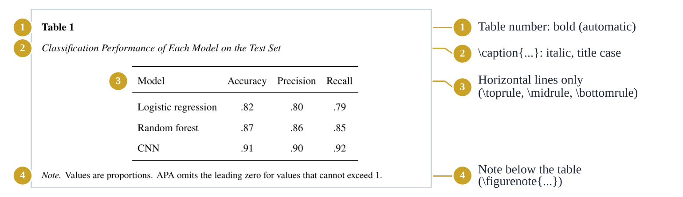
Figure 11. The sample table in the template and the code behind each part.

9.2 The Template Table, Line by Line
\begin{table}[htbp]
\caption{Classification Performance of Each Model on the Test Set}
\label{tab:results}
{\centering
\begin{tabular}{lccc}
\toprule
Model & Accuracy & Precision & Recall \\
\midrule
Logistic regression & .82 & .80 & .79 \\
Random forest & .87 & .86 & .85 \\
CNN & .91 & .90 & .92 \\
\bottomrule
\end{tabular}\par}
\vspace{0.5\baselineskip}
\figurenote{Values are proportions. APA omits the leading zero
for values that cannot exceed 1.}
\end{table}
Code | Meaning
\begin{table}[htbp] | Starts a table float. The letters list the positions LaTeX may use: here, top of a page, bottom, or a separate page.
\caption{...} | The table title. The template adds “Table 1” in bold above it and sets the title in italics.
\label{tab:results} | A name you can refer to with Table~\ref{tab:results}. Always put it after \caption.
{\centering ... \par} | Centers the table body only, so the title and note stay flush left as APA requires.
\begin{tabular}{lccc} | The table body. lccc means four columns: one left-aligned and three centered.
& and \\ | & separates columns; \\ ends a row.
\toprule, \midrule, \bottomrule | The three APA horizontal lines.
\figurenote{...} | The note below the table, starting with Note.

9.3 Column Types
Specifier | Column type
l | Left-aligned text. Good for labels and names.
c | Centered. Good for short values.
r | Right-aligned. Good for numbers you want lined up.
p{6cm} | A paragraph column of fixed width that wraps long text. Good for requirements and descriptions.

9.4 Example: A Requirements Table
Long text needs a p{...} column so it wraps. \small makes the font slightly smaller to fit more text.
\begin{table}[htbp]
\caption{Functional Requirements of the SmartPark System}
\label{tab:requirements}
{\centering\small
\begin{tabular}{l p{8cm} c}
\toprule
ID & Requirement & Priority \\
\midrule
FR-1 & The system shall show the number of open spaces in each
parking lot, updated at least every 60 seconds. & High \\
FR-2 & Users shall be able to filter parking lots by permit type. & Medium \\
FR-3 & The system shall send an alert when a saved lot is full. & Low \\
\bottomrule
\end{tabular}\par}
\end{table}
Watch Out: Count your ampersands
Every row must have the same number of & signs: one fewer than the number of columns. Too many causes the error “Extra alignment tab has been changed to \cr.”

Tip: Building tables faster
- TablesGenerator.com converts a table you paste from Excel or Google Sheets into LaTeX. Turn on the booktabs option so it uses the APA-style lines, then copy only the tabular part into the template’s table structure.
- Keep tables simple. If a table is too wide for the page, shorten the column headings, use \small, or split it into two tables.

CHAPTER 10

10. Figures
Figures include charts, diagrams, screenshots, photographs, and any other images. APA formats figures the same way as tables: bold number, italic title, image, and an optional note.

10.1 Uploading an Image
- In the Overleaf file tree, click the figures folder to select it.
- Click the Upload icon at the top of the file tree and drag your image into the window, or select it from your computer.
- The image appears inside figures. Its path is now figures/your-file-name.png.
Format | Best for
PDF (vector) | Charts and diagrams exported from Python, R, draw.io, or PowerPoint. They stay sharp at any size.
PNG | Screenshots of your application and diagrams with sharp edges.
JPG | Photographs.

Watch Out: File names
File names on Overleaf are case-sensitive and should not contain spaces. Name files like system-architecture.pdf or login_screen.png. Login Screen.PNG will cause problems.

10.2 The Figure Code
\begin{figure}[htbp]
\caption{Training and Validation Accuracy Across 20 Epochs}
\label{fig:accuracy}
{\centering
\includegraphics[width=0.75\linewidth]{figures/sample-figure.png}\par}
\figurenote{Replace this figure with your own. Use the note to explain
abbreviations or to credit the source of an adapted figure.}
\end{figure}
Code | Meaning
\caption{...} | The figure title, in title case. The template adds “Figure 1” in bold above it.
\label{fig:accuracy} | Lets you write Figure~\ref{fig:accuracy} in the text. Always place it after \caption.
width=0.75\linewidth | Makes the image 75% of the text width. Use 1\linewidth for full width and 0.5\linewidth for half.
figures/sample-figure.png | The path to your image. It must match the file name exactly, including capital letters.
\figurenote{...} | Optional note below the figure. Delete the line if you do not need it.

10.3 Referring to Tables, Figures, and Other Elements
Never type a number like “Figure 3” by hand. Use \label and \ref so that numbers update automatically when you add or move things.
Element | Label it | Refer to it
Table | \label{tab:requirements} | Table~\ref{tab:requirements}
Figure | \label{fig:architecture} | Figure~\ref{fig:architecture}
Equation | \label{eq:accuracy} | Equation~\ref{eq:accuracy}
Appendix | \label{app:manual} | Appendix~\ref{app:manual}

The prefixes tab:, fig:, eq:, and app: are not required, but they make your labels easy to read and keep them from clashing. If you see “??” in the PDF, recompile once more; if the question marks stay, check that the label name is spelled the same way in both places.

10.4 Why Did My Figure Move?
Tables and figures are floats: LaTeX places them where they fit best, which may be the top of the next page. This is normal and acceptable in APA papers, because you refer to them by number. Do not fight it with blank lines or \vspace. If a float drifts too far, try [!htbp] instead of [htbp], or move the figure code a paragraph earlier in your source.

10.5 Figures You Did Not Create
If you reproduce or adapt a figure from another source, you must credit it in the figure note and include the source in your reference list. A typical note looks like this:
\figurenote{Adapted from \enquote{Title of the Article,} by A. A. Author
and B. B. Author, 2020, \textit{Journal Name}, \textit{12}(3), p. 45
(https://doi.org/xx.xxxx). Copyright 2020 by the Copyright Holder.}
Images you create yourself, such as screenshots of your own application or diagrams you drew, need no credit.

10.6 Diagrams for Software Projects
- Architecture, UML, and flow diagrams: draw them in diagrams.net (draw.io) and export as PDF or PNG.
- Charts of results: create them in Python (matplotlib), R, or Excel and export as PDF or PNG at 300 dpi.
- Screenshots: capture your application at its normal size. Crop out anything unrelated, such as browser tabs or personal information.
Try It: 6 — Add a table and a figure (20 minutes)
- Add a table that lists three functional requirements of your project, using the example in Section 9.4.
- Upload one image related to your project (a screenshot, sketch, or diagram) to figures and insert it as a figure.
- Give both a \label and refer to both in a sentence using \ref.
Checkpoint: Your PDF shows “Table 1” and “Figure 1” (or the next numbers) with italic titles, and your sentence shows the correct numbers instead of “??”.

CHAPTER 11

11. Equations, Code, Appendices, and More

11.1 Equations
Use inline math for short expressions within a sentence, and the equation environment for important formulas you want to number and refer to. The template includes an example (the F1 score).
We evaluate each model with the F1 score, defined in Equation~\ref{eq:f1}:
\begin{equation}
F_1 = 2 \cdot \frac{\text{Precision} \cdot \text{Recall}}
{\text{Precision} + \text{Recall}}
\label{eq:f1}
\end{equation}
where precision and recall are computed on the test set.
Treat equations as part of the sentence: continue the sentence after the equation and do not start a new paragraph unless you mean to.

11.2 Code in Your Report
APA has no special rules for source code. Good practice for a Senior Project report:
- Include only short, important excerpts, such as a key algorithm, in the text or in an appendix.
- Link to your full repository instead of pasting hundreds of lines, and cite it as an @software entry.
- Explain what the excerpt does in your own words.
To format code nicely, add these two lines to the preamble (in the packages block):
\usepackage{listings}
\lstset{basicstyle=\ttfamily\small, breaklines=true,
frame=single, columns=fullflexible}
Then include code like this:
\begin{lstlisting}[language=Python]
def f1_score(precision, recall):
return 2 * precision * recall / (precision + recall)
\end{lstlisting}
Common language names include Python, Java, C, C++, SQL, and HTML. For a language that listings does not know, simply leave out [language=...].

11.3 Appendices
Appendices come after the reference list. Each one starts on a new page. Start them with \appendix; after that, every \section becomes a new appendix labeled A, B, C, and so on.
\printbibliography

\appendix
\section{User Manual}
\label{app:manual}
...

\section{Test Cases}
\label{app:tests}
...
In the text, write see Appendix~\ref{app:manual}. Typical Senior Project appendices include a user manual, installation instructions, detailed test cases, the full list of requirements, meeting notes, and a team contribution statement.

11.4 Links, Footnotes, and Other Small Elements
You need | Use | Notes
A web address | \url{https://github.com/team/repo} | Handles special characters and line breaks in long URLs.
Linked text | \href{https://www.wichita.edu}{university website} | Shows the text; clicking it opens the link.
A footnote | text\footnote{Extra detail.} | APA discourages footnotes; use them rarely.
A non-breaking space | Table~1, Section~3 | Keeps the word and number on the same line.
A new page | \clearpage | Rarely needed; avoid it unless necessary.

PART III · YOUR REPORT

12. Writing Your Senior Project Report
Note: Your assignment instructions come first
This chapter suggests a structure that is common in computing capstone reports. The official assignment instructions and rubric from Prof. Cody Farlow always take priority over anything in this guide. If they ask for different sections, use theirs.

12.1 Senior Project I and Senior Project II
The two semesters usually emphasize different parts of the project. A typical split looks like this:
 | Senior Project I (typical focus) | Senior Project II (typical focus)
Main question | What are we building, and why? | What did we build, and how well does it work?
Typical content | Problem statement, background and related work, requirements, proposed design, project plan and timeline, risks | Implementation, testing and evaluation, results, discussion of limitations, conclusions, user documentation
Typical figures and tables | Requirements table, architecture diagram, UI mockups, Gantt chart | Screenshots, test results tables, performance charts

12.2 A Suggested Report Outline
Section (heading) | What goes in it | LaTeX
Title page | Title, team members, affiliation, course, instructor, due date | Title-page block
Abstract (if required) | One-paragraph summary of the problem, approach, and results | \abstract{...}
(Introduction, no heading) | The problem, why it matters, who it affects, project objectives, and scope | Text after \maketitle
Background and Related Work | Existing solutions, relevant technologies, and research; what is missing that your project provides. Cite sources here. | \section
Requirements | Functional and non-functional requirements, ideally in a numbered table | \section + table
System Design | Architecture, main components, data model, interface design, key design decisions and trade-offs | \section + figures
Implementation | Technologies and why you chose them, important algorithms, challenges and how you solved them | \section
Testing and Evaluation | Test plan, test types (unit, integration, user testing), results, metrics | \section + tables
Discussion | What worked, what did not, limitations, ethical, privacy, and security considerations | \section
Project Management | Timeline, roles, team contributions, how you collaborated | \section
Conclusion and Future Work | Main outcomes and what could be done next | \section
References | Generated automatically | \printbibliography
Appendices | User manual, test cases, extra material | \appendix + \section

12.3 The Outline in LaTeX
You can paste this skeleton into the body of main.tex to start your report:
\maketitle

% Introduction (no heading): the problem, motivation, objectives, scope.

\section{Background and Related Work}

\section{Requirements}
\subsection{Functional Requirements}
\subsection{Non-Functional Requirements}

\section{System Design}
\subsection{Architecture}
\subsection{Data Model}
\subsection{User Interface}

\section{Implementation}

\section{Testing and Evaluation}
\subsection{Test Plan}
\subsection{Results}

\section{Discussion}

\section{Project Management}

\section{Conclusion and Future Work}

\printbibliography

\appendix
\section{User Manual}

12.4 What to Cite in a Software Project
In a software project, many sources besides research papers need credit. Cite:
- research papers, books, and articles whose ideas, methods, or results you use;
- major libraries and frameworks your system depends on (as @software);
- datasets you use for training, testing, or analysis (as @dataset);
- APIs and external services your system calls (their documentation, as @online);
- code you adapted from tutorials, Stack Overflow, or other repositories (and respect their licenses);
- images, icons, and figures you did not create;
- standards and guidelines you followed, such as accessibility or security standards (as @report or @online); and
- generative AI tools, if the course policy allows their use (Section 8.7).
Key Idea: Academic integrity
Presenting someone else’s words, code, images, or ideas as your own is plagiarism, even if it is accidental. When in doubt, cite. A source that is cited correctly never hurts your report.

12.5 APA Writing-Style Essentials
Topic | APA guidance | Example
Person and voice | First person is fine for describing what your team did. Prefer active voice. | “We designed a REST API” rather than “A REST API was designed.”
Verb tense | Past tense for what you did and what you found; present tense for what the results mean and for describing how the system works. | “We tested 50 users. The results suggest that…”
Numbers | Words for zero to nine; numerals for 10 and above. Always use numerals with units, percentages, times, and statistics. | “three modules,” “12 modules,” “5 ms,” “4%”
Abbreviations | Spell out the full term on first use with the abbreviation in parentheses; then use the abbreviation. | “application programming interface (API)”
Lists in a sentence | Use lowercase letters in parentheses. | “The system (a) collects, (b) cleans, and (c) stores data.”
Bias-free language | Be specific and respectful. Use “they” for a person whose gender is unknown or irrelevant. | “Each user can update their profile.”
Clarity | Short, direct sentences. Define technical terms the reader may not know. Avoid filler and slang. | “The cache reduces load time by 40%.”

12.6 Writing as a Team
Because the free Overleaf plan allows one invited collaborator per project (Section 2.3), plan how your team will write before you start:
Option | How it works | Good for
Share in Overleaf | One teammate owns the project and invites one collaborator by email (Share button). Others can be given a view-only link. | Teams of two
Rotate the editor | One person types into Overleaf at a time; others draft in shared notes and hand over text. | Short writing sessions
One file per section | Each teammate writes a section file (Section 6.7) and sends it to the project owner, who uploads it. | Larger teams on the free plan
Git and GitHub | Keep the report in your project’s Git repository and compile on your own computers (Appendix B). No collaborator limit. | Teams already comfortable with Git

- Agree on conventions early: citation key format (for example, authorYYYYword), label prefixes, and file names.
- Assign one reference manager who checks references.bib for duplicates and errors before each submission.
- Leave notes as comments, such as % TODO (Sam): add test results.
- Compile often, so errors are found when they are small.
- Back up regularly: download the source with File → Download → Download as source (.zip), because the free plan keeps only recent history.

12.7 Submission Checklist
Before you submit, check each item:
✓ | Check
☐ | The project compiles with no errors (the logs show no red error count).
☐ | The title page has the real title in title case, all team members, the affiliation, the course, Prof. Cody Farlow, and the due date.
☐ | The abstract is included only if the assignment requires it, and it fits the word limit.
☐ | There is no “Introduction” heading, and headings follow the APA levels without skipping.
☐ | All sample text, sample tables, sample figures, and the sample appendix from the template have been removed or replaced.
☐ | Every table and figure has a title, is mentioned in the text, and is numbered correctly.
☐ | No “??” appears anywhere in the PDF, and no citation key appears in bold.
☐ | Every source you used is cited, and every reference list entry is cited in the text.
☐ | Reference entries are complete (authors, year, title, source, DOI or URL) and acronyms keep their capitals.
☐ | Direct quotations have quotation marks (or block format) and page or paragraph numbers.
☐ | Adapted figures have a credit note.
☐ | Numbers, abbreviations, and tense follow Section 12.5, and the spell check is clean.
☐ | Appendices (if any) are referred to in the text.
☐ | You downloaded the final PDF, opened it, and checked every page.
☐ | The file is named and submitted as the assignment instructions require.

Try It: 7 — Build your report skeleton (30 minutes)
- Replace the template’s sample body with the outline from Section 12.3, adjusted to your assignment instructions.
- Write two or three sentences of introduction under \maketitle.
- Add at least three real sources to references.bib and cite each one.
- Add one table and one figure from your project.
- Go through the submission checklist and fix anything that does not pass.
Checkpoint: You have a compiling report skeleton with your title page, headings, citations, a table, a figure, and a reference list. From here, you only need to write.

CHAPTER 13

13. Troubleshooting and FAQ

13.1 A Debugging Routine
- Open the logs (the icon next to Recompile) and read the first error.
- Go to the line it mentions. Click the error to jump there. Check that line and the one before it.
- Undo your last change if you are not sure what caused the error, and recompile.
- Narrow it down. Comment out half of the recent text with %. If the error disappears, the problem is in that half. Repeat.
- Clear the cache. If the PDF looks out of date or references are stuck, open the logs and click Clear cached files at the bottom, then recompile.
Key Idea: Errors and warnings are different
Errors (red) must be fixed. Warnings (yellow), such as “Overfull \hbox,” usually mean something small, like a line that sticks out slightly. You can often ignore warnings, but look at the PDF to make sure.

13.2 Common Errors and How to Fix Them
Error message (or symptom) | What it usually means | How to fix it
Undefined control sequence | A command is misspelled, has the wrong capitalization, or needs a package. | Check the spelling and case of the command on that line. Add the package if needed.
Missing $ inserted | A math-only character such as _ or ^ is used in normal text. | Write \_ in text, or put the math inside $...$.
Missing } inserted / Runaway argument / File ended while scanning | A brace { was never closed. | Find the opening brace and add the matching }.
\begin{...} ended by \end{...} | An environment was not closed, or the names do not match. | Make sure every \begin{x} has a matching \end{x}.
File figures/x.png not found | Wrong file name or path, wrong capitalization, or the file was not uploaded. | Compare the name in your code with the file tree, letter by letter.
Extra alignment tab has been changed to \cr | A table row has too many &. | Each row needs one fewer & than the number of columns.
Misplaced alignment tab character & | & is used in normal text. | Write \&.
Bold citation key in the PDF, or “Citation ... undefined” | The key is misspelled or the entry is missing or broken in references.bib. | Check the key in both files. Check the entry for a missing comma or brace. Recompile.
References page is empty | Nothing is cited yet, or Biber failed because of an error in references.bib. | Cite at least one source. Look for Biber messages in the logs.
“??” instead of a number | A \ref points to a label that does not exist yet, or needs another compile. | Recompile. Check that the label is spelled the same in \label and \ref.
Unicode character ... not set up for use with LaTeX | You pasted an unusual character (an emoji, a special symbol, or an invisible character from Word or a PDF). | Delete and retype the text around the line mentioned.
Text after % disappears | % starts a comment. | Write \%.
Compile timeout | The project took longer than the free plan allows, often because of very large images or a chain of errors. | Fix errors first. Compress large images. Use PDF or PNG figures at a reasonable size.
Overfull \hbox (warning) | A line is slightly too wide, often a long URL or word. | Usually ignore it. Wrap URLs in \url{...}.

13.3 Problems With References
- A missing comma between fields in references.bib is the most common cause of broken references. Check the entry you added most recently.
- Duplicate keys: two entries with the same key confuse Biber. Each key must be unique.
- Capital letters disappear in a title (for example, “Bert” instead of “BERT”): protect them with braces, {BERT}.
- A person’s name looks wrong: check that authors are separated by and and written as Last, First.
- An organization’s name is shortened to initials: use double braces, {{National Institute of Standards and Technology}}.

13.4 Frequently Asked Questions
Q: Can I write my report in Word or Google Docs instead?
Follow the requirements in your assignment instructions. This guide covers the LaTeX template.
Q: Do I need an abstract?
Only if your assignment asks for one. APA does not require it for student papers.
Q: Do I need a running head?
No. APA 7 student papers do not have a running head, and the template leaves it out.
Q: Can I change the font?
Keep the template font unless your instructor asks otherwise. It matches the APA Times New Roman 12-pt option.
Q: How do I count words?
In Overleaf, choose File → Word Count. It counts text and ignores LaTeX commands.
Q: How do I download my PDF?
Click the Download PDF icon next to Recompile, or choose File → Download → Download as PDF.
Q: How do I download my source files?
Choose File → Download → Download as source (.zip). Do this regularly as a backup.
Q: I deleted something important. Can I get it back?
Try History (top right). The free plan keeps only recent history, which is why regular source backups are a good idea.
Q: How do I share my project with Prof. Farlow?
Submit the PDF as the assignment instructs. If you are asked to share the project, use Share to create a view-only link.
Q: Why are my figures on a different page than the text?
Figures and tables are floats (Section 10.4). This is normal.
Q: The template was updated. How do I get the new version?
Download the new zip from the repository, upload it as a new project, and copy your text, references.bib entries, and figures into it.
Q: Can I use this template for other courses?
Yes, for non-commercial academic work, under the CC BY-NC 4.0 license. Check each instructor’s requirements first.
APPENDICES

Appendix A. Quick Reference Cheat Sheet

Document and Structure
Task | Code
Title page fields | \title{} \authorsnames{} \authorsaffiliations{{}} \course{} \professor{} \duedate{}
Headings, Levels 1–5 | \section{} \subsection{} \subsubsection{} \paragraph{} \subparagraph{}
New paragraph | Leave a blank line
Comment | % this is hidden
Include another file | \input{sections/design}
Appendices | \appendix then \section{Title}

Text
Task | Code | Task | Code
Bold | \textbf{text} | Quotation marks | ``text'' or \enquote{text}
Italic / emphasis | \textit{text} \emph{text} | En dash (ranges) | 10--20
Monospace | \texttt{text} | Em dash | ---
Bullet list | \begin{itemize} \item ... | Non-breaking space | Table~1
Numbered list | \begin{enumerate} \item ... | URL / link | \url{...} \href{url}{text}

Special Characters
% | & | _ | # | $ | { } | ~ | ^ | \
\% | \& | \_ | \# | \$ | \{ \} | \textasciitilde{} | \textasciicircum{} | \textbackslash{}

Citations
Code | Output
\parencite{key} | (Author, 2020)
\textcite{key} | Author (2020)
\parencite[p.~12]{key} | (Author, 2020, p. 12)
\parencite{key1,key2} | (Author A, 2019; Author B, 2020)
\parencite[see][]{key} | (see Author, 2020)
\citeauthor{key} / \citeyear{key} | Author / 2020

Tables, Figures, and Equations
\begin{table}[htbp] \begin{figure}[htbp]
\caption{Title in Title Case} \caption{Title in Title Case}
\label{tab:name} \label{fig:name}
{\centering {\centering
\begin{tabular}{lcc} \includegraphics[width=0.75\linewidth]
\toprule {figures/file.png}\par}
A & B & C \\ \figurenote{Optional note.}
\midrule \end{figure}
1 & 2 & 3 \\
\bottomrule \begin{equation}
\end{tabular}\par} E = mc^2 \label{eq:name}
\figurenote{Optional note.} \end{equation}
\end{table}
See Table~\ref{tab:name}.

Overleaf Shortcuts
Action | Windows | Mac
Recompile | Ctrl + Enter | Cmd + Enter
Comment / uncomment | Ctrl + / | Cmd + /
Bold / italic | Ctrl + B / Ctrl + I | Cmd + B / Cmd + I
Find and replace | Ctrl + F | Cmd + F
Jump from PDF to source | Double-click in the PDF | Double-click in the PDF

APPENDIX B

Appendix B. Working on Your Own Computer (Optional)
Overleaf is all you need for this course. Working locally is useful if you want to write offline, use your own editor, or keep the report in a Git repository with your code, with no limit on collaborators.

B.1 Install a LaTeX Distribution
System | Distribution | Notes
Windows | MiKTeX or TeX Live | MiKTeX installs missing packages on demand; turn on Always install missing packages during setup. To use latexmk with MiKTeX you also need Perl (for example, Strawberry Perl). TeX Live includes everything but is a large download.
macOS | MacTeX | A complete TeX Live distribution for Mac. Large download; allow time.
Linux | TeX Live | Install from your package manager (for example, the texlive-full package on Ubuntu) or from tug.org.

The template needs the apa7, biblatex-apa, newtx, and csquotes packages and the Biber program. Full TeX Live and MacTeX installations include all of them.

B.2 Choose an Editor
Editor | Setup
Visual Studio Code with the LaTeX Workshop extension | Install the extension from the Extensions panel. Its default recipe uses latexmk, which runs Biber automatically. Save the file to build, and open the PDF in a tab beside your code.
TeXstudio | A dedicated LaTeX editor. In Options → Configure TeXstudio → Build, set Default Bibliography Tool to Biber.

B.3 Compile From the Command Line
latexmk -pdf main.tex # builds main.pdf; runs pdfLaTeX and Biber as needed
latexmk -c # removes temporary files, keeps the PDF
Without latexmk, run the steps from Figure 2 yourself: pdflatex main, then biber main, then pdflatex main twice.

B.4 Get the Template With Git
Install Git (or GitHub Desktop if you prefer a graphical app), then clone the repository:
git clone https://github.com/ParisaRostaami/APA7-LaTeX-Template.git
cd APA7-LaTeX-Template/template
The template folder contains the same files as the zip. Copy it into your own team repository (for example, as a report folder next to your code). The repository also includes a .gitignore file that keeps LaTeX’s temporary files out of Git; copy it too.

B.5 A Simple Team Workflow With Git
- Pull before you write: git pull.
- Write and compile your section.
- Commit small, focused changes: git add report/sections/design.tex, then git commit -m "Add architecture section".
- Push: git push.
Tip: One sentence per line
LaTeX ignores single line breaks, so you can start each sentence on a new line. Git then shows changes sentence by sentence, and two teammates editing the same paragraph rarely conflict.

APPENDIX C

Appendix C. Hands-On Exercises at a Glance
These exercises follow the order of the guide and are designed to be done in class, step by step. Each one builds on the previous one.
# | Exercise | Section | Time | You will have
1 | Your first LaTeX document | 2.5 | 10 min | An Overleaf account and a compiled practice document
2 | Practice the basics | 3.10 | 15 min | Special characters, lists, equations, and one fixed error
3 | Set up your report project | 5.4 | 10 min | Your own copy of the template, compiled in Overleaf
4 | Make the title page yours | 6.7 | 10 min | A correct APA title page for your team
5 | Cite real sources | 8.8 | 20 min | Two correctly cited sources in an APA reference list
6 | Add a table and a figure | 10.6 | 20 min | An APA table and figure, referenced in the text
7 | Build your report skeleton | 12.7 | 30 min | A compiling skeleton of your actual report

Total: about 2 hours. Exercises 1–4 fit a first session, and Exercises 5–7 fit a second one.
APPENDIX D

Appendix D. Further Resources

The Template
- Template repository: github.com/ParisaRostaami/APA7-LaTeX-Template
- The apa7 LaTeX class (documentation): ctan.org/pkg/apa7
- The biblatex-apa citation style (documentation): ctan.org/pkg/biblatex-apa

APA Style
- Purdue OWL, APA General Format: owl.purdue.edu
- APA Style official website: apastyle.apa.org
- APA Style blog, citing ChatGPT: apastyle.apa.org/blog/how-to-cite-chatgpt

LaTeX and Overleaf
- Overleaf, Learn LaTeX in 30 Minutes: overleaf.com/learn
- Overleaf documentation: docs.overleaf.com
- Detexify (find a symbol by drawing it): detexify.kirelabs.org
- Tables Generator: tablesgenerator.com

Tools for Your Project
- Zotero, a free reference manager: zotero.org
- doi2bib, BibTeX from a DOI: doi2bib.org
- diagrams.net (draw.io), free diagrams: diagrams.net
Note: About this guide and template
The APA 7 LaTeX template and this guide were created by Parisa Rostami, Graduate Teaching Assistant, for Senior Project I & II (Prof. Cody Farlow), School of Computing, Wichita State University. The template builds on the apa7 class by Daniel A. Weiss and the biblatex-apa style by Philip Kime.
© 2026 Parisa Rostami. The template and this guide are licensed under the Creative Commons Attribution-NonCommercial 4.0 International License (CC BY-NC 4.0). You may share and adapt them for non-commercial purposes with credit. Papers you write with the template belong to you.
Found a problem or have a suggestion? Open an issue in the GitHub repository or tell your GTA.

