CSE 3204

Implementation of Auto Irrigation

Submitted to: Submitted by:

Saifuddin Mahmud [**Prianka Bhattacharjee**](https://www.facebook.com/prianka.bhattacharjee.35)

Assistant Professer, Dept. of CSE, KUET Roll:1307011

Mohammad Insanur Rahman Shuvo Parisha Ahmed Prodhi

Lecturer, Dept. of CSE, KUET Roll: 1307012

Objective:

* To learn about Arduino UNO and its different Pin functions.
* Familiarization with moisture sensor and its functionalities
* To know the use of L293D IC as motor driver
* Using DC motor

Introduction:

The continuous increasing demand of food requires the rapid improvement in food production technology. In a country like India, where the economy is mainly based on agriculture and the climatic conditions are isotropic, still we are not able to make full use of agricultural resources. The main reason is the lack of rains & scarcity of land reservoir water. The continuous extraction of water from earth is reducing the water level due to which lot of land is coming slowly in the zones of un-irrigated land. Another very important reason of this is due to unplanned use of water due to which a significant amount of water goes to waste. In modern drip irrigation systems, the most significant advantage is that water is supplied near the root zone of the plants drip by drip due to which a large quantity of water is saved. At the present era, the farmers have been using irrigation techniques in India through manual control in which farmers irrigate the land at the regular intervals. This process sometimes consumes more water or sometimes the water reaches late due to which crops Get dried. Water deficiency can be detrimental to plants before visible wilting occurs. Slowed growth rate, lighter weight fruit follows slight water deficiency. This problem can be perfectly rectified if we use automatic micro controller based drip irrigation system in which the irrigation will take place only when there will be acute requirement of water.

Overview:

Moisture sensor detects the water level. When it’s with touch of more water, it faces more current flow, and so, less resistance. And when, it gets less or no water-touch, it gets less current flow and higher resistance. So we find a level of resistance, and when the level is more, we can say, we need more water. And when the level is less than that, we don’t need more water.

The anduino alone can not provide enough power for this whole function, so to protect the arduino, we used the L239D IC. And when the waterlevels very down, we start the motor and light a LED. When there is a good waterlevel,but we still need water, we light another LED. And when the water level’s good enough, we don’t need to do anything.

Apparatus:

Hardware:

|  |  |
| --- | --- |
| Name | Rating |
| Arduino UNO | * Operating Voltage 5V * Digital I/O pin 14 * Clock speed 16 MHz |
| L293D IC | Supply voltage 36V (max) |
| Soil Moisture Sensor | * Operating Voltage 3.3-5V * Dual Output mode (analog and digital) |
| DC Motor |  |
| LED | 5V |
| Wires |  |

Software:

Arduino IDE

Circuit Diagram:

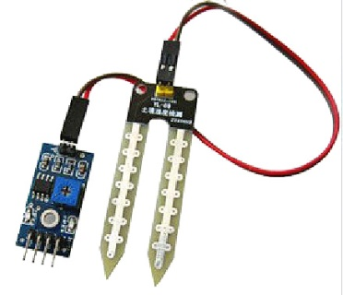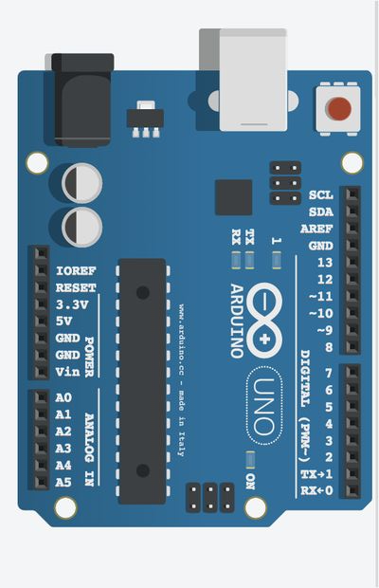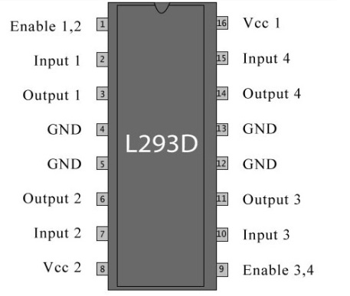

Output

LED 2

Output

LED 1

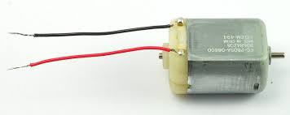

Figure: Interfacing moisture sensor with arduino, L293D, DC motor

Code:

void setup() {

// put your setup code here, to run once:

//pinMode(0,INPUT);

pinMode(8,OUTPUT);

pinMode(9,OUTPUT);

pinMode(3,OUTPUT);

pinMode(4,OUTPUT);

Serial.begin(9600);

}

void loop() {

// put your main code here, to run repeatedly:

int val=analogRead(0);

Serial.println(val);

delay(10);

if (val>500)

{

digitalWrite(9,HIGH);

digitalWrite(8,LOW);

digitalWrite(3,HIGH);

digitalWrite(4,LOW);

}

else if (val<500 & val>350)

{

digitalWrite(8,HIGH);

digitalWrite(9,LOW);

digitalWrite(3,LOW);

digitalWrite(4,LOW);

}

else

{

digitalWrite(8,LOW);

digitalWrite(9,LOW);

digitalWrite(3,LOW);

digitalWrite(4,LOW);

}

}

Discussion:

This was a course project, involving computer periferals and interfacing. Irrigation is one of te most important factors in irrigation. This project can bring ease in farmers work. It will automatically resolve some of their problems. We tried to provide power from a battery, but it appeared that batteries need to be changed periodically.