**Project report on CSE-3200**

**Software Development Project-2**

**Parisha Ahmed Prodhi**

**Roll: 1307012**

**Department of Computer Science and Engineering**

**Khulna University of Engineering & Technology**

**Khulna 9203, Bangladesh**

**Project report on CSE-3200**

**Software Development Project-2**

**Parisha Ahmed Prodhi**

**Roll: 1307012**

A project is submitted in partial fulfillment of the requirements for the degree of

“Bachelor of Science in Computer Science and Engineering”

**Signature:**

**_ _ _ _ _ _ _ _ _ _ _ _ _ _ _ _ _ _ _ _ _ _ _ _ _ _ _ _ _ _ _ _ _ _**

**Supervisor: Mohammad Insanur Rahman Shuvo**

**Lecturer**

**Dept. of Computer Science and Engineering**

**Khulna University of Engineering & Technology**

**Khulna - 9203, Bangladesh**

**Department of Computer Science and Engineering**

**Khulna University of Engineering & Technology**

**Khulna - 9203, Bangladesh**

**ACKNOWLEDGEMENT**

With due honor, *I* wish to express our gratitude to Almighty ALLAH. *I* express *my* indebtedness with reverential acknowledgement to our honorable supervisor **Mohammad Insanur Rahman Shuvo (**Lecturer, Dept. of Computer Science and Engineering, KUET**)** for his huge friendly & excellent guidance.

At the beginning of the term, it was nothing but a dream. *I was* in doubt that *I* could submit the project in time. *I*n *such* *a* difficult moment, our esteemed teacher **Mohammad Insanur Rahman Shuvo** sir stood beside us, supervised perfectly for a good work. He was there beside us all the time with big heart, took pain, motivated superbly, which has promoted our effort to see the light.

And we also express our gratitude to all our teachers, senior students and cordial batch mates who have helped us in various ways throughout this research work with their invaluable support.

**ABSTRACT**

Criminal activities have got our lives at a stake. We all should get to do something to protect each other. In short notice, both reporting to police and saving the victims is not quite possible. My idea is to make the reporting easier and less time consuming, and save the victims. My project is to save time of going to police.

**TABLE OF CONTENTS**

**Title Page No.**

Title Page 1

Acknowledgement 3

Abstract 4

Table of Contents 5

List of figures 7

Chapter 1: Introduction

1.1 Introduction 8

1.2 Statement of Problem 8

1.3 Objectives 9

Chapter 2: Background and Literature review

2.1 Background 10

# **Chapter****3:** Platform

3.1 Android 11

3.2 Firebase from google 12

# **Chapter 4: Implementation and Experimental Result**

# 4.1 **Witness’s Application** 13

4.1.1 Tracking Location 13

4.1.2 Capturing Image 13

# 4.1.3 sending 13

## 4.2 Police's Application 13

## 4.2.1 Getting Location 13

## 4.2.2 Receiving Image 14

## 4.3 Procedure of sending to firebase and Receiving to another app 14

## 4.4 Visualization of Apps Process 16

## 4.5 Result 19

## 

# Chapter 5 : **Conclusion and Recommendation**

5.1 Conclusion 21

5.2 Limitation 22

5.3 Future Development 22

REFERENCES 23

# **List of figures**

# Figure Name Page

4.1 Data Flow Diagram 15

4.2 Splash Screen 16

4.3 Witness’s App Interface 16

4.4 Process bar for Showing Image Upload 17

4.5 Toast after Image is Uploaded 17

4.6 Getting the Location 18

4.7 Toast after the Data is Sent 19

4.8 Police App Interface 19

4.9 Location Pointed at Google Maps 20

**Chapter 1**

**Introduction**

**1.1 Introduction**

It is quite obvious that the rate of crimes are increasing day by day in all societies in the world, but I personally do believe that there are a lot which can be done by both the governments and the individuals to reduce the crimes in communities.

 Individuals in societies can be of great help to cut down on the number of crimes being committed. To my mind, the overwhelming majority of people tend to participate in activities assisting the government to keep the society a safe place for their own families and the others and for all age groups.Most people by reporting the problems to police can play an indispensable role in crime-prevention activities. In addition, when people themselves care about decreasing heinous crimes in cities, it can be sort of a preventive action to harness well the situation in society by government as well.

Police forces also not only need to be good citizens,but also,they do need to be aware of ongoing crimes as fast as possible. Fast they know, and fast will they send their emforcements to help the victims and arrest the criminals as well.

In accordance with the need of reporting to police by the witnesses as fast as they can , I motivated myself to make this app namely pocket witness. If somebody wants to report to police, it is not necessary to go to the police themselves and again and their identity will not be known even by the police.So the individuals can do the report,absolutely anonymously with my app.

**1.2 Statement of Problem**

Nowadays, crimes occur in the daylight before many witnesses and still people don’t get to do anything. If any witness wants to report to the police, he/she will get late enough to have done severe losses with the criminals escaped. From this limitation, the idea of this project came across my mind. I designed such an application form which people will get to report instantly. This app will be able to protect people from losses.

**1.3 Objectives**

The main objective of our application is to save ourselves from losses arised from criminal activities. When a crime got any witness who wants to report to the police, he/she won’t get late enough to have done severe losses with the criminals escaped.Saving time, This app will be able to protect lives.

**Chapter 2**

**Background**

**2.1 Background**

People’s day to day life in our country is at a stake now. **We got to save one another,if we want to save ourselves. If a citizen helps to save another citizen,day by day, we will get some revolutionary changes in our situations. We should grow morality among us and morality is not just not doing bad things yourself, it’s also not letting anything bad occurance be arround us. One day, someone starts starting against, then everyone will protest gradually. We just need a platform to grow such protests.**

**Chapter 3**

Platform

**3.1** Android

Many people probably personally prefer to use an Android device as a phone. A big reason for that is it's openness and less restrictive environment in general. This has catalyzed a large developer community and myriad tools and libraries. Since most people always have an Android phone handy, and it is easy to get the app in hands of them.

When I decided to develop a mobile app,I went with android, with some good reasons.  I'll list them again here for completeness and then add a few more:

* Android is open source, so the developer's destiny is not controlled by Google.
* Android is very friendly to java developers, so developers can easily switch from another platform to Java without retraining.
* Google does not curate its App Marketplace as much as Apple does.
* Android has a large market share
* Google has fewer restrictions on interoperability or deep integration with the phone's features (although restrictions do, in fact, exist)

And here are a few additional reasons why a developer may choose the Android platform:  
  
**Varied development tools:** With Android, there are more options for development- it is easier to select a different IDE, or even another language or some sort of third party utility.  
  
**Fewer restrictions on functionality:** Android developers are free to explore weird or unconventional uses of the phone and it's functionality. An iOS app had approval issues trying to implement a camera that activated via the volume keys.  
  
**Fewer restrictions on mode of development**: On iOS, you'll find that certain development patterns (for instance, writing an app that is just a wrapper for a mobile web site) are frowned upon by Apple.  
  
**Wider Release:**Via alternative methods of distribution, Android apps can be distributed beyond the reach of the standard Android Market. This is crucial for developing nations or countries where electronic payment is still on shaky footing.

**3.2** Firebase **from Google**

Firebase is a technology that permits you to make web applications with no server-side programming so that development turns out to be quicker and easier. With Firebase, we don't have to stress over-provisioning servers or building REST APIs with just a little bit of configuration; we can give Firebase a chance to take every necessary step: storing data, verifying users, and implementing access rules.

It supports the web, iOS, OS X, and Android clients. Applications using Firebase can just use and control data, without having to think about how data would be stored, and synchronized across various examples of the application in real time. There is no need to write server side code, or to deploy a complex server framework to get an app started with Firebase.

* It is a versatile backend with a lot of good uses.
* It is cut down development time and avoids messing with servers and data storage.
* It is Scalable. If you want your application to scale well, you can trust that Firebase will handle all your data without missing a single step.
* It provides cloud service, so there isn't any setup involved.
* Data is stored as native JSON, so what you store is what you see.
* Data is safe because Firebase requires 2048-bit SSL encryption for all data transfers.
* Data is reflected and backed up to multiple secure locations, so there are minimal chances of data loss.
* It integrates nicely with frameworks like Angular JS. So it's very useful and allows you to create an app in a very short time.

**It chose firebase as database and web-host as** it is a database storage option like MySql and it saved my time compared to Mysql. I didn’t have to write the codes myself, Firebase did the work for me.

# **Chapter** 4

## Implementation and Experimental Result

**4.1** **Witness’s Application**

To use this service, a witness must install the witness side app in his/her android phone. The interface of witness side is quite simple.

## 4.1.1 Tracking Location

## There’s a button in the interface which gets you the GPS (Global Positioning System) location of the place you are, where a crime is getting to occured nearby.

**4.1.2 Capturing Image**

## With the capture photo button, it will redirect you to the camera app of your phone and you will be able to take a picture of the place or the incidence as a proof. When you take a photo,you will get a processbar that will tell you how the image is getting uploaded with percentage.

## 4.1.3 sending the data

With the send button there,you can send the tracked location and the image to police.

**4.2 Police’s Application**

The police will have an android application to receive the data, the police will also receive a notification.

**4.2.1 Getting Location**

Police’s application has a button for getting the location. With pressing it, user will be redirected to google maps, pointing the location of the occurrence.

**4.2.2 Receiving Image**

Police’s application has an imageview which will hold the received image.

**4.3 Procedure of sending to firebase and Receiving to another app**

At first, the latitude and longitude of the location and the image is stored at firebase database as children. There is also a child stored in firebase database which is named there as “check”. At every sending of data, the child “check” is updated and with this update, the police interface gets the data.

Get Location

Send

## +

Capture

Firebase Database and Storage

Get Location

Get Image

**Fig 4.1: Data flow diagram**

**4.4 Visualization of apps process**

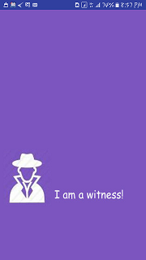

Fig 4.2: Splash Screen

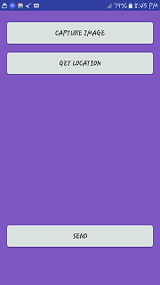

Fig 4.3 : Witness’s App Interface

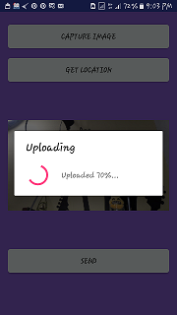

Fig 4.4 : Processbar for showing image upload

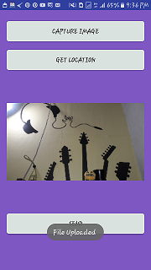

Fig 4.5 : Toast after image is uploaded

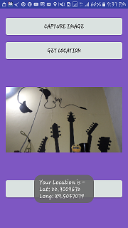

Fig 4.6 : Getting the location

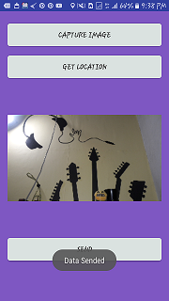

Fig 4.7 : Toast after the data is sent

4.5 Result

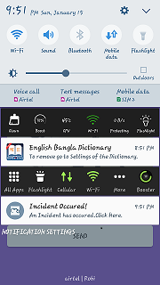

Fig 4.7 : Toast after the data is sent

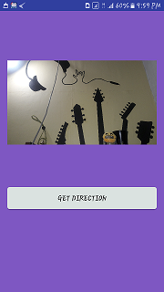

Fig 4.8 : Police app interface

# 

Fig 4.9 : Location pointed at google maps

# **Chapter 5**

# **Conclusion and Recommendation**

## 

## 5.1 Conclusion

## Criminal activities are increasing day by day. There are hardly few apps to be found which has can help people in this problem. We’ve tried a heart and soul to develop a quality app. As we are not professional now, we’ve taken much time. We think this is our first step to be a good developer.

Our sole target was to help people. We want to build a platform where user can easily report to police . Also no one have to go to police and to call them and tell the address. We think this application will be very useful for both common people and the police . We want to take part in contribution of our country. Our success and failure is now depend on people like how they take it.

## 5.2 Limitations

There are some limitations in our work.

Such as:

* This apps can not hold more than one instance at a time.
* Can’t store history.
* Police can not ignore notification.
* Police from everyone, near or far, will receive the same notification.

## 5.3 Future Development

I have a huge plan with the app. The plans are-

1. To send data to the police station nearer to the location first .
2. Police can respond or ignore the request, and then data could be sended to another near police station.
3. When police from near station isn’t responding to the request, police from a little far station will receive request.

**References**

1. <https://developer.android.com/index.html>

**2**. https://firebase.google.com/docs/android/setup

**3.** https://www.youtube.com/playlist?list=PLGCjwl1RrtcTXrWuRTa59RyRmQ4OedWrt