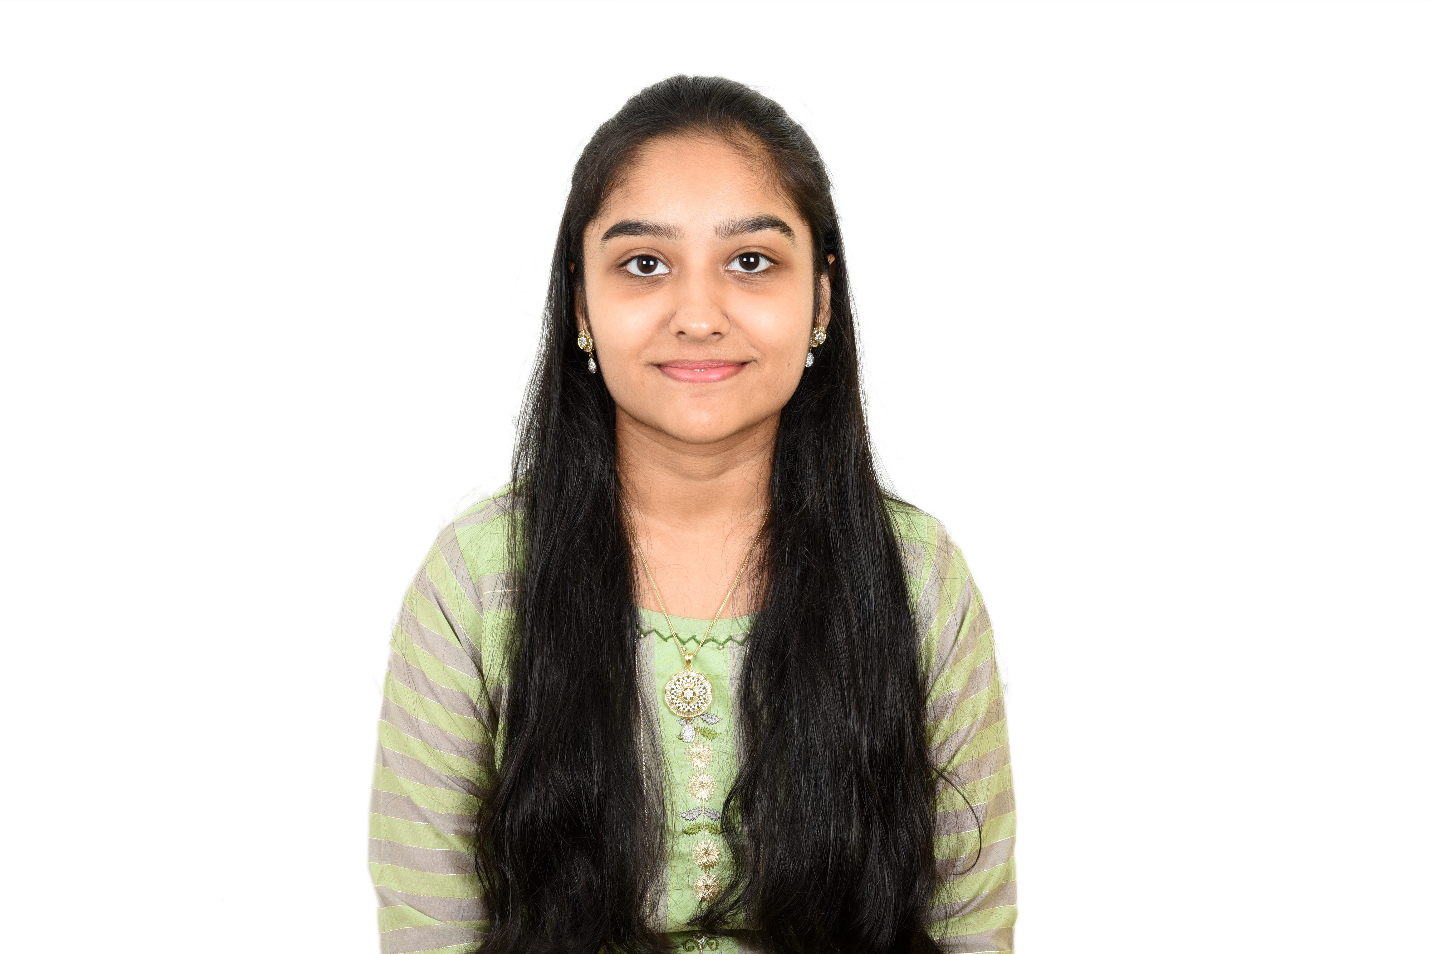 **Parishri Rakesh Shah ** +91-8692992399

Data Science and Artificial Intelligence  [22bds043@iiitdwd.ac.in](mailto:22bds043@iiitdwd.ac.in)

B Tech  [parishrishah24@gmail.com](mailto:parishrishah24@gmail.com) T Indian Institute Of Information Technology, Dharwad  [GitHub Profile](https://github.com/Parishri07)

[My Portfolio](https://parishri-portfolio.netlify.app/)  [LinkedIn Profile](https://www.linkedin.com/in/parishri-shah-0786a9263/)

# Technical Skills and Interests

**Languages**: C, C++, Java, Python

**Developer Tools**: HTML, CSS, JavaScript, Node.js, Git and GitHub, VS code

**Frameworks**: Express.js

**Areas of Interest**: Web Development

# Personal Projects

* **To do list App** *Nov’ 23*

*The To do list app enables to add work and make our own to do list.*

* + Tools technologies used: Node.js, Express.js, HTML, CSS, JavaScript
  + Developed a to do list app which keeps note of all our works to be done. Using visually appealing interface, display the list of work to be done.
  + Project URL: [To-do-list](https://github.com/Parishri07/To-do-list-app.git)
* **Web Based Games** *June’ 23*

*Developed a web platform with 4 interactive games: Tic Tac Toe, Drum Kit, Dice Challenge, Simon Game*

* + Tools technologies used: HTML, CSS, JavaScript
  + Utilized modern web technologies to create visually appealing interfaces, engaging gameplay mechanics, and scor- ing systems. Proficient in web development, game programming, audio integration, and user interface design.

Demonstrated skills in creating intuitive experiences and implementing score tracking and progression

* + Project URL: [Simon Game](https://my-simon-game-challenge.netlify.app/) [Drum Kit](https://my-drum-kit-game.netlify.app/) [Dice Challenge](https://my-dice-challenge.netlify.app/)
* **Decathlon UI** *June’ 23*

*Developed a responsive web application emulating the Decathlon website*

* + Tools technologies used: HTML, CSS, JavaScript
  + Utilized modern front-end frameworks for improved code organization and maintainability. Demonstrated profi- ciency in front-end development principles and responsive design.
  + Project URL: [Decathlon UI](https://decathlon-ui.netlify.app/)

# EDucation

* **Indian Institute of Information Technology, Dharwad** *Dec ’22 – Aug ‘26 Data Science and Artificial Intelligence* CGPA: 8.95
* **Prakash College of Commerce and Science** *2020-2022*

*Board of Intermediate Education, State* Percentage:83

* **Thakur International School Mumbai** *2007-2020*

*Board of Secondary Education, ICSE* Percentage: 95.4

# Positions of responsibility

* **Technical Team Member,** IRIS Club(Robotics club IIIT DWD) *April’23 - Present*

# Achievements

* **Third prize for Vanilla JS Library Making Competition**

College level competition for making a library using Vanilla JS to create, display and hide modal popups.