An Oracle White Paper
March 2013
How to Ship Mixed Pallets

Introduction 3
Definitions of Shipping Units 3
Packaged Item (PI) 3
Packaging Unit (PU) 3
Transport Handling Unit (THU) 3
Equipment Group 4
Item to Equipment Relationship 4
What makes a Mixed Pallet 5
Restrictions for Mixed Pallet 5
Mixed Pallet in an Order Release 6
How Mixed Pallets are Calculated 7
Pallet Determination in Order Release 7
Conclusion 8

Introduction
In the real world, shipments are made up of many different items of various sizes and weights. Oracle Transportation Management provides the functionality to maximize space requirements and reduce costs. One way is to mix different items or packaging units going to the same destination on the same pallet. This is called a mixed or rainbow pallet.
A mixed pallet is a pallet with more than one Order Release line packed on it. There are minor differences in setup along with some restrictions in the use of a mixed pallet. The internal method on how the pallet load is calculated is different from a regular pallet. The following covers how the application differs between the two types of pallets.
]

Definitions of Shipping Units
To understand what a pallet is and what can be packed on the pallet, it is necessary to start with an explanation of the different Ship Unit types. It begins with the item, how it is packaged, loaded and transported. The different Ship Unit types have a hierarchical relationship. To use a pallet, regardless of type you will use one of two load sequences. Before discussing the item to equipment relationship, a quick review of the different terminology we will encounter.

Packaged Item (PI)
This is the item as entered on the Order Base or Order Release form. It can be in each or a dozen, in pounds or ounces, etc. Each individual item has a weight and volume. Lines total for the weight and volume are generated.

Packaging Unit (PU)
Multiple Package Items are then packed into boxes or cartons. This is an optional step.

Transport Handling Unit (THU)
Many Packaged Items or Packaging Units are then further packed together to make loading of the Equipment Group easier. Whether this is a pallet or a box is controlled by the field IN/ON/MAX.
- MAX is an open box which it can be overfilled.
- ON is a pallet
- IN is used in two ways.
  - As a box that will have Packaging Units shipped in it.
  - Mixed (Rainbow) pallet. This is the required setting for a mixed pallet even though the items will be loaded on the pallet.

Equipment Group
A trailer, rail car or container, it must have one or Transport Handling Unit assigned based on its configured carrying capacity.

Item to Equipment Relationship
There are two methods of packing and loading Order Release lines.

Method 1:
Packaged Item > Transport Handling Unit > Equipment Group

Soft drinks are sold as a carton with 12 cans. The carton is the Packaged Item. These are directly placed on the pallet (Transport Handling Unit). Then multiple pallets are loaded into a trailer (Equipment Group).

Method 2:
Packaged Item > Packaging Unit > Transport Handling Unit > Equipment Group

Candy is sold as a box (Packaged Item) consisting of many pieces. These boxes are then packed into a larger box, the Packaging Unit. Packaging Units are then loaded onto the pallet (Transport Handling Unit) before being loaded into a trailer (Equipment Group).

With a mixed pallet, where possible and to gain savings, the goal is to load different Packaged Items and/or Packaging Units onto a single pallet.

Example:
A pallet can hold x number of cubic feet (CUFT). It can hold 48 cartons of drinks (Packaged Item) or 16 large boxes (Packaging Unit). An Order Release consists of a line for 24 cartons and a second line is entered for 12 boxes which are packed into 3 large boxes (Packaging Units). Without mixed pallets, this would require two pallets. When both items can use a mixed pallet and are going to the same destination that can process the pallet, just one pallet is created.

What makes a Mixed Pallet
Regardless of which pallet type defined the setup of the Ship Unit Specifications is the same with the exception of the field IN/ON/MAX.
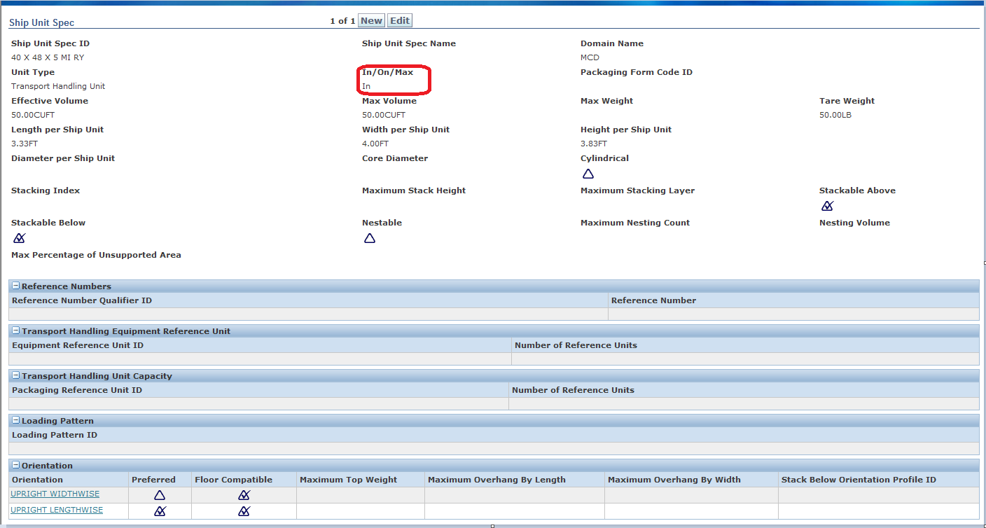Figure 1. Ship Unit Specifications (Shipment Management > Power Data > General > Ship Unit Specifications) for a mixed pallet.

Restrictions for Mixed Pallet
On the Order Release tab of the Order Configuration, you must have Allow Small Quantity Ship Unit Consolidation unchecked (see Figure 2). With this checked, Oracle Transportation Management will NOT create mixed pallets from released lines that have different Transport Handling Units. You will need to uncheck the box on your Order Configuration.

Allow Mixed Freight on Transport Handling Units is set for destination locations only. The reason for this is some locations can handle only certain types of pallets. For example a warehouse that does not break down the pallet before distributing it to a secondary location would not be able to process it. Before checking Allow Mixed Freight on Transport Handling Units, be sure to verify with the destination location if they accept mixed pallets.

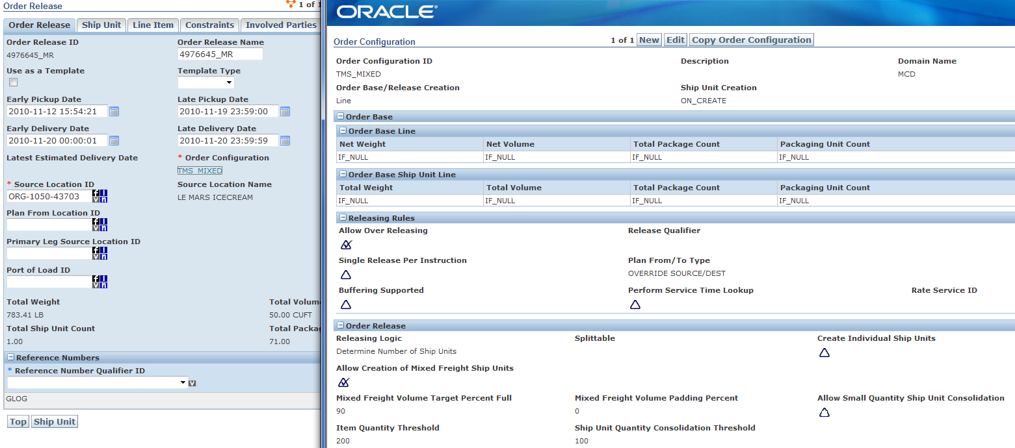
Figure 2. Ship Unit Specifications (Shipment Management > Power Data > General > Ship Unit Specifications) for a mixed pallet.

Oracle Transportation Management will NOT create mixed (rainbow) pallets based on Tier/Height (TiHi). Only the volume of the remaining lines is considered when calculating the mixed (rainbow) pallets. When calculating mixed pallets, the following occurs.

- If ALL the leftovers from multiple release lines (the quantity remaining after full pallets are created) can fit onto a single Mixed Pallet (based on Effective Volume and Maximum Volume), Oracle Transportation Management will create a mixed pallet with the remaining quantity of these lines. As an example, if there is 1 CUFT of CANDY leftover and 1 CUFT of LOLLIPOP and the Maximum Volume of the mixed Transport Handling Unit is 5, a single mixed pallet with both remainders will be created.
- If ALL the leftovers cannot fit together on a Mixed Pallet, then separate Ship Units for each Line (i.e. they will not be mixed) are created. As an example, if the Maximum Volume of the mixed Transport Handling Unit is 5 CUFT and 4 CUFT of CANDY is leftover and 2 CUFT of LOLLIPOP, this will create two separate Ship Units for each Line (1 ship unit for the partial CANDY and 1 ship unit for the partial LOLLIPOP).

- If the leftover volume of a single line exceeds the Maximum Volume of the mixed Transport Handling Unit (THU), Oracle Transportation Management will not use the mixed Transport Handling Unit (THU) and it will assign the partial to the normal Transport Handling Unit (THU). For example, if the mixed Transport Handling Unit (THU) has a Maximum Volume of 5 CUFT and 6 CUFT of CANDY is leftover, then a Mixed Pallet will NOT be created.

Mixed Pallet in an Order Release
To use a mixed pallet in an Order Release the Location for the destination, the Allow Mixed Freight on Transport Handling Units field must be checked. When this field is checked, the Transport Handling Unit field will appear. Use the List feature to see the valid available mixed pallets or New to define one.
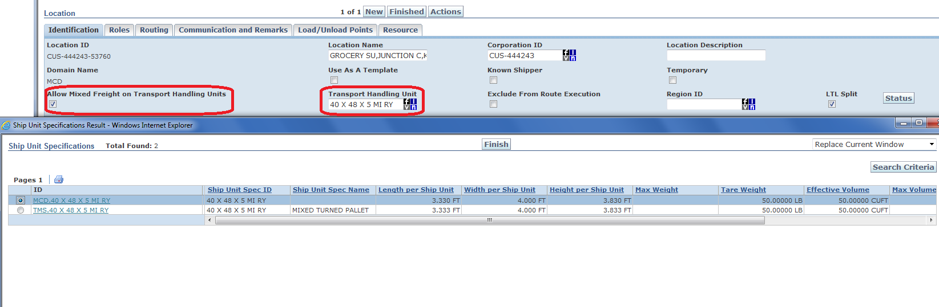
Figure 3. Location (Shipment Management > Location Manager) settings for a mixed pallet.

How Mixed Pallets are Calculated
When the Allow Mixed Freight on Transport Handling Units box is checked, Oracle Transportation Management uses a different ship unit building logic. Additional it uses the Mixed Freight Volume Target Percent Full along with the weight and volume defined on the Ship Unit Specifications form to determine how much to load on the pallet. For example, if set to 90, then a mixed pallet with a Ship Unit Specifications Effective Volume of 100 cubic feet (CUFT), then the mixed pallet will only pack to 90 cubic feet (CUFT).

Pallet Determination in Order Release
When Allow Mixed Freight on Transport Handling Units is not checked, Oracle Transportation Management calculates the pallets for each Order Release line individually. As shown in Figure 4 each Line Item is associated with its own pallet. The Weight of the Line Item matches the Total Gross Weight of the pallet.

With Allow Mixed Freight on Transport Handling Units checked, Oracle Transportation Management calculates the pallets for each Order Release line individually and all remaining quantities from the lines are evaluated to determine if they will fit on a single mixed pallet. As shown in Figure 5 both Line Items are loaded onto the same pallet. The Weight of both Line Items is added together to become the Total Gross Weight of the pallet. Once mixed pallets are created, they are shown in the Ship Unit tab of the Order Release.

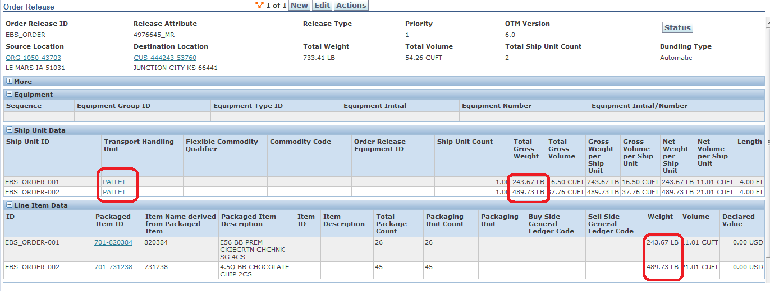
Figure 4. Order Release pallets calculated when Allow Mixed Freight on Transport Handling Units is unchecked.

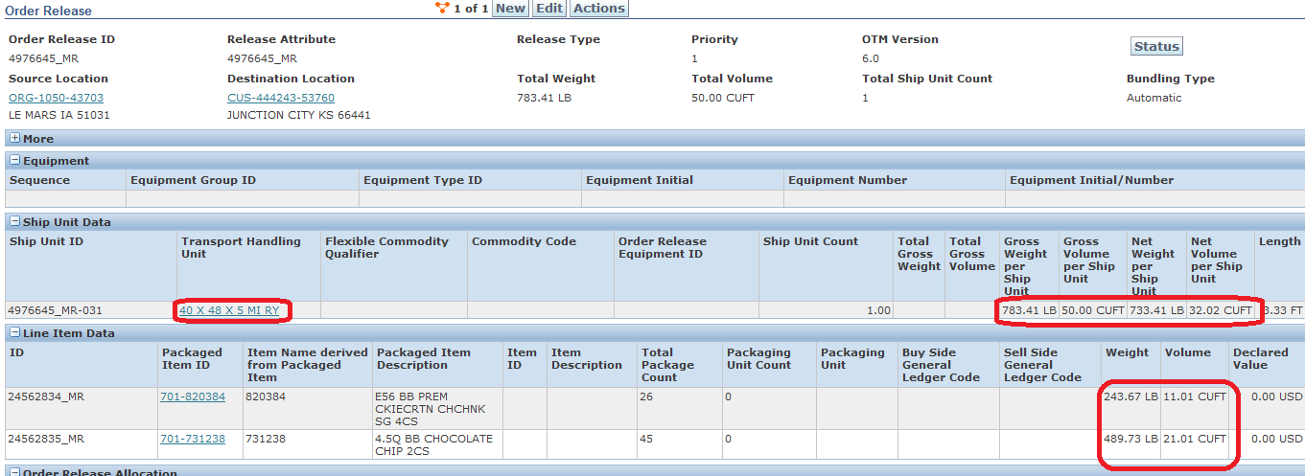
Figure 5. Order Release pallets calculated when Allow Mixed Freight on Transport Handling Units is checked.

Conclusion

Using a mixed or rainbow pallet is a simple effective way to reduce transportation costs. It is simple to set up and use. The two required setups to use a mixed pallet are: Mixed Freight on Transport Handling Units on the Location form for the destination location and IN/ON/MAX set to IN on the Ship Unit Specifications form.

How to Ship Mixed Pallets  March 2013  Author: Alice Thurmond  Contributing Authors: Lee Sargant  Oracle Corporation  World Headquarters  500 Oracle Parkway  Redwood Shores, CA 94065  U.S.A.  Worldwide Inquiries:  Phone: +1.650.506.7000  Fax: +1.650.506.7200  oracle.com | Copyright © 2011, Oracle and/or its affiliates. All rights reserved. This document is provided for information purposes only and the contents hereof are subject to change without notice. This document is not warranted to be error-free, nor subject to any other warranties or conditions, whether expressed orally or implied in law, including implied warranties and conditions of merchantability or fitness for a particular purpose. We specifically disclaim any liability with respect to this document and no contractual obligations are formed either directly or indirectly by this document. This document may not be reproduced or transmitted in any form or by any means, electronic or mechanical, for any purpose, without our prior written permission.  Oracle and Java are registered trademarks of Oracle and/or its affiliates. Other names may be trademarks of their respective owners.  AMD, Opteron, the AMD logo, and the AMD Opteron logo are trademarks or registered trademarks of Advanced Micro Devices.  Intel and Intel Xeon are trademarks or registered trademarks of Intel Corporation. All SPARC trademarks are used under license  and are trademarks or registered trademarks of SPARC International, Inc. UNIX is a registered trademark licensed through X/Open  Company, Ltd. 1010

