|  |  |
| --- | --- |
| **Student ID 30118549** | **Student Name Sunil Pariyar** |
| **Course Code ITECH3217** | **Course Name Programming 3** |
| **Date Submitted 11/05/2016** | **Lecturer’s Name Vani Madhula** |
| **Tutor’s Name Vani Madhula** | |

**ASSIGNMENT TITLE: Assignment 1 - Individual Assignment**

**Feedback / Assessment:**



|  |  |
| --- | --- |
| **LECTURER’S SIGNATURE:** | **DATE:** |
|  |  |

# 

PLAGIARISM

Plagiarism is the presentation of the expressed thought or work of another person as though it is one's own without properly acknowledging that person. You must not allow other students to copy your work and must take care to safeguard against this happening.

Plagiarism is a serious offence. As set out in University Regulation 6.1.1., students who are caught plagiarising will, for a first offence, be given a zero mark for that task. A second offence will result in a failing grade for the Course(s) involved and any subsequent offence will be referred to the Student Discipline Committee.

|  |
| --- |
| Declaration  Except where appropriately acknowledged, this assignment is my own work, has been expressed in my own words and has not previously been submitted for assessment. I have also retained a copy of this assessment piece for my own records.    Signature:___Sunil Pariyar___________________________ Date:__11/05/2016_________________ |

Contents

Acknowledgement 3

How the code works 4

Pseudocode, UML4 and screenshots. 4

Pseudocode 4

Class GUI: 4

Class PrimeNumbers: 4

It will have five members: 4

It will have five methods: 4

UML 6

Correct working of code. 6

Input: 6

Output: 6

Exceptions implemented in the application. 7

Exception 1: input empty string 7

Exception 2 : input non integer 7

Layout of your GUI and the reasons behind the design. 8

Issues that might arise in implementing the application on a mainframe 8

# Acknowledgement

I would like to thank all my class mates(Prakash Kandel, Bikram Dongol and Sajjan Gurung) to help me understand the concept of multithreading and the prime numbers, which helped me a lot on completing this assignment.

# How the code works

The name of the application is PrimeNumbers, which is self-explanatory that its purpose is to find prime numbers. The application has two classes (PrimeNumbers and GUI). All the logics are in the PrimeNumbers and the GUI class only contains the user interface.

The working of the code will be explained in the next part of this report

# Pseudocode, UML4 and screenshots.

## Pseudocode

First import all the necessary library files, for example;

1. Swing
2. Awt
3. JFrame

### Class GUI:

This class extends the JFrame

It will have only one method, which is a constructor with no parameter, which allow to create an object of this class. This object will be a JFrame object with title, layout , size and close operation for the frame.

### Class PrimeNumbers:

This class extends Thread and it also contains main method

### It will have five members:

1. Boolean[] prime
2. Int i
3. Int size
4. GUI g

### It will have five methods:

1. Main method

The purpose of this method is to start the application, initiate all the objects, threads and logic of the application

* Initiates the GUI object
* Adds all the necessary components to the frame (please check out GUI layout and design part of this report): button, label, text field, text area and scrollpane
* Adds the action listener to the button to perform the calculation with the help of inner class
* The inner class contains a method called action performed, where all the logics are implemented
  + Sets the text on text area to null
  + If the user does not give any input, it will show a message dialog to enter an integer
  + Else it will perform try catch statement
    - Initiate an array with the size taken from the user input
    - Sets the first and second elements of the array to false
    - Starts for loop to set all the elements from third to last to true
    - Starts another for loop to create the threads and to check the indexes of the array to be prime and also joins the thread for the synchronization purpose

for(index = 2; index < Math.sqrt(size); index++){

if(primes[index] == true){

Thread t = new PrimeNumbers();

t.start();

try {

t.join();

} catch (InterruptedException ex) {

ex.getMessage();

}

}

}

* + - Catches if the user input is not an integer

1. Run method

The purpose of this method is to find out if the indexes of the array are prime numbers or not.

* Start the loop from the index that is set while the thread is started and less than the size of an array
* Checks all the array indexes if they are divisible by the index set by the thread
* If the condition is true, calls the isPrime method, which sets the array index to false

1. isPrime method (synchronized method)

The purpose of this method is to restrict more than one thread to act on the array at a time

* Takes one integer parameter
* Sets the index of array with the received parameter to false

1. primesPrint method:

The purpose of this method is to print out all the indexes of an array(Boolean[] primes) which corresponds to the Boolean value true into the text area.

* Start the loop from 0 to less than the size of an array
* If the array index corresponds to true, append the index to text area

## UML

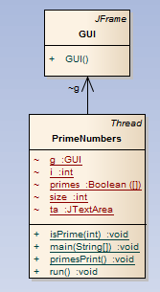

# Correct working of code.

## Input:

1000

## Output:

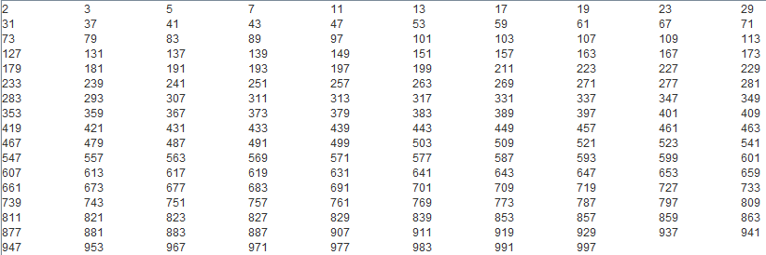

# Exceptions implemented in the application.

## Exception 1: input empty string

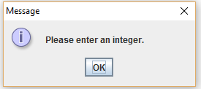

## Exception 2 : input non integer

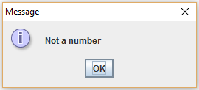

# Layout of your GUI and the reasons behind the design.

The layout of the GUI is very simple as it should be easy for the user to understand and use the application. The GUI has a title and a label which describes the purpose of the application and what the user is supposed to do. It has a text field to enter the integer and a go button, which will execute the program and it has a text area to display the results.

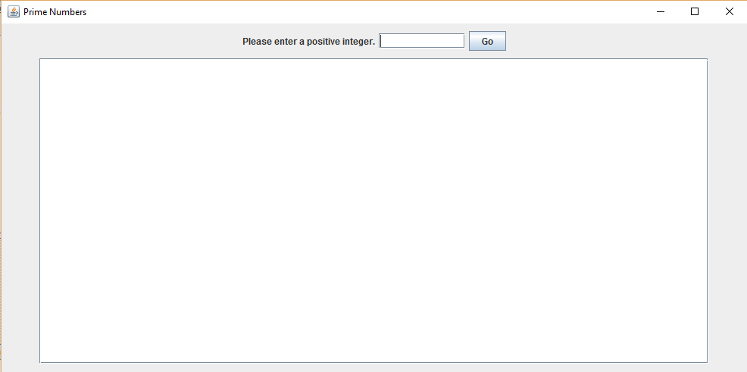

# Issues that might arise in implementing the application on a mainframe

1. As this application is very simple and small, the resource will be underutilized
2. We need to carry the third party library files with the application
3. Might need to install JVM first
4. Configuring the mainframe for the application might be very hard